Assignment 5
Melissa Dennis
2025-11-22
Read data
cereal.df <- read.csv("C:/Users/m_den/OneDrive/Documents/GitHub/64060_-mdenni23/Assignment_5/Cereals.csv")
Evaluate the data
str(cereal.df)
## 'data.frame': 77 obs. of 16 variables:
## $ name : chr "100%_Bran" "100%_Natural_Bran" "All-Bran" "All-Bran_with_Extra_Fiber" ...
## $ mfr : chr "N" "Q" "K" "K" ...
## $ type : chr "C" "C" "C" "C" ...
## $ calories: int 70 120 70 50 110 110 110 130 90 90 ...
## $ protein : int 4 3 4 4 2 2 2 3 2 3 ...
## $ fat : int 1 5 1 0 2 2 0 2 1 0 ...
## $ sodium : int 130 15 260 140 200 180 125 210 200 210 ...
## $ fiber : num 10 2 9 14 1 1.5 1 2 4 5 ...
## $ carbo : num 5 8 7 8 14 10.5 11 18 15 13 ...
## $ sugars : int 6 8 5 0 8 10 14 8 6 5 ...
## $ potass : int 280 135 320 330 NA 70 30 100 125 190 ...
## $ vitamins: int 25 0 25 25 25 25 25 25 25 25 ...
## $ shelf : int 3 3 3 3 3 1 2 3 1 3 ...
## $ weight : num 1 1 1 1 1 1 1 1.33 1 1 ...
## $ cups : num 0.33 1 0.33 0.5 0.75 0.75 1 0.75 0.67 0.67 ...
## $ rating : num 68.4 34 59.4 93.7 34.4 ...
summary(cereal.df)
## name mfr type calories
## Length:77 Length:77 Length:77 Min. : 50.0
## Class :character Class :character Class :character 1st Qu.:100.0
## Mode :character Mode :character Mode :character Median :110.0
## Mean :106.9
## 3rd Qu.:110.0
## Max. :160.0
##
## protein fat sodium fiber
## Min. :1.000 Min. :0.000 Min. : 0.0 Min. : 0.000
## 1st Qu.:2.000 1st Qu.:0.000 1st Qu.:130.0 1st Qu.: 1.000
## Median :3.000 Median :1.000 Median :180.0 Median : 2.000
## Mean :2.545 Mean :1.013 Mean :159.7 Mean : 2.152
## 3rd Qu.:3.000 3rd Qu.:2.000 3rd Qu.:210.0 3rd Qu.: 3.000
## Max. :6.000 Max. :5.000 Max. :320.0 Max. :14.000
##
## carbo sugars potass vitamins
## Min. : 5.0 Min. : 0.000 Min. : 15.00 Min. : 0.00
## 1st Qu.:12.0 1st Qu.: 3.000 1st Qu.: 42.50 1st Qu.: 25.00
## Median :14.5 Median : 7.000 Median : 90.00 Median : 25.00
## Mean :14.8 Mean : 7.026 Mean : 98.67 Mean : 28.25
## 3rd Qu.:17.0 3rd Qu.:11.000 3rd Qu.:120.00 3rd Qu.: 25.00
## Max. :23.0 Max. :15.000 Max. :330.00 Max. :100.00
## NA's :1 NA's :1 NA's :2
## shelf weight cups rating
## Min. :1.000 Min. :0.50 Min. :0.250 Min. :18.04
## 1st Qu.:1.000 1st Qu.:1.00 1st Qu.:0.670 1st Qu.:33.17
## Median :2.000 Median :1.00 Median :0.750 Median :40.40
## Mean :2.208 Mean :1.03 Mean :0.821 Mean :42.67
## 3rd Qu.:3.000 3rd Qu.:1.00 3rd Qu.:1.000 3rd Qu.:50.83
## Max. :3.000 Max. :1.50 Max. :1.500 Max. :93.70
##
##Remove NA
df <- na.omit(cereal.df)
##Examine dataset
head(df)
## name mfr type calories protein fat sodium fiber carbo
## 1 100%_Bran N C 70 4 1 130 10.0 5.0
## 2 100%_Natural_Bran Q C 120 3 5 15 2.0 8.0
## 3 All-Bran K C 70 4 1 260 9.0 7.0
## 4 All-Bran_with_Extra_Fiber K C 50 4 0 140 14.0 8.0
## 6 Apple_Cinnamon_Cheerios G C 110 2 2 180 1.5 10.5
## 7 Apple_Jacks K C 110 2 0 125 1.0 11.0
## sugars potass vitamins shelf weight cups rating
## 1 6 280 25 3 1 0.33 68.40297
## 2 8 135 0 3 1 1.00 33.98368
## 3 5 320 25 3 1 0.33 59.42551
## 4 0 330 25 3 1 0.50 93.70491
## 6 10 70 25 1 1 0.75 29.50954
## 7 14 30 25 2 1 1.00 33.17409
Convert the names of cereals to row names
##Convert Names to row names
rownames(df) <- df$name
##Remove duplicate column
df$name = NULL
##Remove MFR and Type columns
df <- df[,-(1:2)]
head(df)
## calories protein fat sodium fiber carbo sugars potass
## 100%_Bran 70 4 1 130 10.0 5.0 6 280
## 100%_Natural_Bran 120 3 5 15 2.0 8.0 8 135
## All-Bran 70 4 1 260 9.0 7.0 5 320
## All-Bran_with_Extra_Fiber 50 4 0 140 14.0 8.0 0 330
## Apple_Cinnamon_Cheerios 110 2 2 180 1.5 10.5 10 70
## Apple_Jacks 110 2 0 125 1.0 11.0 14 30
## vitamins shelf weight cups rating
## 100%_Bran 25 3 1 0.33 68.40297
## 100%_Natural_Bran 0 3 1 1.00 33.98368
## All-Bran 25 3 1 0.33 59.42551
## All-Bran_with_Extra_Fiber 25 3 1 0.50 93.70491
## Apple_Cinnamon_Cheerios 25 1 1 0.75 29.50954
## Apple_Jacks 25 2 1 1.00 33.17409
Scaling and standardizing dataset
df <- scale(df, center = T, scale = T)
#Reexamine the scaled data
head(df)
## calories protein fat sodium
## 100%_Bran -1.8659155 1.3817478 0.0000000 -0.3910227
## 100%_Natural_Bran 0.6537514 0.4522084 3.9728810 -1.7804186
## All-Bran -1.8659155 1.3817478 0.0000000 1.1795987
## All-Bran_with_Extra_Fiber -2.8737823 1.3817478 -0.9932203 -0.2702057
## Apple_Cinnamon_Cheerios 0.1498180 -0.4773310 0.9932203 0.2130625
## Apple_Jacks 0.1498180 -0.4773310 -0.9932203 -0.4514312
## fiber carbo sugars potass
## 100%_Bran 3.22866747 -2.5001396 -0.2542051 2.5605229
## 100%_Natural_Bran -0.07249167 -1.7292632 0.2046041 0.5147738
## All-Bran 2.81602258 -1.9862220 -0.4836096 3.1248675
## All-Bran_with_Extra_Fiber 4.87924705 -1.7292632 -1.6306324 3.2659536
## Apple_Cinnamon_Cheerios -0.27881412 -1.0868662 0.6634132 -0.4022862
## Apple_Jacks -0.48513656 -0.9583868 1.5810314 -0.9666308
## vitamins shelf weight cups
## 100%_Bran -0.1818422 0.9419715 -0.2008324 -2.0856582
## 100%_Natural_Bran -1.3032024 0.9419715 -0.2008324 0.7567534
## All-Bran -0.1818422 0.9419715 -0.2008324 -2.0856582
## All-Bran_with_Extra_Fiber -0.1818422 0.9419715 -0.2008324 -1.3644493
## Apple_Cinnamon_Cheerios -0.1818422 -1.4616799 -0.2008324 -0.3038480
## Apple_Jacks -0.1818422 -0.2598542 -0.2008324 0.7567534
## rating
## 100%_Bran 1.8549038
## 100%_Natural_Bran -0.5977113
## All-Bran 1.2151965
## All-Bran_with_Extra_Fiber 3.6578436
## Apple_Cinnamon_Cheerios -0.9165248
## Apple_Jacks -0.6553998
Load libraries
library(stats)
library(cluster)
library(factoextra)
## Warning: package 'factoextra' was built under R version 4.3.3
## Loading required package: ggplot2
## Welcome! Want to learn more? See two factoextra-related books at https://goo.gl/ve3WBa
library(tidyverse)
## Warning: package 'dplyr' was built under R version 4.3.3
## ── Attaching core tidyverse packages ──────────────────────── tidyverse 2.0.0 ──
## ✔ dplyr 1.1.4 ✔ readr 2.1.4
## ✔ forcats 1.0.0 ✔ stringr 1.5.0
## ✔ lubridate 1.9.2 ✔ tibble 3.2.1
## ✔ purrr 1.0.1 ✔ tidyr 1.3.0
## ── Conflicts ────────────────────────────────────────── tidyverse_conflicts() ──
## ✖ dplyr::filter() masks stats::filter()
## ✖ dplyr::lag() masks stats::lag()
## ℹ Use the conflicted package (<http://conflicted.r-lib.org/>) to force all conflicts to become errors
Calculate the distance measures
##Use the euclidean distance measure
dist <- dist(df, method = "euclidean")
hc_fit <- hclust(dist, method = "ward.D2")
Plot using complete, single, ward, and avereage to determine which linkage is best
hc1 <- hclust(dist, method = "complete")
plot(hc1, cex = 0.3, hang = -1)
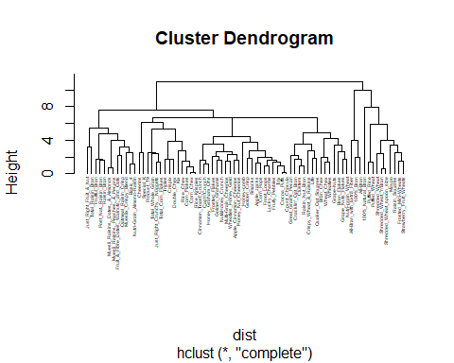 Plot using average
hc2 <- hclust(dist, method = "average")
plot(hc2, cex = 0.3, hang = -1)
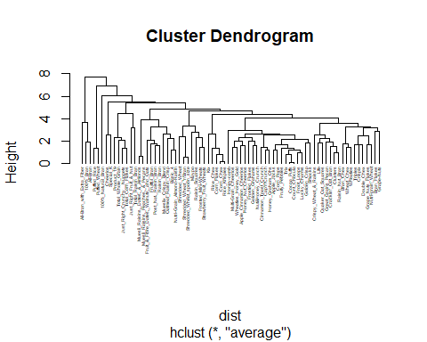 Plot using median
hc3 <- hclust(dist, method = "median")
plot(hc3, cex = 0.3, hang = -1)
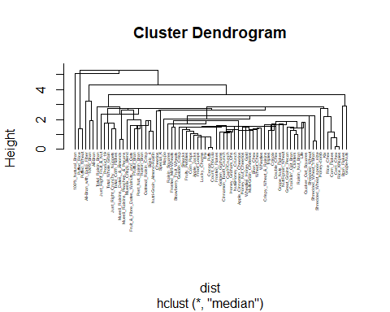 Plot using centroid
hc4 <- hclust(dist, method = "centroid")
plot(hc4, cex = 0.3, hang = -1)
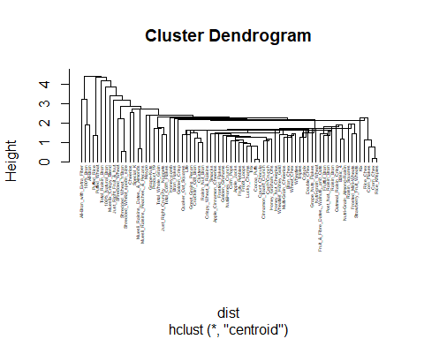 Plot using ward
hc5 <- hclust(dist, method = "ward.D2")
plot(hc5, cex = 0.3, hang = -1)
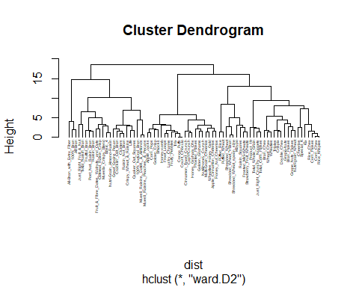 Plot using single
hc6 <- hclust(dist, method = "single")
plot(hc6, cex = 0.3, hang = -1)
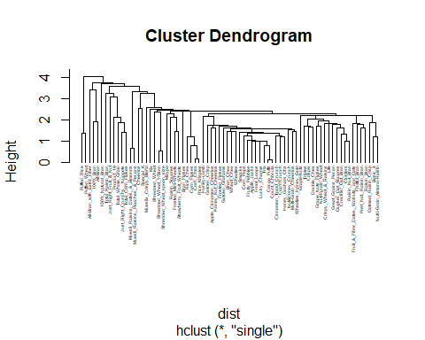 Calculate and plot using Agnes for each linkage
##Compute with agnes and with different linkage methods
hc_single <- agnes(df, method = "single")
hc_complete <- agnes(df, method = "complete")
hc_average <- agnes(df, method = "average")
hc_ward <- agnes(df, method = "ward")
##Compare Agglomerative coefficients
pltree(hc_complete, cex = 0.3, hang = -1, main = "Dendrogram of Complete Agnes")
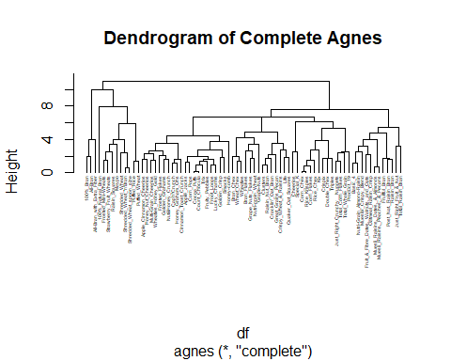
pltree(hc_average, cex = 0.3, hang = -1, main = "Dendrogram of Average Agnes")
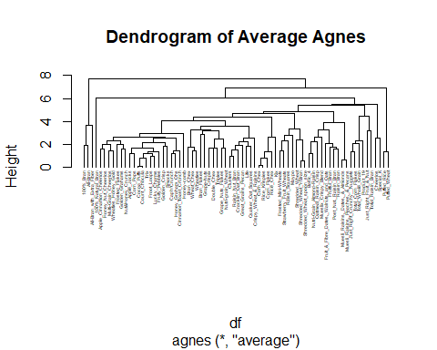
pltree(hc_single, cex = 0.3, hang = -1, main = "Dendrogram of Single Agnes")
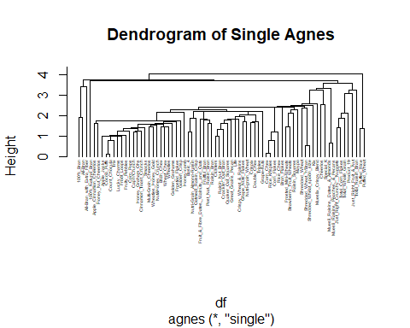
pltree(hc_ward, cex = 0.3, hang = -1, main = "Dendrogram of Ward Agnes")
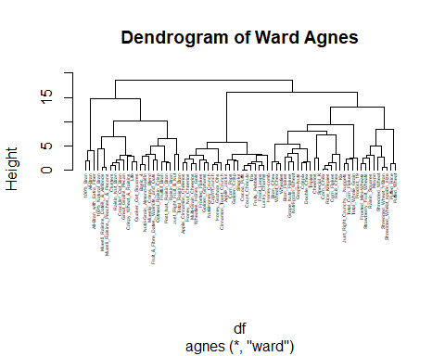
print(hc_single$ac)
## [1] 0.6067859
print(hc_complete$ac)
## [1] 0.8353712
print(hc_average$ac)
## [1] 0.7766075
print(hc_ward$ac)
## [1] 0.9046042
Ward linkage provides the strongest clustering structure because of it has the highest Agglomerative coefficient.
Using a height cutoff of 10, 6 cluster can be established.
##Plot ward linkage with 6 clusters bordered
plot(hc_fit, cex = 0.3, hang = -1, main = "Dendrogram of Ward Agnes", xlab = "Cereal Name")
rect.hclust(hc_fit, k = 6, border = 2:8)
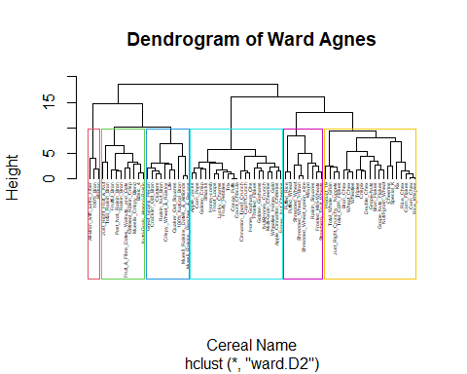
Add column to dataset denoted the cluster the cereal is located in
points_hc <- cutree(hc_fit, k = 6)
##Store the clusters in a data frame along with the cereals data
cereals_clusts_hc <- cbind(points_hc, df)
##The head of the new data frame
colnames(cereals_clusts_hc)[1] <- "cluster_hc"
head(cereals_clusts_hc)
## cluster_hc calories protein fat
## 100%_Bran 1 -1.8659155 1.3817478 0.0000000
## 100%_Natural_Bran 2 0.6537514 0.4522084 3.9728810
## All-Bran 1 -1.8659155 1.3817478 0.0000000
## All-Bran_with_Extra_Fiber 1 -2.8737823 1.3817478 -0.9932203
## Apple_Cinnamon_Cheerios 3 0.1498180 -0.4773310 0.9932203
## Apple_Jacks 3 0.1498180 -0.4773310 -0.9932203
## sodium fiber carbo sugars
## 100%_Bran -0.3910227 3.22866747 -2.5001396 -0.2542051
## 100%_Natural_Bran -1.7804186 -0.07249167 -1.7292632 0.2046041
## All-Bran 1.1795987 2.81602258 -1.9862220 -0.4836096
## All-Bran_with_Extra_Fiber -0.2702057 4.87924705 -1.7292632 -1.6306324
## Apple_Cinnamon_Cheerios 0.2130625 -0.27881412 -1.0868662 0.6634132
## Apple_Jacks -0.4514312 -0.48513656 -0.9583868 1.5810314
## potass vitamins shelf weight
## 100%_Bran 2.5605229 -0.1818422 0.9419715 -0.2008324
## 100%_Natural_Bran 0.5147738 -1.3032024 0.9419715 -0.2008324
## All-Bran 3.1248675 -0.1818422 0.9419715 -0.2008324
## All-Bran_with_Extra_Fiber 3.2659536 -0.1818422 0.9419715 -0.2008324
## Apple_Cinnamon_Cheerios -0.4022862 -0.1818422 -1.4616799 -0.2008324
## Apple_Jacks -0.9666308 -0.1818422 -0.2598542 -0.2008324
## cups rating
## 100%_Bran -2.0856582 1.8549038
## 100%_Natural_Bran 0.7567534 -0.5977113
## All-Bran -2.0856582 1.2151965
## All-Bran_with_Extra_Fiber -1.3644493 3.6578436
## Apple_Cinnamon_Cheerios -0.3038480 -0.9165248
## Apple_Jacks 0.7567534 -0.6553998
Print the cereal and assigned cluster
memb <- cutree(hc_fit, k = 6)
memb
## 100%_Bran 100%_Natural_Bran
## 1 2
## All-Bran All-Bran_with_Extra_Fiber
## 1 1
## Apple_Cinnamon_Cheerios Apple_Jacks
## 3 3
## Basic_4 Bran_Chex
## 4 5
## Bran_Flakes Cap'n'Crunch
## 5 3
## Cheerios Cinnamon_Toast_Crunch
## 5 3
## Clusters Cocoa_Puffs
## 2 3
## Corn_Chex Corn_Flakes
## 5 5
## Corn_Pops Count_Chocula
## 3 3
## Cracklin'_Oat_Bran Crispix
## 2 5
## Crispy_Wheat_&_Raisins Double_Chex
## 2 5
## Froot_Loops Frosted_Flakes
## 3 3
## Frosted_Mini-Wheats Fruit_&_Fibre_Dates,_Walnuts,_and_Oats
## 6 4
## Fruitful_Bran Fruity_Pebbles
## 4 3
## Golden_Crisp Golden_Grahams
## 3 3
## Grape_Nuts_Flakes Grape-Nuts
## 5 5
## Great_Grains_Pecan Honey_Graham_Ohs
## 2 3
## Honey_Nut_Cheerios Honey-comb
## 3 3
## Just_Right_Crunchy__Nuggets Just_Right_Fruit_&_Nut
## 5 4
## Kix Life
## 5 2
## Lucky_Charms Maypo
## 3 6
## Muesli_Raisins,_Dates,_&_Almonds Muesli_Raisins,_Peaches,_&_Pecans
## 2 2
## Mueslix_Crispy_Blend Multi-Grain_Cheerios
## 4 3
## Nut&Honey_Crunch Nutri-Grain_Almond-Raisin
## 3 4
## Nutri-grain_Wheat Oatmeal_Raisin_Crisp
## 5 4
## Post_Nat._Raisin_Bran Product_19
## 4 5
## Puffed_Rice Puffed_Wheat
## 6 6
## Quaker_Oat_Squares Raisin_Bran
## 2 4
## Raisin_Nut_Bran Raisin_Squares
## 2 6
## Rice_Chex Rice_Krispies
## 5 5
## Shredded_Wheat Shredded_Wheat_'n'Bran
## 6 6
## Shredded_Wheat_spoon_size Smacks
## 6 3
## Special_K Strawberry_Fruit_Wheats
## 5 6
## Total_Corn_Flakes Total_Raisin_Bran
## 5 4
## Total_Whole_Grain Triples
## 5 5
## Trix Wheat_Chex
## 3 5
## Wheaties Wheaties_Honey_Gold
## 5 3
Plot clusters on a heat map
##Set labels
row.names(cereals_clusts_hc) <- paste(memb, ": ", row.names(cereals_clusts_hc), sep = "")
##Create a dendrogram object
##We use as.dendrogram so heatmap knows how to handle it
my_dendrogram <- as.dendrogram(hc5)
##Plot heatmap
heatmap(as.matrix(cereals_clusts_hc),
Rowv = my_dendrogram,
Colv = NA,
col = rev(paste("grey",1:99,sep="")),
scale = "none",
main = "Heatmap Ordered by Ward Clustering (k=6)"
)
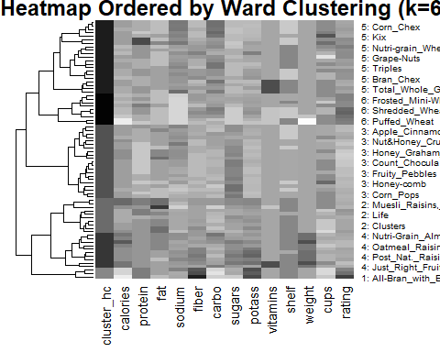
Build a kmeans model with k = 2
set.seed(123)
km_basic <- kmeans(cereals_clusts_hc, centers = 2)
str(km_basic)
## List of 9
## $ cluster : Named int [1:74] 2 2 2 2 1 1 2 1 1 1 ...
## ..- attr(*, "names")= chr [1:74] "1: 100%_Bran" "2: 100%_Natural_Bran" "1: All-Bran" "1: All-Bran_with_Extra_Fiber" ...
## $ centers : num [1:2, 1:14] 4.353 2.739 -0.206 0.457 -0.313 ...
## ..- attr(*, "dimnames")=List of 2
## .. ..$ : chr [1:2] "1" "2"
## .. ..$ : chr [1:14] "cluster_hc" "calories" "protein" "fat" ...
## $ totss : num 1092
## $ withinss : num [1:2] 572 306
## $ tot.withinss: num 879
## $ betweenss : num 214
## $ size : int [1:2] 51 23
## $ iter : int 1
## $ ifault : int 0
## - attr(*, "class")= chr "kmeans"
Plot cereals in 2 clusters
fviz_cluster(km_basic, df)
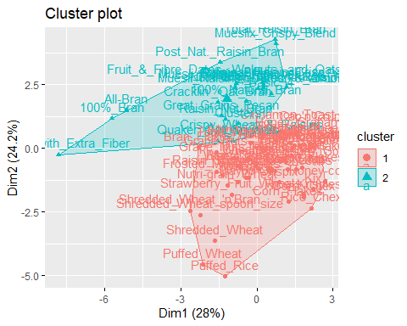
cat("The elementary public schools would like to choose a set of cereals to include in their daily cafeterias. Every day a different cereal is offered, but all cereals should support a healthy diet. For this goal, you are requested to find a cluster of “healthy cereals.” Should the data be normalized? If not, how should they be used in the cluster analysis? \n\nElementary public schools should choose cluster 1 as this has the healthiest selection of cereals")
## The elementary public schools would like to choose a set of cereals to include in their daily cafeterias. Every day a different cereal is offered, but all cereals should support a healthy diet. For this goal, you are requested to find a cluster of “healthy cereals.” Should the data be normalized? If not, how should they be used in the cluster analysis?
##
## Elementary public schools should choose cluster 1 as this has the healthiest selection of cereals
Cluster the data to confirm which cereals are the best choice.
sub_grp <- cutree(hc5, k = 6)
fviz_cluster(list(data = df, cluster = sub_grp))
