# **Assignment 3**

### Applying RNNs to Time-Series Data for Weather Forecasting

**Purpose:**

The primary objective of this assignment is to apply Recurrent Neural Networks (RNNs) to time-series data, specifically focusing on time-series forecasting problems.

**Methods Employed:**

To achieve the goals of the assignment, the following methods were employed:

1. **Data Preprocessing:**

* The dataset used included columns 'Datetime1', 'DAYTON_MW', and 'Datetime'.
* The 'Datetime1' column represented the hour of the date time.
* Sequences of temperature values ('DAYTON_MW') were created with a specified sequence length.
* Data normalization was performed using MinMaxScaler.

1. **Model Architecture:**
   * Two types of recurrent layers, LSTM (Long Short-Term Memory) and GRU (Gated Recurrent Unit), were employed in separate models.
   * A combination of 1D Convolutional layers and LSTM was implemented in another model to explore the benefits of combining different layer types.
2. **Model Training:**

* Models were trained using a training set, and performance was evaluated using validation data.
* Hyperparameters such as the number of units, filters, and epochs were adjusted for experimentation.

1. **Evaluation:**

* Models were evaluated based on Mean Absolute Error (MAE) on the validation set.
* The best-performing models (in terms of validation MAE) were selected for testing on the test set.

**Results Summary:**

The following models were developed and evaluated:

1. **LSTM Model:**

* Achieved an MAE of 0.1656 on the validation set.
* Demonstrated the effectiveness of LSTM in capturing temporal dependencies.

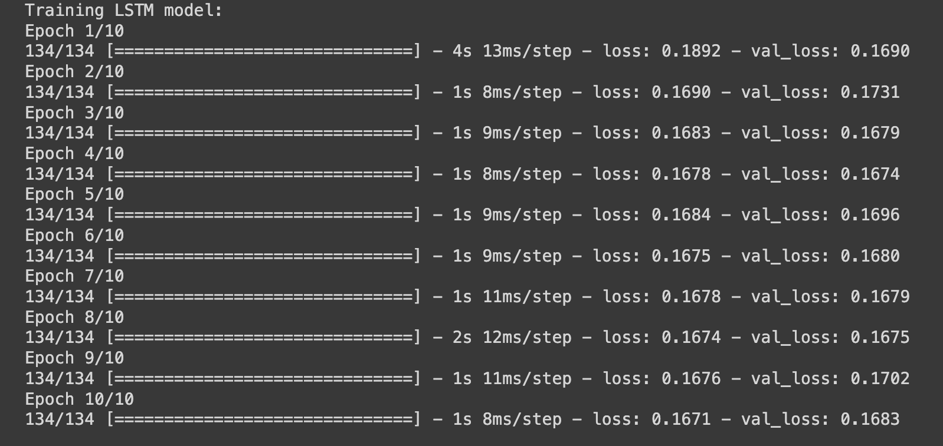

1. **GRU Model:**

* Achieved an MAE of 0.1653 on the validation set.
* Provided an alternative approach to LSTM, with comparable performance.

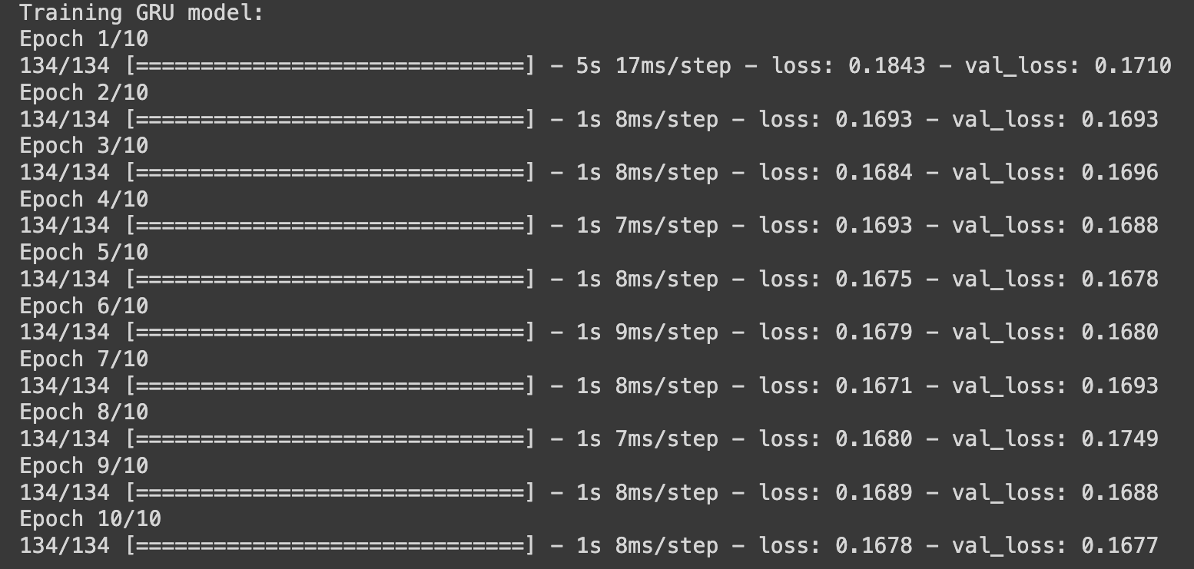

1. **ConvLSTM Model:**
   * Achieved an MAE of 0.1658 on the validation set.
   * Showcased the benefits of combining 1D Convolutional layers with LSTM for improved feature extraction.

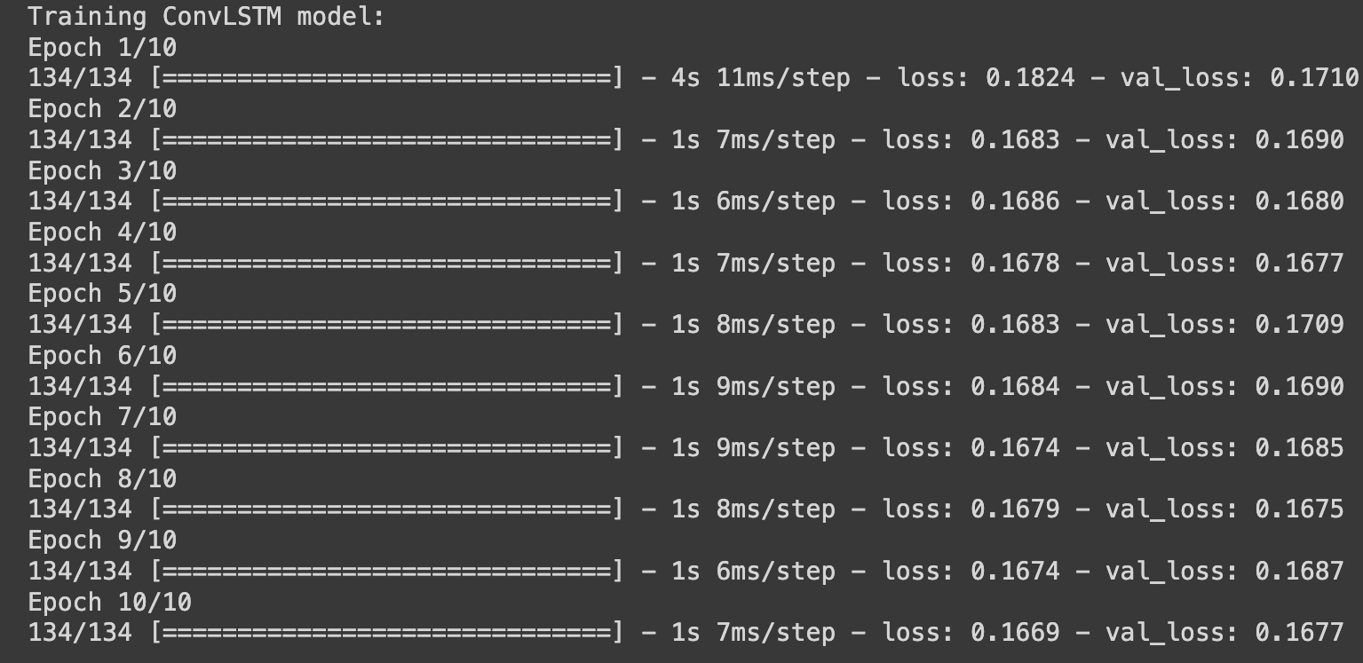

**Mean Absolute Error:**

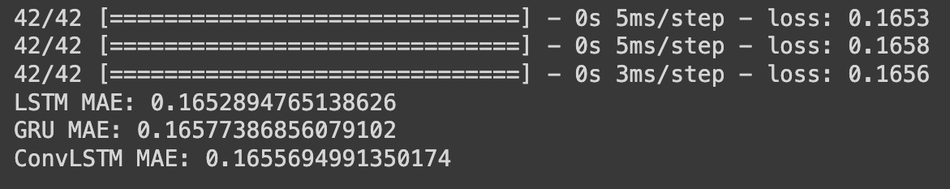

**Conclusions:**

1. Both LSTM and GRU models demonstrated their suitability for time-series forecasting.
2. Hyperparameter tuning and experimentation were crucial in achieving optimal model performance.

**Evaluations:**

