**11. Enhancing Crop Production in IoT.**

Prof Priyanca Gonsalves (Dwarkadas J Sanghvi College of Engineering) (priyanca.gonsalves@djsce.ac.in )

Dev Makadia (Dwarkadas J Sanghvi College of Engineering) (makadiadev38@gmail.com)

Mihir Desai (Dwarkadas J Sanghvi College of Engineering) (mihir27desai2002@gmail.com)

# Abstract

Considering the rising worldwide need for food production, there is a pressing need to maximize crop yields while ensuring resource efficiency. A potential response to this problem is the incorporation of Internet of Things (IoT) technology. This abstract highlight an efficient approach to increase crop production by leveraging ESP32, a powerful microcontroller, in conjunction with various sensors including humidity, light, temperature, and moisture.

The proposed IoT system aims to optimize environmental conditions for plant growth by continuously monitoring key parameters. The ESP32 acts as the central hub, real-time data gathering from the sensors and transmitting it wirelessly for analysis and decision-making. The humidity sensor enables precise monitoring and control of moisture levels in the soil, ensuring optimal conditions for plant hydration. The light sensor measures the intensity of light, aiding in optimizing the duration and quality of light exposure necessary for photosynthesis. The temperature sensor provides crucial insights into ambient temperature, facilitating efficient climate control for different crops. Lastly, the moisture sensor helps monitor soil moisture content, preventing overwatering or underwatering.

By employing the ESP32 and these interconnected sensors, farmers can gather comprehensive data on the crop environment, allowing for precise and timely interventions. Advanced data analytics techniques can be applied to the collected data to gain valuable insights into crop behaviour and growth patterns, enabling informed decision-making.

The emphasis is to find the potential of IoT-based systems in revolutionizing agriculture and increasing crop production. By leveraging the ESP32 microcontroller and integrating humidity, light, temperature, and moisture sensors, farmers can adopt data-driven cultivation strategies, leading to improved resource utilization, enhanced crop yields, and ultimately, contributing to sustainable agriculture. The implementation of this integrated IoT solution holds significant promise in addressing the global food security challenge of our time.

**Keywords**

Internet of Things (IoT), crop production, ESP32, humidity sensor, light sensor, temperature sensor, moisture sensor, resource efficiency, data analytics, and sustainable agriculture.

* 1. **Introduction**
* Agriculture is the fundamental career of India. High demand for food due to increasing population and decline in crop quality due to pollution and climate changes has led to the introduction of new technologies in the field of agriculture. Due to the high cost and maintenance of the devices and systems, small-scale farmers are deprived of the use of these technologies in their fields to bridge the gap and help small-scale farmers we design an agriculture monitoring system.
* According to a modern-day assessment with the useful resource of the use of Grand View Research, Inc., the size of the worldwide smart agriculture market is predicted to obtain USD 54.71 billion by 2030, growing at a CAGR of 13.4% during the projected period. The widespread application of artificial intelligence (AI), the Internet of Things (IoT), and the incorporation of image processing technology into agriculture are the main reasons propelling the expansion of the ag-tech sector. Precision farming IoT techniques have led to a major increase in agriculture in recent years. [1]
* The agriculture sector has undergone a tremendous amount of change in the last 50 years. Because to technological developments, farm equipment has become bigger, quicker, and more productive, allowing for more efficient cultivation of large regions. Seed, irrigation have all advanced greatly and helped farmers increase agricultural yields. Data and connection are driving the current transformation in agriculture, which is still in its early stages. Emerging technologies like artificial intelligence, analytics, networked sensors, and others could help crop agriculture in the future by increasing yields even more, enhancing the efficiency of water and other inputs, and fostering sustainability and efficient yields. [2]
* By leveraging IoT technology, farmers can create a more efficient and sustainable farming system. They can monitor the crop growth conditions in real-time and take appropriate measures to optimize crop yield and reduce the use of water. This leads to an eco-friendlier farming system, with a reduced environmental impact.
* An internet-connected network of sensors and gadgets makes up a smart agricultural monitoring system., enabling real-time data collection and analysis. These sensors can monitor various factors that affect crop growth, such as temperature, humidity, soil moisture. The data collected from these sensors can send to the cloud for storing and monitoring data by the farmers. [3]
* IoT technology in agriculture can change how farmers manage and monitor their crops overall, leading to improved crop yield and sustainability. In-depth analysis of the advantages of an IoT-based smart agricultural monitoring system will be done in this chapter, along with an examination of how it might support farmers in developing more productive and sustainable farming practises.
  1. **Review of Literature**

In the realm of smart farming, Khalifa, Alkhatib, and Al-haj's paper on "Smart Farming Monitoring System Using Internet of Things" demonstrated the potential of IoT in smart farming by enabling real-time data collection and analysis. Their system's good points include leveraging IoT devices and wireless communication technologies, empowering farmers to make informed decisions based on real-time data. However, limitations include the lack of extensive discussion on scalability, cost implications, connectivity challenges, energy efficiency, data privacy and security, and user interface design.[4]

The novelty of Saraswathi et al.'s (2018) study lies in their exploration of integrating IoT technologies for automating hydroponics greenhouse farming. They focused on monitoring and controlling parameters like temperature, humidity, and nutrient levels. However, limitations include the study's limited scope, potential scalability issues, cost implications, technical challenges, and the absence of a long-term evaluation.[5]

In the same year, Mishra et al. (2018) proposed an automated irrigation system based on IoT, leveraging soil moisture sensors and actuators. The system's good points include optimized water usage and real-time monitoring. Limitations include the need for further exploration of scalability, cost implications, and addressing potential technical challenges.[6]

In the ever-evolving landscape of smart farming, Asghar et al. made a significant contribution through their comprehensive review paper titled "IoT-Based Smart Farming: A Review on Trends and Developments.” The authors explored various IoT-based applications in smart farming, covering aspects such as crop monitoring, precision agriculture, and livestock management. They provided an overview of the existing technologies and discussed the challenges and future trends in the field. Their work contributed to consolidating the knowledge in the domain and identifying areas for further research and improvement.[7]

Through research paper titled "Smart Agriculture: Monitoring Environmental Parameters and Automated Irrigation System Using IoT," Lakshmi and Srinivasa brought forth an innovative solution to revolutionize traditional farming practices. By harnessing the power of IoT, their work aimed to optimize water usage and enhance crop yield through the integration of an automated irrigation system. With a keen focus on monitoring environmental parameters, their pioneering efforts set the stage for a more sustainable and efficient approach to agriculture.[8]

In the paper titled "Utilization of IoT: Automated Seed Plantation based Smart Agriculture," Mukherjee, Nandi, Mondal, and Nandi introduced an innovative system that automated seed plantation using IoT technologies. Their work focused on optimizing agricultural operations by integrating IoT devices, sensors, and actuators. By automating the seed sowing process, they aimed to reduce manual labor and improve efficiency in smart agriculture. Their research opens new avenues for streamlining farming practices and enhancing productivity through IoT-driven automation. [9]

Li, Xu, and Huang published a paper titled "Design and Implementation of Smart Agriculture Monitoring System Based on IoT." Their work presented a comprehensive smart agriculture monitoring system that integrated various IoT technologies. They created a system that can keep track of variables including temperature, humidity, and light intensity. The authors emphasized the importance of real-time data collection and analysis for efficient agricultural management. Their novelty lay in the holistic approach to designing and implementing a smart agriculture monitoring system using IoT. [10]

The literature review highlights the progression of IoT-based smart agriculture monitoring systems over the years. From the initial works in 2018, which introduced the concept of IoT-enabled farming monitoring, to the latest developments in 2023, which focused on automation and precise control, researchers have made significant contributions to the field. These advancements hold the potential to positively impact farming practices by optimizing resource usage, enhancing productivity, and facilitating informed decision-making for farmers.

**11.3 Proposed Methodology/Approach to build Smart Agriculture Monitoring System**

The proposed approach aimed to build a cost-efficient agriculture monitoring system to assist small-scale farmers in monitoring their fields. The key features of this approach were as follows:

* Use of ESP32 for connectivity: Instead of more expensive options like Arduino with Ethernet shield or Raspberry Pi, the ESP32 microcontroller was chosen for its built-in Wi-Fi connectivity, making it a cost-effective choice for transmitting data to the cloud.
* Essential sensors: The system included important sensors for monitoring agricultural conditions. The soil moisture sensor was utilised to gauge the moisture level of the soil, enabling automatic regulation of water supply through the relay and DC motor. The temperature and humidity sensor (DHT11) and the light sensor (LDR) were utilized to monitor and notify the current environmental conditions such as humidity, temperature, and light intensity.
* Data transmission to Blynk cloud server: The collected data gathered by the sensors was transmitted to the Blynk cloud server via Wi-Fi. The Blynk cloud server served as a storage platform for the sensor data, enabling farmers to access the data through the Blynk mobile application.
* Blynk mobile/web application: The Blynk mobile/web application provided a user-friendly interface for farmers to monitor the conditions in their farms. Farmers have access to real-time data from the sensors through the mobile application, enabling them to make knowledgeable judgements and take necessary action in response to the monitored circumstances. It provides data privacy and good user interface design.

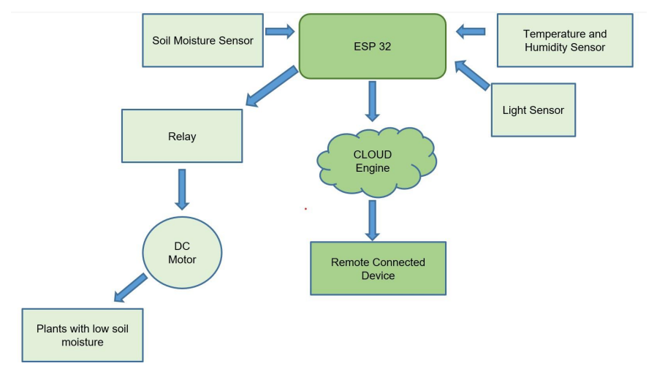

Figure 1.1: Proposed System Architecture

The systemic strategy suggested consisted of the following high-level steps:

* Gather hardware requirements: The first step involved gathering all the necessary hardware components, including the ESP32, sensors such as the soil moisture sensor, temperature sensor, light sensor, relay, DC motor, breadboard, and various types of connecting wires (female-female, male-male, female-male wires).
* Build individual circuit diagrams: In this stage, individual circuit diagrams were designed for each sensor. This included setting up the wiring and building the circuit on platforms like Tinkercad. The purpose was to verify the working of each sensor individually and gain a better understanding of the connections and how they are configured. As the ESP32 option was disabled in Tinkercad, the Arduino Uno was used as a substitute to draw the circuit diagrams.
* 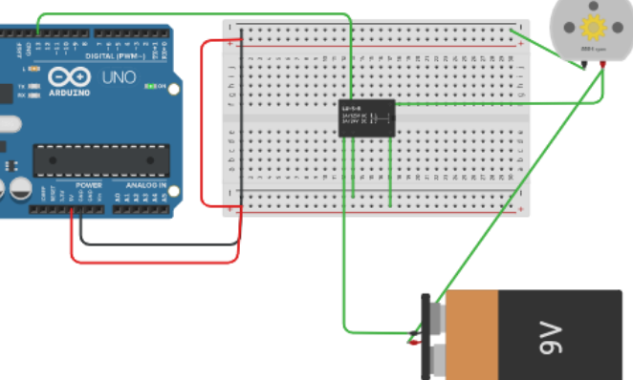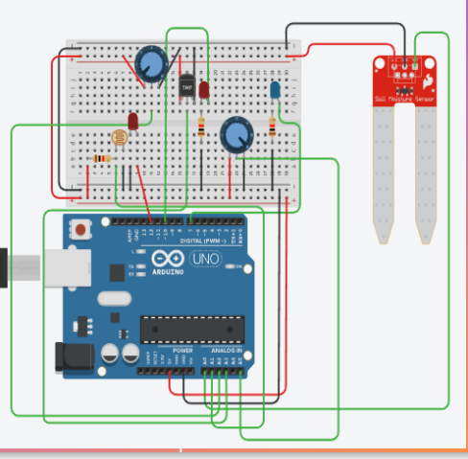Integrate the complete system: This was a crucial stage where a comprehensive circuit diagram was constructed by integrating all the individual sensor circuits together. The aim was to create a unified system on Tinkercad and verify its overall functionality.

Figure 1.3: Circuit Diagram for Relay and DC

Figure 1.2: Circuit Diagram for Sensors

* Set up the hardware: After confirming that the complete system worked properly on Tinkercad, the final hardware setup was implemented. All the components were connected according to the circuit diagram, and thorough testing was conducted to ensure the proper functioning of the entire system.
* Display on web/phone: Blynk was used as the platform to display real-time data from the sensors on mobile devices or web browsers. By integrating Blynk with the system, users could easily monitor and visualize the sensor data through an intuitive interface.

**11.4 Project Resources**

**11.4.1 Hardware Requirements: -** Basic knowledge about pin diagram of all the sensors was that there are three pins in almost every sensor.

* Power Supply Pin: - It is used for [powering a sensor using an external power supply board](https://www.bing.com/ck/a?!&&p=4ef32fe1ae4a3df3JmltdHM9MTY4ODk0NzIwMCZpZ3VpZD0wNmZiYTU4NC0zMGQ1LTY5MjEtMjlhYy1iNmFiMzE0ZTY4M2YmaW5zaWQ9NTM3OA&ptn=3&hsh=3&fclid=06fba584-30d5-6921-29ac-b6ab314e683f&psq=what+is+power+supply+pin+in+sensor&u=a1aHR0cHM6Ly9yYXNwYmVycnlwaS5zdGFja2V4Y2hhbmdlLmNvbS9xdWVzdGlvbnMvODkwODIvcG93ZXJpbmctYS1zZW5zb3ItdXNpbmctYW4tZXh0ZXJuYWwtcG93ZXItc3VwcGx5LWJvYXJk&ntb=1).
* Ground Pin: - This is a GND pin used to connect to the GND of the system.
* 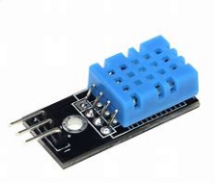Analog Pin: - Analog pins are used to read/write analog values.

1. Temperature and Humidity Sensor [DHT11]: -

* Power pin [VCC] - Connected to ESP32 at 3v3 pin.
* Ground pin [GND] - Connected to breadboard on negative line.
* Analog Data pin [AO] - Connected to ESP32 at G26 pin.
* Digital Data pin [DO]- Not Required.

Figure 1.4: DHT11 Sensor

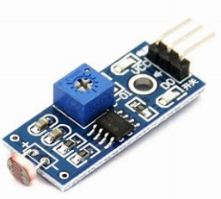2. Light Sensor: -

* Power pin - Connected to ESP32 at 3v3 pin.
* Ground pin - Connected to ESP32 at GND pin.
* Data pin - Connected to ESP32 at G32 pin.

3. LED for Light Sensor: -

* Positive terminal Connected to ESP32 at G33 pin.

Figure 1.5: LDR Sensor

* Negative terminal Connected to one terminal of resistor.
* Other side of resistor connected to GND pin.

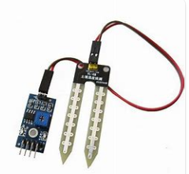4. Soil Moisture Sensor: -

* Power pin - Connected to breadboard on positive line.
* Ground pin - Connected to breadboard on negative line.
* Data pin - Connected to ESP32 at SP pin.

Figure 1.6: Soil Moisture Sensor

5. 4-Channel Relay: - [2-Channel Relay was also enough.]

* Power pin - Connected to V5 pin.
* 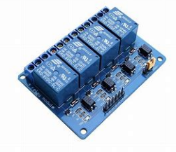Ground pin - Connected to breadboard on negative line.
* Action pin [IN4] - Controls relay 4, active Low! Relay turned on according to given input. Connected it to ESP32 at G13 pin.
* D4 Channel was used to connected DC Motor.

Figure 1.7: Relay [4 channel]

* The middle pin of D4 which is Common Pin connected to 1.5V Battery.

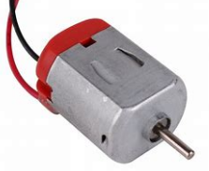6. DC Motor: - Using D4 Channel,

* One terminal of DC Motor connected to 1.5V Battery.
* One terminal of DC Motor connected to NO terminal of D4 on Relay. We want device to mostly to remain OFF, so we connected it with the NO pin of the module, otherwise use NC pin.

Figure 1.8: DC Motor

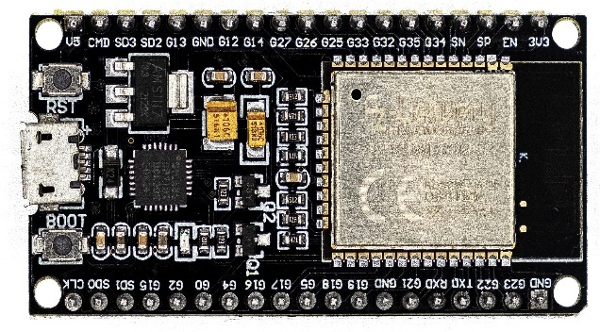

7. ESP32 Dev Module: - It has connections to attach peripherals, built-in power and control LEDs, an antenna for wi-fi transmission, and other important features. This development board also has all the circuitry required to programme and power the chip. The ESP32 contains several pins with a variety of purposes, however some of them might not be appropriate for applications. There is a table that lists the pins that may be used without issue and those that need to be handled carefully.[12]

Figure 1.9: ESP32 Board

* + 1. **Software Requirements**

1. Blynk Cloud-Based Platform: - Smart agricultural systems employ data collection software to collect and store environmental data from sensors, including temperature, humidity, and soil moisture levels. The data is centralised in a database or cloud-based platform for analysis thanks to this programme. Integration with Blynk also makes it easier for farmers to collaborate and share data, fostering the sharing of insights. Farmers can more easily spot trends and patterns by using visualisation tools like dashboards, charts, and graphs to analyse and visualise the data that has been collected.

2. Arduino IDE: - Because it offers a user-friendly programming environment, vast libraries, and a helpful community, the Arduino IDE is a popular option for IoT integration. This makes it appropriate for designing and prototyping IoT applications.

• The IDE includes pre-built code modules called Arduino libraries that provide ready-to-use functions and classes for a variety of activities. They streamline difficult processes including motor control, communication protocols, and sensor integration. Libraries are included in Arduino sketches so that programmers can quickly access and use a variety of features without writing a lot of code. Libraries isolate low-level processes, letting developers to concentrate on high-level logic while saving time and effort. We utilised the following libraries in our code:

1. BlynkSimpleEsp32.h - IoT board Blynk library. works with ESP32, Arduino, ESP8266, Raspberry Pi, Particle, ARM Mbed, etc.

* Launching the Arduino IDE programme is necessary.
* Select "Preferences" from the "File" menu.
* Type the following address into your browser's address bar: "https://dl.espressif.com/dl/package_esp32_index.json".
* In the text box next to "Additional Boards Manager URLs," type the URL.
* Select "Boards Manager" from "Tools," "Board," and then "Board.
* Enter "esp32" by Espressif Systems in the Boards Manager.
* Clicking "Install" will begin the ESP32 board package installation.
* Select "Manage Libraries" under "Sketch," then "Include Library," from the menu.
* Conduct a search for "Blynk" by Volodymyr Shymanskyy in the library manager. It is possible to install the Blynk library by choosing "Install.
* It is advisable to restart the Arduino IDE right away after installation. Immediately following installation, it is advised to restart the Arduino IDE. Choose the ESP32 board type (often "ESP32 Dev Module") by going to "Tools," "Board," and then "Board.
* Go to "File," then "Examples," then "Blynk," then "Boards_WiFi," and pick "Esp32_WiFi.
* You will see the line "#include <BlynkSimpleEsp32.h>" in the example sketch.

1. WiFi.h - This library enables an Arduino board to establish an internet connection.
2. DHT.h **-** In projects for the Arduino and ESP32, the DHT.h library is used to interface with DHT (Digital Humidity and Temperature) sensors. This library offers tools for precisely reading temperature and humidity readings from DHT sensors.

**11.5 Working of System**

* The core component of that setup was the ESP32 microcontroller, which served as the central hub for collecting data from the sensors and transmitting it to the cloud. The ESP32 was a powerful and energy-efficient microcontroller that supported Wi-Fi and Bluetooth connectivity, making it an ideal choice for IoT applications.
* To gauge the soil's moisture content, a soil moisture sensor was employed. It provided valuable information about the water needs of the plants, allowing farmers to implement precise irrigation strategies. The humidity sensor measured the amount of moisture present in the air, helping determine the optimal humidity levels for different crops. The temperature sensor monitored the ambient temperature, which was crucial for understanding plant growth patterns and detecting potential risks such as frost or heat stress. Lastly, the light sensor measured the intensity of light, aiding in determining the right amount of light exposure required for perfect planting.
* Through the Blynk mobile application or web dashboard, users were able to access real-time sensor data, including soil moisture levels, humidity, temperature, and light intensity. This data could be presented in the form of intuitive graphs and charts, enabling farmers to visualize the environmental conditions of their crops.
* In addition to monitoring, the system also enabled control actions based on the collected data. For example, if the soil moisture is lesser than required, the ESP32 could trigger an irrigation system to water the plants automatically.
* Moreover, through Blynk, alerts and notifications were set up. Users could set custom thresholds for each sensor and receive instant alerts via email or push notifications whenever these thresholds were exceeded. This ensured that farmers stayed informed about any critical changes in the environment, allowing them to take immediate action and prevent potential crop damage.

**11.5.1 Interface Design**

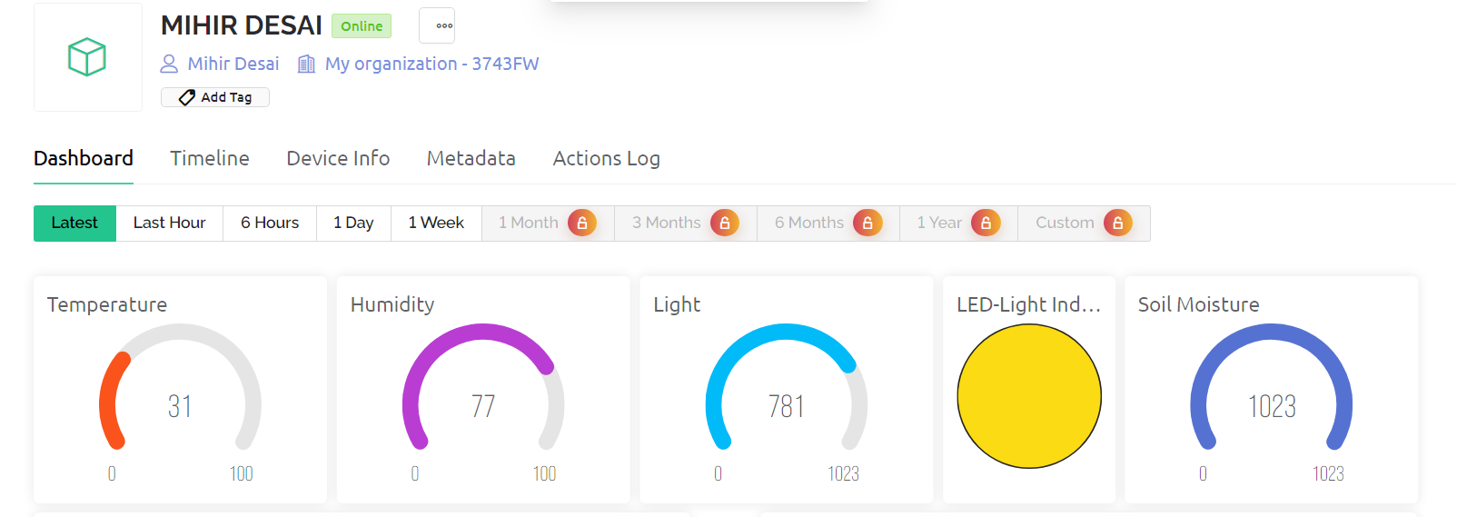

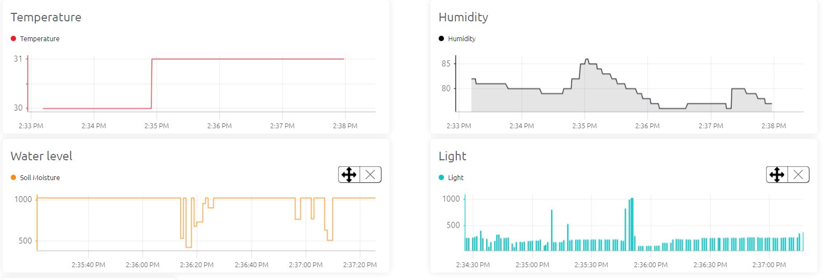

The interface design of the Blynk cloud was carefully crafted to provide a user-friendly and intuitive experience for farmers and users of smart agriculture monitoring systems. Here is the past tense conversion:

1. Dashboard: A customizable central hub was provided that offered an overview of essential data, allowing users to arrange widgets and prioritize information.

* The Blynk app displayed the temperature and humidity data, with values mapped between 0 to 100.
* The data for light was shown, and if there was inadequate light, the LED would glow, notifying that the light was insufficient for the crop to grow. A value of 1023 indicated 100% darkness, while 0 indicated 100% brightness.
* Soil moisture sensor values were displayed, and if the water supply was below the specified threshold, the relay would activate the DC motor. The motor would automatically stop when the water level matched the required level. A value of 1023 indicated 0% water level, and vice versa.
* Graphs for all four sensors were displayed to monitor the values and check for fluctuations or make comparisons.

1. Real-time Data Visualization: Sensor data was displayed in visually appealing formats such as graphs, charts, gauges, or numerical values, providing up-to-date information for quick understanding.
2. Alerts and Notifications: Farmers were notified when specific conditions or thresholds were met, enabling timely action through push notifications and emails. These alerts and notifications were set for light and soil sensors. These need to be code in Arduino.

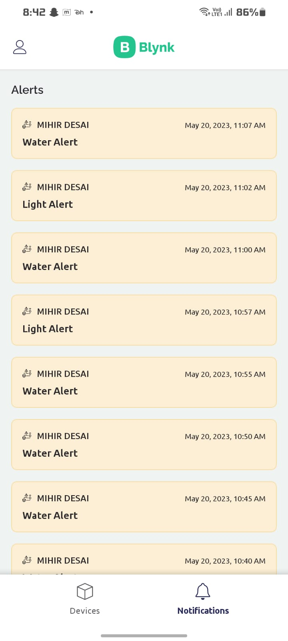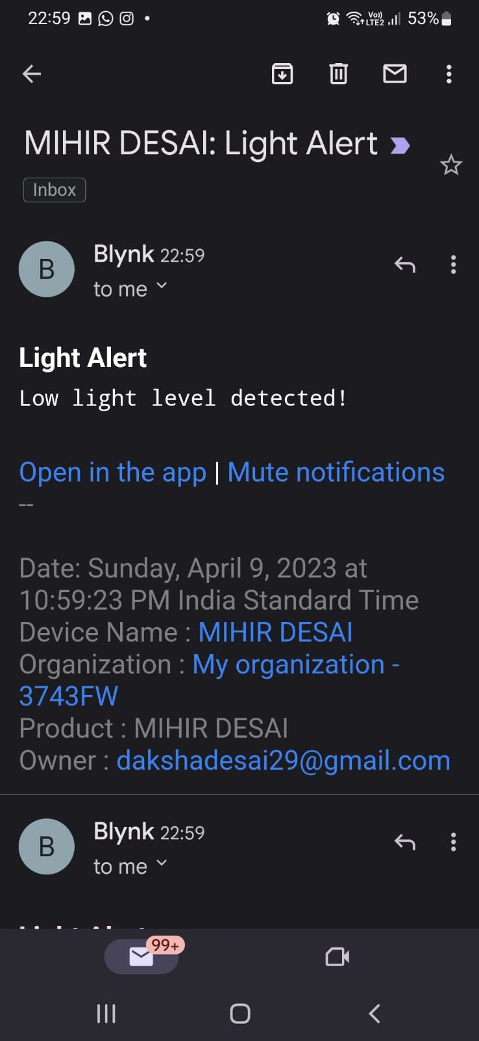   
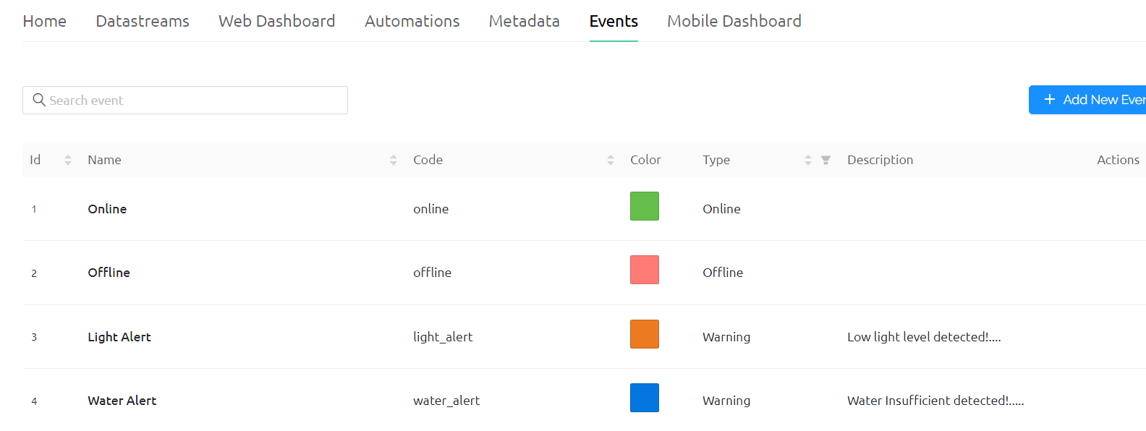

**11.6 Testing and Experimental Results**

**11.6.1 Test Scenarios**

a. Sensor Data Acquisition:

i. Test the accuracy and reliability of soil moisture sensor readings.

ii. Verify the humidity sensor's ability to measure relative humidity accurately.

iii. Validate the temperature sensor's accuracy in measuring ambient temperature.

iv. Ensure the light sensor provides reliable readings for light intensity.

b. Data Transmission and Cloud Integration:

i. Test the wireless transmission of sensor data from the ESP32 to the Blynk cloud service.

ii. Verify the successful integration of the sensor data with the Blynk cloud service.

iii. Ensure data synchronization between the ESP32 and the Blynk cloud service.

c. Real-time Monitoring and Visualization:

i. Validate the real-time monitoring of sensor data through the Blynk interface.

ii. Check to see if the sensor data is being updated and shown appropriately.

iii. Test the visualization of sensor data using different widgets (graphs, charts, gauges).

d. Alerts and Notifications:

i. Set threshold values for different parameters (moisture, humidity, temperature, light intensity). Verify that alerts and notifications are triggered when the defined thresholds are exceeded or not met. Test the delivery and accuracy of alerts through various communication channels (push notifications, email).

e. Compatibility and Performance with Different Plant Types:

i. Test the system's performance and accuracy with different plant species. Evaluate the system's ability to provide accurate recommendations and insights for different crops.

ii. Assess the adaptability of the system to varying environmental conditions.

**11.6.2 Results**

The system was tested on two different plants to evaluate its performance in monitoring and optimizing the environmental conditions for plant growth. Here are the experimental results obtained:

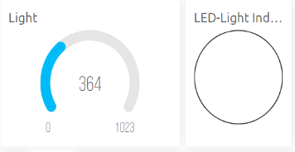1] Light Monitoring: The input threshold given was 450. It should be below it.

• Plant 1: The light sensor recorded sufficient light intensity levels for Plant 1, ensuring optimal conditions for photosynthesis and growth. The LED was turned off, indicating ample natural light.

Plant 1

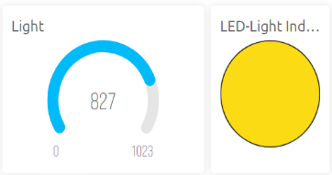• Plant 2: The light sensor detected lower light intensity levels and crossed the threshold in the location of Plant 2. The LED was turned on, indicating insufficient natural light. The system adjusted the placement of the plant or activated artificial lighting systems to provide adequate light exposure.

Plant 2

2] Temperature and Humidity Monitoring:

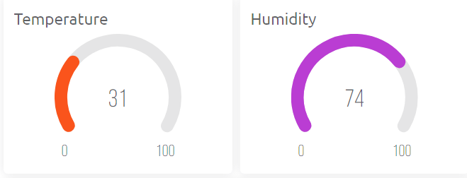•The temperature sensor consistently measured temperature within the optimal range for Plant 1 and Plant 2, promoting healthy growth.

•The humidity sensor recorded humidity levels in the desired range for Plant 1 and Plant 2, indicating an optimal environment for growth.

Plant 1 & Plant 2

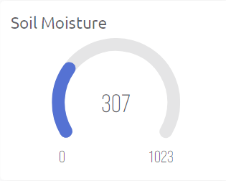3] Soil Monitoring: The input threshold given was 350, which needed to be within it.

• Plant 1: The soil moisture sensor consistently measured moisture levels within the optimal range for Plant 1. The system triggered irrigation processes when the value cross a defined threshold, indicating adequate watering needed.

Plant 1

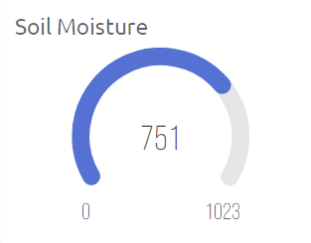• Plant 2: The soil moisture sensor detected lower moisture levels in the soil and crossed the threshold, indicating insufficient watering. With the help of the relay, the DC motor automatically started pumping water and stopped after reaching an adequate water level.

Plant 2

**11.7 Conclusion**

To sum up, putting in place a smart agriculture monitoring system has various advantages, including increased output, resource optimization, sustainability, and precision farming. By embracing technology and data-driven initiatives, farmers may increase productivity, make better decisions, and contribute to a more sustainable and thriving agricultural industry. A major shift in agriculture is being ushered in by the adoption of such a system, propelling the industry into a future marked by more technological innovation and sustainability. To adapt the system to various crops and farming situations, more study can be done.

**References**

[1] *Smart agriculture market size worth $ 54.71 billion by 2030* (no date) *Market Research Reports & Consulting*. Available at: https://www.grandviewresearch.com/press-release/global-smart-agriculture-farming-market (Accessed: 20 May 2023).

[2] Goedde, L. *et al.* (2020) *Agriculture’s connected future: How technology can yield new growth*, *McKinsey & Company*. Available at: https://www.mckinsey.com/industries/agriculture/our-insights/agricultures-connected-future-how-technology-can-yield-new-growth (Accessed: 20 May 2023).

[3]Agarwal, Dr.A. (2023) *How IOT based smart crop monitoring systems can help maximize farming productivity*, *Times of India Blog*. Available at: https://timesofindia.indiatimes.com/blogs/voices/how-iot-based-smart-crop-monitoring-systems-can-help-maximize-farming-productivity/ (Accessed: 20 May 2023).

[4] A. M. Khalifa, H. F. Alkhatib and S. H. A. Al-haj, "Smart Farming Monitoring System Using Internet of Things," 2018 International Conference on Electrical and Computing Technologies and Applications (ICECTA), Ras Al Khaimah, United Arab Emirates, 2018, pp. 1-4. DOI: 10.1109/ICECTA.2018.8534971

[5] D. Saraswathi, P. Manibharathy, R. Gokulnath, E. Sureshkumar and K. Karthikeyan, "Automation of Hydroponics Green House Farming using IOT," 2018 IEEE International Conference on System, Computation, Automation and Networking (ICSCA), 2020, pp. 1-4, doi: 10.1109/ICSCAN.2018.8541251.

[6] D. Mishra, A. Khan, R. Tiwari and S. Upadhay, "Automated Irrigation System-IoT Based Approach," 2018 3rd International Conference On Internet of Things: Smart Innovation and Usages (IoT-SIU), 2021, pp. 1-4, doi: 10.1109/IoT-SIU.2018.8519886.

[7] M. R. Asghar, et al., "IoT-Based Smart Farming: A Review on Trends and Developments," Sensors (Basel), vol. 19, no. 14, 2019.

[8] M. Prasanna Lakshmi and K. G. Srinivasa, "Smart Agriculture: Monitoring Environmental Parameters and Automated Irrigation System Using IoT," 2019 IEEE International Conference on System, Computation, Automation and Networking (ICSCAN), Warangal, India, 2019, pp.1-5. DOI: 10.1109/ICSCAN46943.2019.9012815

[9] D. Mukherjee, M. Nandi, S. Mondal and S. Nandi, "Utilization of IoT: Automated Seed Plantation based Smart Agriculture," 2021 5th International Conference on Electronics, Materials Engineering & Nano-Technology (IEMENTech), 2021, pp. 1-4, doi: 10.1109/IEMENTech53263.2021.9614831.

[10] Li, T., Xu, Y., & Huang, G. (2021). Design and Implementation of Smart Agriculture Monitoring System Based on IoT. In 2021 International Conference on Communications, Information System and Computer Engineering (CISCE) (pp. 482-485). IEEE.

[11] (No date) *YouTube*. YouTube. Available at: https://youtube.com/playlist?list=PLFepjo7TI_AFu8UiU9y_FZM4JK8uA4Z54 (Accessed: 10 February 2023).

[12] L. M. Engineers, “ESP32 Pinout Reference,” *Last Minute Engineers*, Mar. 02, 2023. https://lastminuteengineers.com/esp32-pinout-reference/