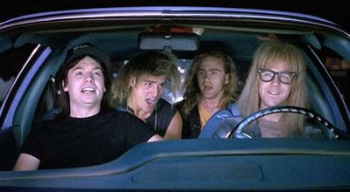

Pair up with a another student. One will be the driver the other one will be the..... “wayne’s world!! party time!!! excellent!!!....... navigator. Swap roles every ten minutes. We are going to do a number of simple exercises to familiarize ourselves with Java, Eclipse and some object oriented design principles.

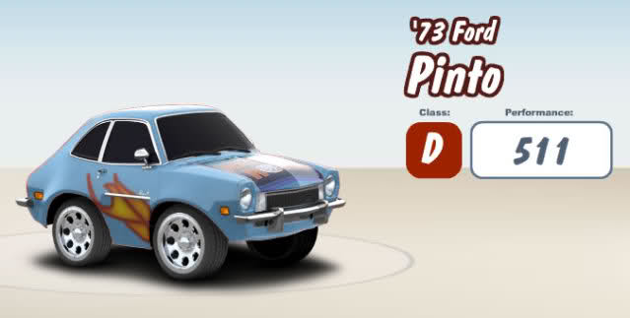 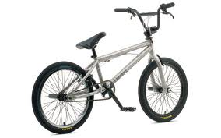

Assignment 1: Implement a simple car class for Wayne’s ford pinto and a bicycle class for Garth’s BMX bike. Create constructors for each class. Use a class with a main method to instantiate/test each class.

Assignment 2: Think of a set of useful properties (color? name?) for each class. Should these properties be private or public? implement getters and setter when appropriate.

Assignment 3: Think of a set of useful methods (start()? pedal()?) for each class.

Assignment 4: Sometimes classes are composed with entities that are not expressible using Java base classes (e.g. integer, string). For example, a car and bike both have wheels or a car has an engine. Create subclasses for each entity and use composition to add them to your car or bicycle class. You may use the same wheel class for cars and bikes.

Assignment 5: Abstract both classes into a vehicle class. Should this class be abstract or not? Figure out what methods and properties should go in the vehicle class and what should stay in the car and bicycle class.

Assignment 6: Test in your main class if you can use polymorphism, e.g., create a vehicle object and assign it to a car, test something and then assign it to a bicycle.

Assignment 7: Try to create a class diagram for your solution using tinyUML (see link website).