Michael Des Roches
Homework # 4
28 Feb 2019

Description of purpose:
This homework assignment is aimed to tech us how to read table configuration for the Arduino. I’m not too sure what Absolute decoding is writing this statements now but it appears that we will be learning that too. Memory mapping, memory address tables and Boolean questions are all part of the homework too. Which we were quized on already, doesn’t make sense but whatever.

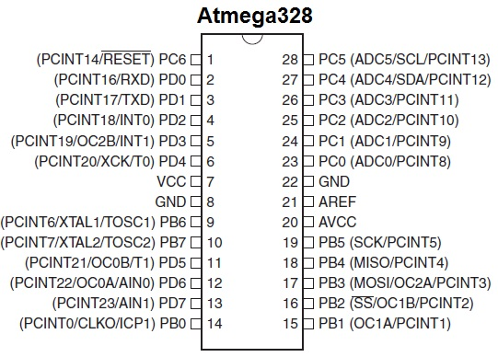
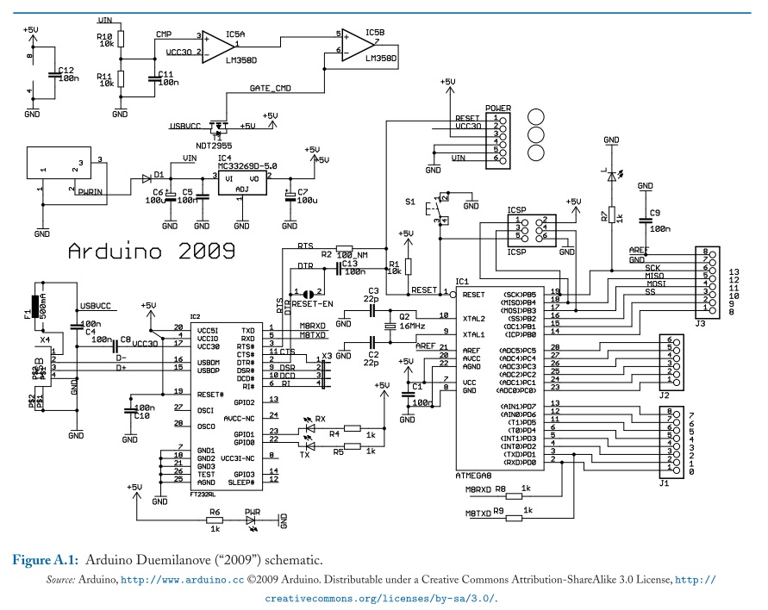
The Data Bus and Address Bus are fully decoded and available as an output from this board. The board itself has locations for two 2732 (4Kx8) EPROMS and a 6116 SRAM. These are assigned memory addresses; 0XXX, 1XXX, and 2XXX by default. Other address locations may be assigned off-card using the Address and Control Busses.

