**Lab 3**

**by Md Fahim Hasan**

The codes are available in this GitHub Repo: [QEcoHydro/Hydro_T at master · mdfahimhasan/QEcoHydro (github.com)](https://github.com/mdfahimhasan/QEcoHydro/tree/master/Hydro_T)

**Catchment 13:**

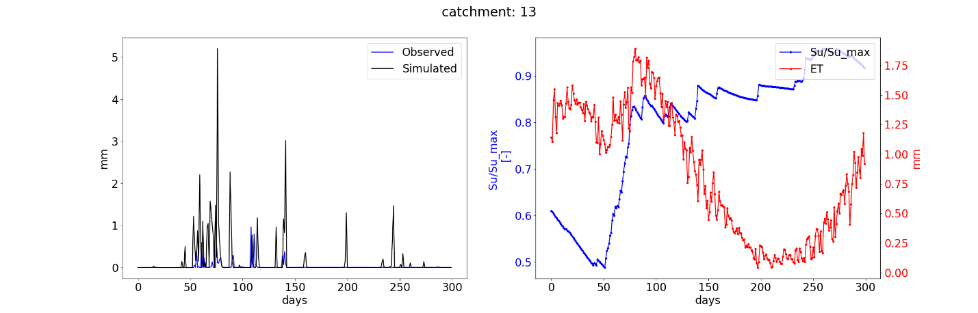

**Catchment 8:**

