Historical Changes in Irrigation Water Use in the for the Western United States
- Goals
  - Identify how historic precipitation and warming climate (ETo) has impacted Irrigation Water Use (IWU) across the Western US
  - We can also investigate the influence of other drivers, such as irrigated acreage
  - The proposed model can also be used to test impacts of policies; however, I am not sure whether there have been major policy changes in the Western US. We can definitely perform case studies for particular regions

- Spatial scale– Aquifer-state unit (AQ_State, e.g., BR_AZ, CP_OR) — defined by intersecting USGS principal aquifer boundaries with state boundaries. This yields N = 15 units. This scale is preferred over whole states: each unit is hydrogeologically homogeneous, the αi fixed effect captures aquifer-type + state management simultaneously, and the gw vs sw classification (RQ3) is directly embedded in the unit definition.
- IWU = Irrigated ET – Peff
⚠ CAUTION: IWU = Irrigated ET − Peff means precipitation appears on BOTH sides of the regression. β1 will conflate a genuine behavioral response with a mechanical accounting artifact. Run a robustness check with independent pump records; acknowledge this limitation explicitly in the manuscript.
  - We can consider 1985 onward. But Midwest doesn’t have irrigated cropland data from 1985-2000. Or we can do it 2000 onward, when we have full data coverage.
  - May need to use pycropwat for Peff calculation from 1985 to 2000.

Method: Fixed effects model (Panel Regression)
Fixed effects model is an advanced form of linear regression model, typically used in econometric modeling, and is used for causal inference or trend detection. Frances et al. (2021) is an excellent example of this model’s application in hydrology.
The motivation for fixed effects estimation arises from the presence of unobserved, time-invariant factors—such as state-specific characteristics or common time effects—that influence the dependent variable but are not explicitly included as regressors. In a standard linear regression model, these omitted factors are absorbed into the error term and may be correlated with the regressors, leading to biased and inconsistent coefficient estimates due to omitted-variable bias.
Fixed effects models address this issue by explicitly controlling for such unobserved, time-invariant heterogeneity through the inclusion of entity and/or time fixed effects (equivalently, dummy variables or a within transformation). By isolating the influence of these unobserved factors, fixed effects estimation identifies regression coefficients using within-entity variation over time, thereby mitigating confounding arising from time-invariant omitted variables. Standard OLS standard errors are not appropriate for this panel structure; two-way clustered standard errors (clustered by state and year simultaneously) must be used to account for serial autocorrelation within states and spatial autocorrelation across states driven by shared climate systems (ENSO, PDO).
$$IWU_{i,t}=α_{i}+{}_{r, t}+ β_{1}{P^{'}}_{i,t}+β_{2}{T^{'}}_{i,t}+∈_{i, t}$$
- where $i$ indexes aquifer-state units (e.g., BR_AZ, CP_OR) and $r$ is the aquifer-type group containing unit $i$.
- $α_{i}$ : Aquifer-state fixed effects. This controls for all time-invariant characteristics specific to each aquifer-state unit: aquifer type and geology (rock type, transmissivity, recharge characteristics), state water law and allocation regime, dominant crop type and irrigation technology within the unit, and baseline groundwater depth. Because units are defined by aquifer type × state, the fixed effect absorbs far more hydrogeological heterogeneity than a state-only fixed effect would.
- $γ_{r, t}$ : Region-year fixed effects (where r indexes aquifer-type groups: e.g., r ∈ {Basin and Range, Columbia Plateau, High Plains, Central Valley, Other}). Grouping by aquifer type is more natural than geographic sub-regions given our panel structure: units within the same aquifer type share similar hydrogeological responses and are likely exposed to correlated climate shocks. Region-year FEs do not remove climate change effects as long as climate varies differently across aquifer-state units within the same aquifer-type group. Examples - a regional drought, a shared policy shock, common technology diffusion across the West, ENSO effects. These vary year to year but affect all units in a region together.
⚠ CAUTION: We initially planned for year fixed effect. However, that can absorb climate change effects that happens for all Western US states across years, underestimating the effect of climate change in IWU. Therefore, we changed it to region-year fixed effect to preserve within-region common climate signals.
- ${P^{'}}_{i,t}$ and ${T^{'}}_{i,t}$ are annual total precipitation and mean temperature anomalies from baseline periods (1986-2000). Details are in RQ1.
While this improves causal interpretation relative to pooled OLS, fixed effects models do not eliminate bias due to time-varying unobserved confounders. Instrumental variable regression would be required for full resolution of time-varying confounders.
⚠ CAUTION: With N = 15 aquifer-state units, two-way clustering is unreliable. Use Driscoll–Kraay standard errors as the primary inference method (robust to serial and spatial correlation, no minimum cluster requirement). Available in Stata (xtscc), R (sandwich), Python (linearmodels). Two-way clustered SEs may be reported as a supplementary robustness check.
Overall interpretation:
After accounting for aquifer-state and region-year fixed effects, the model identifies the effects of precipitation and temperature using within-state and within-aquifer variation across years. Thus, identification is driven by intra-annual changes in climate conditions.

*** The model estimates a single set of coefficients (pooled across all N = 15 aquifer-state units), assuming a homogeneous climate–IWU response. Moving from state to aquifer-state units makes this assumption more defensible — units within the same aquifer type share similar hydrogeology — but pooling across fundamentally different aquifer types (e.g., consolidated rock aquifers vs unconsolidated basin-fill) remains a strong assumption. A Chow test partitioned by aquifer type should be run before adopting this specification. $β_{1}$and $β_{2}$, representing the average marginal effects of precipitation and evaporative demand on irrigation water use across the entire study area.
⚠ CAUTION: Initially I thought about adding an interaction term with precipitation and temperature for each aquifer_state unit. But that would mean that there will be 15 separate slopes, each derived from their separate time series. This makes the datasets for each aquifer_state very small sample, resulting in very large standard error and unreliable estimates.
The best way would be to be pool within aquifer type (e.g., all Basin and Range units). This will make the coefficients statistically more powerful than unit-level interactions and more interpretable. Run a Chow test (F-test) partitioned by aquifer type (AQ_code). Report aquifer-type-specific β coefficients as the primary result.
$$IWU_{i,t}=α_{i}+{}_{r, t}+ ∑β_{1, a} ({P^{'}}_{i,t }× D_{a})+∑β_{2, a} ({T^{'}}_{i,t }× D_{a})+∈_{i, t}$$
$D_{a}$= 1, if unit $i$ belongs to aquifer type $a$(Basin and Range, Columbia Plateau, High Plains, etc.). This gives you aquifer-type-specific coefficients rather than unit-specific ones
*** We can also associate lagged precipitation effects with IWU and test other hypothesis by slightly changing the model design.

Potential Directions

RQ1 – How much has climate change impacted IWU?
Method needs further thoughts and revisions.
- An analysis with annual data.
- We first model IWU as a function of observed precipitation and mean temperature, which contain both short-term variability and long-term climate trends. IWU will be normalized with irrigated acres and log transformed. The fixed effects model (panel regression) described earlier will be employed.
- To isolate the impact of climate change, we will construct a counterfactual climate scenario (stationary climate) considering 1986–2000 as the baseline period. We will construct a dataset with the means of precipitation, temperature, and IWU.
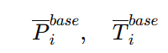
📌 LIMITATION: The zero-anomaly counterfactual represents climate at the 1986–2000 mean, not a pre-industrial baseline. If the baseline period contains early warming, total climate change impact is underestimated. Describe this precisely in the published version.
- Construct annual climate anomalies
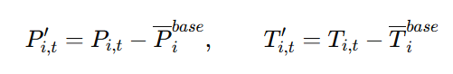
Anomalies represent –
- natural climate variability (ENSO, PDO, random weather)
- long-term climate change
- measurement noise
- Build the aquifer-state level fixed effect model.
  - Step 0 — Poolability test (required before estimation): Run a Chow test (F-test) with H₀: β1 and β2 are equal across all aquifer-state units. If H₀ is rejected at p < 0.05, adopt the aquifer-type-interaction model as the primary specification:
$$IWU_{i,t}=α_{i}+{}_{r, t}+ ∑β_{1, a} ({P^{'}}_{i,t }× D_{a})+∑β_{2, a} ({T^{'}}_{i,t }× D_{a})+∈_{i, t}$$
where Da is an aquifer-type dummy equal to 1 for aquifer type a (e.g., Basin and Range, Columbia Plateau). This produces aquifer-type-specific marginal effects β1,a and β2,a that can be mapped spatially and interpreted in terms of hydrogeological differences in climate sensitivity. The Chow test result must be reported regardless of outcome.
- Now, using the fitted model, predict $IWU_{i,t}^{obs}$ (predicted IWU using each aquifer_state’s annual anomalies. The $IWU_{i,t}^{obs}$ represents irrigation water use due to deviation of climate from long-term normal (1986–2000 baseline) for each aquifer-state unit. The fixed effects and betas come from the fitted model.
$$IWU_{i,t}^{obs}=α_{i}+γ_{r,t}+∑β_{1, a} ({P^{'}}_{i,t }× D_{a})+∑β_{2, a} ({T^{'}}_{i,t }× D_{a})+∈_{i,t}$$
- Now, we will set the precipitation and temperature to zero and estimate $IWU_{i,t}^{cf}$. The $IWU_{i,t}^{cf}$ represents irrigation water use for an aquifer_state unit in a particular year if there were no climate anomaly (climate follows the 1986–2000 baseline mean).
$$IWU_{i,t}^{cf}=α_{i}+γ_{r,t}+0+0+∈_{i,t}$$
- The difference between $IWU_{i,t}^{obs}$ and $IWU_{i,t}^{cf}$ is the change in IWU due to climate change.
$$∆IWU_{i,t}^{climate}=IWU_{i,t}^{obs}- IWU_{i,t}^{cf}$$
$$=> ∆IWU_{i,t}^{climate}=∑β_{1, a} ({P^{'}}_{i,t }× D_{a})+∑β_{2, a} ({T^{'}}_{i,t }× D_{a})$$

  - Note: setting climate anomalies to zero does not represent a world entirely without climate change — it represents each aquifer_state’s climate equaling its 1986–2000 average. We need to be careful about interpreting it.
    - Sensitivity analysis plan to address this uncertainty
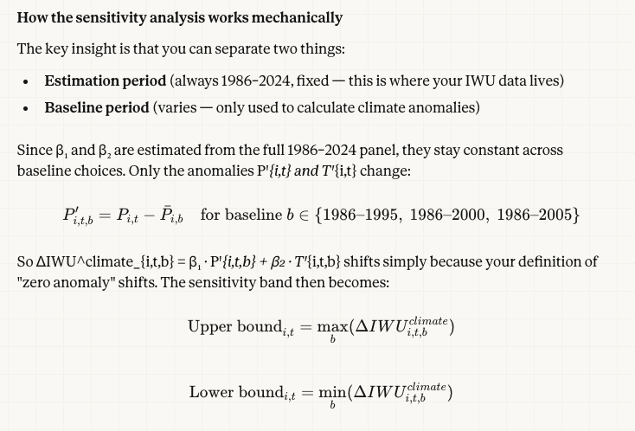
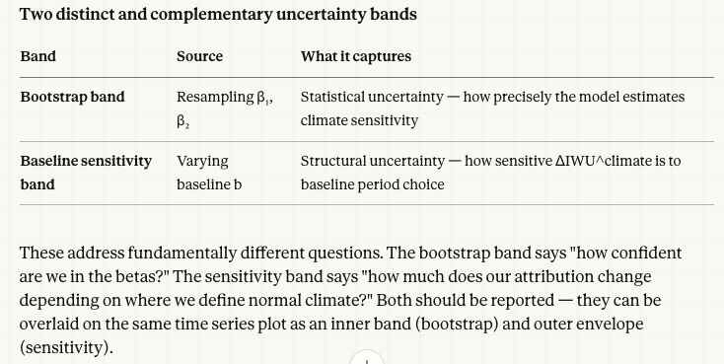
- Results –
  - Depending on the F-test results, $β_{1}$ and $β_{2}$ can be singles values for the entire study area or they can be aquifer type specific. However, we can input each aquifer-state unit’s climate to generate the change in IWU due to climate and map it spatially, with each unit displayed as its aquifer-state polygon.
- We can make time series plot of $∆IWU_{i,t}^{climate}$ for each aquifer_state.
- We can also show average $∆IWU_{i,t}^{climate}$ spatially for each aquifer_state.
RQ2– Changes in IWU in future climate
- Here, we can integrate the average of future anomalies (2030-2050, 2050-2070) to predict IWU in the future. We will follow a similar approach to RQ1 to see how IWU will change in the future.
- Future mean anomalies
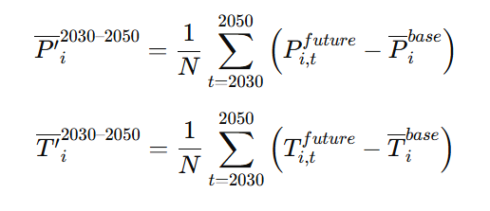
    - Predict future changes in IWU due to climate change.
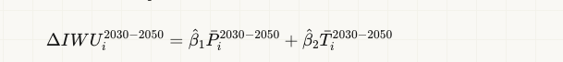
We don’t need the fixed effects here, only the betas from the historic model. This is because we are already using the averages of anomalies, which is mathematically the same as setting the precipitation and temperature as zeros and subtracting generated $IWU_{i,t}^{cf}$ from $IWU_{i,t}^{obs}$. Refer to the attached image –
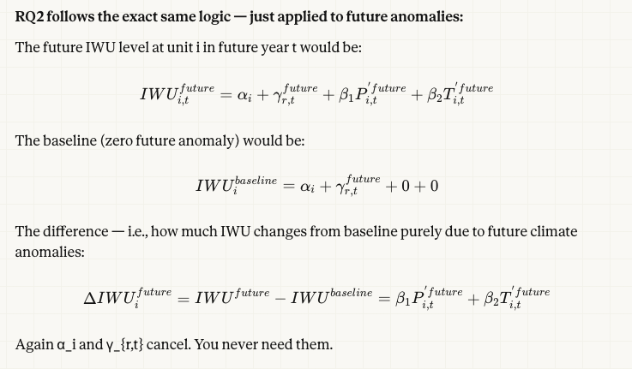
📌 LIMITATION: β₁ and β₂ capture how IWU actually responded to climate during 1986–2024, including whatever adaptation farmers made along the way (e.g., switching crops, improving irrigation efficiency). Because this adaptation was partly driven by the same climate trends we are measuring, the fixed effects cannot fully separate it out — so the betas reflect the net climate effect after real-world adaptation. This is ok for RQ1. For RQ2, this means we are assuming future farmers adapt similarly to historical farmers, which may not hold under more severe future climate conditions. We need to declare that in the manuscript.

RQ3 – Are groundwater-dominated basins more impacted by climate change than surface water-dominated basins?
- Because the panel is defined at the aquifer-state level, we will embed the gw vs sw (gw-dominated vs conjunctive) irrigation classification is directly embedded in the panel structure via the aquifer type (AQ_code). The gw-domianted vs conjucnctive classification will be based on USGS HUC12 dataset and as performed in Hasan et al. 2026.
- Initial plan was to build separate gr-dominated vs conjunctive panel model and assess climate impact on IWU. However, rather than running two separate models, we can add an indicator GWᵢ (= 1 if groundwater-dominated) and interact it with climate anomalies within a single pooled model:
$$IWU_{i,t}^{obs}=α_{i}+γ_{r,t}+ β_{1} {P^{'}}_{i,t }+ β_{2} {T^{'}}_{i,t }+ δ1(P’ᵢ,t × GWᵢ) + δ2(T’ᵢ,t × GWᵢ) +∈_{i,t}$$
δ1 and δ2 capture the differential climate sensitivity of groundwater-dominated vs conjunctive aquifer-state units. Canal density and dam presence will be used to verify the classification.
- Then, we will follow the same counterfactual setup to identify the change in IWU in groundwater-dominated vs conjunctive basins.
- Results –
- Spatial map of change in IWU due to climate relative to total IWU. This will show relative change in IWU for gw- vs sw-dominated basins.
- Time series comparison.
RQ4 – How does IWU response to climate changes in shallow vs deep water table?
- We will use the CONUS-wide water table depth (WTD) data to represent long-term aquifer conditions. Using long-term (static) WTD instead of dynamic WTD reduces, but does not fully eliminate, the endogeneity between WTD and IWU: long-term average WTD is itself a product of decades of pumping history and correlates with historical crop patterns and irrigation technology — all of which are also correlated with climate variables. The interaction coefficients (θ1, θ2) therefore partially reflect endogenous management history in addition to aquifer geology.
- The panel regression model will be modified by adding WTD as an interaction term -
$$IWU_{i,t}=α_{i}+γ_{t}+β_{1}{P'}_{i,t}+β_{2}{T'}_{i,t}+θ_{1}({P^{'}}_{i,t}* {WTD}_{i})+θ_{2}({T^{'}}_{i,t}* {WTD}_{i})+ ∈_{i,t}$$
$β_{1}+θ_{1}* {WTD}_{i}$ $→$ precipitation effects on IWU in shallow vs deep groundwater table (the marginal effect of precipitation)
$β_{2}+θ_{2}* {WTD}_{i}$ $→$ temperature effects on IWU in shallow vs deep groundwater table (the marginal effect of temperature)
- We can further assess scenarios like – how would changes in WTD in the future effect the interaction between climate and IWU. Might introduce endogeneity.

- 📌 LIMITATION: Residual endogeneity in WTD: even static WTD reflects historical pumping decisions. θ1 and θ2 cannot be interpreted as purely geological. If available, pre-agricultural aquifer thickness or geological recharge rates (exogenous to modern irrigation) could serve as instruments for WTD to strengthen the causal interpretation.
We can explore Instrumental Variable approach (as a main or supplementary) to address the endogeneity issue. IV complements the WTD approach — not replaces it.
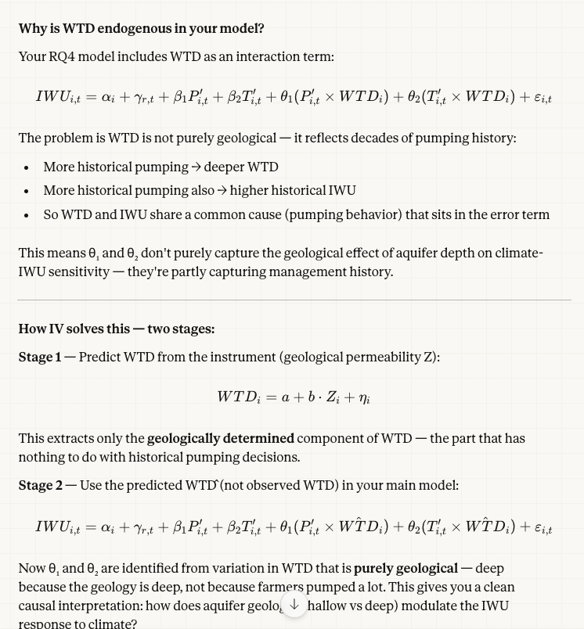
We can run both using IV approach and without the IV approach to test if our original panel model in reliable or not.
Additional scopes to explore-
- What are the long-term trends and spatial patterns of Irrigation Water Use (IWU) in the Western US?
- Across-basin distributional changes
  - How does the distribution of IWU across all basins evolve over time?
  - We will calculate the 25th/50th/75th/95th percentile of IWU across all basins for each year. We can then plot each percentile’s value against time to check the temporal trend across all basins.
- Within-basin (within-state) trend
  - How does IWU change within individual basins over time and how do these changes vary spatially?
  - We can construct a linear regression model between time and IWU for each basin. The slope will be the long-term trend of IWU change. This will be the mean trend.
  - To account for potential distributional shifts in different parts of IWU, we can do basin-specific time trends using quantile regression. This will help answer question like – is IWU on the extreme ends changing more than the median/mean?

Results –
- IWU time-series which will show change in 25th/50th/75th/95th percentile of IWU change over 2000 to 2024.
  - Spatial IWU trend for each unit (basin/state).
- Correlation between lagged precipitation (proxy of snow) and IWU. Does the response between climate and IWU change when we add lagged precipitation?
- Does climate change increase irrigation water use primarily by increasing water applied to existing irrigated land or by changing the amount of land under irrigation?
- We have the base IWU model, where IWU is normalized by acres. From that model, we will quantify change in IWU attributed to climate $∆IWU_{state,year}^{climate}$.
- Following the IWU-climate model, we will develop another model with irrigated acres as the response variable and climate variables as the regressors -
$${Acre}_{i,t}=α_{i}+γ_{t}+β_{1}{P'}_{i,t}+β_{2}{T'}_{i,t}+{ ∈}_{i,t}$$
Using this model, we will estimate change in irrigated acres ($∆{Acre}_{state,year}^{climate}$) due to climate, using a similar approach as the $∆IWU_{state,year}^{climate}$.
- In the next step, we will convert $∆IWU_{state,year}^{climate}$ and $∆{Acre}_{state,year}^{climate}$ to acre-ft unit. Here, we will use baseline $\overline{Acre}$ (average of 1986-2000) and $\overline{IWU}$. These baseline averages indicate the irrigated acres and irrigation water that would have been used anyway, without climate change impacts.
  - The additional irrigation water use attributable to increased water application (due to climate change) on existing irrigated land is calculated as (intensive response) -
$$∆{IWU}_{state,year}^{intensive}= ∆IWU_{state,year}^{climate}* \overline{Acre}$$
  - The additional irrigation water use attributable to changes in irrigated area is calculated as the extensive response. Note: the full accounting identity includes a cross-term: ΔIWUtotal = ΔIWUintensive + ΔIWUextensive + (ΔIWU × ΔAcre). The cross-term is dropped in the decomposition below; it should be calculated and reported as a residual to verify the two-way attribution is complete.
Step 3 — Cross-term (required for complete decomposition): Calculate the interaction between climate-driven changes in IWU intensity and irrigated area:
ΔIWUcross_{state,year} = ΔIWU_{state,year}^{climate} × ΔAcre_{state,year}^{climate}
The full decomposition then becomes: ΔIWUtotal = ΔIWUintensive + ΔIWUextensive + ΔIWUcross. Report all three components. The cross-term ΔIWUcross quantifies how much additional water use arises from expanding irrigation into land that also experiences higher per-acre demand due to climate change. For large simultaneous changes in both intensity and area, this term may be non-trivial. The ΔIWUcross should be reported alongside the percentage shares so that all components sum to 100%.
📌 LIMITATION: The intensive + extensive decomposition omits the cross-term (ΔIWU × ΔAcre). The percentages will not sum to 100% when both IWU intensity and irrigated area change simultaneously. Calculate and report this cross-term as a residual. For large climate signals, the cross-term may be non-trivial.
$$∆{IWU}_{state,year}^{extensive}= ∆{Acre}_{state,year}^{climate}* \overline{IWU}$$
- Now, we calculate the percentage of climate-driven IWU change attributable to increased water application on baseline irrigated acreage versus the percentage attributable to climate-induced changes in irrigated area.
$$\% intensive ∆IWU= \frac{∆{IWU}_{state,year}^{intensive}}{∆{IWU}_{state,year}^{intensive}+ ∆{IWU}_{state,year}^{extensive}}$$
Additional thoughts
- Because IWU is defined as Irrigated ET – Peff, precipitation enters both sides of the regression equation, creating a structural endogeneity issue: the estimated β1 conflates (a) the genuine behavioral response of irrigators to rainfall and (b) a mechanical accounting artifact. A robustness check using independent pump-record data (total irrigation water applied) is recommended to disentangle these effects. This limitation must be acknowledged explicitly in the paper.

