Project Report
Name: Md. Fahim Rahman
ID: 2024-3-60-134
Course Code: CSE 200
Course Title: Computer Aided Engineering Drawing
Section: 2
Semester: Summer 2025
Faculty: SDIS
Submission Date: 11/09/2025

Screenshot of 2D floor plan:
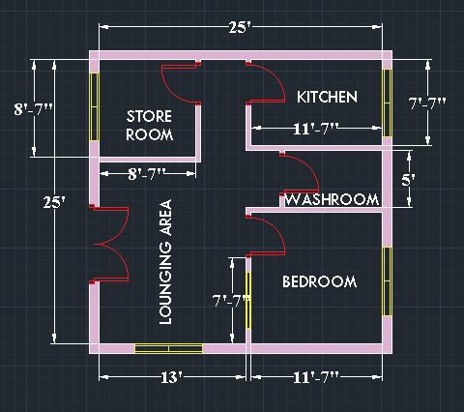

Screenshots of 3D Design: