**1.) Identify your problem statement :**

**Machine Learning**

**Supervised Learning**

**Classification**

**2.) The dataset has the following basic information:**

* **Total number of rows:** 398
* **Total number of columns:** 25

The columns in the dataset are:

1. **age**
2. **bp**
3. **al**
4. **su**
5. **bgr**
6. **bu**
7. **sc**
8. **sod**
9. **pot**
10. **hrmo**
11. **pcv**
12. **wc**
13. **rc**
14. **sg**
15. **rbc**
16. **pc**
17. **pcc**
18. **ba**
19. **htn**
20. **dm**
21. **cad**
22. **appet**
23. **pe**
24. **ane**
25. **classification**

**3.) Mention the pre-processing method :-**

**Handle Categorical Variables:**

Use one-hot encoding to convert **sg, rbc, pcc, pc, ba,**  **htn, dm, cad, appet, pe, ane, classification** columns into numerical format.

**Feature Scaling:**

* Standardize numerical features.

**Splitting the Data:**

* Split the dataset into training and testing sets (1/3 testing).

**4.) All the research values:**

**Machine Learning-Classification-Confusion_Matrix**

**Dataset: CKD**

**1. RandomForest_Grid_Classifier:**



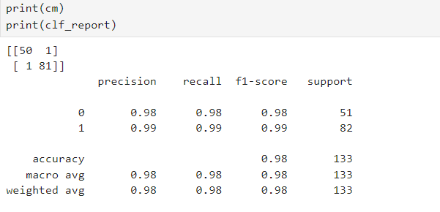

Classification Report **accuracy = 0.98**

**2.DecisionTree_Grid_Classifier:**



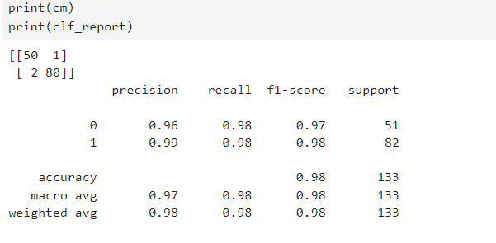

Classification Report **accuracy = 0.98**

**3.SVM_Grid_Classifier**:



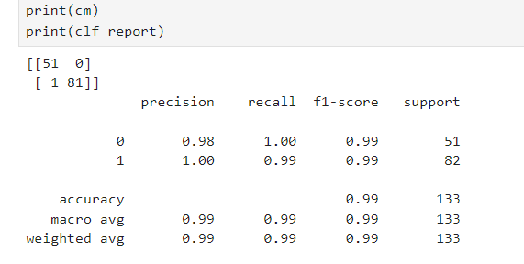

Classification Report **accuracy = 0.99**

**4.LogisticRegression_Grid_Classifier:**



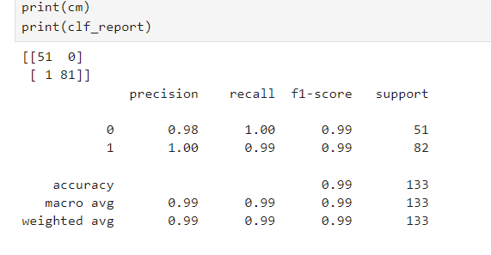

Classification Report **accuracy = 0.99**

**5.KNN_Grid_Classifier:**



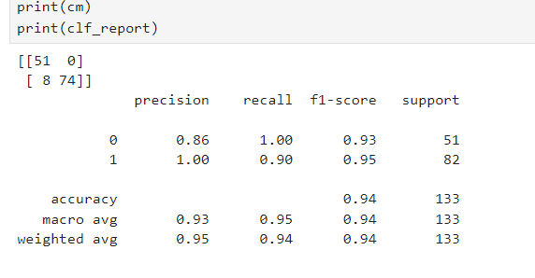

Classification Report **accuracy = 0.94**

**6.1.Naive_Baye's_Classifier_MultinomialNB**:



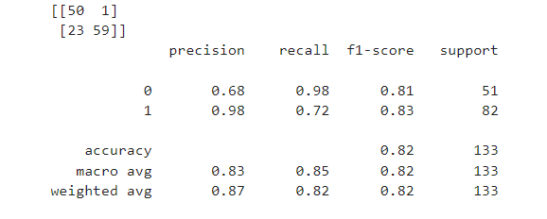

Classification Report **accuracy = 0.82**

**6.2.Naive_Baye's_Classifier_ BernoulliNB:**



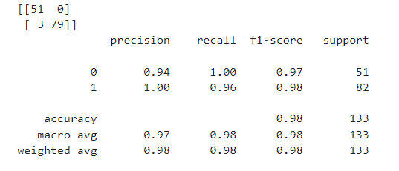

Classification Report **accuracy = 0.98**

**6.3.Naive_Baye's_Classifier_ ComplementNB**:



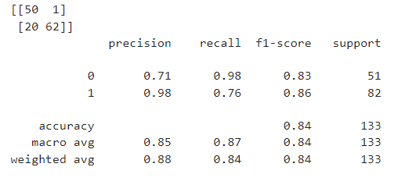

Classification Report **accuracy = 0.84**

**6.4.Naive_Baye's_Classifier_ GaussianNB:**



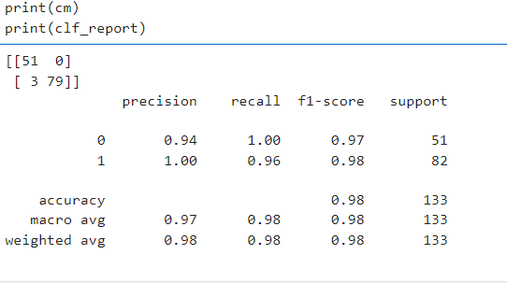

Classification Report **accuracy = 0.98**

**6.5.Naive_Baye's_Classifier CategoricalNB:**

Classification Report **accuracy = 1.00**

**5.) The Final Machine Learning best method of Classification is**

**LogisticRegression_Grid_Classification**





Classification Report **accuracy = 0.99**