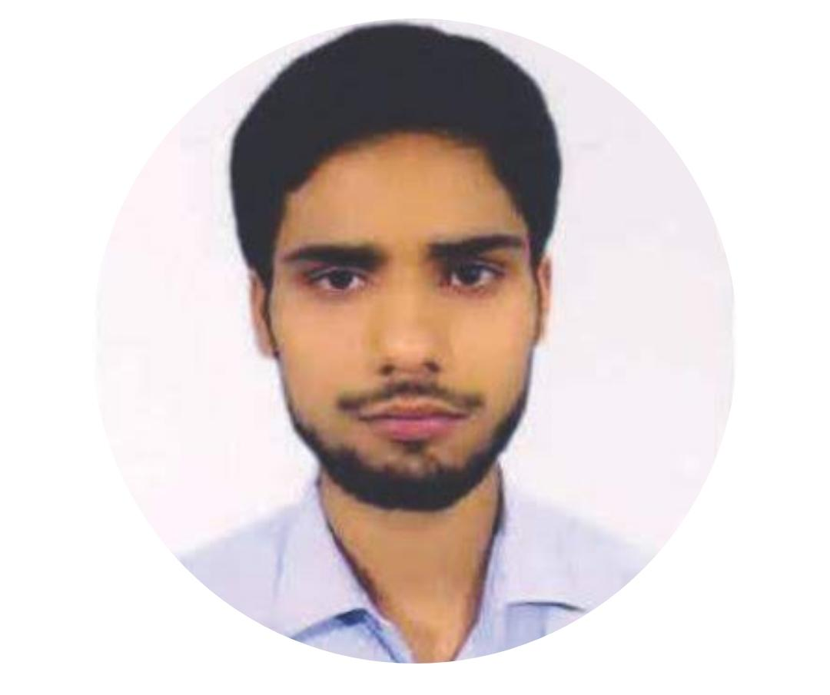


C V

Personal Information

Md Gul Moajjam Faizy
Email: mdgmfaizy@gmail.com
Phom:7254065338

Address: Aijanii, Chhaurahi, Begusarai, Bihar
Pin Cord :848204
Hobby

Playingcricket.
ListeningtoMusic.
ListeningtoMusic.
Interactwithnewpeople.
STRENGTHS

Sincerityandhardworking
Motivating goal oriented
Having good convincing power
Education
GRADUTION :from 2020-2024
Bachelor of Engineering in INFORMATION TECHNOLOGY
DEPARTMENT OF ENGINEERING AND TECHNOLOGICAL
STUDIES UNIVERSITY OF KALYANI,NADIA,WEST
BENGALPIN-741235
1st Year Sem 1 Marks: SGPA 7.20 OUT OF 10(2021)
12th
S S Inter Collage Rajupur Chhaurahi BeguseraiI Bihar
Biher School Examination Bord Patna,Bihar
Final Marks:64% (2019)
10th
High School Chhaurahi Mathine Beguserai ,Bihar
Biher School Examination Bord Patna,Bihar
Final Marks:63.4% (2016)

Work Experience
Personal Skills

ProgrammingLanguage:C,C++,
HTML5,CSS, Javascript, Bootstrap, python,dsa,react js,SQL
Ms Word,Ms Power
Language:Hindi, English

