Project Report

“Simulate Traffic Control System with Adaptive Control for Vehicles and Pedestrians”

Project Description

This project uses Python object-oriented programming to make a Smart Traffic Control System. The system makes a four-way intersection with lanes going North, South, East, and West look like it does in real life. Instead of using fixed-time signal cycles, the system changes the timing and priority of signals based on how many cars and people are on the road at the time.

The simulation goes through several cycles, randomly adding traffic to each lane in each cycle. Then, it uses smart decision-making to figure out which lane group gets a green light, how long it lasts, and if switching lanes early is necessary. This is similar to how modern adaptive traffic management systems work in smart cities.

Features

Feature | Description
Adaptive Timing | Based on the amount of traffic at the time, it dynamically sets the length of the green light (15s, 30s, or 60s) in Low, Normal, or High Traffic modes.
Priority Routing | Detects which lane group (North-South or East-West) has higher traffic and gives the green signal to the busier group first.
Early Switching | During a green phase, if the opposing lane group suddenly goes above 8 cars, the system shortens the current green light after a minimum of 15 seconds
Pedestrian Priority | When a pedestrian is detected waiting, the green phase is limited to 15 seconds, regardless of traffic mode, to ensure timely crossing.
Anti-Starvation | This prevents the same lane group from getting consecutive green signals, enforcing alternation so no direction is skipped repeatedly
Visual Bar Display | It shows a real-time ASCII bar chart in the terminal that displays car count per lane and the current signal state (RED/GREEN).
Yellow Phase | It implements a realistic 3-second yellow transition when green ends, followed by a 2-second all-yellow phase before switching sides.
Modular OOP Design | The entire system is contained in the SmartTrafficSystem class, which includes separate methods for updating traffic, calculating priority, timing, and display.

3. System Logic & Flow

3.1 Traffic Modes & Green Timer

The system calculates the total number of cars in the active green lane group and assigns a mode:
- High Traffic (≥ 25 cars total): A maximum duration of 60 seconds is allocated to clear heavy congestion.
- Normal Traffic (10–24 cars): A standard duration of 30 seconds is applied.
- Low Traffic (< 10 cars): A brief 15-second phase is used to maintain flow without idling.
- Pedestrian Priority (any count): Regardless of vehicle count, if a pedestrian sensor is triggered (WAITING), the system enforces a safe 15-second crossing window.

3.2 Intelligent Priority Selection

For determining which lanes will be allowed the green signal, the program analyzes the intersection condition at the beginning of each cycle:

• Demand Analysis: This involves comparing the number of vehicles in the North-South cluster with those in the East-West cluster.
• Preventing Starvation: In order to prevent starvation, there is an implementation of “last green” in the code. This means that if the most congested cluster had control in the previous cycle, the program will give way to the other cluster.

3.3 Dynamic Early Switching

This system actively observes the operation at the intersection during the green signal, with the purpose of adjusting to abrupt traffic conditions:

Minimum Green Signal: This ensures that the minimum duration of green time is not less than 15 seconds to avoid any quick and confusing signals.

Traffic Congestion Detection: After this minimum period, the system checks whether the number of waiting cars is more by 8 units compared to the active cars. If such a condition prevails, then the green cycle ends before the designated end time.

3.4 Signal Transition Phases

In order to make the intersection safe by clearing the “box,” the following transition process is followed:
Phase Green: Active countdown during which vehicles can enter the intersection.
Yellow Standard (3 sec): Warning period indicating that the active lanes should stop.
Yellow All Lanes (2 sec): “Clearance period” wherein all lights show restrictive signs, thereby allowing any vehicles in the intersection to exit before the other side goes green.

Code :

import time
import random

lanes_group = [
["North", "South"],
["East", "West"]
]

class SmartTrafficSystem:
def __init__(self):
self.traffic = {}
self.pedestrian_waiting = False
self.last_green_group = None

def update_traffic(self):
for group in lanes_group:
for lane in group:
self.traffic[lane] = random.randint(0, 20)

def get_priority_group(self):
g0 = sum(self.traffic[l] for l in lanes_group[0])
g1 = sum(self.traffic[l] for l in lanes_group[1])

preferred = 0 if g0 >= g1 else 1

if preferred == self.last_green_group:
preferred = 1 - preferred

return preferred

def get_timing(self, total):
if total >= 25:
return "High Traffic", 60
elif total >= 10:
return "Normal Traffic", 30
else:
return "Low Traffic", 15

def display(self, cycle, green_group, state, timer, group_index):
print(f"CYCLE {cycle}")

print("\nTraffic Density:")
for lane in ["North", "South", "East", "West"]:
count = self.traffic[lane]
bar = "█" * (count // 2)
signal = "GREEN" if lane in green_group else "RED"
print(f"{lane:<6}: {count:2d} cars | {bar:<10} | {signal}")

print(f"\nMode: {state}")
print("Pedestrian:", "WAITING" if self.pedestrian_waiting else "None")

print(f"\nGREEN SIGNAL: {green_group}")
print(" Green light countdown:")

threshold = 8
min_green = 15

elapsed = 0

while elapsed < timer:
remaining = timer - elapsed
print(f" {remaining} sec remaining...")

if elapsed >= min_green:
current = sum(self.traffic[l] for l in lanes_group[group_index])
opposite = sum(self.traffic[l] for l in lanes_group[1 - group_index])

if opposite > current + threshold:
print(" Heavy traffic on opposite → switching early!")
break

time.sleep(1)
elapsed += 1

print(" Green phase ended!")

print("\nSwitching to YELLOW (current lanes prepare to stop)...")
for t in range(3, 0, -1):
print(f" {t} sec remaining (YELLOW)...")
time.sleep(1)

print(" Yellow phase ended!")

print("\nALL LANES YELLOW (prepare to switch)...")
for t in range(2, 0, -1):
print(f" {t} sec remaining (ALL-YELLOW)...")
time.sleep(1)

print(" Switching sides now!")

def run(self, cycles=5):
for i in range(1, cycles + 1):

self.update_traffic()
self.pedestrian_waiting = random.choice([True, False])

group_index = self.get_priority_group()
green_group = lanes_group[group_index]

total = sum(self.traffic[l] for l in green_group)
state, timer = self.get_timing(total)

if self.pedestrian_waiting:
state = "Pedestrian Priority"
timer = 15

self.display(i, green_group, state, timer, group_index)

self.last_green_group = group_index

system = SmartTrafficSystem()
system.run(5)
Output :
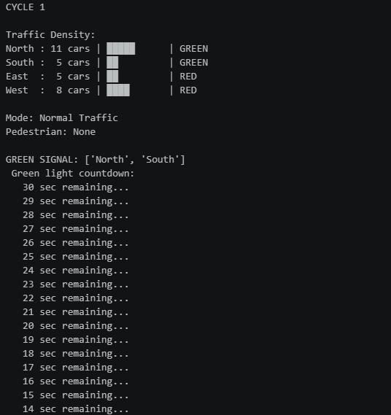
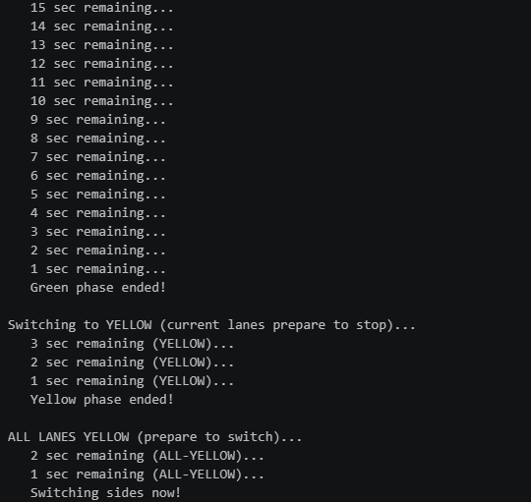
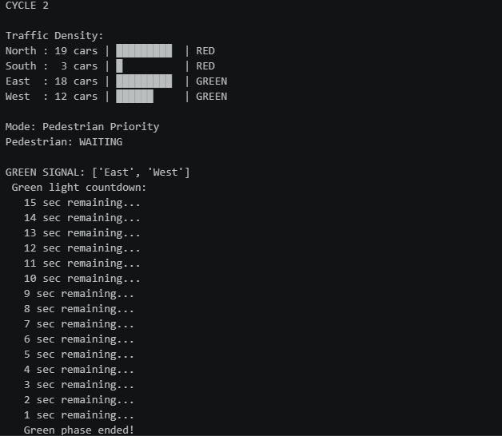
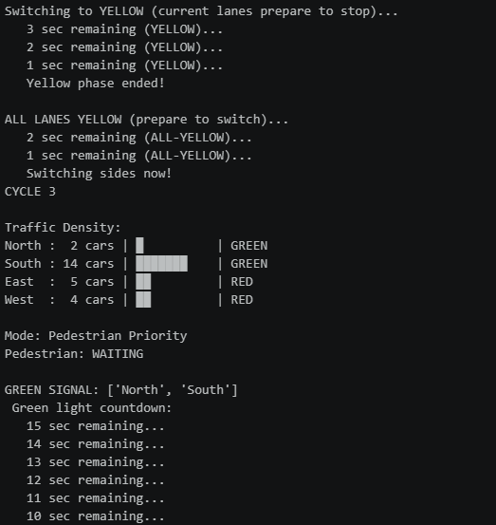

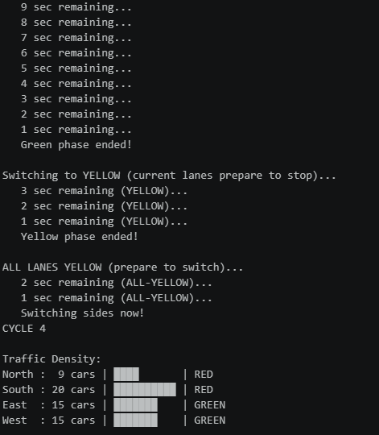
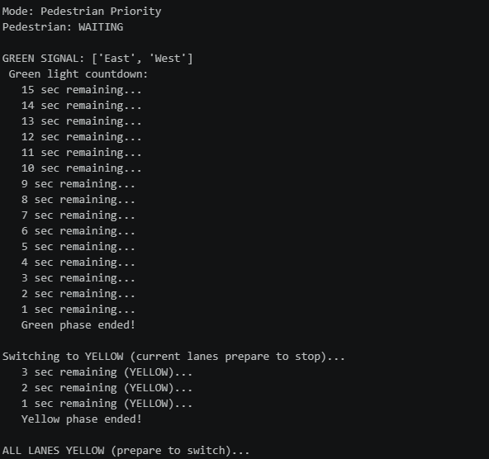
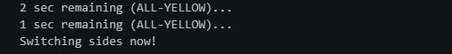

4. Conclusion
This project demonstrates the application of object-oriented software engineering principles to a real-world urban infrastructure problem. The SmartTrafficSystem successfully implements adaptive green timing, intelligent priority routing, dynamic early switching, pedestrian priority handling, and anti-starvation guarantees within a clean, modular Python class.

The simulation highlights how relatively simple rule-based algorithms — when properly structured and composed — can produce nuanced, responsive behavior that approximates the logic of commercial adaptive traffic controllers. The system's modular design also provides a strong foundation for the enhancements described in Section 7, enabling a natural progression from a terminal simulation toward a production-ready smart city component.

From a software engineering perspective, the project reinforces core competencies in class design, state management, real-time loop control, and human-centric system override logic. These are directly transferable skills for students pursuing careers in systems programming, embedded software, and urban technology.

