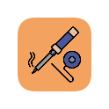
Introduction to Soldering
A hands-on guide to soldering electronics

i2s.cmmn.com
eugenemakerspace.com

