Lab 3 - Arbiter and FSM Design

PART 1 - Arbiter

1. Round-Robin Arbiter

State Machine Diagram
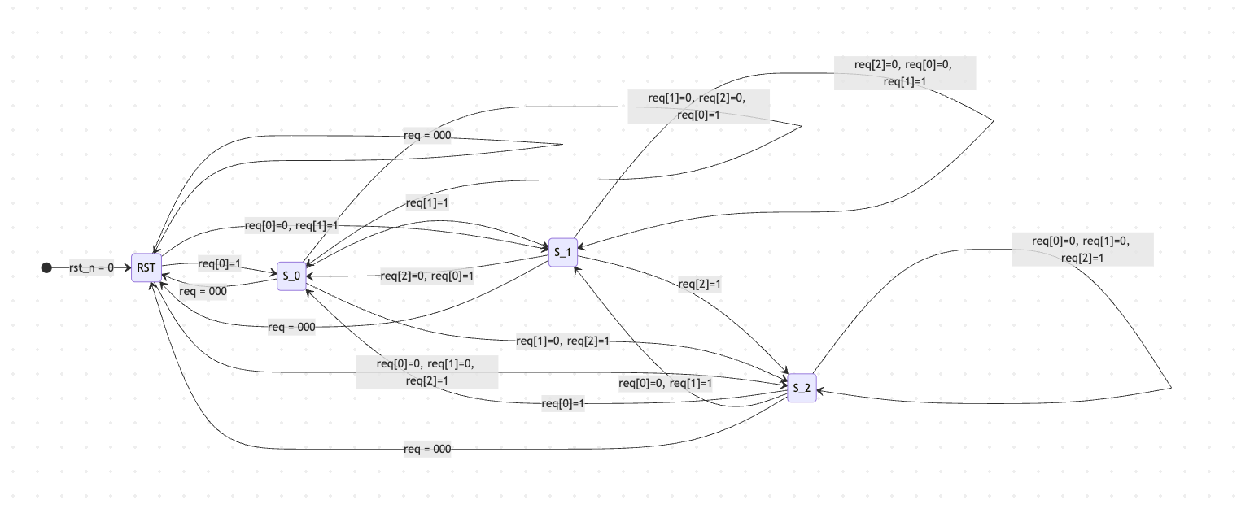
stateDiagram-v2
direction LR

[*] --> RST : rst_n = 0

%% 1. Primary Path (Highest Priority / Next in Round-Robin)
RST --> S_0 : req[0]=1
S_0 --> S_1 : req[1]=1
S_1 --> S_2 : req[2]=1
S_2 --> S_0 : req[0]=1

%% 2. Secondary Path (Skip one state)
RST --> S_1 : req[0]=0, req[1]=1
S_0 --> S_2 : req[1]=0, req[2]=1
S_1 --> S_0 : req[2]=0, req[0]=1
S_2 --> S_1 : req[0]=0, req[1]=1

%% 3. Tertiary Path (Skip two states)
RST --> S_2 : req[0]=0, req[1]=0, req[2]=1

%% 4. Self Loops (Hold current state)
RST --> RST : req = 000
S_0 --> S_0 : req[1]=0, req[2]=0, req[0]=1
S_1 --> S_1 : req[2]=0, req[0]=0, req[1]=1
S_2 --> S_2 : req[0]=0, req[1]=0, req[2]=1

%% 5. Return to Idle
S_0 --> RST : req = 000
S_1 --> RST : req = 000
S_2 --> RST : req = 000

Verilog Code (arb.v)
module arb (
input wire clk,
input wire rst_n, // active low and asynchronous
input wire [2:0] req,
output reg [2:0] gnt
);
parameter RST = 3'b000;
parameter S_0 = 3'b001;
parameter S_1 = 3'b010;
parameter S_2 = 3'b100;
reg [2:0] state, next_state;
// State transition
always @(posedge clk or negedge rst_n) begin
if (!rst_n) begin
state <= RST;
end else begin
state <= next_state;
end
end
// Next state logic
always @(*) begin
case (state)
RST: begin
if (req[0]) next_state = S_0;
else if (req[1]) next_state = S_1;
else if (req[2]) next_state = S_2;
else next_state = RST;
end
S_0: begin
if (req[1]) next_state = S_1;
else if (req[2]) next_state = S_2;
else if (req[0]) next_state = S_0;
else next_state = RST;
end
S_1: begin
if (req[2]) next_state = S_2;
else if (req[0]) next_state = S_0;
else if (req[1]) next_state = S_1;
else next_state = RST;
end
S_2: begin
if (req[0]) next_state = S_0;
else if (req[1]) next_state = S_1;
else if (req[2]) next_state = S_2;
else next_state = RST;
end
default: next_state = RST;
endcase
end
// Output logic
always @(*) begin
gnt = state;
end
endmodule

Testbench Code (arb_tb.v)
`timescale 1ns/1ps
module arb_tb;
reg clk;
reg rst_n;
reg [2:0] req;
wire [2:0] gnt;
// Instantiate the arbiter
arb uut (
.clk(clk),
.rst_n(rst_n),
.req(req),
.gnt(gnt)
);
// Clock generation
initial begin
clk = 0;
forever #5 clk = ~clk;
end
// Function or string for state name
reg [23:0] state_name;
always @(*) begin
case (uut.state)
3'b000: state_name = "RST";
3'b001: state_name = "S_0";
3'b010: state_name = "S_1";
3'b100: state_name = "S_2";
default: state_name = "INV";
endcase
end
// Stimulus
initial begin
$dumpfile("arb.vcd");
$dumpvars(0, arb_tb);
// Initialize inputs
rst_n = 0;
req = 3'b000;
// Wait for a few clock cycles before releasing reset
#12;
rst_n = 1;
// Apply specified combinations of requests
@(negedge clk) req = 3'b000;
@(negedge clk) req = 3'b001;
@(negedge clk) req = 3'b010;
@(negedge clk) req = 3'b100;
@(negedge clk) req = 3'b111;
@(negedge clk) req = 3'b110;
@(negedge clk) req = 3'b100;
@(negedge clk) req = 3'b000;
@(negedge clk) req = 3'b111;
// Let it run for a few more cycles to observe behavior
@(negedge clk);
@(negedge clk);
@(negedge clk);
$finish;
end
// Clear printouts of grants at each clock cycle
always @(posedge clk) begin
// delay by a small amount to allow state and gnt to update
#1;
$display("Time=%0t | req=%b | gnt=%b | state=%s", $time, req, gnt, state_name);
end
endmodule

Simulation Output

Time=6000 | req=000 | gnt=000 | state=RST
Time=16000 | req=000 | gnt=000 | state=RST
Time=26000 | req=000 | gnt=000 | state=RST
Time=36000 | req=001 | gnt=001 | state=S_0
Time=46000 | req=010 | gnt=010 | state=S_1
Time=56000 | req=100 | gnt=100 | state=S_2
Time=66000 | req=111 | gnt=001 | state=S_0
Time=76000 | req=110 | gnt=010 | state=S_1
Time=86000 | req=100 | gnt=100 | state=S_2
Time=96000 | req=000 | gnt=000 | state=RST
Time=106000 | req=111 | gnt=001 | state=S_0
Time=116000 | req=111 | gnt=010 | state=S_1
Time=126000 | req=111 | gnt=100 | state=S_2
arb_tb.v:65: $finish called at 130000 (1ps)

Waveform Images
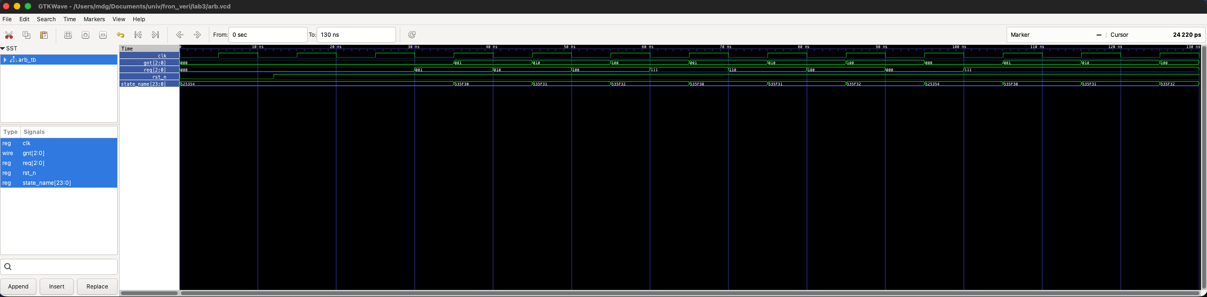

2. Smart(er) Arbiter

Design Explanation
The Smart Arbiter design does not use a traditional FSM with a single state variable. Instead, it utilizes two registers, last_one_gnt and last_two_gnt, to keep track of the history. To ensure absolute fairness, a combinational logic block assigns a 'priority score' to each requester based on the history:
- Score 2 (Highest): The requester is NOT present in the history registers.
- Score 1 (Medium): The requester was granted two cycles ago (last_two_gnt).
- Score 0 (Lowest): The requester was granted in the immediately preceding cycle (last_one_gnt).
When multiple requests arrive, the arbiter compares the active requesters' scores and grants access to the one with the highest score. In the event of a score tie, the system defaults to granting the requester with the lower ID number, ensuring a deterministic and fair decision.

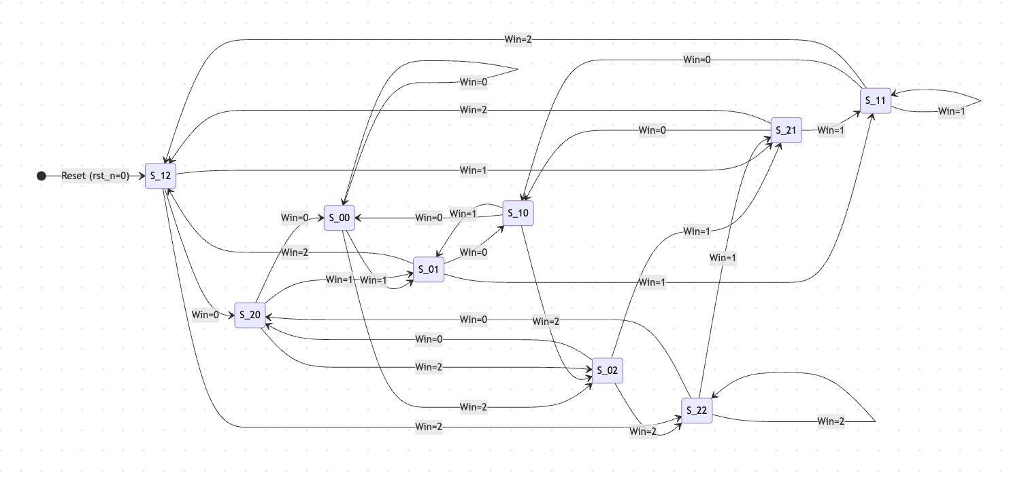
stateDiagram-v2
direction LR

[*] --> S_12 : Reset (rst_n=0)
note "For any state, if req=000,\nit stays in the same state." as N1

%% -----------------------------------------------------
%% Group 0: Current Winner is 0 (States ending in '0')
%% Next state will always be S_0X
%% -----------------------------------------------------
S_00 --> S_00 : Win=0
S_10 --> S_00 : Win=0
S_20 --> S_00 : Win=0

S_00 --> S_01 : Win=1
S_10 --> S_01 : Win=1
S_20 --> S_01 : Win=1

S_00 --> S_02 : Win=2
S_10 --> S_02 : Win=2
S_20 --> S_02 : Win=2

%% -----------------------------------------------------
%% Group 1: Current Winner is 1 (States ending in '1')
%% Next state will always be S_1X
%% -----------------------------------------------------
S_01 --> S_10 : Win=0
S_11 --> S_10 : Win=0
S_21 --> S_10 : Win=0

S_01 --> S_11 : Win=1
S_11 --> S_11 : Win=1
S_21 --> S_11 : Win=1

S_01 --> S_12 : Win=2
S_11 --> S_12 : Win=2
S_21 --> S_12 : Win=2

%% -----------------------------------------------------
%% Group 2: Current Winner is 2 (States ending in '2')
%% Next state will always be S_2X
%% -----------------------------------------------------
S_02 --> S_20 : Win=0
S_12 --> S_20 : Win=0
S_22 --> S_20 : Win=0

S_02 --> S_21 : Win=1
S_12 --> S_21 : Win=1
S_22 --> S_21 : Win=1

S_02 --> S_22 : Win=2
S_12 --> S_22 : Win=2
S_22 --> S_22 : Win=2

Verilog Code (Smart_arb.v)
module Smart_arb (
input wire clk,
input wire rst_n,
input wire [2:0] req,
output reg [2:0] gnt
);
reg [1:0] last_one_gnt;
reg [1:0] last_two_gnt;
reg [1:0] score0, score1, score2;
reg [1:0] winner;
// Calculate scores based on history
// 2 = not in history (highest priority)
// 1 = in last_two_gnt but not last_one_gnt
// 0 = in last_one_gnt (lowest priority)
always @(*) begin
score0 = (last_one_gnt == 2'd0) ? 2'd0 : ((last_two_gnt == 2'd0) ? 2'd1 : 2'd2);
score1 = (last_one_gnt == 2'd1) ? 2'd0 : ((last_two_gnt == 2'd1) ? 2'd1 : 2'd2);
score2 = (last_one_gnt == 2'd2) ? 2'd0 : ((last_two_gnt == 2'd2) ? 2'd1 : 2'd2);
end
// Determine the winner among active requesters
always @(*) begin
case (req)
3'b000: winner = 2'd3; // No request
3'b001: winner = 2'd0; // Only req[0]
3'b010: winner = 2'd1; // Only req[1]
3'b100: winner = 2'd2; // Only req[2]
3'b011: begin // req[0] and req[1]
if (score0 >= score1) winner = 2'd0;
else winner = 2'd1;
end
3'b101: begin // req[0] and req[2]
if (score0 >= score2) winner = 2'd0;
else winner = 2'd2;
end
3'b110: begin // req[1] and req[2]
if (score1 >= score2) winner = 2'd1;
else winner = 2'd2;
end
3'b111: begin // All requests
if (score0 >= score1 && score0 >= score2) winner = 2'd0;
else if (score1 > score0 && score1 >= score2) winner = 2'd1;
else winner = 2'd2;
end
default: winner = 2'd3;
endcase
end
// Update state and output
always @(posedge clk or negedge rst_n) begin
if (!rst_n) begin
// At reset, prefer lower number requester if no conflicts
// So we set history such that 0 > 1 > 2
last_one_gnt <= 2'd2;
last_two_gnt <= 2'd1;
gnt <= 3'b000;
end else begin
if (winner != 2'd3) begin
last_two_gnt <= last_one_gnt;
last_one_gnt <= winner;
if (winner == 2'd0) gnt <= 3'b001;
else if (winner == 2'd1) gnt <= 3'b010;
else if (winner == 2'd2) gnt <= 3'b100;
end else begin
gnt <= 3'b000;
// last_one_gnt and last_two_gnt remain unchanged when no requests are given
end
end
end
endmodule

Testbench Code (smart_arb_tb.v)
`timescale 1ns/1ps
module smart_arb_tb;
reg clk;
reg rst_n;
reg [2:0] req;
wire [2:0] gnt;
// Instantiate the smart arbiter
Smart_arb uut (
.clk(clk),
.rst_n(rst_n),
.req(req),
.gnt(gnt)
);
// Clock generation
initial begin
clk = 0;
forever #5 clk = ~clk;
end
// Stimulus
initial begin
$dumpfile("smart_arb.vcd");
$dumpvars(0, smart_arb_tb);
// Initialize inputs
rst_n = 0;
req = 3'b000;
// Wait for reset
#12;
rst_n = 1;
// Apply scenarios to test history and fairness
// Test 1: req 0 gets grant twice
@(negedge clk) req = 3'b001;
@(negedge clk) req = 3'b001;
// Test 2: all requests asserted. Since 0 just got it twice, it should prefer lower number between 1 and 2, which is 1
@(negedge clk) req = 3'b111;
// Test 3: all requests asserted again. Now history is (0, 1), so 2 should win
@(negedge clk) req = 3'b111;
// Test 4: all requests asserted again. History is (1, 2), so 0 should win
@(negedge clk) req = 3'b111;
// Test 5: req 1 and 2. History is (2, 0). 1 is not in history, so 1 should win
@(negedge clk) req = 3'b110;
// Test 6: No requests. gnt should be 000 and history unchanged.
@(negedge clk) req = 3'b000;
// Test 7: req 0 and 2. History is still (0, 1) from before req=000?
// Wait, after req=110, history became (0, 1).
// Let's see what happens here!
@(negedge clk) req = 3'b101;
// Additional cycles to observe the output
@(negedge clk);
@(negedge clk);
$finish;
end
// Clear printouts of grants and history at each clock cycle
always @(posedge clk) begin
// delay by a small amount to allow state and gnt to update
#1;
$display("Time=%0t | req=%b | gnt=%b | last_one=%0d | last_two=%0d",
$time, req, gnt, uut.last_one_gnt, uut.last_two_gnt);
end
endmodule

Simulation Output
Time=6000 | req=000 | gnt=000 | last_one=2 | last_two=1
Time=16000 | req=000 | gnt=000 | last_one=2 | last_two=1
Time=26000 | req=001 | gnt=001 | last_one=0 | last_two=2
Time=36000 | req=001 | gnt=001 | last_one=0 | last_two=0
Time=46000 | req=111 | gnt=010 | last_one=1 | last_two=0
Time=56000 | req=111 | gnt=100 | last_one=2 | last_two=1
Time=66000 | req=111 | gnt=001 | last_one=0 | last_two=2
Time=76000 | req=110 | gnt=010 | last_one=1 | last_two=0
Time=86000 | req=000 | gnt=000 | last_one=1 | last_two=0
Time=96000 | req=101 | gnt=100 | last_one=2 | last_two=1
Time=106000 | req=101 | gnt=001 | last_one=0 | last_two=2
smart_arb_tb.v:67: $finish called at 110000 (1ps)

Waveform Images
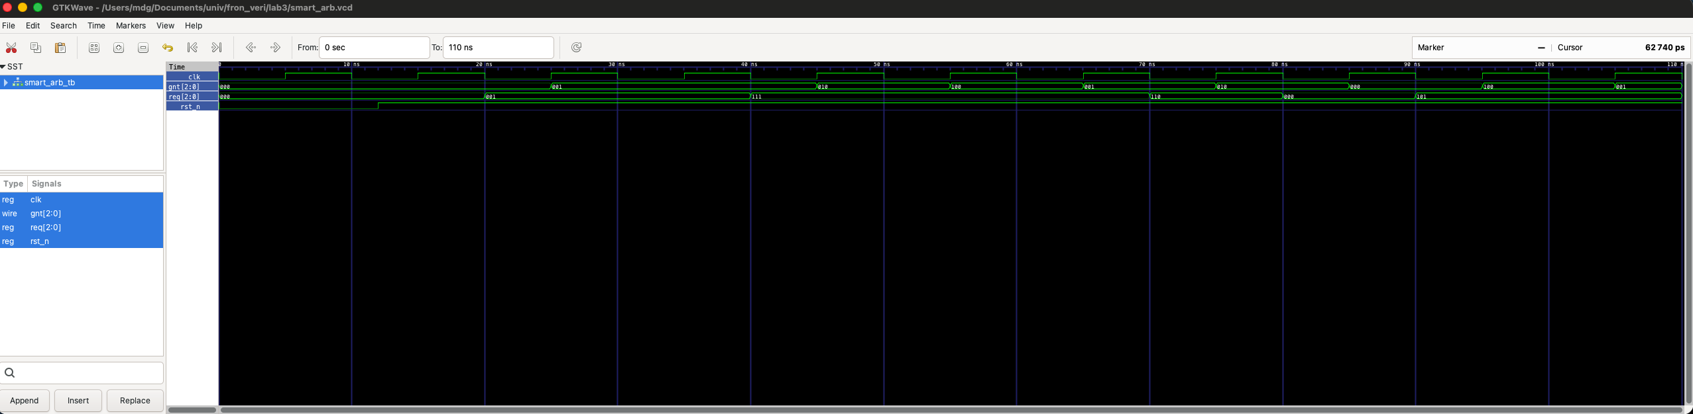

PART 2 - Datapath, Control, and Finite State Machines

State Machine Diagrams

FSM for w=1 for two preceding cycles (Question 5)

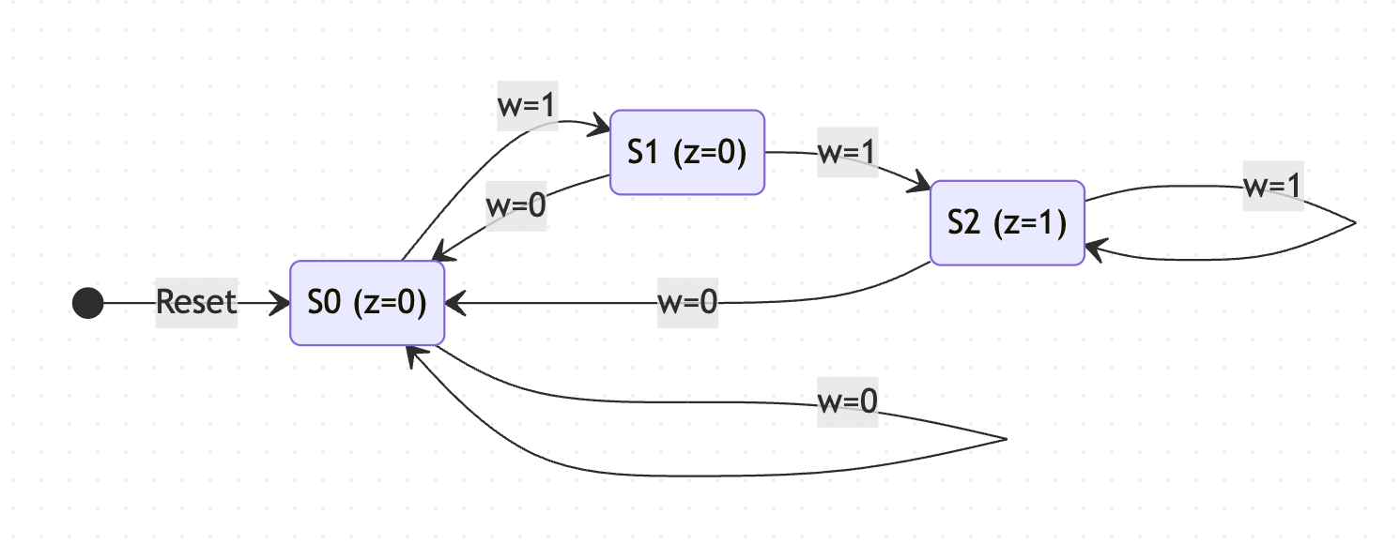
FSM for w != x for 3 consecutive cycles (Question 6)

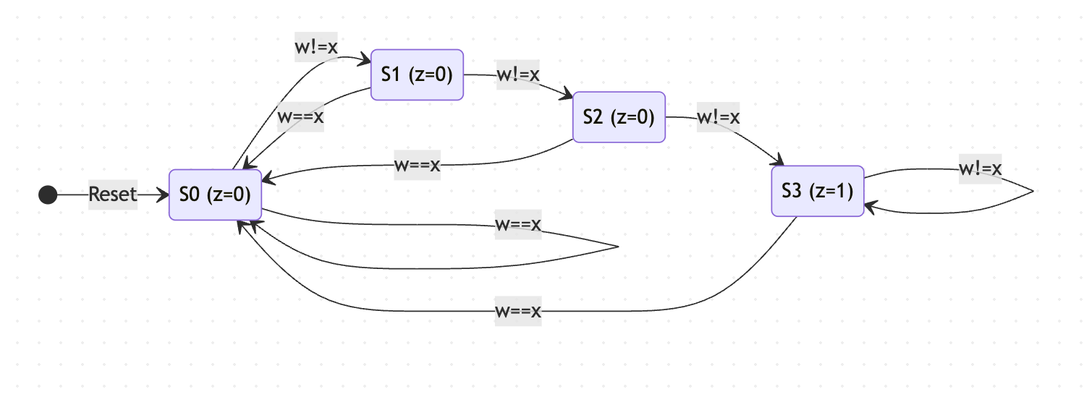
FSM for sequence '1101' detection (Question 7)
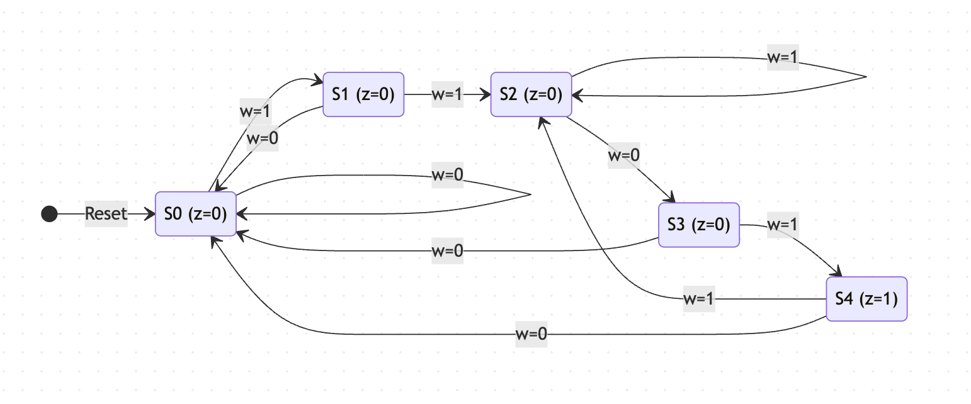

Verilog Code (part2.v)
Contains edge detectors and all three FSMs.
module rising_edge_det (
input wire clk,
input wire button,
output wire pulse
);
reg button_d, button_dd;
always @(posedge clk) begin
button_d <= button;
button_dd <= button_d;
end
assign pulse = button_d & ~button_dd;
endmodule
module falling_edge_det (
input wire clk,
input wire button,
output wire pulse
);
reg button_d, button_dd;
always @(posedge clk) begin
button_d <= button;
button_dd <= button_d;
end
assign pulse = ~button_d & button_dd;
endmodule
module fsm_w (
input wire clk,
input wire rst_n,
input wire w,
output reg z
);
parameter S0 = 2'b00, S1 = 2'b01, S2 = 2'b10;
reg [1:0] state, next_state;
always @(posedge clk or negedge rst_n) begin
if (!rst_n) state <= S0;
else state <= next_state;
end
always @(*) begin
case (state)
S0: next_state = w ? S1 : S0;
S1: next_state = w ? S2 : S0;
S2: next_state = w ? S2 : S0;
default: next_state = S0;
endcase
end
always @(*) z = (state == S2);
endmodule
module fsm_wx (
input wire clk,
input wire rst_n,
input wire w,
input wire x,
output reg z
);
parameter S0 = 2'b00, S1 = 2'b01, S2 = 2'b10, S3 = 2'b11;
reg [1:0] state, next_state;
wire diff = (w != x);
always @(posedge clk or negedge rst_n) begin
if (!rst_n) state <= S0;
else state <= next_state;
end
always @(*) begin
case (state)
S0: next_state = diff ? S1 : S0;
S1: next_state = diff ? S2 : S0;
S2: next_state = diff ? S3 : S0;
S3: next_state = diff ? S3 : S0;
default: next_state = S0;
endcase
end
always @(*) z = (state == S3);
endmodule
module fsm_1101 (
input wire clk,
input wire rst_n,
input wire w,
output reg z
);
parameter S0 = 3'd0, S1 = 3'd1, S2 = 3'd2, S3 = 3'd3, S4 = 3'd4;
reg [2:0] state, next_state;
always @(posedge clk or negedge rst_n) begin
if (!rst_n) state <= S0;
else state <= next_state;
end
always @(*) begin
case (state)
S0: next_state = w ? S1 : S0;
S1: next_state = w ? S2 : S0;
S2: next_state = w ? S2 : S3;
S3: next_state = w ? S4 : S0;
S4: next_state = w ? S2 : S0;
default: next_state = S0;
endcase
end
always @(*) z = (state == S4);
endmodule

Testbench Code (part2_tb.v)
`timescale 1ns/1ps
module part2_tb;
reg clk;
reg rst_n;
reg button;
reg w_5, w_6, x_6, w_7;
wire pulse_rise;
wire pulse_fall;
wire z_5;
wire z_6;
wire z_7;
rising_edge_det u_rise (.clk(clk), .button(button), .pulse(pulse_rise));
falling_edge_det u_fall (.clk(clk), .button(button), .pulse(pulse_fall));
fsm_w u_fsm_w (.clk(clk), .rst_n(rst_n), .w(w_5), .z(z_5));
fsm_wx u_fsm_wx (.clk(clk), .rst_n(rst_n), .w(w_6), .x(x_6), .z(z_6));
fsm_1101 u_fsm_1101 (.clk(clk), .rst_n(rst_n), .w(w_7), .z(z_7));
initial begin
clk = 0;
forever #5 clk = ~clk;
end
initial begin
$dumpfile("part2.vcd");
$dumpvars(0, part2_tb);
rst_n = 0;
button = 0;
w_5 = 0; w_6 = 0; x_6 = 0; w_7 = 0;
#12;
rst_n = 1;
$display("--- Testing Edge Detectors ---");
@(negedge clk) button = 1;
@(negedge clk) button = 1;
@(negedge clk) button = 0;
@(negedge clk) button = 0;
$display("--- Testing FSM 5 (w=1 for two preceding cycles) ---");
// w: 0 1 0 1 1 0 1 1 1 0 1
@(negedge clk) w_5 = 0;
@(negedge clk) w_5 = 1;
@(negedge clk) w_5 = 0;
@(negedge clk) w_5 = 1;
@(negedge clk) w_5 = 1;
@(negedge clk) w_5 = 0;
@(negedge clk) w_5 = 1;
@(negedge clk) w_5 = 1;
@(negedge clk) w_5 = 1;
@(negedge clk) w_5 = 0;
@(negedge clk) w_5 = 1;
$display("--- Testing FSM 6 (w!=x for three cycles) ---");
@(negedge clk) w_6 = 0; x_6 = 1; // 1 cycle
@(negedge clk) w_6 = 1; x_6 = 0; // 2 cycles
@(negedge clk) w_6 = 0; x_6 = 1; // 3 cycles -> z=1
@(negedge clk) w_6 = 1; x_6 = 1; // 0 cycles
@(negedge clk) w_6 = 0; x_6 = 1; // 1 cycle
$display("--- Testing FSM 7 (1101) ---");
@(negedge clk) w_7 = 1;
@(negedge clk) w_7 = 1;
@(negedge clk) w_7 = 0;
@(negedge clk) w_7 = 1; // Sequence 1101 complete -> z=1
@(negedge clk) w_7 = 1; // Sequence is now 11011 (suffix 11)
@(negedge clk) w_7 = 0; // Suffix 110
@(negedge clk) w_7 = 1; // Sequence 1101 again -> z=1
@(negedge clk);
@(negedge clk);
$finish;
end
always @(posedge clk) begin
#1;
$display("Time=%0t | btn=%b rise=%b fall=%b | w5=%b z5=%b | w6=%b x6=%b z6=%b | w7=%b z7=%b",
$time, button, pulse_rise, pulse_fall, w_5, z_5, w_6, x_6, z_6, w_7, z_7);
end
endmodule

Simulation Output
Time=6000 | btn=0 rise=0 fall=x | w5=0 z5=0 | w6=0 x6=0 z6=0 | w7=0 z7=0
--- Testing Edge Detectors ---
Time=16000 | btn=0 rise=0 fall=0 | w5=0 z5=0 | w6=0 x6=0 z6=0 | w7=0 z7=0
Time=26000 | btn=1 rise=1 fall=0 | w5=0 z5=0 | w6=0 x6=0 z6=0 | w7=0 z7=0
Time=36000 | btn=1 rise=0 fall=0 | w5=0 z5=0 | w6=0 x6=0 z6=0 | w7=0 z7=0
Time=46000 | btn=0 rise=0 fall=1 | w5=0 z5=0 | w6=0 x6=0 z6=0 | w7=0 z7=0
--- Testing FSM 5 (w=1 for two preceding cycles) ---
Time=56000 | btn=0 rise=0 fall=0 | w5=0 z5=0 | w6=0 x6=0 z6=0 | w7=0 z7=0
Time=66000 | btn=0 rise=0 fall=0 | w5=0 z5=0 | w6=0 x6=0 z6=0 | w7=0 z7=0
Time=76000 | btn=0 rise=0 fall=0 | w5=1 z5=0 | w6=0 x6=0 z6=0 | w7=0 z7=0
Time=86000 | btn=0 rise=0 fall=0 | w5=0 z5=0 | w6=0 x6=0 z6=0 | w7=0 z7=0
Time=96000 | btn=0 rise=0 fall=0 | w5=1 z5=0 | w6=0 x6=0 z6=0 | w7=0 z7=0
Time=106000 | btn=0 rise=0 fall=0 | w5=1 z5=1 | w6=0 x6=0 z6=0 | w7=0 z7=0
Time=116000 | btn=0 rise=0 fall=0 | w5=0 z5=0 | w6=0 x6=0 z6=0 | w7=0 z7=0
Time=126000 | btn=0 rise=0 fall=0 | w5=1 z5=0 | w6=0 x6=0 z6=0 | w7=0 z7=0
Time=136000 | btn=0 rise=0 fall=0 | w5=1 z5=1 | w6=0 x6=0 z6=0 | w7=0 z7=0
Time=146000 | btn=0 rise=0 fall=0 | w5=1 z5=1 | w6=0 x6=0 z6=0 | w7=0 z7=0
Time=156000 | btn=0 rise=0 fall=0 | w5=0 z5=0 | w6=0 x6=0 z6=0 | w7=0 z7=0
--- Testing FSM 6 (w!=x for three cycles) ---
Time=166000 | btn=0 rise=0 fall=0 | w5=1 z5=0 | w6=0 x6=0 z6=0 | w7=0 z7=0
Time=176000 | btn=0 rise=0 fall=0 | w5=1 z5=1 | w6=0 x6=1 z6=0 | w7=0 z7=0
Time=186000 | btn=0 rise=0 fall=0 | w5=1 z5=1 | w6=1 x6=0 z6=0 | w7=0 z7=0
Time=196000 | btn=0 rise=0 fall=0 | w5=1 z5=1 | w6=0 x6=1 z6=1 | w7=0 z7=0
Time=206000 | btn=0 rise=0 fall=0 | w5=1 z5=1 | w6=1 x6=1 z6=0 | w7=0 z7=0
--- Testing FSM 7 (1101) ---
Time=216000 | btn=0 rise=0 fall=0 | w5=1 z5=1 | w6=0 x6=1 z6=0 | w7=0 z7=0
Time=226000 | btn=0 rise=0 fall=0 | w5=1 z5=1 | w6=0 x6=1 z6=0 | w7=1 z7=0
Time=236000 | btn=0 rise=0 fall=0 | w5=1 z5=1 | w6=0 x6=1 z6=1 | w7=1 z7=0
Time=246000 | btn=0 rise=0 fall=0 | w5=1 z5=1 | w6=0 x6=1 z6=1 | w7=0 z7=0
Time=256000 | btn=0 rise=0 fall=0 | w5=1 z5=1 | w6=0 x6=1 z6=1 | w7=1 z7=1
Time=266000 | btn=0 rise=0 fall=0 | w5=1 z5=1 | w6=0 x6=1 z6=1 | w7=1 z7=0
Time=276000 | btn=0 rise=0 fall=0 | w5=1 z5=1 | w6=0 x6=1 z6=1 | w7=0 z7=0
Time=286000 | btn=0 rise=0 fall=0 | w5=1 z5=1 | w6=0 x6=1 z6=1 | w7=1 z7=1
Time=296000 | btn=0 rise=0 fall=0 | w5=1 z5=1 | w6=0 x6=1 z6=1 | w7=1 z7=0
part2_tb.v:75: $finish called at 300000 (1ps)

Waveform Images
