Q1: is it ok for me to move these three /3 .py files into a new folder called "src"?

Q2: C:\Users\Milen\UserMdell\git2\SiPr1\.venv\Scripts\python.exe C:\Users\Milen\UserMdell\git2\SiPr1\src\test2.py
Traceback (most recent call last):
File "C:\Users\Milen\UserMdell\git2\SiPr1\src\test2.py", line 2, in <module>
from .lib import LinkedList
ImportError: attempted relative import with no known parent package

Process finished with exit code 1

q3: run with module mode here in the pycharm IDE?

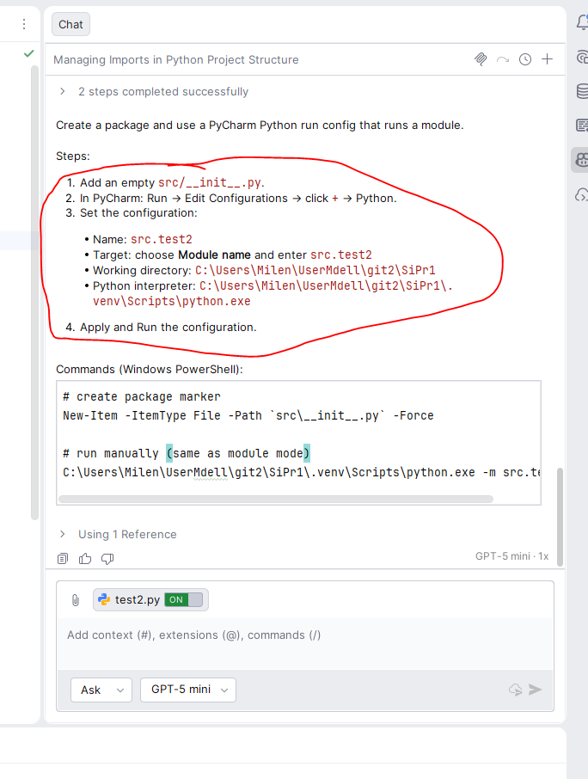

SUCCESS
test2.py has been run like a module and the relative import works.

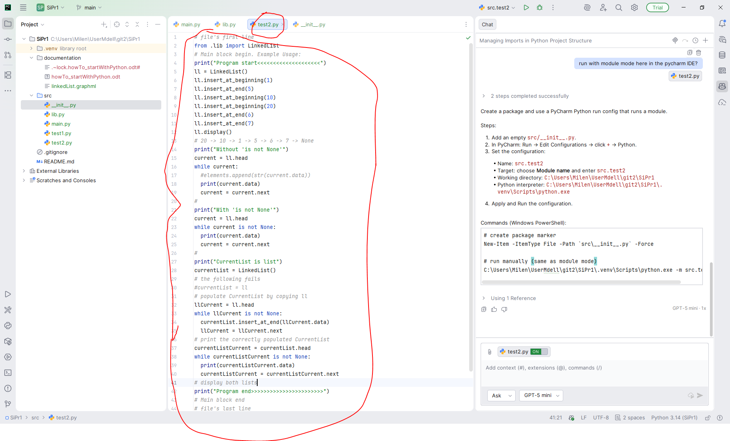
E
