NEWVALE SMART CITY INFRASTRUCTURE
Modular Assignment 8 | Deployment and Simulation Report
Md Habib Ahmed | IHC – Cloud Development | November 2026

Project summary
Newvale demonstrates two parts of a smart city system. An AWS lab accepts synthetic traffic and energy readings from simulated devices, validates them and stores them in Amazon S3. Local Python scripts forecast traffic and use those forecasts to estimate street lighting demand. A Streamlit dashboard presents the historical data, forecasts and demonstration alerts.
On 1,136 held-out synthetic observations, the traffic model achieved a mean absolute error of 10.80 vehicles per hour, compared with 13.82 for the same-hour-yesterday baseline. The adaptive lighting scenario estimated a 43.38% reduction in energy use for matched hours. The results describe the lab and the synthetic scenarios.
Stakeholders and requirements
Stakeholder | Need | Project response
Transport authority | Track traffic and flag likely congestion | Traffic forecast and configurable dashboard alert threshold
Energy provider | Explore lower street lighting energy use | Forecast-based dimming simulation against a fixed baseline
City council and IT | Review security, reliability and operating costs | Restricted cloud access, validation logs and a monthly cost model
Healthcare and waste teams | Plan for future telemetry sources | Proposed extensions with separate access and data governance
The lab prioritises authenticated access, encrypted storage and repeatable evaluation. A production deployment would need explicit latency and availability targets, real sensor trials, and retention and privacy requirements for each city service.

1. Architecture and data flow
The lab uses the NIST public-cloud deployment model. AWS supplies services offered for public use, with on-demand capacity, resource pooling and metered usage. AWS Europe (Stockholm), eu-north-1, hosts the ingestion path. MQTT, TLS and JSON keep the device contract portable. A workstation runs the simulation and analytics.
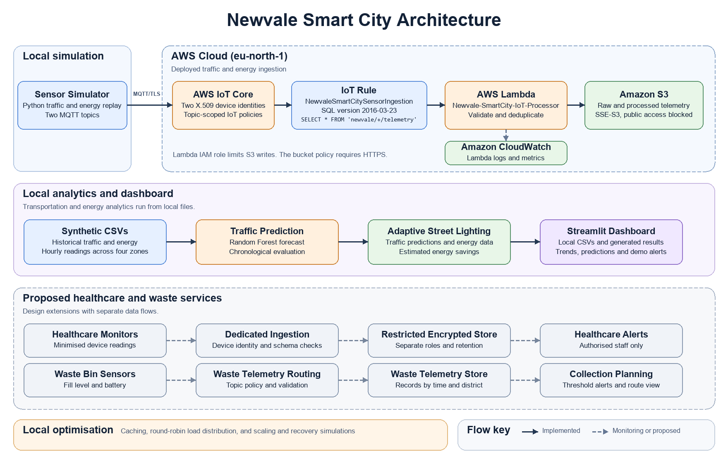
Figure 1. Verified Newvale AWS ingestion, local analytics and proposed city services.
AWS ingestion
Two Python MQTT clients represent the traffic and energy Things. Each authenticates with an X.509 certificate and sends JSON over TLS. The IoT rule invokes a Python 3.14 Lambda function, which validates the event and stores raw and processed JSON in a private S3 bucket. CloudWatch receives Lambda logs and metrics.
Local analytics
Two historical CSVs feed the local traffic model and lighting simulation. Streamlit reads local data and generated outputs for historical exploration and demonstration alerts. The lower diagram section shows proposed extensions.

2. Proposed services and reliability targets
Healthcare monitoring
Device certificates would identify monitors at a dedicated ingestion endpoint. A schema check would admit only approved measurements and a pseudonymous device identifier. A restricted encrypted store would separate healthcare data from city telemetry. Authorised healthcare staff would receive threshold alerts through an access-controlled view. Governance review would set retention, deletion and access auditing before collecting patient data.
Waste collection
Bin sensors would publish fill level, battery state and a device identifier to a dedicated topic. Validation would check the fill range and timestamp before storing district and time records. A collection planner would use fill thresholds to prioritise routes. City operations staff would receive access to district summaries.
Proposed pilot acceptance targets
Target | Proposed threshold | Validation method
Ingestion latency | p95 at or below 5 seconds | Measure send to durable storage in a bounded cloud pilot.
Ingestion availability | 99.9% monthly success | Run scheduled valid-event probes and verify both stored objects.
Worker recovery | Resume within 5 minutes | Interrupt a worker and confirm replay of unacknowledged events.
Regional disruption | RTO 60 min and RPO 15 min | Test recovery from a policy-approved replicated store and reconcile device sequences.
These are proposed design targets. The local tests use simulated time and cover queue scaling and retry after a partial write. For a larger pilot, use durable buffering and bounded retries, route repeatedly failing messages to a dead-letter queue, and alarm on backlog and errors. A regional recovery design requires a separate data-residency and cost review.

3. Deployment and verification
The simulator publishes two rows per device to newvale/traffic/telemetry and newvale/energy/telemetry. A read-only AWS console check on 10 November 2026 confirmed that NewvaleSmartCitySensorIngestion was active in Stockholm. It uses SQL version 2016-03-23 and SELECT * FROM 'newvale/+/telemetry', with one action targeting Newvale-SmartCity-IoT-Processor.
Validation and delivery
The handler checks the sensor type and parses the timestamp. It accepts a non-negative integer traffic count or a finite energy value from zero up to, but excluding, 1,000,000 kWh. It hashes the entire event as canonical JSON with SHA-256 and writes under raw-sensor-data and processed-data, grouped by sensor type.
The raw object holds the incoming event. The processed object adds the identifier, receipt time and validation status. S3 conditional writes preserve existing objects. An identical retry can complete a missing write. The handler reports a duplicate when both objects already exist. Changing sent_at_utc produces a new hash.
Check | Recorded observation | Evidence
Device identity | Both IoT Things show an active attached certificate. | M8-02
Valid telemetry | CloudWatch shows a successful sensor storage message. | M8-03
Invalid traffic | CloudWatch shows Invalid vehicle_count and a later successful storage message. | M8-08
Lambda metrics | 12 invocations, maximum concurrency of two and zero throttles in the capture. | M8-07
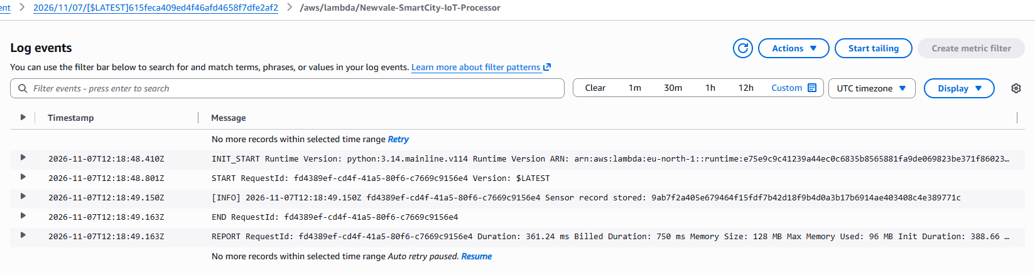
Figure 2. CloudWatch log showing a successful storage message (M8-03).
Offline checks of the supplied handler also exercised both sensor types, invalid inputs, duplicate delivery and a retry after a partial S3 write.

4. Traffic forecasting and model evaluation
The two synthetic datasets contain 5,760 records each. They represent hourly traffic counts and lighting energy for four zones from 1 August to 29 September 2026 in UTC. The analysis joins datasets on zone_id and timestamp_utc.
A Random Forest regressor uses zone, hour, weekday and observed traffic from one and 24 hours earlier. The chronological split follows lag creation and uses 4,528 training rows and 1,136 test rows. The test period begins on 18 September 2026 at 04:00 UTC. The baseline uses the observed count for the same hour the previous day.
Model | MAE | RMSE | R²
Same hour the previous day | 13.8248 | 18.0836 | 0.8397
Random Forest | 10.7985 | 14.0251 | 0.9036
MAE and RMSE are in vehicles per hour. The model reduced MAE by about 21.9% relative to the baseline. Evaluation uses observed lag values during the test period, so it represents one-hour-ahead forecasts with recent readings available. Field performance still needs validation.
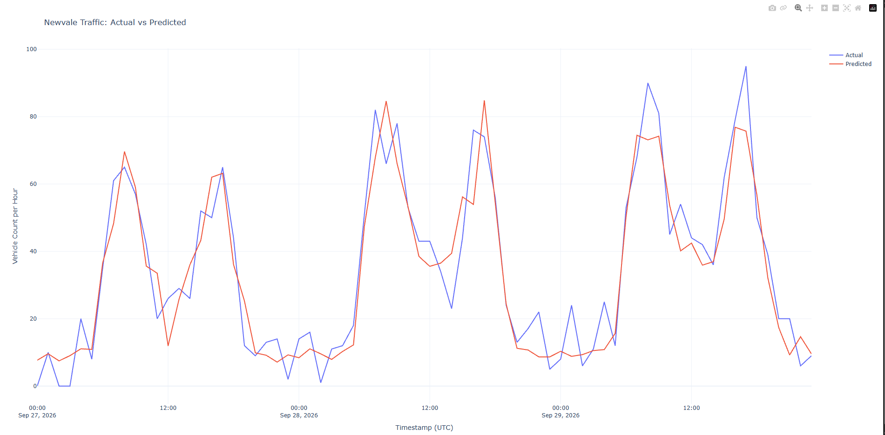
Figure 3. Actual and predicted hourly counts for the final 72 hours in zone Z01 (M8-04).

5. Adaptive lighting and resource optimisation
The lighting simulation joins the traffic forecast to the synthetic energy baseline across 1,136 matched hours and zones. For hours when lights are on, the scenario uses 40% brightness below 20 predicted vehicles per hour, 70% from 20 to below 60, and full brightness from 60 upward. It assumes energy use is proportional to brightness.
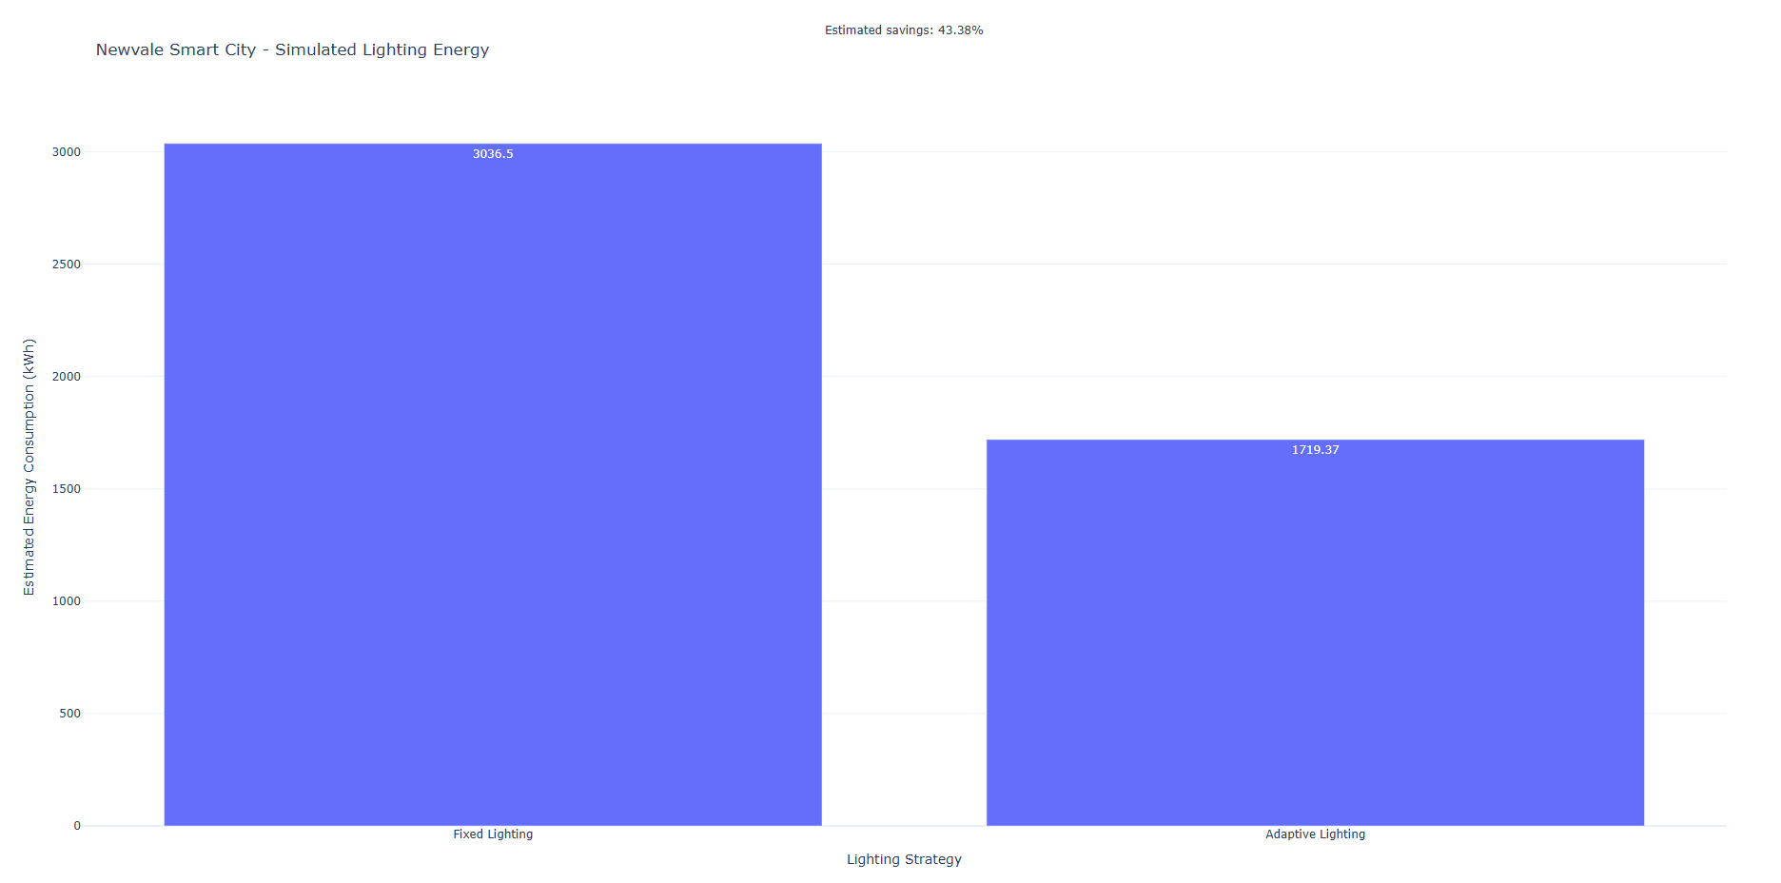
Figure 4. Fixed lighting baseline and simulated adaptive consumption (M8-05).
The scenario reduced estimated energy from 3,036.504 to 1,719.370 kWh, a difference of 1,317.134 kWh or 43.38%. A field trial would need to validate the energy model and minimum lighting levels before operational use.
Caching load distribution and scaling
The local cache test recorded 196 hits in 200 requests. The round-robin simulation distributed 100 requests to each of two workers. These results show reuse and even request assignment in the controlled workload. Lambda provides managed concurrency, with two concurrent executions observed in the lab. The capture gives no basis for a production capacity estimate.
Dashboard
The Streamlit app presents traffic and energy trends, forecast comparisons, the lighting scenario and a configurable congestion threshold. M8-06 shows a demonstration alert for zone Z04 with the threshold set to 20 vehicles per hour.

6. Scaling and recovery evaluation
The deterministic capacity model assigns one job per worker per tick from a first-in, first-out queue. Both policies receive the same arrivals. The steady run sends one job per tick for 20 ticks. The burst run sends six jobs per tick for eight ticks between two six-tick steady periods. The elastic policy starts with one worker, adds workers when pending jobs exceed two per worker, caps at six workers and returns to one after three ticks with an empty queue.
Workload and policy | Completed | Peak workers | Peak backlog | p95 ticks
Steady fixed | 20/20 | 1 | 0 | 1
Steady elastic | 20/20 | 1 | 0 | 1
Burst fixed | 60/60 | 1 | 40 | 41
Burst elastic | 60/60 | 6 | 5 | 2
Peak backlog counts jobs remaining after service. Completion time includes the service tick. The elastic burst used 98 available worker slots versus 60 for the fixed burst. This quantifies the trade-off between simulated delay and available capacity. Workers start immediately in the model, and ticks have no real-time duration.
Partial write and replay
The offline test ran the supplied Lambda handler against an in-memory S3 substitute. The first invocation wrote the raw object, then received an injected failure on the processed write. A second handler instance retried the identical event and completed the missing write. A further replay returned a duplicate response and left exactly one raw and one processed object. An invalid count was rejected without creating an object.
Run src/evaluate_scaling_recovery.py to reproduce the simulation and handler test. The results folder contains the summary and per-tick CSV trace. CloudWatch evidence M8-07 separately records a peak concurrency of two in the AWS lab.

7. Security controls and verification
Device certificates authenticate MQTT connections over TLS. Topic-scoped IoT policies limit publishing and a Lambda IAM role authorises S3 writes. The bucket configuration uses SSE-S3 and HTTPS-only access. The supplied S3 screenshot confirms Block Public Access, while the policy and encryption details come from the project configuration notes. Keep private keys outside the repository.
Threat | Control | Verification and limits
Device impersonation | Per-device X.509 credentials and TLS | M8-02 shows active attachments. An unauthorised connection was outside this validation.
Public data exposure | S3 Block Public Access and restricted IAM | M8-01 shows public access blocked. A denied IAM operation was outside this validation.
Invalid telemetry | Handler checks timestamp, type and measurement | M8-08 and the offline test show negative traffic validation.
Identical event replay | Payload hash and S3 conditional writes | Offline test verifies replay and partial-write recovery. A changed timestamp gives a new hash.
Stolen device key | Proposed rotation, revocation and alerting | Validate revocation and alarm delivery before the pilot.
Before collecting health data, the city would need to approve data purpose, retention, role-based access, deletion and incident response. This report documents technical controls and design decisions. A production compliance assessment would require policy review and operational evidence.

8. Observed and estimated costs
The Cost Explorer capture for 1–8 November 2026 displays approximately USD 0.00 for IoT, Lambda, S3 and CloudWatch after rounding (M8-09). The service totals cover the account during that period.
The 30-day Stockholm estimate assumes 100 continuously connected sensors, each sending one message every five minutes. It uses 864,000 billable messages with one rule, one action and one Lambda invocation per message. The model uses AWS regional on-demand USD rates checked on 10 November 2026, before credits or free tier allowances.
Charge | Usage and assumed unit rate | USD
IoT connectivity | 4.32M minutes × $0.096 per million | 0.415
IoT messages and rules | 0.864M each × ($1.20 + $0.18 + $0.18) per million | 1.348
Lambda invocations | 0.864M × $0.20 per million | 0.173
Lambda duration | 32,400 GB-s × $0.0000166667 (x86, 128 MB, 0.30 s) | 0.540
S3 writes and storage | 1.728M PUTs × $0.005 per 1,000 plus 1.728 GB × $0.023 | 8.680
CloudWatch ingestion | 0.864 GB × $0.54 per GB (Standard vended logs) | 0.467
Estimated total | Sum before credits and taxes | 11.62
The model assumes 1 KB per stored object and per invocation’s logs, and uses the month-end S3 volume as a full-month storage allowance. It excludes retries, reads, log retention, egress and taxes. The same inputs give USD 5.81 for 50 sensors and USD 23.24 for 200. S3 requests contribute about 74% of the base estimate.
The repository file results/stockholm_cost_model.json records the AWS catalogue versions, item codes, rates and calculations. Actual charges depend on the workload and account allowances.
Evidence and reproduction details are indexed in the accompanying README.md.
Cloud model reference NIST SP 800-145 https://csrc.nist.gov/pubs/sp/800/145/final
GitHub repository https://github.com/mdhabibhameedi/cloud-based-smartcity-m8

