LOGISTICS DELAY PREDICTION
Modular Assignment 6 | AI/ML Solution
Md Habib Ahmed | IHC – Cloud Development | November 2026

1. Objective and scope
The project developed and validated a cloud-supported machine learning solution for estimating shipment delivery delays. It combines shipment and weather datasets, Python feature engineering, comparative regression evaluation, Amazon S3, managed Amazon SageMaker training and real-time inference, and Amazon CloudWatch monitoring. The implementation was performed in AWS Stockholm (eu-north-1), with evidence captured at each key stage.

2. Architecture and deployment
Shipment and Open-Meteo weather data were merged and prepared locally before the processed dataset was uploaded to Amazon S3. SageMaker used the S3 training input to train a Random Forest regression model and produce archived model artifacts. A temporary SageMaker endpoint served a successful prediction, while CloudWatch recorded execution logs. The SageMaker execution role supported access to required resources. The hosted endpoint was deleted after validation to avoid recurring charges.
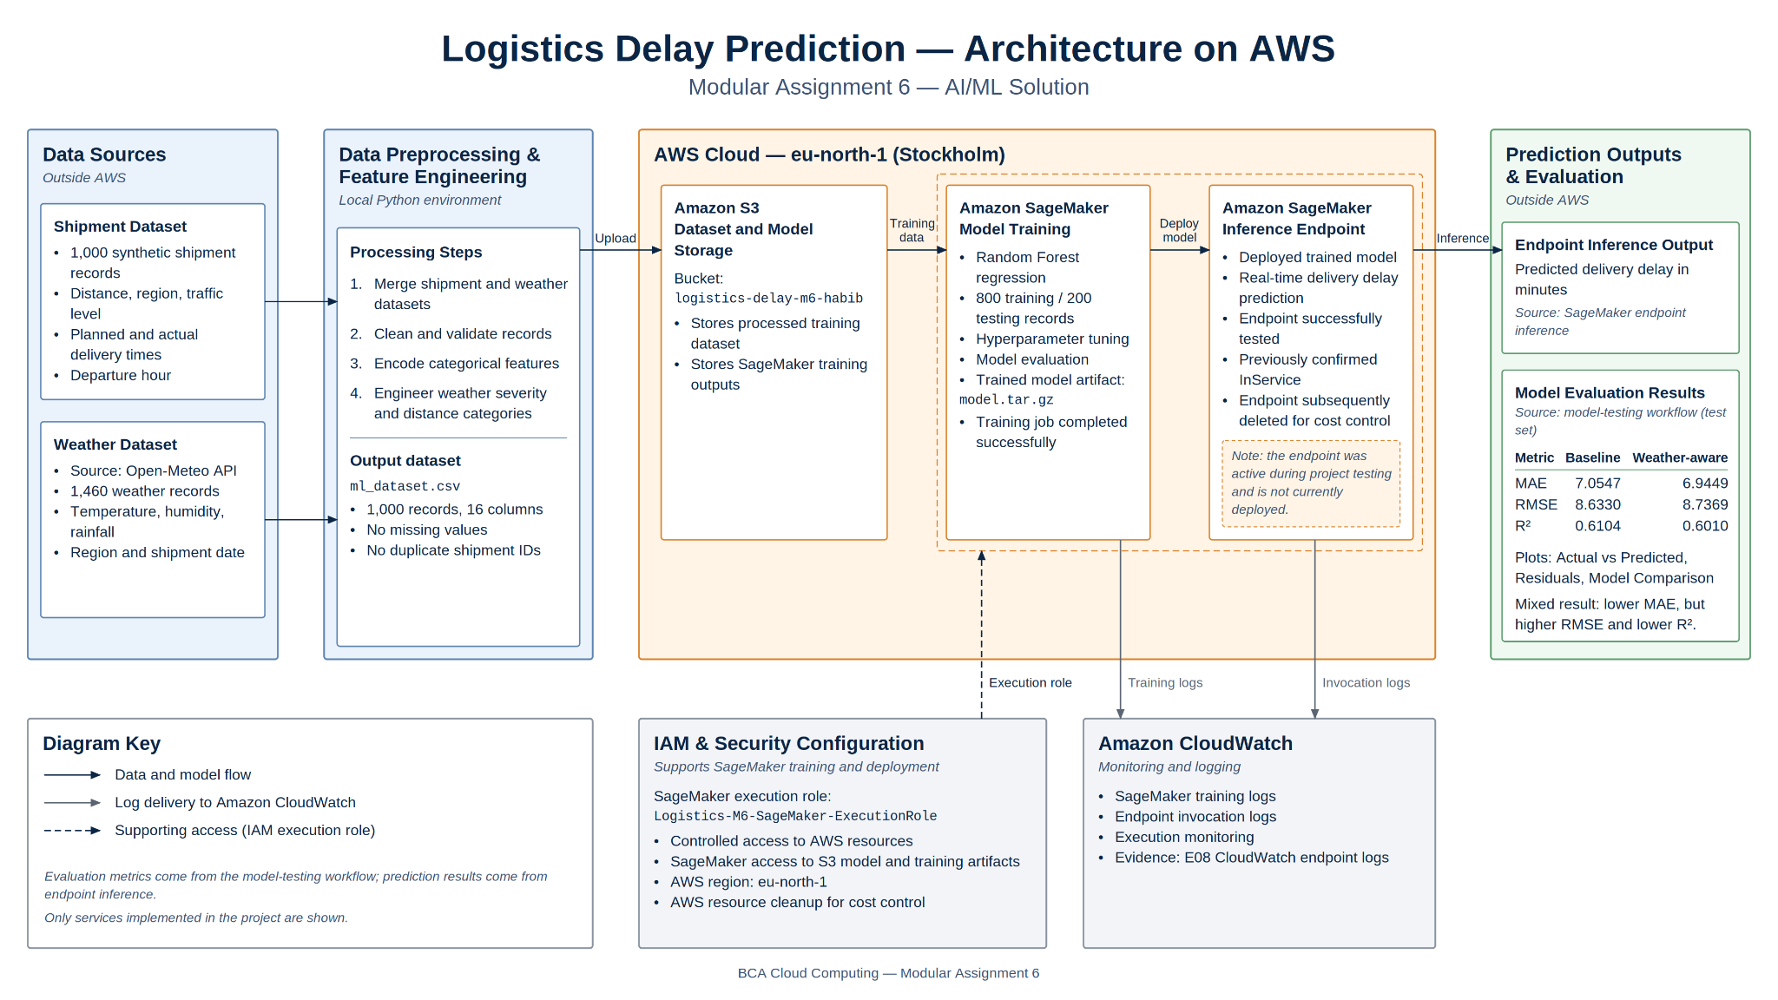
Figure 1. Logistics Delay Prediction architecture: preprocessing, S3, SageMaker, IAM and CloudWatch.

3. Datasets and preprocessing
The shipment dataset contains 1,000 synthetic records, including region, distance, traffic conditions, departure hour and planned versus actual delivery times. Weather data from Open-Meteo comprise 1,460 observations with temperature, humidity and rainfall. These were matched by region and date, checked for integrity, and enriched with weather severity, distance categories and encoded traffic features. The final ml_dataset.csv has 1,000 rows and 16 columns, with no missing values or duplicate shipment IDs. Shipment delays are simulated for this academic experiment, not real carrier outcomes.
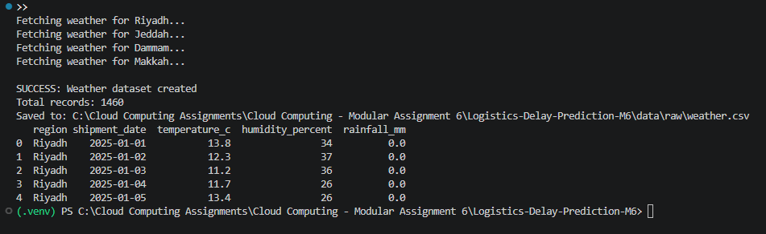
Figure 2. E01 — Weather API integration evidence.

4. Machine learning method and performance
The dataset was divided into 800 training records and 200 test records. The baseline model excluded weather variables; the weather-aware Random Forest included region, distance, traffic level, departure hour, planned delivery minutes, temperature, humidity and rainfall. Selected weather-aware hyperparameters were 200 trees, maximum depth 8 and minimum leaf size 3. Model accuracy was assessed using MAE, RMSE and R² on held-out test data.
Metric | Baseline | Weather-aware
MAE (minutes) | 7.0547 | 6.9449
RMSE (minutes) | 8.6330 | 8.7369
R² | 0.6104 | 0.6010
The weather-aware model reduced MAE slightly, from 7.0547 to 6.9449 minutes, whereas the baseline had lower RMSE and higher R². The results therefore indicate a mixed comparison, not uniform improvement. Three supporting charts—actual versus predicted, residuals, and model comparison—are preserved in docs/plots/ of the accompanying project.
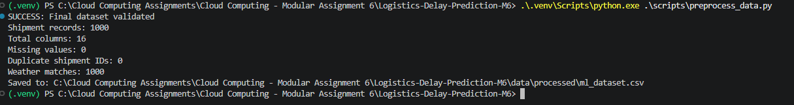
Figure 3. E03 — Processed dataset verification.

5. SageMaker training and model artifacts
The processed dataset was uploaded to S3 bucket logistics-delay-m6-habib. The managed training job logistics-delay-m6-training-2026-10-29-11-22-38-826 completed using an ml.m5.large instance and the Logistics-M6-SageMaker-ExecutionRole. The resulting model.tar.gz and output.tar.gz archives were downloaded and validated locally. The S3 bucket remains retained pending final submission packaging.
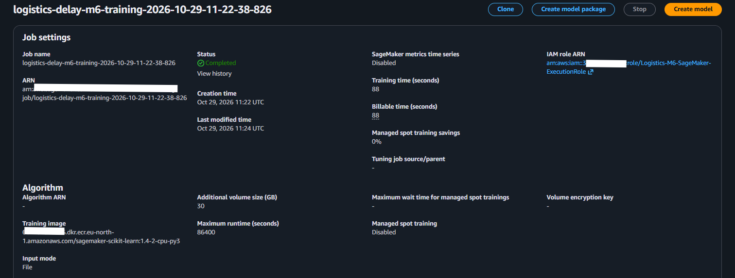
Figure 4. E05 — Completed managed SageMaker training job.

6. Endpoint testing and monitoring
The trained model was hosted temporarily at logistics-delay-m6-endpoint. The endpoint reached InService and successfully returned a delivery-delay prediction. CloudWatch endpoint logs were inspected and captured as execution evidence. After testing, the endpoint, endpoint configuration and hosted SageMaker model were removed; the endpoint is no longer available for live invocation. Local notebook validation separately confirmed a model inference prediction of approximately 46.47 minutes.
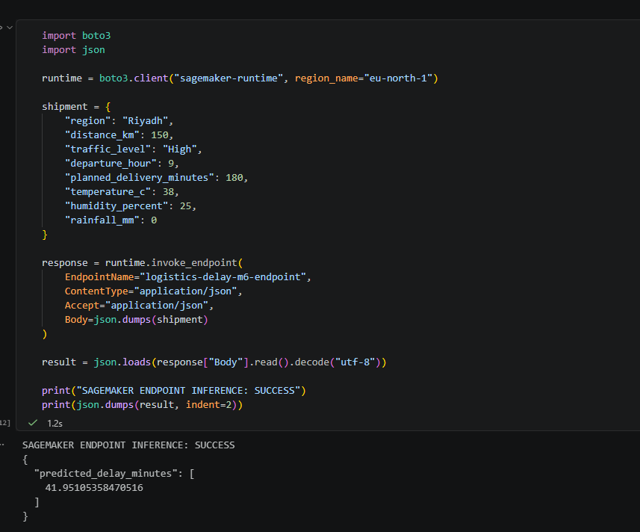
Figure 5. E07 — Successful SageMaker endpoint inference test.
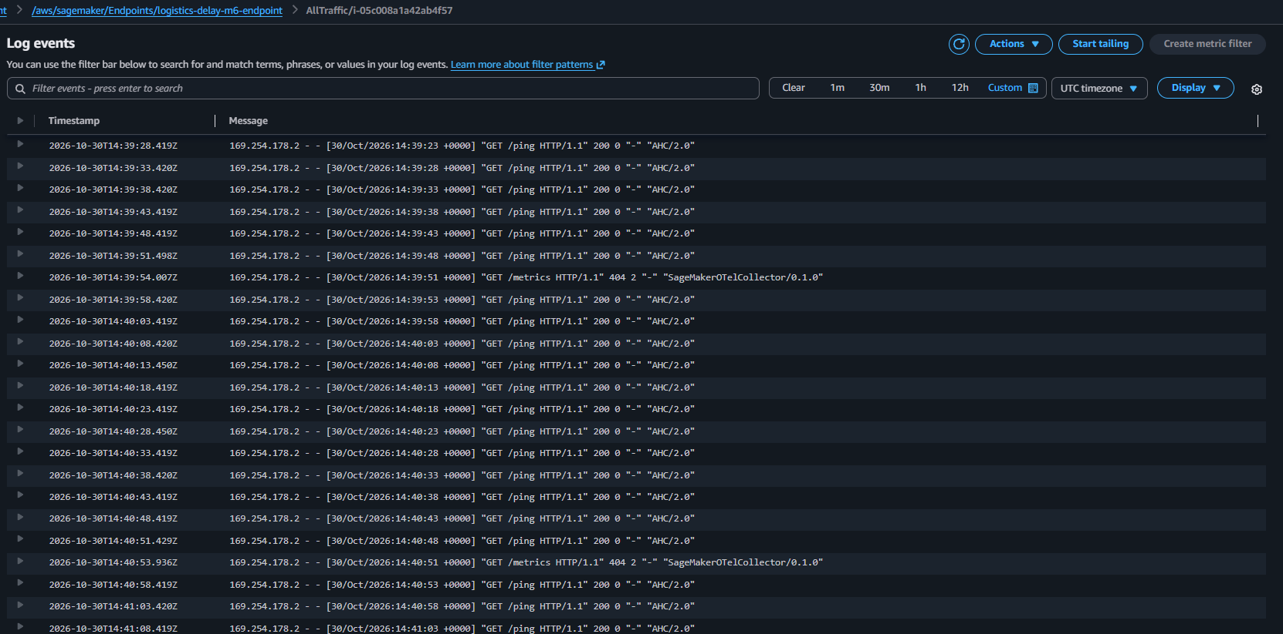
Figure 6. E08 — CloudWatch endpoint execution logs.

7. Verification and reproducibility
The dataset integrity test passed (1,000 rows, 16 columns, no missing values, no duplicate shipment IDs). The reviewed notebook also passed local inference, evaluation-metric and plot-file checks, and archive-integrity tests for both SageMaker tarballs. The repository contains raw and processed datasets, Python preparation and training scripts, SageMaker training/inference source, saved model files, a reviewed notebook, the architecture diagram, and eight evidence screenshots E01–E08. The notebook documents historical cloud execution rather than recreating a live endpoint.

8. Security and cost management
SageMaker training and deployment used the project execution IAM role to access the necessary cloud resources. Under the shared-responsibility model, AWS manages underlying managed-service infrastructure while the project operator controls permissions, datasets, deployment configuration and cleanup. The Git configuration excludes local environment and secret files. Specific unverified encryption or network settings are not claimed. Time-bounded training and removal of hosted inference resources limited continuing costs; retained S3 objects should be reviewed after submission.

9. Conclusion and submission evidence
The experiment demonstrated an end-to-end AI/ML workflow: weather integration, feature preparation, comparative model evaluation, completed SageMaker training, successful real-time endpoint inference, CloudWatch monitoring, and resource cleanup. The archived evidence and artifacts support independent review of the implementation. Project documentation and supporting files are organized in README.md, docs/diagrams/, docs/evidence/, docs/plots/, data/, models/, scripts/ and deployment/ of the accompanying repository.

