NFL MVP Site Plan

Owen Heap

WDD 130

Overview

Purpose
To explain why Justin Herbert should win the MVP award in the NFL in the 2025 season

Audience
Sports fans that are interested in the NFL

Branding

Website Logo


Style Guide

Color Palette
Primary | Secondary | Accent 1 | Accent 2
Powder Blue: #0073CF | Sunshine Gold: #FFC20E | Navy Blue: #002244 | White Smoke: #F5F5F5



Typography

Heading Font: Impact

Paragraph Font: Roboto

Navigation
Home Page View The Analytics Understand the Context

Home page paragraph:
Justin Herbert deserves the NFL MVP award this season for his elite statistical production and undeniable influence on a playoff-bound Los Angeles Chargers team. Through the first ten weeks, he ranks second in the entire league in passing yards (2,610) and is tied for third in touchdown passes (19), all while showcasing an underrated dual-threat ability by leading all quarterbacks with 324 rushing yards. He is a primary reason the Chargers hold a strong 7-3 record and a coveted Wild Card spot in the deep AFC conference, proving he has fully developed into a franchise centerpiece whose consistent, high-level performance is directly translating into crucial team success.


Title: View the analytics paragraph
A deeper dive into advanced metrics reveals why Herbert is not just a high-volume passer, but truly the league's Most Valuable Player. He is operating behind an offensive line that has been consistently decimated by injuries, resulting in him being pressured an astonishing 173 times—significantly more than any other quarterback in the league. Despite this constant duress and the challenge of having to throw or scramble quickly, Herbert has still managed to maintain an elite Pro Football Focus (PFF) grade of 91.8, ranking him among the very top signal-callers. This disparity between his poor protection and his top-tier output is the clearest analytical argument that he is doing "a lot with a little."
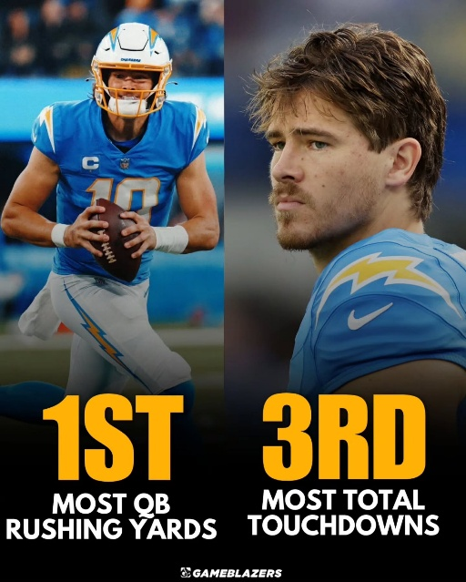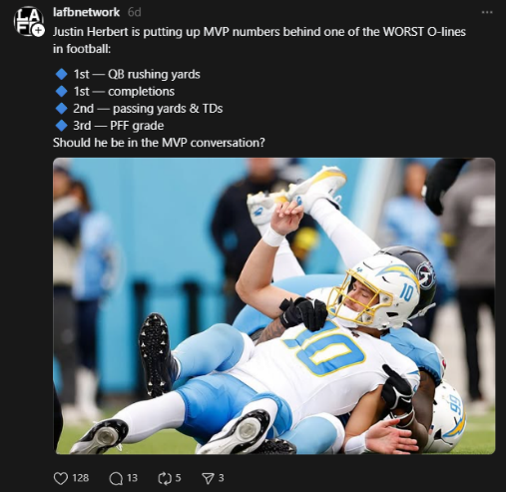
Pic #1 explanation: Justin Herbert's MVP case is significantly boosted by his decision to expand his game as a legitimate running threat, effectively neutralizing the intense pressure he constantly faces. He is currently leading all quarterbacks in rushing yards (over 300 yards through the first nine weeks of the season), frequently turning busted plays or coverage sacks into crucial gains and first downs. This newfound athleticism and willingness to run for yardage adds a critical, high-value dimension to the Chargers' offense and demonstrates his commitment to doing whatever it takes to win, cementing his value to the team.
Pic #2 explanation:
Justin Herbert is the central pillar of a highly pass-dependent offense, shouldering the load for a team with notably limited consistency in its rushing attack. By Week 13, the Chargers were among the league leaders in pass attempts, demonstrating the team's reliance on his arm to generate virtually all of their offensive production and maintain competitiveness. This extreme passing volume further highlights his exceptional value, as he must deliver elite statistical output without the benefit of a dominant ground game to alleviate pressure or dictate defensive schemes.

Title: Understand the context
What truly elevates Herbert’s candidacy is the severely disadvantaged context in which he is operating. The Chargers have been forced to start backup and reserve tackles following season-ending injuries to stars like Rashawn Slater and Joe Alt, transforming the offensive line into the most bruised and battered unit in the NFL. Furthermore, the team has had to adjust its offensive scheme under a new coordinator, yet Herbert has continued to deliver, posting career-low times to throw and utilizing quick passes and scrambles to neutralize ferocious pass-rushes. His ability to elevate a hampered offense and single-handedly keep the Chargers competitive in the AFC makes him the player who provides the most value to his team's success in the entire league.
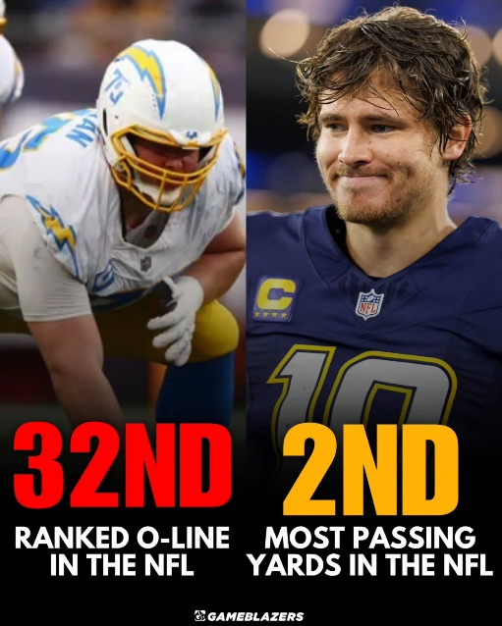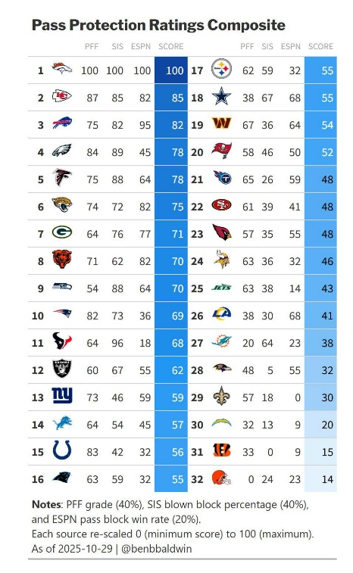
Pic #1 explanation: Justin Herbert is consistently playing behind an offensive line that is arguably the worst in the entire NFL right now, evidenced by the fact that the Chargers have allowed the second-most pressures in the league. This disastrous protection forces Herbert to operate in chaos, demanding immediate decisions and pinpoint accuracy while constantly facing contact—a job that is exponentially more difficult than for his MVP competitors.
Pic #2 explanation: While Justin Herbert navigates one of the league's most injured and poorly graded offensive lines, his primary MVP rivals like Matthew Stafford and Drake Maye benefit from vastly superior protection. These top contenders are operating behind units that rank among the NFL's best in pass-blocking efficiency, affording them the clean pockets and extra time needed to comfortably execute long-developing plays.

Wireframes

