I have designed the 9inch bell tower only with the image. I have learned the design software to the next level and I get to know some design tools in software and how to use it efficiently also scale down approach.

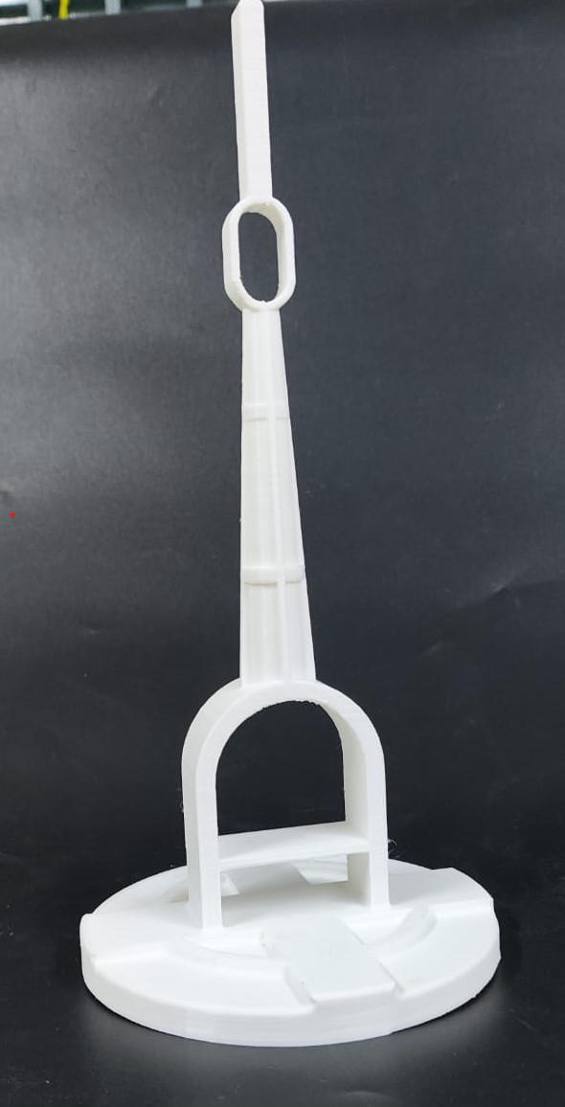

I rebuilt it and made some changes. I have changed the shape of the bell ring and I placed the shaft to hook up the bell.

