A GUIDE TO THE “HOME-PERSONALISED” ANDROID TV LAUNCHER
Home-Personalised: Your TV, Your Way
How I replaced a cluttered Android TV home screen with one page of my own: a character who reacts to the remote, a black-and-white favourites line-up that opens each show directly, and a kids section. It is open source, plain Java with no libraries, and everything you would change lives in one file. Each part below is a short guide followed by what to run or paste.
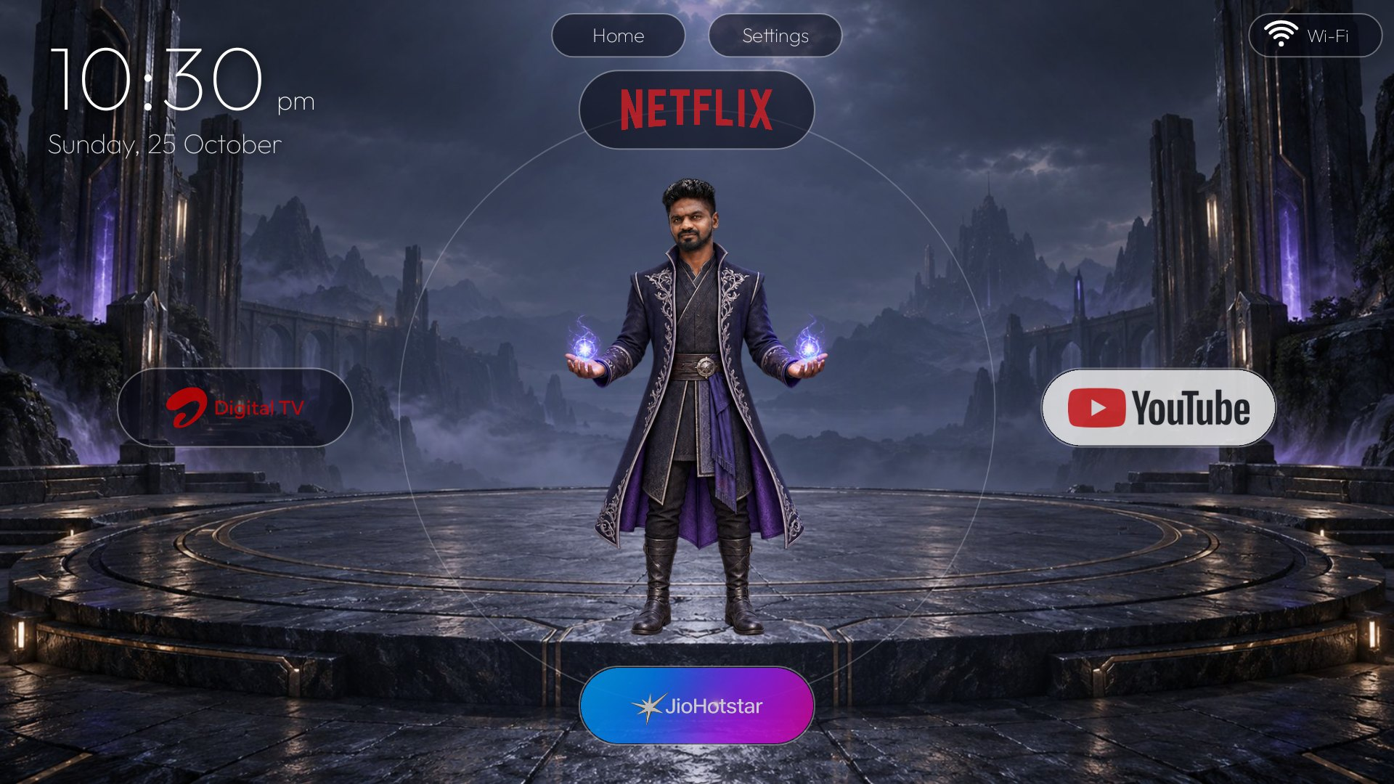
The home screen at the end of this guide.

The route
- Before you start
- Get the code
- Build and install
- Make it your default home
- Section 1: the radial home
- Section 2: My Favourites
- Section 3: Kids
- Make it yours
- Finish up and undo

GitHub
Repository: https://github.com/mdharoonh/tv-clutter-personalized
Licence: MIT for the code. Copyright (c) 2026 Haroon Haneef (mdharoonharoonhaneef@gmail.com). The logos and show art in the repo are only there to show how it looks. They belong to their owners: replace them with your own.

1. Before you start
- An Android TV or Google TV (tested on a MediaTek TV running Android 11, 1920x1080).
- A computer on the same Wi-Fi as the TV, with Android Studio or the Android SDK, JDK 17 and adb.
- Developer mode on the TV. Settings → Device Preferences → About → press OK on “Build” seven times. Then in Developer options turn on USB debugging and Network/ADB debugging. When the computer first connects, the TV asks “Allow USB debugging?”. Say yes.
- Claude Code (optional). It can run every step below for you, including the debloat, and it is how this project was built.
- Your own artwork if you want to personalise it. See “Make it yours”.

2. Get the code
RUN · CLONE
git clone https://github.com/mdharoonh/tv-clutter-personalized.git
cd tv-clutter-personalized

Layout: app/src/main/java holds seven small classes, app/src/main/assets holds config.json and all the art, docs/ holds the TV setup guide, and tools/preview.py renders layout previews on a PC.

3. Build and install
- Connect the TV: adb connect <tv-ip>:5555 (find the IP in the TV’s network settings).
- Create local.properties in the project folder with your SDK path, using forward slashes.
- Build and install.
RUN · BUILD
sdk.dir=C:/Users/you/AppData/Local/Android/Sdk (inside local.properties)

./gradlew assembleDebug
adb install -r app/build/outputs/apk/debug/app-debug.apk
adb shell am start -n com.rabbit.tvhome/.HomeActivity

At this point it runs as an ordinary app. Controls: the D-pad moves the selection, OK opens, Back deselects or returns to section 1, and Down or Up at the edge of a section scrolls to the next page.

4. Make it your default home
Android TV picks the Home app by filter priority. The stock launcher has priority 2 and the setup wizard has priority 1. A normal app has 0 and cannot raise it, so the “default home” setting is ignored until those two are switched off. The shell can only disable whole packages, not single components. Everything uses pm disable-user, which is fully reversible. Nothing is uninstalled.
RUN · MAKE DEFAULT (Google TV package names; check yours first)
# see what handles Home on your TV
adb shell pm query-activities --brief -a android.intent.action.MAIN -c android.intent.category.HOME

adb shell pm disable-user --user 0 com.google.android.apps.tv.launcherx
adb shell pm disable-user --user 0 com.google.android.tungsten.setupwraith
adb shell cmd role add-role-holder --user 0 android.app.role.HOME com.rabbit.tvhome
adb shell cmd package set-home-activity com.rabbit.tvhome/.HomeActivity
adb shell input keyevent 3

Side effect: voice search and the stock recommendation rows live in the stock launcher and will not appear. Optional: you can also disable vendor apps you never use. Only disable what you recognise, and keep a list so you can undo it.

5. Section 1: the radial home
A character stands in the middle with four tiles around them. Move the remote and the character changes pose while the body stays put, so only the arms seem to move. Up is Netflix, Left is an HDMI input, Right is YouTube and Down is JioHotstar. The top bar has Home, Settings and Wi-Fi, and there is a big clock with the day and date at the top left. Back returns the character to idle. The first Down selects the bottom tile and the next Down scrolls to Favourites.
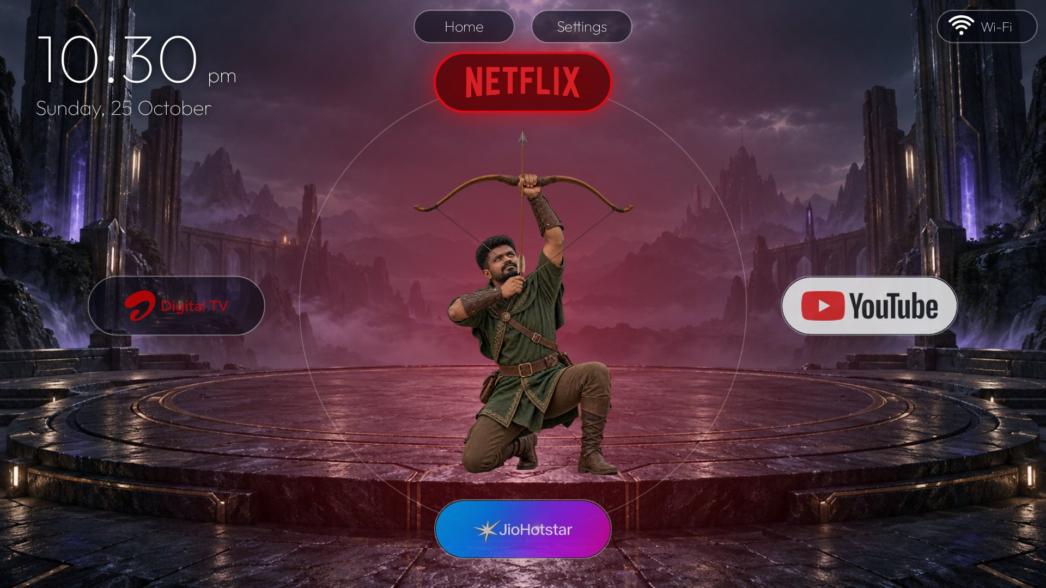 | 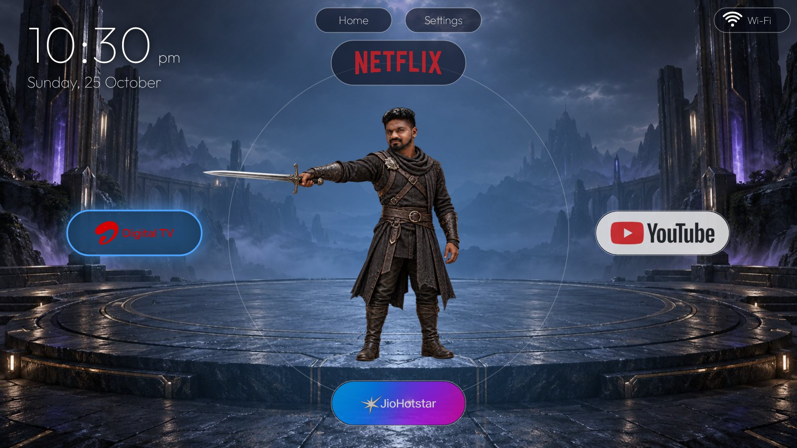
Up: Netflix | Left: HDMI input
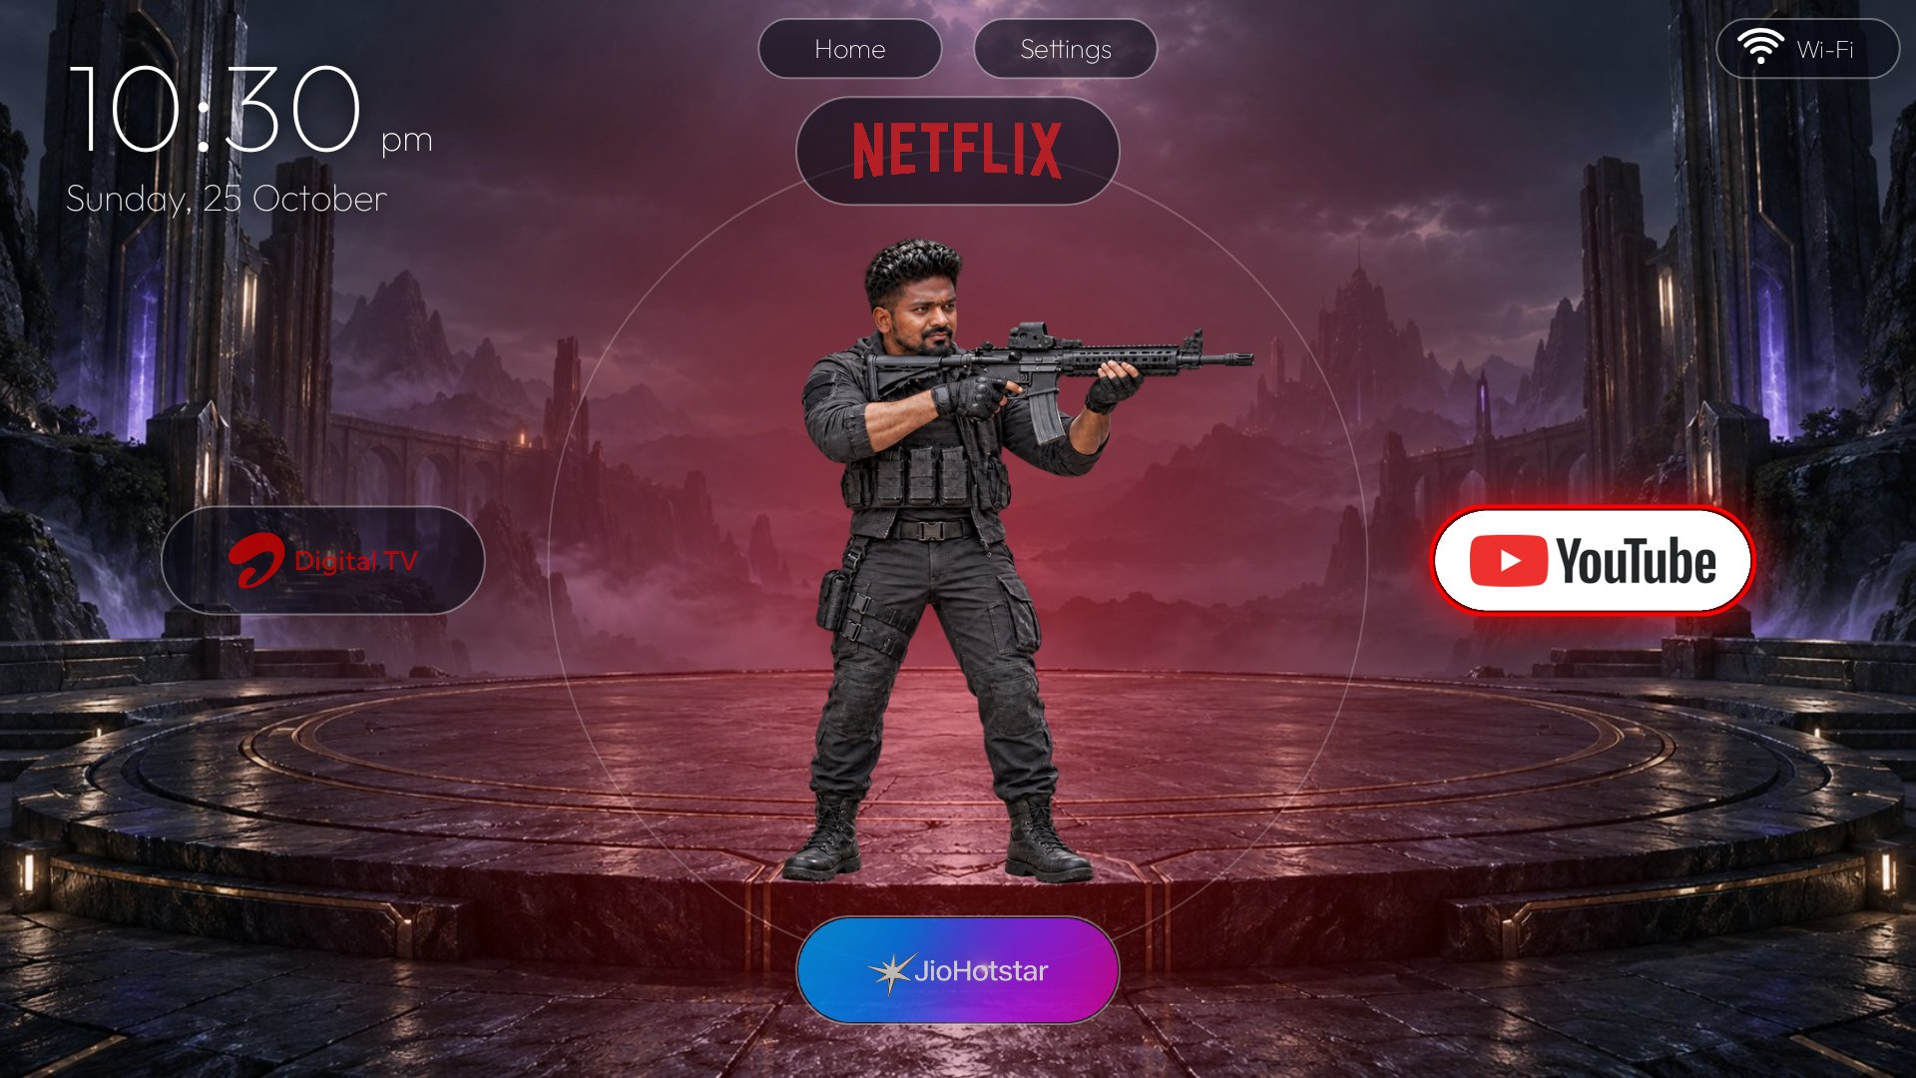 | 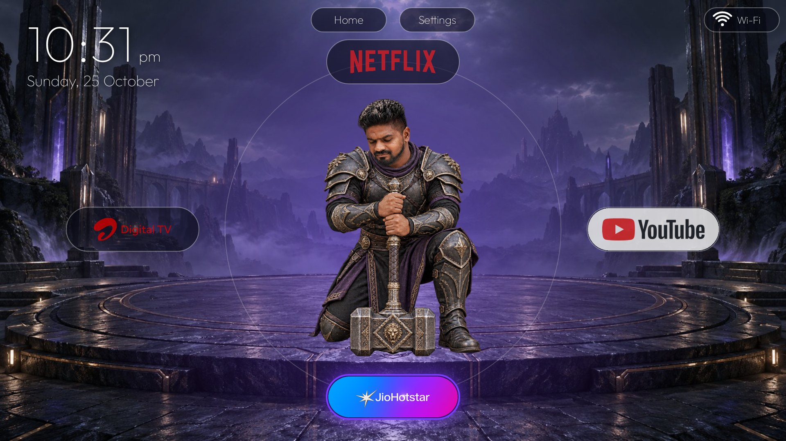
Right: YouTube | Down: JioHotstar

Change what each tile does in config.json under “radial”: a tile is either an app (by package name) or an HDMI port.

6. Section 2: My Favourites
A line-up of characters from your favourite shows, all in black and white. Move to one and they turn to colour, step forward and glow, a dark scene from the show fades in behind, the title and the streaming app’s logo appear above, and OK opens that show directly in its app.
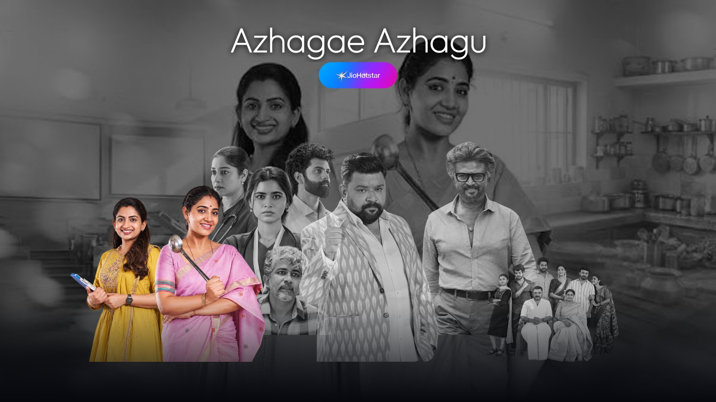 | 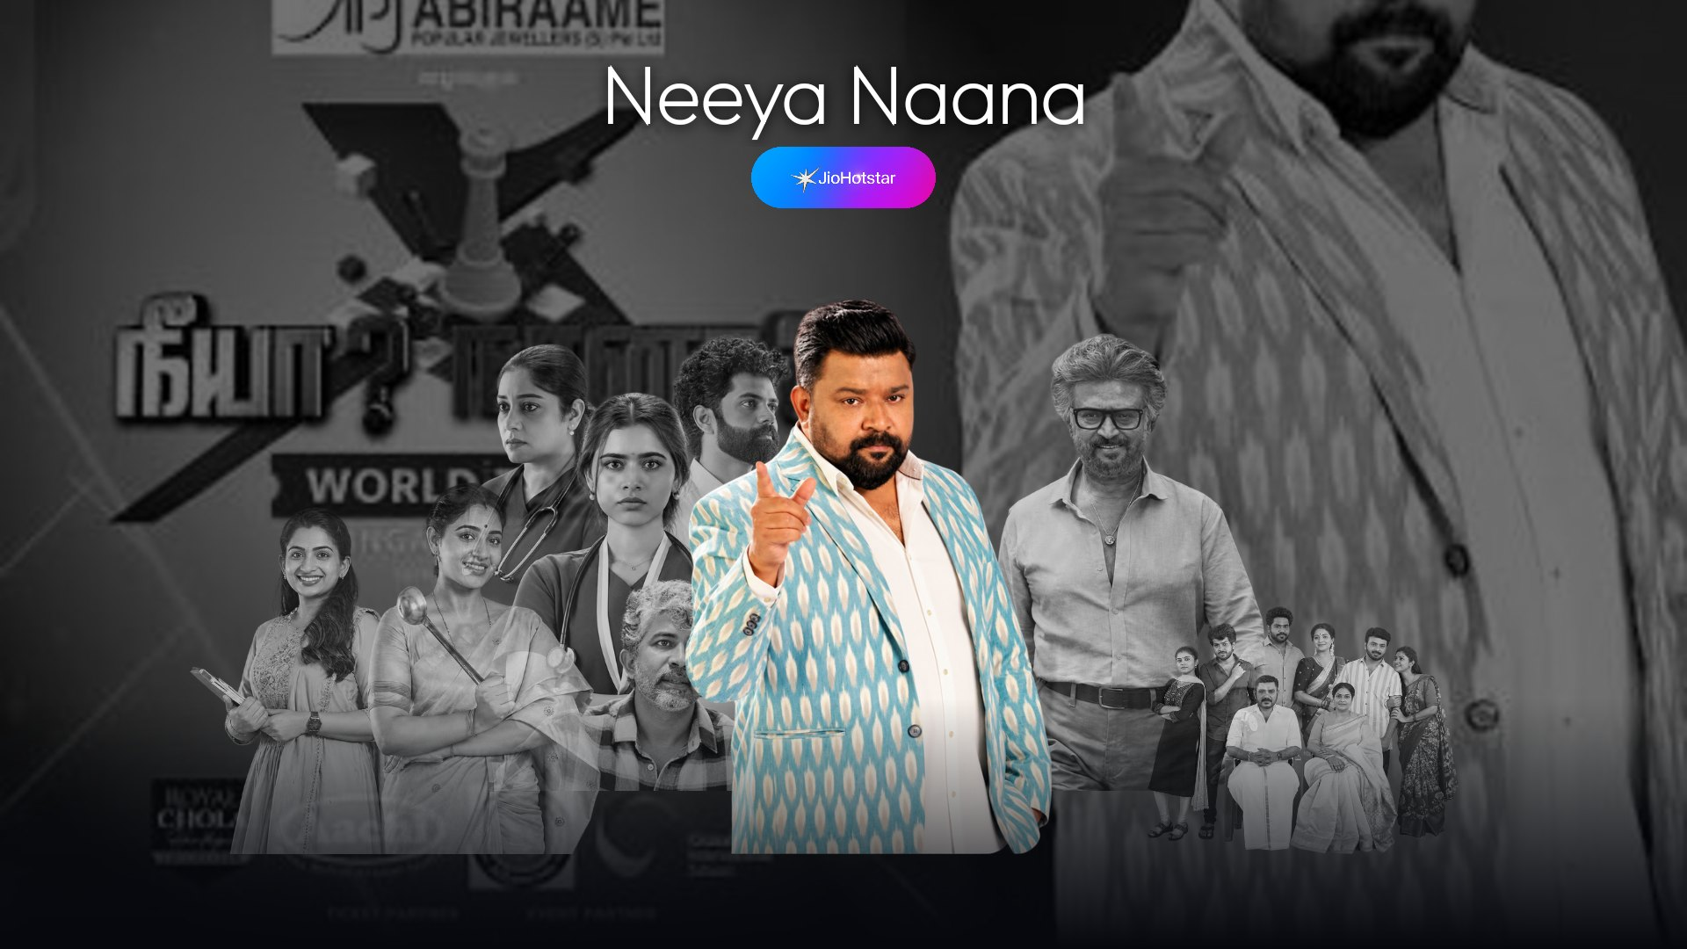
Azhagae Azhagu | Neeya Naana
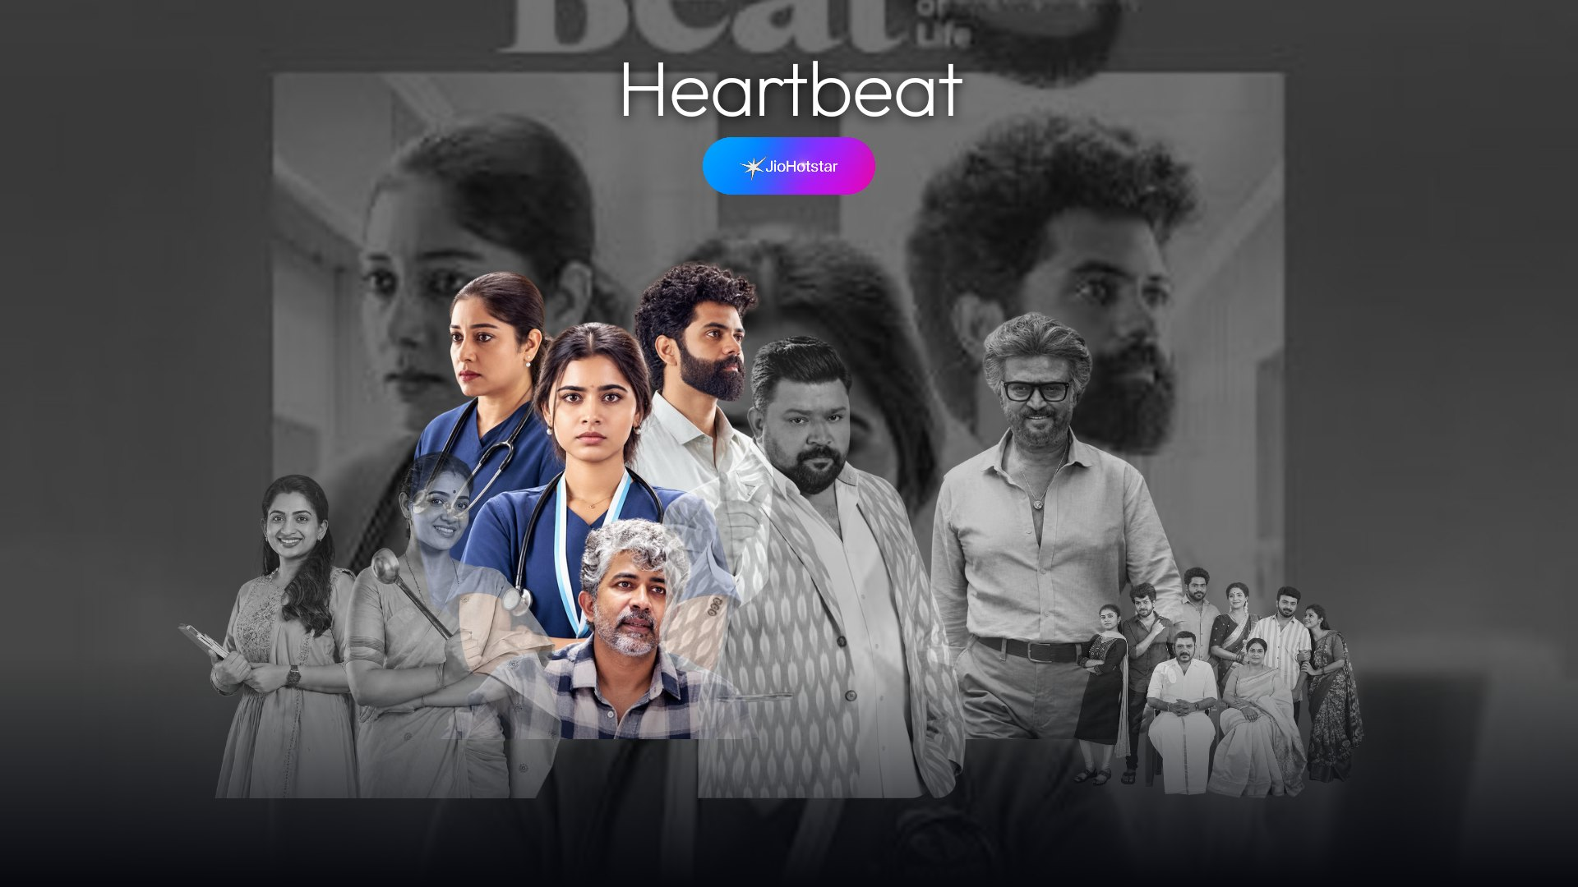 | 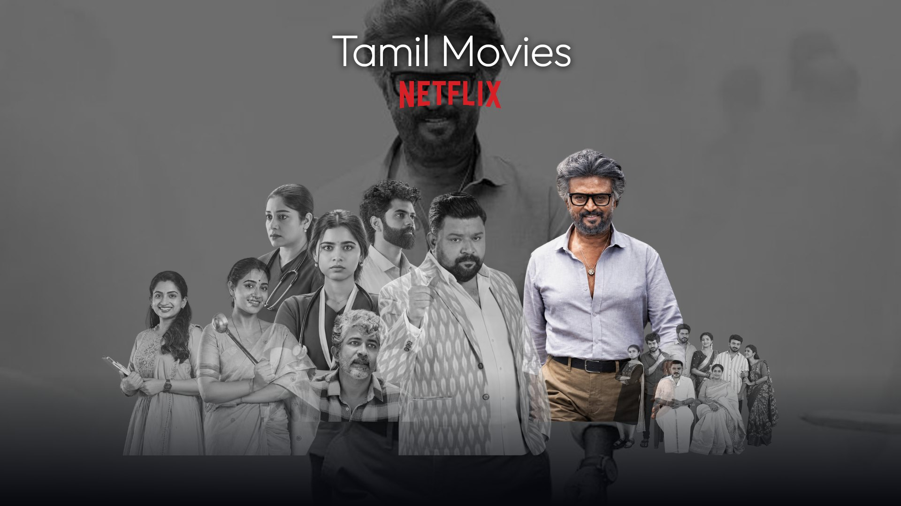
Heartbeat | Tamil Movies (Netflix)

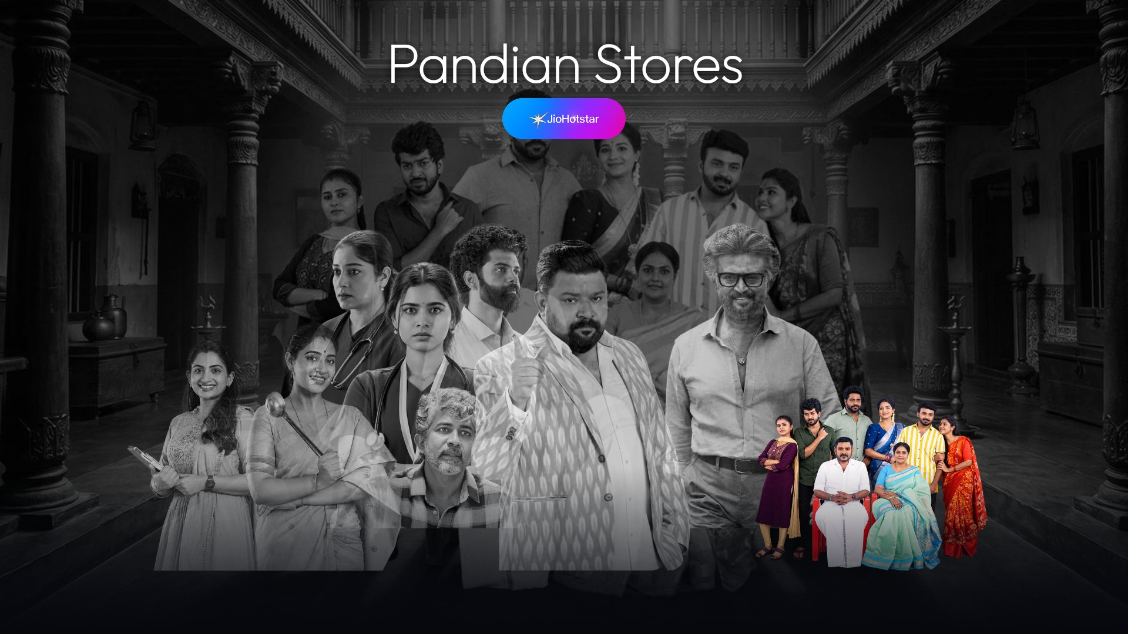
Pandian Stores

How the deep links work
- Each favourite has a normal https link in config.json. The launcher opens it with the chosen app, and if the app does not take the link it opens the app normally.
- JioHotstar opens the show page. On a cold start it first shows “Who’s watching?”; after you pick a profile it continues to the show. Once it is running, links go straight to the show.
- Netflix opens genre pages, not single titles, so use Netflix for a category.
- Test each link on your own TV before you trust it.

7. Section 3: Kids
A “Little Adventures” scene with four worlds. Pick one and OK opens its YouTube playlist or channel in the YouTube TV app. The links in the repo are placeholder searches: replace them with your own playlists.
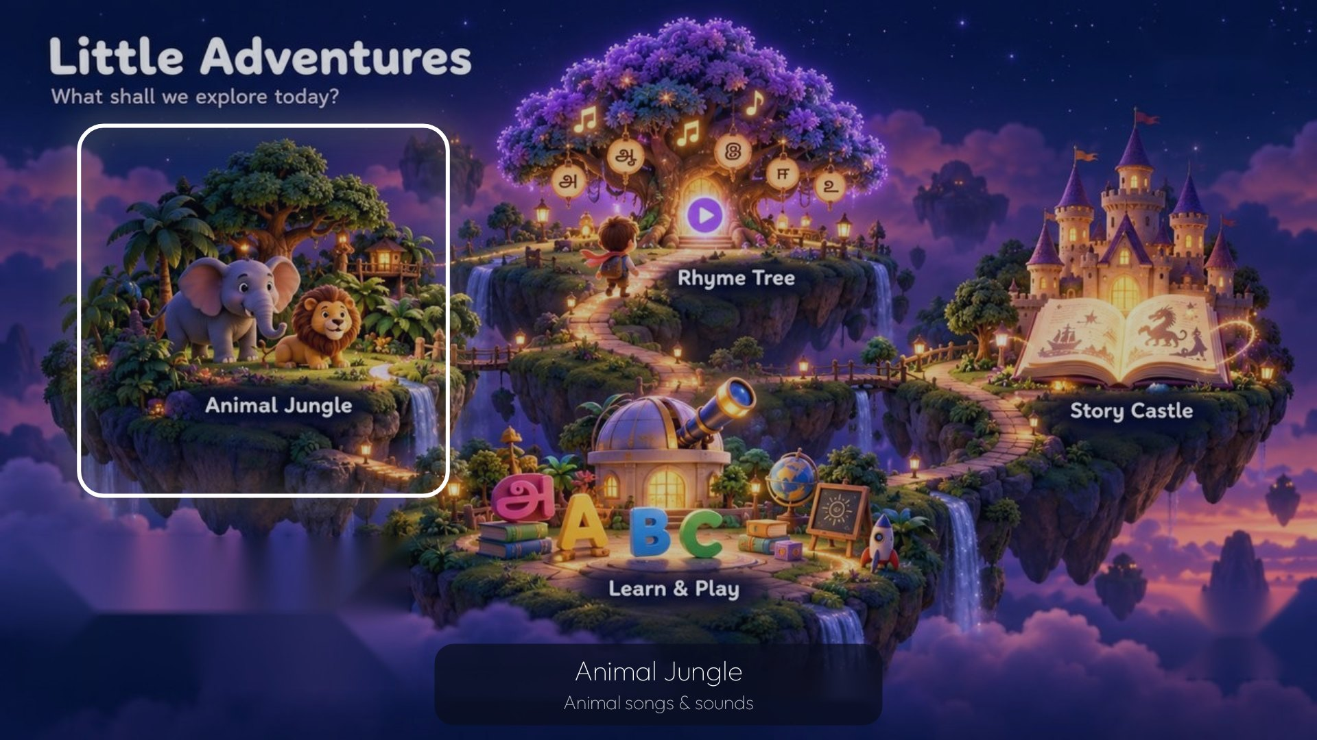 | 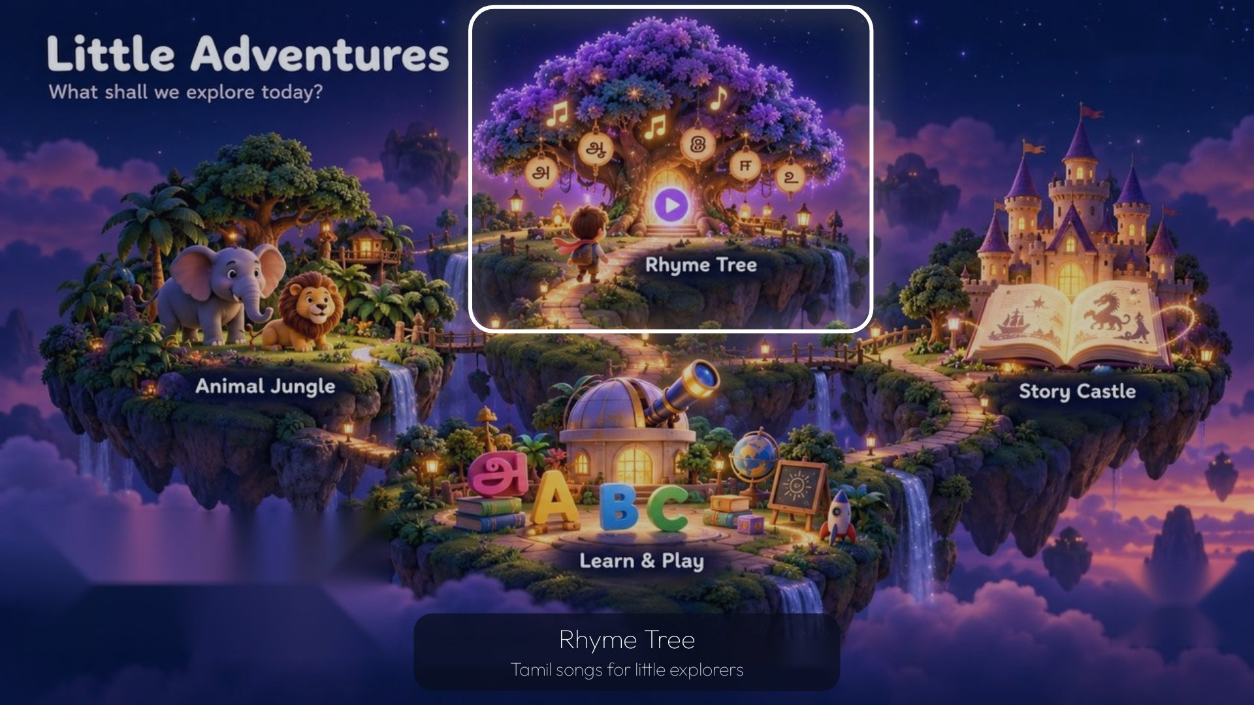
Rhyme Tree selected | Next world selected

8. Make it yours
Everything personal is in app/src/main/assets/config.json plus the images next to it.
Section of config.json | What it controls
apps | The streaming apps: label, Android package names, logo, brand colour.
radial | What the up, left, right and down tiles open (app or HDMI) and the five pose images.
favourites | Per show: title, app, link, colour, cut-out, scene, and its place in the line-up (x, y, w, h as fractions; row front or back).
kids.worlds | Four titles with a YouTube link and a position on the scene.

Assets to replace
Folder | What goes there | Size and format
radial/ | bg.jpg plus idle, up, left, right, down poses of your character | Background 1920x1080. Poses: transparent PNG, same canvas size, feet on the bottom edge.
logos/ | One logo per app tile | Transparent PNG, about 900x300. Filled “pill” logos set logoFill true.
fav/ | One cut-out per favourite | Transparent PNG, at least 1500 px tall.
scenes/ | One scene per favourite, ideally a place without people | 16:9, at least 1280 wide. The TV makes it black and white and darkens it.
kids/ | One scene with four clear areas | 16:9, at least 1920 wide.

The artwork in the repo (logos, show art and the character) is a demo. Replace every image in logos/, fav/ and scenes/ with your own before you publish a fork or use it on your TV. Find posters and backdrops on TMDB, and check where each title streams on JustWatch.
PROMPT · CHANGE IT WITH CLAUDE CODE
This repo is a custom Android TV launcher (Home-Personalised). My files are in [~/Downloads/tv-assets].
- Replace the character poses in radial/ and the background with mine.
- Replace the favourites with these shows: [title | app | link].
Use my cut-outs from fav/ and my scenes from scenes/, and place them in two rows (back and front).
- Replace the four kids links with my playlists: [links].
Rebuild, install on the TV, and show me a screenshot of each section. Check every link opens the right title.

Tip: make small, specific requests and check each change on the TV. “Move the title a bit lower” works better than one giant prompt. tools/preview.py (needs Pillow) renders approximate previews on your PC if you do not want to reinstall every time.

9. Finish up and undo
- Turn USB debugging off when you are done. While it is on, any computer on your Wi-Fi can ask to connect. Switch it back on when you want to change something.
- Everything can be undone. Apps were disabled, not uninstalled.
- Keep your assets folder. Swapping a character or a show later is one short change.
RUN · RESTORE THE ORIGINAL HOME
adb shell pm enable com.google.android.apps.tv.launcherx
adb shell pm enable com.google.android.tungsten.setupwraith
adb shell cmd role remove-role-holder --user 0 android.app.role.HOME com.rabbit.tvhome
adb shell pm clear-preferred-activities com.rabbit.tvhome
adb shell input keyevent 3

# still stuck? adb shell pm uninstall --user 0 com.rabbit.tvhome

If ADB is unreachable and Home is broken, open Settings with the remote’s settings button, go to Apps → show system apps, and enable the stock launcher and setup wizard again. You may need to re-enable wireless debugging in Developer options first.
Credits: this project grew out of CleanYourTV by Gathin23 (github.com/Gathin23/cleanyourtv, MIT) and the “Your TV, Your Way” guide (docs.google.com/document/d/1JrGoSIpS25907k3UYvtLf_s34vReFVZV), whose idea of a black-and-white favourites line-up with deep links and a prompt-driven build I followed. Built with Claude Code. Typeface Outfit (SIL Open Font License). Netflix, YouTube, JioHotstar and Airtel logos and the show art belong to their owners. Not affiliated with any of them. Code by Haroon Haneef, MIT licence.

