Accuracy Analysis of the National Weather Service (NWS) Weather Predictions

Jordan Brooker ^{1,2}, Justin Lavoie^{1,3}, Md Hasan^{1,4}

¹ Department of Computer Science, University of Illinois at Urbana-Champaign, Urbana, 61801-2302, USA
²brooker3@illinois.edu
³jlavoie2@illinois.edu
⁴mdhasan2@illinois.edu

Abstract—In this project, we used Cloud Computing Applications (CCA) to collect, analyze, and measure the accuracy of the weather forecasted by the National Weather Service (NWS) [1] for different geographic locations in the United States. We address three main research questions: 1) The accuracy of predictions of whether there will be precipitation or not 2) The accuracy and precision of temperature predictions compare to the actual observed weather, 3) Identify National Oceanic and Atmospheric Administration’s (NOAA) offices that make better predictions than others.
Keywords— ATLAS, DynamoDB, Ridge Regression

Introduction
Being able to predict the weather with a high amount of accuracy is an invaluable tool. According to a report published by ForecastWatch [2], the weather forecasts can predict tomorrow’s high temperature to within three degrees with 80% accuracy. They also found the forecasts reach the same accuracy 57% of the time, which is an improvement from a previous three-degree accuracy of 44%. This report lacks analysis of other aspects of weather, like precipitation, wind, and hazardous weather conditions.
In another report, Robbins and Richard [3] examined the difference in precipitation forecast accuracy from the same day out to 10-day predictions at one location over the course of five months, with forecasted and actual precipitation data from the Weather Channel. In addition to only covering one location, this project also only covered one season, while it has been shown that prediction accuracy varies across different seasons (with accuracy being lower in November and December, for this particular region).
In this project, we will analyze the accuracy of the National Oceanic and Atmospheric Administration’s (NOAA) weather prediction abilities by locations and seek answers to the following research questions.
1) Accuracy of precipitation predictions: Of the days with a probability of at least 50% rain, what percent actually had rain? Also, the reverse for days with <50% rain probability.
2) Accuracy and precision of temperature predictions: Does the daily high-temperature prediction tend to be higher or lower than what is actually observed? What is the variability of the difference between actual and observed temperature?
3) Which NOAA Offices regularly make better predictions than others? Which are the best and which are worst?

Related Works
Weather prediction is an invaluable tool for modern society. Knowledge of potential future weather conditions is used for everything from mundane tasks like planning picnics to potentially life-saving ones, like warning communities of impending natural disasters. Consequently, improving the accuracy of weather forecasts would result in a variety of positive outcomes, such as increased productivity of construction projects [4], crop yield efficiency [5], and reduced energy costs of businesses like heating plants [6], on top of reducing property damage and personal harm resulting from extreme weather events.
There are many different ways that researchers are trying to improve weather predictions. A software library called ATLAS has been created specifically for parallel processing of weather data on HPCs [7]. Others have tried to come up with specific algorithms for predicting individual weather conditions, such as wind speed [8]. There is also a push to move numerical weather prediction to cloud-based storage and processing. Work has been done to prove that the cloud is a viable option over HPC [9].
The current state of weather prediction has greatly improved over the last few decades. The accuracy of 5 to 7-day forecasts is the same as 1-day forecasts 50 years ago [10]. However, there is still room for improvement in general temperature forecasts and for precipitation, wind speed, and extreme weather events.

Data Set Generation
In order to determine the accuracy of predictions, data was regularly gathered from NOAA's weather forecast API, and the actual weather outcomes were compared to earlier predictions for that day. The forecast API was called for over 2,000 of NOAA's land-based weather stations every 6 hours, and many steps were involved in storing and processing the large amount of data generated by these API calls.
An Amazon EC2 instance was provisioned for regularly running a script to download all the forecast data in the JSON format provided by the NOAA API. The script then used a Python API from Amazon Web Services to save this raw JSON data to Amazon's DynamoDB key-value store. At the time of writing, there are over 378,000 forecasts and 36 GB in the DynamoDB key-value store.
These JSON forecasts needed to be processed so that predictions for a given day could be correlated to outcomes for the same day. This was done with another script which stored the resulting rows of data to an HBase cluster running on Amazon's Elastic Map Reduce service. The weather properties of daily maximum temperature, precipitating volume, and probability of precipitation were extracted and put into their own HBase tables, which were distributed among the cluster for efficient parallel processing. The code used for accessing the APIs, parsing the JSON files, and loading data into HBase is available at the project’s Github page [11].
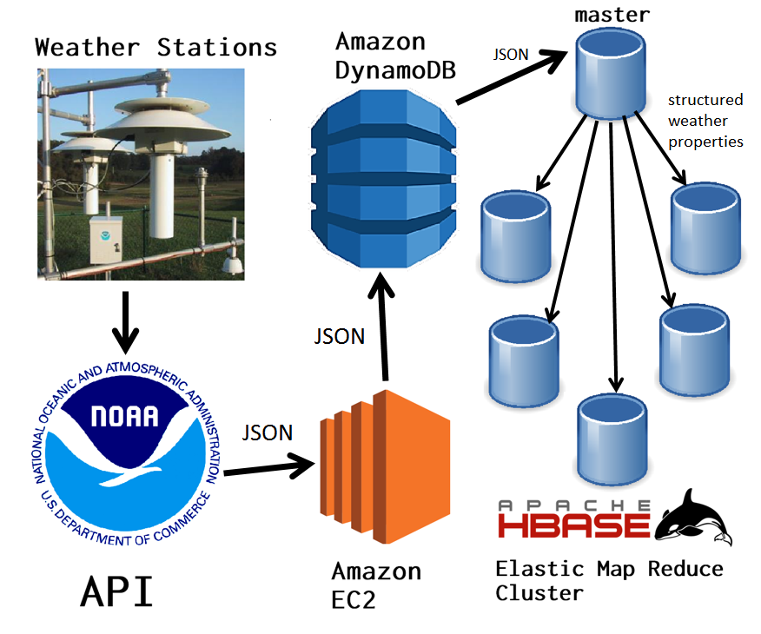

Assessing Prediction accuracy
The 24-hour-ahead-of-time accuracy and precision of maximum temperature predictions at each weather station was calculated using the data in HBase. The difference between predicted and actual high temperatures was averaged to determine average accuracy, and variance of these differences was taken to measure precision. For brevity, the top five most accurate and precise weather stations are given:
- Most Accurate Daily High Temperature predictions
Average Bias (Celsius) | Station Code | Station Name
0.00000 | KHJO | Hanford, Hanford Municipal Airport
0.00000 | PHMK | Kaunakakai, Molokai Airport
0.00000 | KSDC | Wayne
0.00000 | KDKX | Knoxville Downtown Airport
0.00000 | K3LF | Litchfield Municipal Airport

- Lowest variance in high temperature prediction accuracy:
Bias Variance (Celsius^2) | Station Code | Station Name
0.31545 | PHMU | Kamuela
0.31656 | PHMK | Kaunakakai, Molokai Airport
0.31656 | KHJO | Hanford, Hanford Municipal Airport
0.36703 | PADK | Adak Island, Adak Airport
0.46279 | KSOW | Show Low, Show Low Regional Airport

Many more stations had tied for first by having an effectively zero bias in their predictions, and variance is usually under one degree Celsius.
Similarly, the 24-hour-ahead-of-time accuracy of predictions of rain was calculated. Forecasts of greater than or equal to 50% probability of rain were considered to be predictions of rain, and all such cases for a given station were compared against their outcomes to determine the rate of true positive predictions.
- Most accurate predictions of rain:
Accuracy (%) | Station Code | Station Name
100.000 | PADE | Deering, Deering/New Airport
100.000 | KSRQ | Sarasota / Bradenton, Sarasota-Bradenton International Airport
100.000 | KSOW | Show Low, Show Low Regional Airport
100.000 | KHBV | Hebbronville, Jim Hogg County Airport
100.000 | ESPA | Espanola

Many stations besides these also got a perfect score for the window of time we considered. The collected data could be used to assess the accuracy predictions for up to ten days in advance. Although this analysis is limited by only looking at data from Spring 2018, it generally shows a high degree of accuracy in NOAA’s prediction models.

models
In order to build an appropriate model to predict precipitation level, we filtered out the Global Surface Summary of the Day (GSOD) data for the month of April from 1929 to 2018. We compared model “Accuracy of precipitation predictions” for the days with at least 50% chance of rain. We also demonstrated the model accuracy for the first week of April because the Masters’ Golf tournament [13] was held in Augusta, GA in this week. The amount of rain in this week plays a significant role for the golfers as well as the fans.
We started with a linear regression model [11]. This model predicts total precipitation in inches from the GSOD [12] data. By examining the p-values, we noticed that Mean Dew Point, Gust Wind Speed, and Maximum Temperature values are the most significant variables to predict the amount of precipitation. We also noted the model has a Root Mean Square Error value of 0.27.
Next, we performed a ridge regression to see if parameterization could improve the model. We found a cross-validation error value of 261.89 for the minimum regularization parameter of 0.70. We also noted the Root Mean Square Error value to be 9.97 which is significantly higher than that of the linear regression model. Figure 1 shows the Mean-Squared Error vs. log(Lambda). We noticed that the MSE value increased with the increase of the log(Lambda) value. We also noticed that the data may have a lot of outlier data.
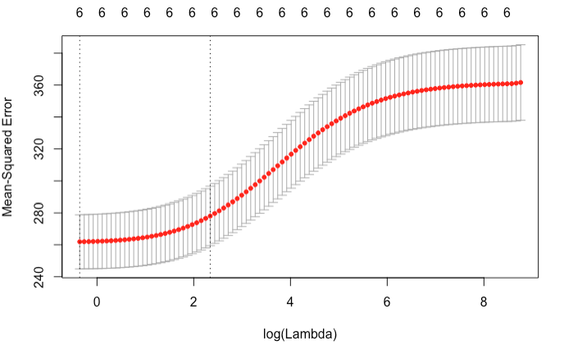
Figure 1: Ridge Regression
As our third model, we considered lasso regression. We found a cross-validation error of 262.12 at a minimum regularized parameterization value of 0.02 which is lower than that of the previous model. The model performs little bit better than the ridge model with a RMSE value of 9.69. Also, Figure 2 depicts the MSE vs. log(Lambda) value. We found the model keeps the range of MSE value at a constant width with no sign of improvement.
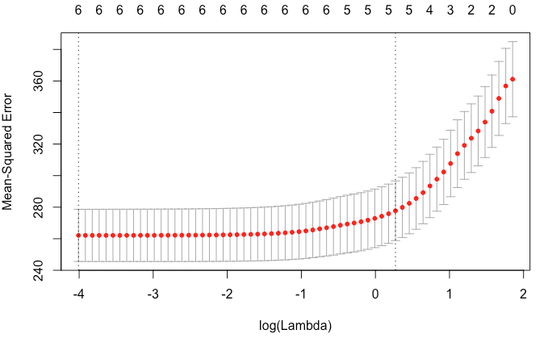Figure 2: Lasso Regression
As our final model, we built an elastic net combining both ridge and lasso regression to gauge the model’s performance. We applied 0.1 through 0.9 as the different alpha parameter for the glmnet function. We found the best elastic model at a minimum lambda value of 0.02 with a cross-validation error of 258.40.
Although during the prototype model building, we found the ridge regression was performing significantly better than the linear regression model, the simple linear regression showed improved performance with the significantly increased amount of training data. Next, we compared predicted precipitation values to the forecasted precipitation values collected from the cloud infrastructure.

results

We displayed forecasted precipitation amount in inches (Left) and probabilities (Right) in Table IV. Only days with at least 50% chance of rain are shown in the tables.

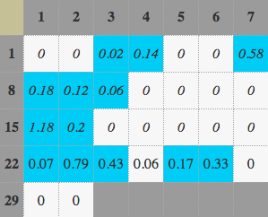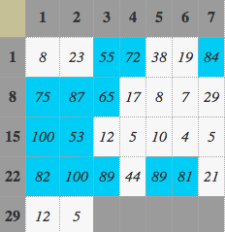

- Forcasted precipitation in Inches (left) and prob. of preciptiatin (right) [14]
Table V shows Linear Regression Model (LRM) (Left) and Ridge Regression Model (RRM) (Right) data. Both tables display negative precipitation values as zero. LRM model predicts better than that of RRM. RMM is overfitting the train data. Overall, LRM shows an accuracy of precipitation prediction of 92.31%; RMM shows that of 0%.
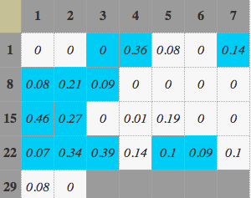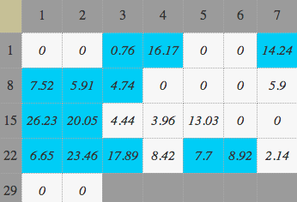
- Predicted precipitation- lm model (left) and ridge model (Right)
Table VI shows Lasso Regression Model (LaRM) (Left) and Elastic Net Model (ENM) (Right) data. Both tables display negative precipitation values as zero. ENM model predicts better than that of LaRM. Both models are overfitting the train data. Overall, ENM shows an accurary of precipitation precition of 7.69%; LaRM shows that of 7.69%.

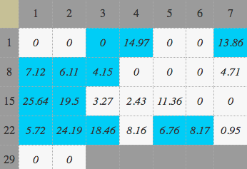
- Predicted precipitation- lasso model (left) and elastic model (right)

final model
During building model prototype, RRM performed better than all other models. With the increased amount of training dataset, we noticed that the LRM is performing better with low RMSE and higher accuracy. We assumed that this might be due to high variation in the dataset within the window of time data we collected data. Results could be different with the aggregation of multiple years of data.

Future research
Future research could include investigating model parameters and outlier detections in the dataset. Also, for this research project, we only looked at less than six months data from Spring 2018 to present date. Future research could find a better accuracy model with more aggregated data from 10-100 years.

Conclusion
In this project, we used Cloud Computing Applications to collect, analyze, and measure the accuracy of the weather forecasted by the National Weather Service for different geographic locations in the United States. We found that NWS predictions for probability of precipitation and maximum daily temperature are generally highly accurate. We also found Ridge Regression Model to perform better than other models for the purpose of predicting days with rain based on other weather data.

References

- NWS API Site: https://forecast-v3.weather.gov/documentation
- Rose, Bruce and Floehr, Eric. 2017. Analysis of High Temperature Forecast Accuracy of Consumer Weather Forecasts from 2005-2016. Forecast Watch, LLC. https://www.forecastwatch.com/static/High_Temperature_Accuracy_Study_12_Years.pdf
- Robbins, Richard. 2015. How accurate are weather forecasts? The Huffington Post. https://www.huffingtonpost.com/richard-robbins/how-accurate-are-weather-_b_6558770.html
- P. Ballesteros-Perez, Y. A. Rojas-Cespedes, W. Hughes, S. Kabiri, E. Pellicer, D. Mora-Melia, and M.L. del Campo Hitschfeld, “Weather-wise: a weather-aware planning tool for improving construction productivity and dealing with claims,” Auto. in Constr. Vol 84, pp. 81 - 95, August 2018.
- T. V. Prabha and G. Hoogenboom, “Evaluation of the weather research and forecasting model for two frost events,” Comp. and Elect. in Agri. Vol 64, pp. 234 - 247, December 2008.
- J. Vascak, R. Jaksa, J. Koscak, and J. Adamcak, “Local weather prediction system for a heating plant using cognitive approaches,” Comp. in Industry. Vol 74, June 2015.
- W. Deconinck, P. Bauer, M. Diamantakis, M. Hamrud, C. Kuhnlein, et al, “Atlas: A library for numerical weather prediction and climate modeling,” Comp. Phys. Comm. Vol 220, pp. 188 - 204, November 2017.
- X. Zhao, J. Liu, D. Yu, J. Chang, “One-day-ahead probabilistic wind speed forecast based on optimized numerical weather prediction data,” Energy Conv. and Mgmt. Vol 164, pp. 560 - 569, May 2018.
- E. D. Carreno, E. Roloff, P. O. A. Navaux, “Challenges and solutions in executing numerical weather prediction in a cloud infrastructure,” Proc. Comp. Sci. Vol 51, pp. 2832 - 2837, 2015.
- H. Stern and N. E. Davidson, “Trends in the skill of weather prediction at lead times of 1-14 days,” Roy. Met. Soc. Vol. 141, pp. 2726 - 2736, October 2015.
- Source Code to access, collect, and analyze the data https://github.com/JustinL42/Team42Project
- GSOD Site: ftp://ftp.ncdc.noaa.gov/pub/data/gsod
- Masters Golf: https://www.masters.com/en_US/index.html
- Masters Golf Tournament Week Weather Forcast: https://api.weather.gov/gridpoints/FFC/94,63

