Accuracy Analysis of the National Weather Service (NWS) Weather Predictions

Jordan Brooker ^{1,2}, Justin Lavoie^{1,3}, Md Hasan^{1,4}

¹ Department of Computer Science, University of Illinois at Urbana-Champaign, Urbana, 61801-2302, USA
²brooker3@illinois.edu
³jlavoie2@illinois.edu
⁴mdhasan2@illinois.edu

Abstract—In this project, we will use Cloud Computing Applications (CCA) to collect, analyze, and measure the accuracy of the weather forecasted by the National Weather Service (NWS) [1] for different geographic locations in the United States. We look forward to answering three main research questions 1) The accuracy of predictions of whether there will be precipitation or not 2) The accuracy and precision of temperature predictions compare to the actual observed weather, 3) Identify National Oceanic and Atmospheric Administration’s (NOAA) offices that make better predictions than others.
Keywords— ATLAS, DynamoDB, Ridge Regression

Introduction
Being able to predict the weather with a high amount of accuracy is an invaluable tool. According to a report published by ForecastWatch [2], the weather forecasts can predict tomorrow’s high temperature to within three degrees with 80% accuracy. They also found the forecasts reach the same accuracy 57% of the time, which is an improvement from a previous three-degree accuracy of 44%. This report lacks analysis of other aspects of weather, like precipitation, wind, and hazardous weather conditions.
In another report, Robbins and Richard [3] examined the difference in precipitation forecast accuracy from the same day out to 10-day predictions at one location over the course of five months, with forecasted and actual precipitation data from the Weather Channel. In addition to only covering one location, this project also only covered one season, while it has been shown that prediction accuracy varies across different seasons (with accuracy being lower in November and December, for this particular region).
In this project, we will analyze the accuracy of the National Oceanic and Atmospheric Administration’s (NOAA) weather prediction abilities by locations and seek answers to the following research questions.
1) Accuracy of precipitation predictions: Of the days with a probability of at least 50% rain, what percent actually had rain? Also, the reverse for days with <50% rain probability.
2) Accuracy and precision of temperature predictions: Does the daily high-temperature prediction tend to be higher or lower than what is actually observed? What is the variability of the difference between actual and observed temperature?
3) Which NOAA Offices regularly make better predictions than others? Which are the best and which are worst?

Related Works
Weather prediction is an invaluable tool for modern society. Knowledge of potential future weather conditions is used for everything from mundane tasks like planning picnics to potentially life-saving ones, like warning communities of impending natural disasters. Consequently, improving the accuracy of weather forecasts would result in a variety of positive outcomes, such as increased productivity of construction projects [4], crop yield efficiency [5], and reduced energy costs of businesses like heating plants [6], on top of reducing property damage and personal harm resulting from extreme weather events.
There are many different ways that researchers are trying to improve weather predictions. A software library called ATLAS has been created specifically for parallel processing of weather data on HPCs [7]. Others have tried to come up with specific algorithms for predicting individual weather conditions, such as wind speed [8]. There is also a push to move numerical weather prediction to cloud-based storage and processing. Work has been done to prove that the cloud is a viable option over HPC [9].
The current state of weather prediction has greatly improved over the last few decades. The accuracy of 5 to 7-day forecasts is the same as 1-day forecasts 50 years ago [10]. However, there is still room for improvement in general temperature forecasts and for precipitation, wind speed, and extreme weather events.

Data Set Generation
In order to determine the accuracy of predictions, data was regularly gathered from NOAA's weather forecast API, and the actual outcomes were compared to earlier predictions for that day. The forecast API was called for over 2000 of NOAA's land-based weather stations every 6 hours, and many steps were involved in storing and processing the large amount of data generated by these API calls.
An Amazon EC2 instance was provisioned for regularly running a script to download all the forecast data in the JSON format provided by the NOAA API. The script then used a python API from Amazon Web Services to save this raw JSON data to Amazon's DynamoDB key-value store. At the time of writing, there are over 378,000 forecasts and 36 GB in the DynamoDB key-value store.
These JSON forecasts needed to be processed so that predictions for a given day could be correlated to outcomes for the same day. This was done with another script which stored the resulting rows of data to an HBase cluster running on Amazon's Elastic Map Reduce service. The weather properties of daily maximum temperature, precipitating volume, and probability of precipitation were extracted and put into their own HBase tables, which were distributed among the cluster for efficient parallel processing. The code used for accessing the APIs, parsing the json, and loading into HBase is available at the projects github page.
https://github.com/JustinL42/Team42Project
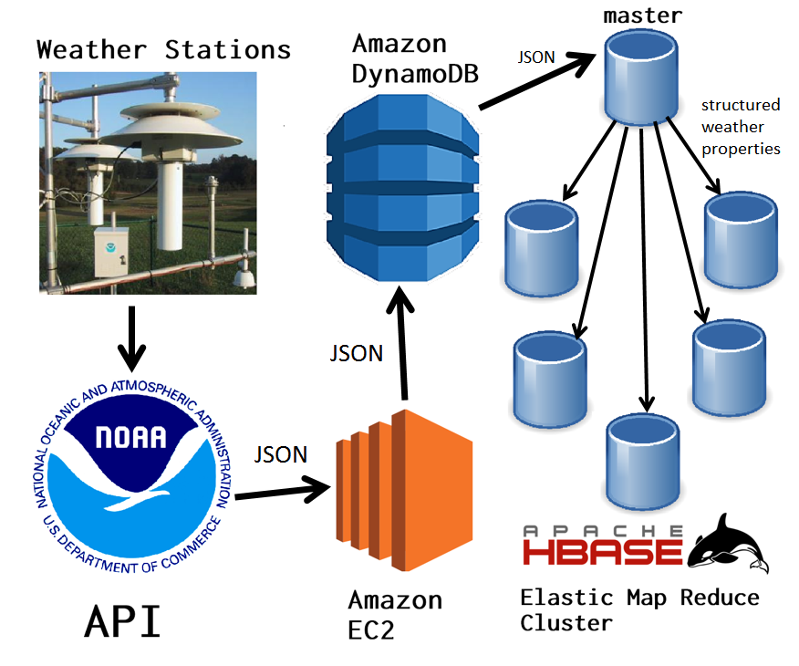

Assessing Prediction accuracy
The 24-hour-ahead-of-time accuracy and precision of maximum temperature predictions at each weather station was calculated using the data in HBase. The difference between predicted and actual high temperatures was averaged to determine average accuracy, and variance of these differences was taken to measure precision. For brevity, the top five most accurate and precise weather stations are given:
- Most Accurate Daily High Temperature predictions
Average Bias (Celsius) | Station Code | Station Name
0.00000 | KHJO | Hanford, Hanford Municipal Airport
0.00000 | PHMK | Kaunakakai, Molokai Airport
0.00000 | KSDC | Wayne
0.00000 | KDKX | Knoxville Downtown Airport
0.00000 | K3LF | Litchfield Municipal Airport

- Lowest variance in high temperature prediction accuracy:
Bias Variance (Celsius^2) | Station Code | Station Name
0.31545 | PHMU | Kamuela
0.31656 | PHMK | Kaunakakai, Molokai Airport
0.31656 | KHJO | Hanford, Hanford Municipal Airport
0.36703 | PADK | Adak Island, Adak Airport
0.46279 | KSOW | Show Low, Show Low Regional Airport

There were many more stations had tied for first by having an effectively zero bias in their predications, and variance is usually under one degree Celsius.
Similarly, the 24-hour-ahead-of-time accuracy of predictions of rain was calculated. Forecasts of greater than or equal to 50% probability of rain were considered to be predictions of rain, and all such cases for a given station were compared against their outcomes to determine the rate of true positive predictions.
- Most accurate predictions of rain:
Accuracy (%) | Station Code | Station Name
100.000 | PADE | Deering, Deering/New Airport
100.000 | KSRQ | Sarasota / Bradenton, Sarasota-Bradenton International Airport
100.000 | KSOW | Show Low, Show Low Regional Airport
100.000 | KHBV | Hebbronville, Jim Hogg County Airport
100.000 | ESPA | Espanola

Many stations besides these also got a perfect score for the window of time we considered. The data could be used to make the same assess the accuracy predictions for up to ten days in advance. Although this analysis is limited by only looking at data from spring of 2018, it generally shows a high degree of accuracy in NOAA’s prediction models.

model
In order to build a prototype of the model, we filter out the GSOD data for the 1st week of April from 1929 to 2018. We are particularly interested in the 1st week of April because the Masters’ Golf tournament [13] will be held in Augusta, GA in this week and amount of rain in this week plays a significant role for the golfers as well as the fans.
We simply start with a linear regression model [11]. This model predicts total precipitation in inches from the GSOD [12] data. Just examining the p-values, we noticed that Mean Temperature, Mean Dew Point, and Mean Wind Speed values are the most significant variables to predict the amount of precipitation. We also noted the Root Mean Square Error value to be 0.2049012.
Next, we perform a ridge regression to see if parameterization can improve the model. We found 0.1242661 cross-validation error for the minimum regularization parameter of 0.02037. We also found the Root Mean Square Error value to be 0.2030056 which is 0.92% improvement from the linear regression model.
- Predicted precipitation
Model Prototype | Precipitation in Inches (April 18)
Model Prototype | 01Apr | 02Apr | 03Apr | 04Apr | 05Apr | 06Apr | 07Apr
Linear Regression | 1.24 | 1.22 | 0.99 | 1.24 | 1.04 | 0.93 | 1.05
Ridge Regression | 0.29 | 0.31 | 0.29 | 0.35 | 0.22 | 0.22 | 0.25

- Forcasted precipitation [14]
Model Prototype | Precipitation (Inches) / Prob. of Precipitation (%) (April 18)
Model Prototype | 01Apr | 02Apr | 03Apr | 04Apr | 05Apr | 06Apr | 07Apr
Masters Golf Week | 0/0 | 0/1 | 0/5 | 0.13/70 | 0/4 | 0/19 | 0.17/46

We see that the ridge regression performs significantly better than the linear regression model though we need to conduct more analysis to ensure the model is functioning accurately. The accuracy of the model is close to 100%, as per our research questions we are seeking for “Accuracy of precipitation predictions” only for days with at least 50% chance of rain.

Results
.

comparision
.

final model
.

Challenges
It was originally planned to have the python script called as an AWS Lambda function to avoid having to have a server continually running just to request the data. Unfortunately, AWS Lambda functions have a maximum time-out limit of 5 minutes and it takes longer than this to download all the forecast data. Because of this, it is necessary to maintain a server just for this task.
It is useful to maintain a copy of the original data pulled from the API in JSON format, but this isn't convenient or efficient for comparing outcomes to predictions since these are in different entries. The next step in building this dataset will be to copy the values of interest (precipitation and temperature) to the second database with all the data for a time period and location in a single entry. This database should ideally be distributed and accessible by Spark so that analysis on many dates and locations can be done quickly. The method we develop to move data from DynamoDB to the second database, such as a Hadoop job, should be automatable so that new data from the API can be added on a regular basis without additional work.

Conclusion
.

Timetable
We plan to finish this project according to the following timetable with the asscociated task such as Model Comparison, Model Selection, and writing the final report.
- Project Schedule
Project Schedule | Milestones
Project Schedule | Highlights | Status | As of Date
02/23/2018 | Milestone 2: Project Proposal | Approved | 03/06/2018
04/01/2018 | Milestone 3: Progress Report | Submitted | 04/01/2018
04/11/2018 | Milestone 3.1: Model Comparison
04/25/2018 | Milestone 3.2: Model Selection
04/29/2018 | Milestone 3.3: Draft for Final Report
05/02/2018 | Milestone 4: Final Report
- Project Schedule (Team 42)

References

- NWS API Site: https://forecast-v3.weather.gov/documentation
- Rose, Bruce and Floehr, Eric. 2017. Analysis of High Temperature Forecast Accuracy of Consumer Weather Forecasts from 2005-2016. Forecast Watch, LLC. https://www.forecastwatch.com/static/High_Temperature_Accuracy_Study_12_Years.pdf
- Robbins, Richard. 2015. How accurate are weather forecasts? The Huffington Post. https://www.huffingtonpost.com/richard-robbins/how-accurate-are-weather-_b_6558770.html
- P. Ballesteros-Perez, Y. A. Rojas-Cespedes, W. Hughes, S. Kabiri, E. Pellicer, D. Mora-Melia, and M.L. del Campo Hitschfeld, “Weather-wise: a weather-aware planning tool for improving construction productivity and dealing with claims,” Auto. in Constr. Vol 84, pp. 81 - 95, August 2018.
- T. V. Prabha and G. Hoogenboom, “Evaluation of the weather research and forecasting model for two frost events,” Comp. and Elect. in Agri. Vol 64, pp. 234 - 247, December 2008.
- J. Vascak, R. Jaksa, J. Koscak, and J. Adamcak, “Local weather prediction system for a heating plant using cognitive approaches,” Comp. in Industry. Vol 74, June 2015.
- W. Deconinck, P. Bauer, M. Diamantakis, M. Hamrud, C. Kuhnlein, et al, “Atlas: A library for numerical weather prediction and climate modeling,” Comp. Phys. Comm. Vol 220, pp. 188 - 204, November 2017.
- X. Zhao, J. Liu, D. Yu, J. Chang, “One-day-ahead probabilistic wind speed forecast based on optimized numerical weather prediction data,” Energy Conv. and Mgmt. Vol 164, pp. 560 - 569, May 2018.
- E. D. Carreno, E. Roloff, P. O. A. Navaux, “Challenges and solutions in executing numerical weather prediction in a cloud infrastructure,” Proc. Comp. Sci. Vol 51, pp. 2832 - 2837, 2015.
- H. Stern and N. E. Davidson, “Trends in the skill of weather prediction at lead times of 1-14 days,” Roy. Met. Soc. Vol. 141, pp. 2726 - 2736, October 2015.
- Source Codes to access, collect, and analyze the data https://github.com/JustinL42/Team42Project/tree/master/weatherAPIScripts
- GSOD Site: ftp://ftp.ncdc.noaa.gov/pub/data/gsod
- Masters Golf: https://www.masters.com/en_US/index.html
- Masters Golf Tournament Week Weather Forcast: https://api.weather.gov/gridpoints/FFC/94,63

