Comparing new_deaths in USA & UK

Md Easin Hasan

4/17/2021

data<-read.csv(file="owid-covid-data417.csv",header=TRUE)  
dim(data)

## [1] 82087 59

data1 <- data[data$iso_code == "USA", ]   
data2 <- data[data$iso_code == "GBR", ]   
data3<-rbind(data1,data2)  
country <- ifelse(data3$iso_code == "USA",0,1)  
data4 <- cbind(country,data3)  
data4$country<-as.factor(data4$country)  
data4$country<-factor(data4$country,levels=c(0,1),labels=c("USA", "UK"))  
data5 <- data4[,-c(2)]  
dat2 <-data5[,c(1,4,9)]  
colnames(dat2)

## [1] "country" "date" "new_deaths"

We have obtained the data-set on COVID-19 (coronavirus) by Our World in Data. They have up-to-date data on confirmed cases, deaths, hospitalizations, testing, and vaccinations, throughout the duration of the COVID-19 pandemic.

library(ggplot2)  
library(gganimate)  
library(viridis)

## Loading required package: viridisLite

library(scales)

##   
## Attaching package: 'scales'

## The following object is masked from 'package:viridis':  
##   
## viridis_pal

theme_set(theme_bw())  
plot <- ggplot(dat2, aes(x = as.Date(date), y = new_deaths, color = country)) +  
 geom_line()+  
 geom_point(alpha = 0.3)+   
 scale_x_date(labels = date_format("%m-%d-%Y"))+  
 labs(x = "date")+  
 labs(y = "Number of new_deaths")+  
 ggtitle("Plot of new deaths in USA & UK \n due to COVID-19")  
plot

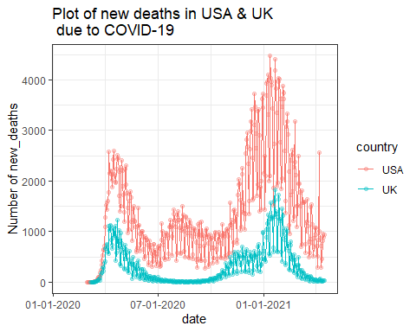

From this visualization, we can compare the new_deaths in USA & UK due to COVID-19. In addition, we can figure out the number of new_deaths.

# Data Visualization improvement:

library(magick)

## Linking to ImageMagick 6.9.12.3  
## Enabled features: cairo, freetype, fftw, ghostscript, heic, lcms, pango, raw, rsvg, webp  
## Disabled features: fontconfig, x11

plot <- ggplot(dat2, aes(x = as.Date(date), y = new_deaths, color = country)) +  
 geom_line()+  
 geom_point(alpha = 0.7)+  
 transition_reveal(as.Date(date))+   
 scale_x_date(labels = date_format("%m-%d-%Y"))+  
 labs(x = "date")+  
 labs(y = "Number of new_deaths")+  
 ggtitle("Plot of new deaths in USA & UK \n due to COVID-19")  
animation <- animate(plot, nframes=100, renderer=magick_renderer())   
animation

