Data Visualization Association

Md Easin Hasan

4/2/2021

setwd("E:/Data Visualization")  
data<-read.csv(file="owid-covid-data_new.csv",header=TRUE)  
dim(data)

## [1] 78245 59

data1 <- data[data$iso_code == "USA", ]   
dat2 <-data1[,c(1,6,8,11,18,20)]  
colnames(dat2)

## [1] "iso_code" "new_cases"   
## [3] "total_deaths" "total_cases_per_million"  
## [5] "icu_patients" "hosp_patients"

miss.info<- function(dat, filename=NULL){   
   
 vnames <- colnames(dat); vnames   
   
 n <- nrow(dat)   
   
 out <- NULL   
   
 for (j in 1: ncol(dat)){   
   
 vname <- colnames(dat)[j]   
   
 x <- as.vector(dat[,j])   
   
 n1 <- sum(is.na(x), na.rm=T)   
   
 n2 <- sum(x=="NA", na.rm=T)   
   
 n3 <- sum(x=="", na.rm=T)   
   
 nmiss <- n1 + n2 + n3   
   
 ncomplete <- n-nmiss   
   
 out <- rbind(out, c(col.number=j, vname=vname, mode=mode(x), n.levels=length(unique(x)), ncomplete=ncomplete, miss.perc=nmiss/n)) }   
   
 out <- as.data.frame(out)   
   
 row.names(out) <- NULL   
   
 return(out)   
   
}   
  
miss.info(dat2)

## col.number vname mode n.levels ncomplete  
## 1 1 iso_code character 1 433  
## 2 2 new_cases numeric 400 432  
## 3 3 total_deaths numeric 395 395  
## 4 4 total_cases_per_million numeric 406 433  
## 5 5 icu_patients numeric 248 249  
## 6 6 hosp_patients numeric 250 249  
## miss.perc  
## 1 0  
## 2 0.0023094688221709  
## 3 0.0877598152424942  
## 4 0  
## 5 0.424942263279446  
## 6 0.424942263279446

library(mice)

## Warning: package 'mice' was built under R version 4.0.4

##   
## Attaching package: 'mice'

## The following object is masked from 'package:stats':  
##   
## filter

## The following objects are masked from 'package:base':  
##   
## cbind, rbind

fit.mice.dat_f <- mice(dat2, m = 1, maxit = 50, method = 'pmm', seed = 500)

##   
## iter imp variable  
## 1 1 new_cases total_deaths icu_patients hosp_patients  
## 2 1 new_cases total_deaths icu_patients hosp_patients  
## 3 1 new_cases total_deaths icu_patients hosp_patients  
## 4 1 new_cases total_deaths icu_patients hosp_patients  
## 5 1 new_cases total_deaths icu_patients hosp_patients  
## 6 1 new_cases total_deaths icu_patients hosp_patients  
## 7 1 new_cases total_deaths icu_patients hosp_patients  
## 8 1 new_cases total_deaths icu_patients hosp_patients  
## 9 1 new_cases total_deaths icu_patients hosp_patients  
## 10 1 new_cases total_deaths icu_patients hosp_patients  
## 11 1 new_cases total_deaths icu_patients hosp_patients  
## 12 1 new_cases total_deaths icu_patients hosp_patients  
## 13 1 new_cases total_deaths icu_patients hosp_patients  
## 14 1 new_cases total_deaths icu_patients hosp_patients  
## 15 1 new_cases total_deaths icu_patients hosp_patients  
## 16 1 new_cases total_deaths icu_patients hosp_patients  
## 17 1 new_cases total_deaths icu_patients hosp_patients  
## 18 1 new_cases total_deaths icu_patients hosp_patients  
## 19 1 new_cases total_deaths icu_patients hosp_patients  
## 20 1 new_cases total_deaths icu_patients hosp_patients  
## 21 1 new_cases total_deaths icu_patients hosp_patients  
## 22 1 new_cases total_deaths icu_patients hosp_patients  
## 23 1 new_cases total_deaths icu_patients hosp_patients  
## 24 1 new_cases total_deaths icu_patients hosp_patients  
## 25 1 new_cases total_deaths icu_patients hosp_patients  
## 26 1 new_cases total_deaths icu_patients hosp_patients  
## 27 1 new_cases total_deaths icu_patients hosp_patients  
## 28 1 new_cases total_deaths icu_patients hosp_patients  
## 29 1 new_cases total_deaths icu_patients hosp_patients  
## 30 1 new_cases total_deaths icu_patients hosp_patients  
## 31 1 new_cases total_deaths icu_patients hosp_patients  
## 32 1 new_cases total_deaths icu_patients hosp_patients  
## 33 1 new_cases total_deaths icu_patients hosp_patients  
## 34 1 new_cases total_deaths icu_patients hosp_patients  
## 35 1 new_cases total_deaths icu_patients hosp_patients  
## 36 1 new_cases total_deaths icu_patients hosp_patients  
## 37 1 new_cases total_deaths icu_patients hosp_patients  
## 38 1 new_cases total_deaths icu_patients hosp_patients  
## 39 1 new_cases total_deaths icu_patients hosp_patients  
## 40 1 new_cases total_deaths icu_patients hosp_patients  
## 41 1 new_cases total_deaths icu_patients hosp_patients  
## 42 1 new_cases total_deaths icu_patients hosp_patients  
## 43 1 new_cases total_deaths icu_patients hosp_patients  
## 44 1 new_cases total_deaths icu_patients hosp_patients  
## 45 1 new_cases total_deaths icu_patients hosp_patients  
## 46 1 new_cases total_deaths icu_patients hosp_patients  
## 47 1 new_cases total_deaths icu_patients hosp_patients  
## 48 1 new_cases total_deaths icu_patients hosp_patients  
## 49 1 new_cases total_deaths icu_patients hosp_patients  
## 50 1 new_cases total_deaths icu_patients hosp_patients

## Warning: Number of logged events: 101

dat_f.imputed <- complete(fit.mice.dat_f,1)  
datf <- as.data.frame(dat_f.imputed)

library("corrplot")

## corrplot 0.84 loaded

dat3 <- datf[,-c(1)]  
M <- cor(dat3)  
corrplot(M, method="number")

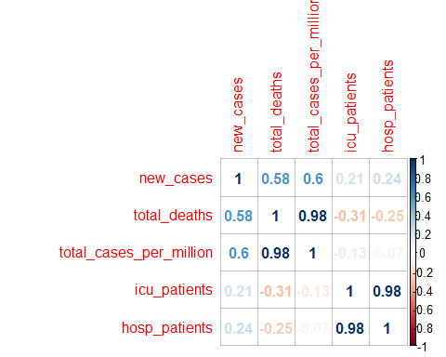

From this correlation plot among the selected variables, we can see that total_deaths and total+cases_per_million, and icu_patients and hosp_patients in USA are very strongly correlated.

# Data Association Imporvements:

library(ggcorrplot)

## Warning: package 'ggcorrplot' was built under R version 4.0.4

## Loading required package: ggplot2

#dat4 <- data.frame(dat3)  
corr <- round(cor(dat3), 1)  
ggcorrplot(corr)

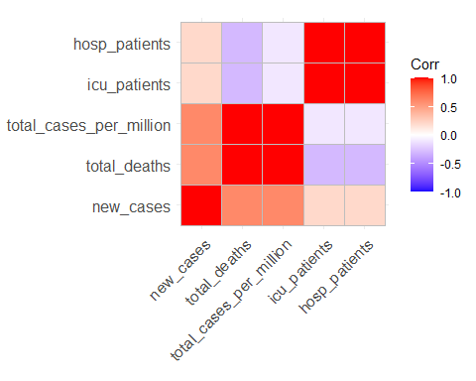

Here the red color is indicating the variables are very strongly correlated and blue color is indicating very weekly correlated.

ggcorrplot(corr, hc.order = TRUE, type = "lower",  
 lab = TRUE)

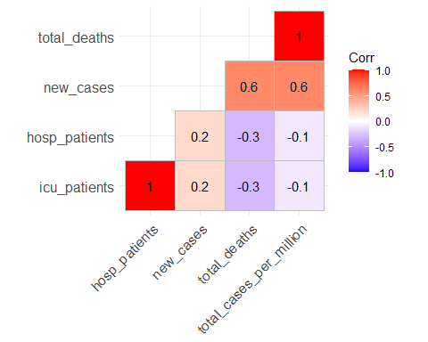

From this correlation plot, we can very easily visualize that total_deaths and total+cases_per_million, and icu_patients and hosp_patients in USA are very strongly correlated. Hence, when the hospitalized patients were high the icu_patients also high in USA during the covid-19 pandemic.