Data visualization proportion

Md Easin Hasan

3/28/2021

data<-read.csv(file="owid-covid-data_new.csv",header=TRUE)  
dim(data)

## [1] 78245 59

USA_20 <- data[74514:74514, ]  
UK_20 <- data[74081:74081, ]  
CAN_20 <- data[13100:13100, ]  
FRA_20 <- data[25899:25899, ]  
ITA_20 <- data[35349:35349, ]  
data_20<-rbind(USA_20,UK_20,CAN_20,FRA_20,ITA_20)  
data_f20 <- data_20[,c(1,4,8)]  
  
USA_21 <- data[74602:74602, ]  
UK_21 <- data[74169:74169, ]  
CAN_21 <- data[13188:13188, ]  
FRA_21 <- data[25987:25987, ]  
ITA_21 <- data[35437:35437, ]  
data_21<-rbind(USA_21,UK_21,CAN_21,FRA_21,ITA_21)  
data_f21 <- data_21[,c(1,4,8)]  
data_final <- rbind(data_f20,data_f21)

#library(tidyverse)  
#library(magrittr)  
library(ggplot2)  
#library(reshape2)  
#library(scales)  
  
ggplot(data_final, aes(x = date, y = total_deaths, fill = iso_code)) +  
 xlab("Years") + ylab("Total deaths")+  
 geom_bar(stat="identity", position = 'dodge')+  
 geom_col()+  
 scale_x_discrete(name = "Countries", labels=c("2020-12-31" = "2020", "2021-03-29" = "2021"))+  
 scale_y_continuous(name="Total deaths")

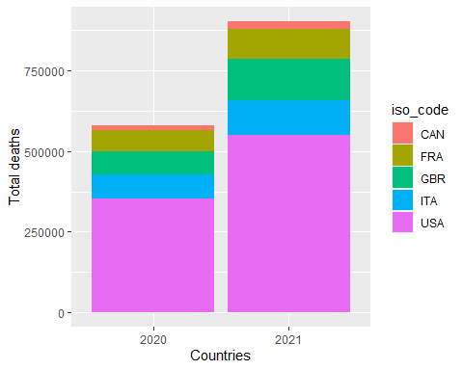

From this data visualization, we can see the total deaths due to Covid-19 in Canada, France, Great Britain, Italy, and United States respectively.

## Data visualization proportion improvement:

plot <- ggplot(data_final, aes(date, total_deaths, fill=iso_code))  
plot <- plot + geom_bar(stat = "identity", position = 'dodge')+  
 scale_x_discrete(name = "Years", labels=c("2020-12-31" = "2020", "2021-03-29" = "2021"))+  
 scale_y_continuous(name="Total deaths")  
plot

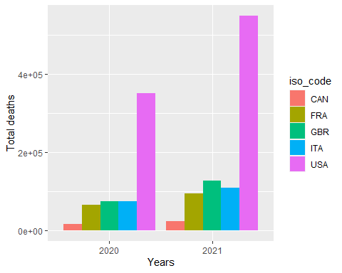

From this data visualization, we can see the total deaths due to Covid-19 in Canada, France, Great Britain, Italy, and United States in 2020 and 2021 respectively. The number of total deaths very higher in USA compare to other countries.