ZEAL

**Story:** Our game name is “ZEAL”. Our main character’s name is Marco Derick. His father Carlo Derick was a famous explorer who has explored many hidden mysteries & treasures of the world. As a boy Marco always looked up to his father and admired him. His ambition is also to walk the same path as his father. Carlo Derick often went off to his missions leaving his family for months.

On a peaceful day while Marco was playing in a room his father came and hugged him for a while. Then Carlo gave him a photo, patted his head and left for a precarious mission. Marco was too young to understand anything that time. Marco looked at the door every day in hopes of his father’s return. Many days, months, years passed but his father didn’t return. This way 15 years passed. On a sudden evening Marco was staring at the photo of his father. To his utter surprise something slipped of the photo frame a little. It was a Letter that his Father left for him. He read the letter,

[Dear Son,

Hope you are healthy & fit. I have discovered something really important from my research. And I am going for it. It will bring huge change for our mankind. But this is a very risky mission, much more dangerous than my previous ones. But I am willing to take the bet for greater purpose. My success is really uncertain.

If you are reading this letter, that means I haven’t come back home. I want you to complete my mission. According to the map & my research paper, which you will find behind the photo frame in the secret space. That is my last wish.

Be well, my beloved son.]

Thus, Marco Derick’s journey starts.

**Note:** To represent his resolve about completing his father’s incomplete mission, we gave the game title “ZEAL”.

**Gameplay:** Marco has to move through jungle, desert, Iceland and many other rough environments.He has to collect all the treasures stated as special stones namely Philosopher Stone, Luminescence Ruby, Sharingun, Infinite Stone & others. We have developed only the first mission of the game. The first mission is divided into three parts.

In the first part he will face many obstacles on his way such as logs, tree, rock, river, hole etc. He will overcome those obstacles by jumping and sliding. For example, if he finds log, rock, river and hole he has to jump over those obstacles to overcome it. If somehow, he falls into the river or hole, he will be dead and the game will be over. On the other hand, if he finds tree branches on his way, he has to slide under the tree branch to overcome that obstacle. On his way he will find many coins. By running through those coins, he can obtain those coins and increase his score.

In the second part he will face Orcs & flying Wyverns which are guarding the stone. He will face three kinds of orcs. Among them one type of orc has special kind of power. It can shoot poisonous power which will decrease our player’s health/shield. And the third type of orc is a normal orc. Besides, our player will face flying wyverns which will throw poisonous venom towards him. If any the orcs or venom touches our player, his health / shield will decrease by one. Initially our player has five health and shield points. At first his shield will decrease. If his shield becomes zero then his health will decrease. He can increase health and shield by taking health and shield points which will appear randomly in screen and will vanish after some times. After reaching at the end of a level he will have to face a boss Goblin.

After defeating it in the third part, he will find a cave which contains the stone. He has to solve a puzzle to open the door of the cave. Only after solving this he can collect the STONE. Thus, the level will be over.

**Features:**

Our character can shoot, run , jump and slide in both directions.

We have added different obstacles in the way of our character such as log, tree branch, rock, river and hole. Our player has to jump and slide to overcome those.

Orc can shoot poisonous venom and flying wyverns can throw poison from the sky which can decrease our health and shield.

Our character has shield and health. Firstly, his shield will decrease by enemy attack. After finishing his shield his health will start decreasing by enemy attack.

Our character health and shield can be regenerated by taking health and shield points.

In the end our character has to fight against a goblin king. The goblin king can throw rock at him which can decrease his health / shield.

We have added a puzzle and it can be solved by mouse click. By solving that puzzle the cave door will open and he can get that stone.

**Implementation:**

To create any console game or this kind of software in c/c++, there is no built-in library. W**e** have developed this game using “SFML Graphics Library”. We have used “Object Oriented Programming” in C++ and pointers for extreme performance.

In SFML there is a game loop which always execute when the game is running. Here this game loop is the main game engine, because each and every component of this game have to control and render in the game loop. SFML provides the graphics, audio, network, system and window module.

To make this game we use Visual Studio software. At first, we have to setup the environment for this game, because SFML is not a bult-in library. We have to download it form it’s website and then setup the environment.

In the main.cpp file we only control the game loop. We create a class “Game” for working as a game engine and handle all other classes. Here we create the window using default SFML class “RenderWindow” for playing game.

sf::Window window(sf::VideoMode(1366, 768), "My window", Style:: FullScreen);

In this file we create all the custom classes pointer and in all the initialization function create all the custom class object and use memory in the heap.

void Game::initMenu()

{

this->menu = new Menu;

}

We also create some other custom classes as Global, Menu, Playing, stdafx.

Global Class works for handling all the global variables and game states. Menu class works for handle the menu and playing class is as well as controlling full gameplay. Here most importantly we use stdafx for pre-compiled header, this helps to run the game more smoothly.

We use SFML library class Texture and Sprite for controlling all the image.

sf::Sprite sprite;

sprite.setTexture(texture);

We use two types of audio. One is pre-loaded like shooting sound and another is open in the run time like background music. For controlling this audio, we use Sound, SoundBuffer and Music class.

sf::SoundBuffer buffer;

// load something into the sound buffer...

sf::Sound sound;

sound.setBuffer(buffer);

sound.play();

**Figure 1:** Diagram of Game Structure

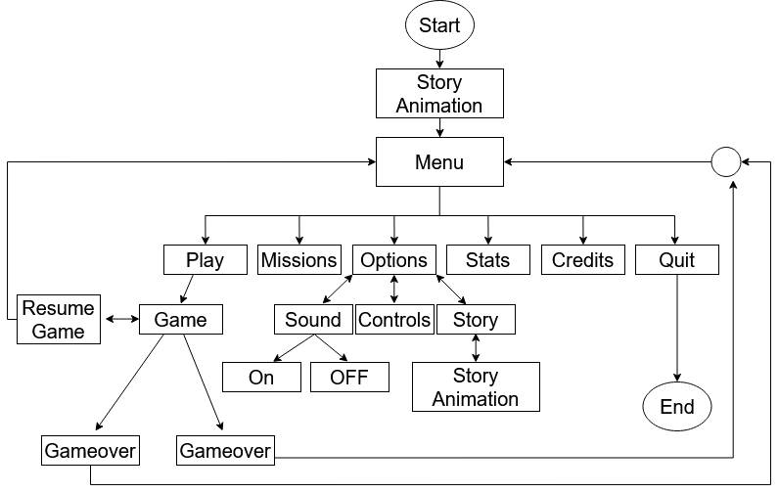

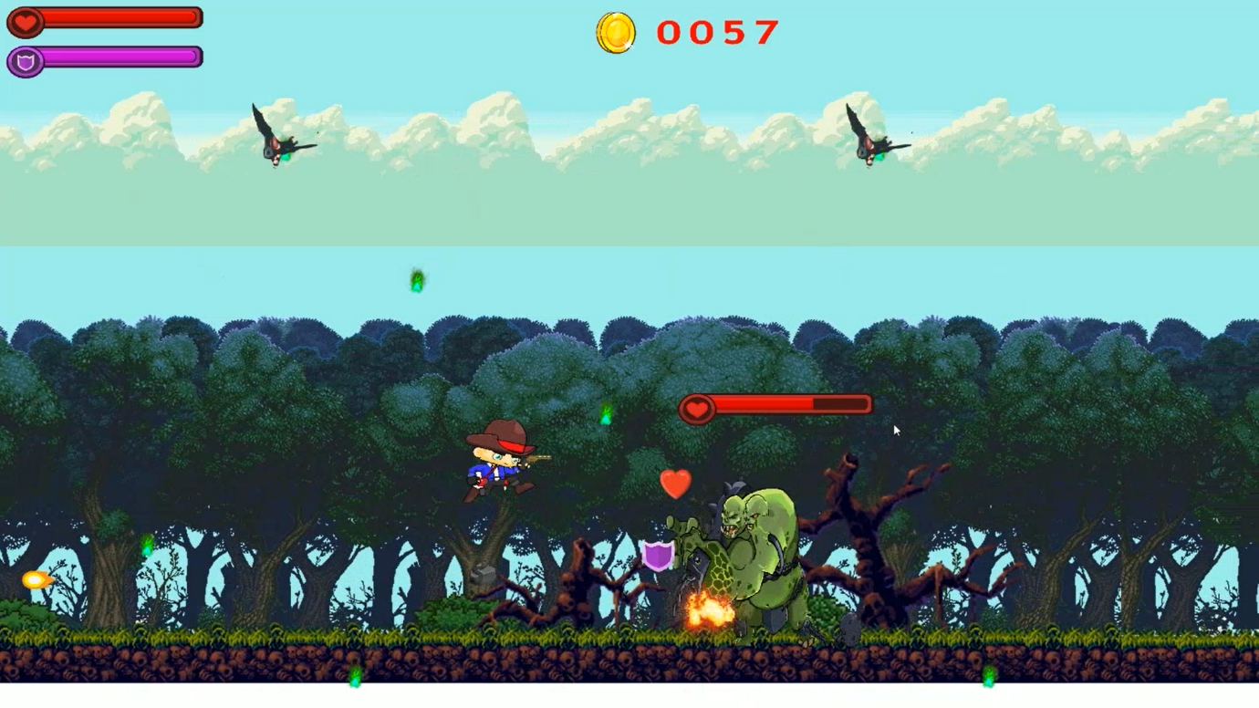

**Figure 2:** Game Play Image

**Future Plan:**

We plan to develop our game further in near future. Currently there is only one level in our game but there will be more than ten levels in our game. We also have plans for some extra features. Like adding programing puzzles, predators and new environments & more background music. We will add more sound effects such as walking sound, wind sound, bombardment sound, predators roar & monsters cry. We want to modify our shooting too, like we desire to be able to shoot upside & downside too. We want to make our game more flexible within our current frame rate. We make a animation video, but sfml doesn’t support playing video. We have planned to use OpenGL library to play the video in future.

Our final/true/main plan is to make it look like, he will find his father alive in the true ending.

Reference

[1] <https://www.sfml-dev.org/index.php>

[2] <https://www.sfml-dev.org/tutorials/2.5/start-vc.php>

[3] <https://www.sfml-dev.org/tutorials/2.5/window-window.php>

[4] <https://www.sfml-dev.org/tutorials/2.5/graphics-sprite.php>

[5] <https://visualstudio.microsoft.com/>  
[6] <https://www.youtube.com/watch?v=axIgxBQVBg0&list=PL21OsoBLPpMOO6zyVlxZ4S4hwkY_SLRW9>

[7] <https://www.youtube.com/watch?v=BySDfVNljG8&list=PL6xSOsbVA1eb_QqMTTcql_3PdOiE928up>

[8] <https://www.youtube.com/watch?v=euuJ24cfsG0>

[9] <https://github.com/robinrezwan/TreasureGuardian>

**Team Name**: **Unsolved RU**

|  |  |  |  |
| --- | --- | --- | --- |
| No. | Name | Student ID | Phone |
| 1. | Md. Hasnain Ali | 2010976153 | 01784864901 |
| 2. | Md. Shoaib Abdullah Khan | 2010976135 | 01303608379 |
| 3. | Sadman Sakib | 2010976106 | 01995010056 |