[http://threejs.org/examples/#webgl\_buffergeometry\_lines](http://threejs.org/examples/" \l "webgl_buffergeometry_lines)

Mogelijke visualizatie: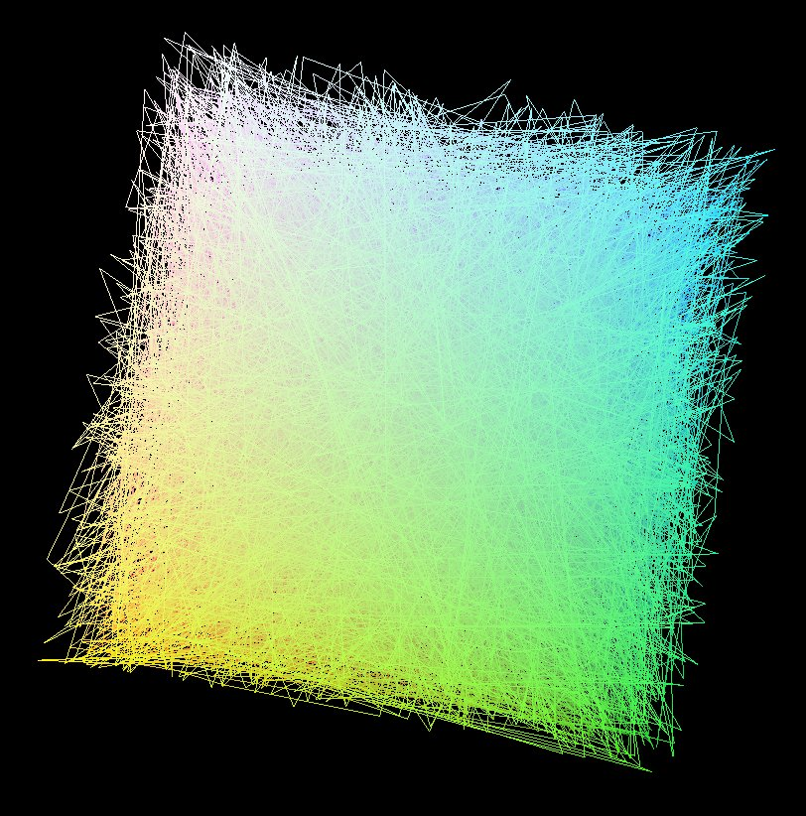

in Javascript

http://threejs.org/examples/#canvas\_lines\_colors