Cloud Native Operations : Kubernetes and Helm

Martin Chabot

Group Exercises Warm-up GE#1

Group Warm-up questions GE#1

Instructions
- Login as ericsson username and start your Kubernetes Nocentino Lab. These exercises should ONLY be done on the Nocentino lab.
- Be mindful of the words used throughout this document.
- Ensure you have at least 3 worker nodes running and ensure they are configured to accept the scheduling of pods.
- Ensure you have no leftovers of resources from previous exercises.
- Work as a team, help each other’s and try not to do all the exercises on your own.
- Every question should be discussed with your peers to ensure all the options have been looked at.
- Some answers will vary between labs. Some answer will be the same. Don’t cut’n paste someone else’ answer, find the answer from your own lab.
- When you answer a question, your instructor must see the prompt of your lab, the command you used, the output it generated and highlight the section you want the instructor grading your exercises to focus on. Don’t let your instructor guess for your answer in a long output. Be specific.
- Some of the questions may be tricky, sometimes an error output may be a valid answer.

Example of a good answer:
Question: What ip address the pod busybox1 has ?

Preparation:

- The prompt of your Nocentino Kube-1 lab should have been set-up in previous exercises. Only If the prompt of your Kube-1 is not showing your name/signum, proceed with the following command on Kube-1 only:

  - wget -qO /tmp/prompt.sh https://raw.githubusercontent.com/martin-eric/cn-class/main/prompt_setup.sh && bash /tmp/prompt.sh && rm -rf /tmp/prompt.sh
- Close all your ssh sessions to your control-plane node and log back in. The prompt must contain your name before you continue.

Section 0
Your name: Md Rabiul Ahamed Bin Hanif
Your team leader is: Arunakumari Yedurupaka

Section 1
Find the version of the following binaries on your lab control-plane node, if they are installed:
  - Kubectl
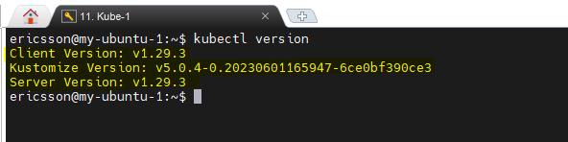
  - Kubeadm
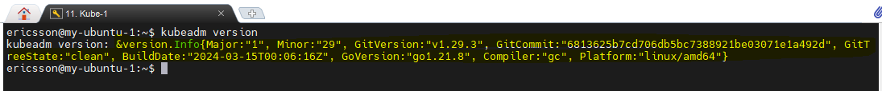
  - Helm
- Does not exit.
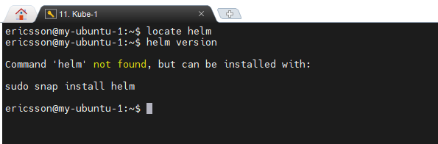

Section 2
- Find the number of nodes you have in this cluster, their state, and their role.
One control node three worker nodes
- How many cpu are Allocatable by Kubernetes in each of the nodes?
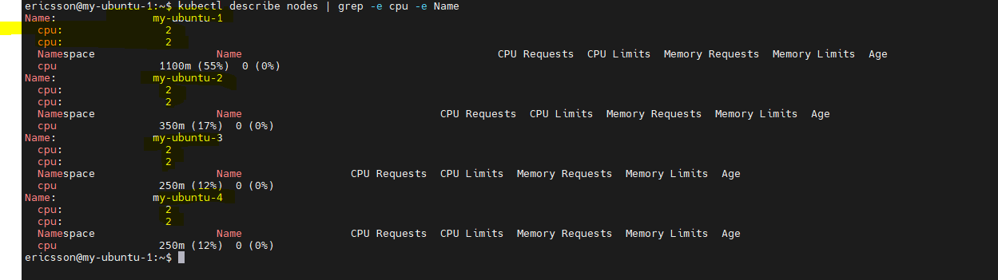
- Explain why my-ubuntu-1 has taints and none of the other nodes have any?
- My-ubuntu-1 is control node for this group, so it will not run workload on it.

Section 3
- Which kubectl command would you use to verify which CONTAINER RUNTIME is dockinstalled on each of your worker nodes?
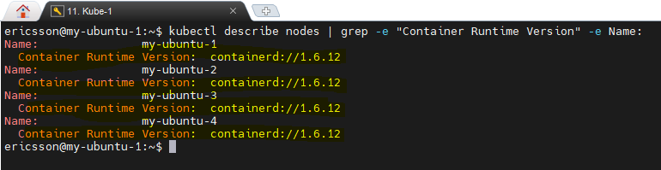
- The network plug-in used on this lab is Calico. Can you confirm if the calico-node pod is running only on the control plane or if it is running on every worker node? (don’t forget to show your work to answer the questions.)
- In every node
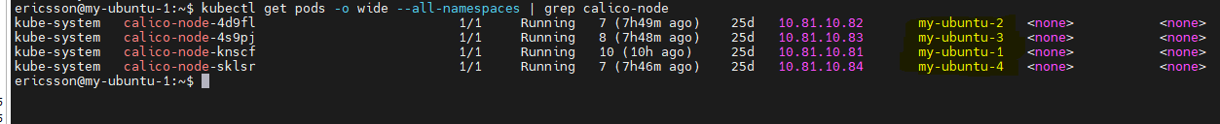

- How many pods are currently running in your default namespace?
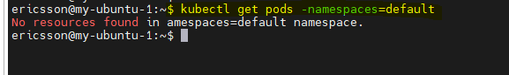
- What are the other namespaces available in your cluster? Do they have running pods and containers in them?
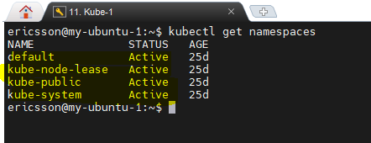

Section 4
- By default, Kubernetes provides its own DNS server in the cluster to allow resolution of FQDN. If you want to send a query to your cluster’s DNS, which ip(s) will listen to your queries? (Hint: more than 1, less than 5 ips)

- Which kube node(s) has the pods that will respond to the DNS queries?
- At first, we used kubectl describe svc kube-dns -n kube-system to confirm the endpoint.
- Then kubectl get pods --all-namespaces -o wide to confirm the coredns.
- Finally kubectl get pods --all-namespaces -o wide | grep -e 192.168.243.95 -e 192.168.243.96
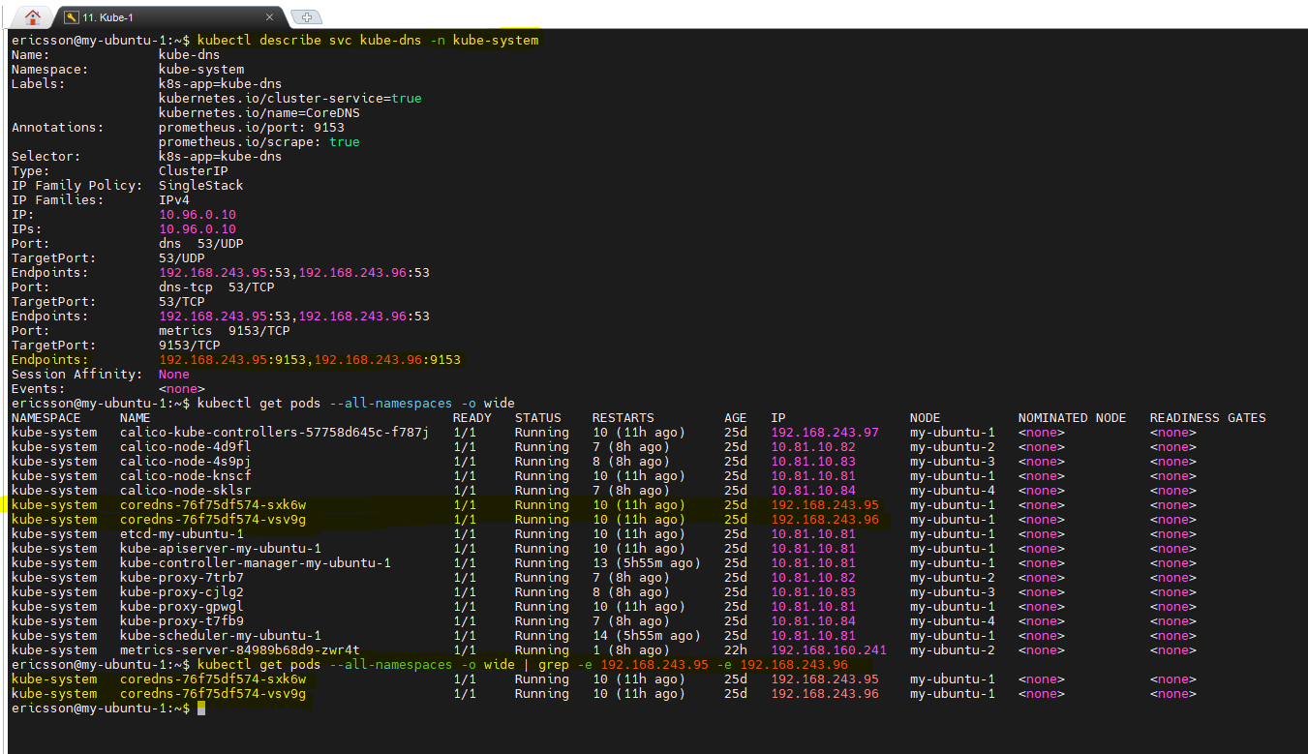

Conclusion:
- Send all your answers by email to your instructors. Ensure the title of the email is the name of this exercise.
- If the file is too big, use zip to compress it.

