Yes
Group Exercises #2
Cloud Native Operations : Kubernetes and Helm

Martin Chabot

Group Exercises #2

Instructions
- Be mindful of the words used throughout this document.
- Work as a team, help each other’s and try not to do all the exercises on your own.
- Every question should be discussed with your peers to ensure all the options have been looked at.
- Some answers will vary between labs. Some answer will be the same. Don’t cut’n paste someone else’ answer, find the answer from your own lab.
- Cut ’n paste the command you used AND the output you received to answer each question in this word document. If the output is long, highlight the section you want the instructor grading your exercises to focus on.
- Some of the questions may be tricky, sometimes an error output may be a valid answer.

Example of a good answer:
Question: What ip address the pod busybox1 has?

Preparation
Ensure your cluster is still running (Warm up exercises for GE#2), if it’s not started, follow installation document on how to properly start the cluster without any workload/user applications.
Let create some workload by instantiating a PCC with one cMME and one cEPG. I have a script that will do that, it will take 10-15 mins to deploy and initialize. While it’s deploying, use this time to look at the script to understand what it does:
- cd pcc-lab/martin-scripts ; ./create_martin_cMME_cEPG_pcc1.sh
NOTE: CP-0 and CP-1 may not reach a working state within 10-15 mins. You can continue your exercises as we will not focus on them.

Section 0
Your name: Md Rabiul Ahamed Bin Hanif
Your team leader is: Arunakumari Yedurupaka

Section 1
Monitor the status of all PCC pods for about 10-15 mins. After that time, focus on the deployment called eric-pccsm-controller. Find a way to identify the following:
- How many containers is/are inside each pod and which image is/are they using?
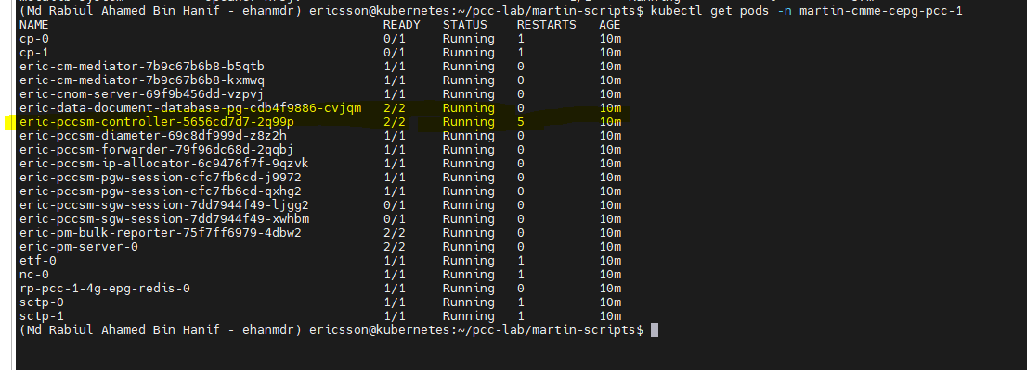
- How many volumes are attached to each pod?
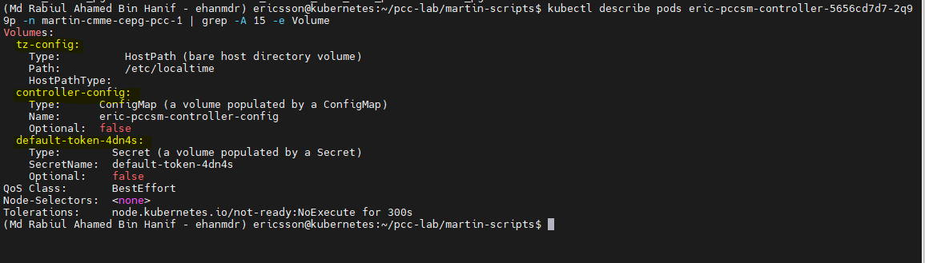

- This deployment is controlled by a replicaset. How many replicas are set for it ?

Section 2
Focus on the deployment called eric-pccsm-pgw-session. Find a way to identify the following:
- How many containers is/are inside each pod and which image is/are they using?
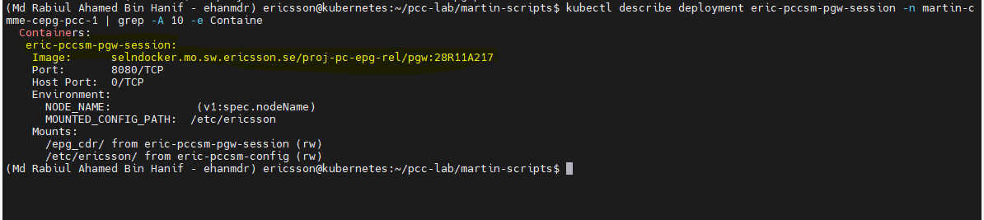
- How many volumes are attached to each pod?
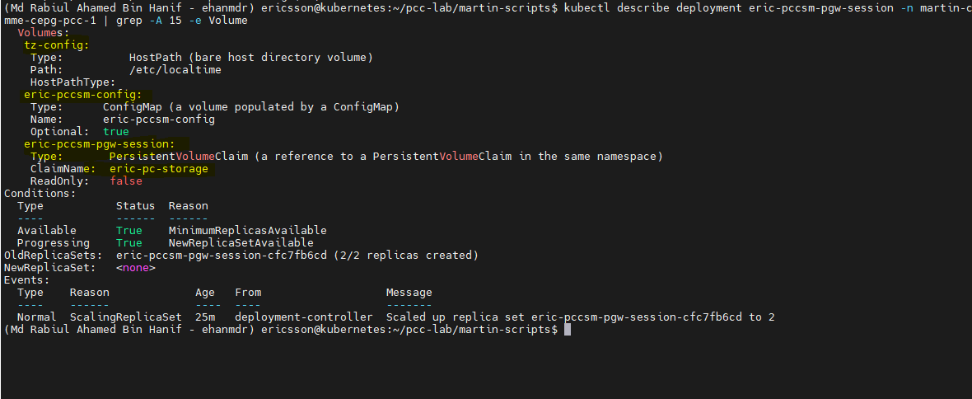
- This deployment is controlled by a replicaset. How many replicas are set for it ?
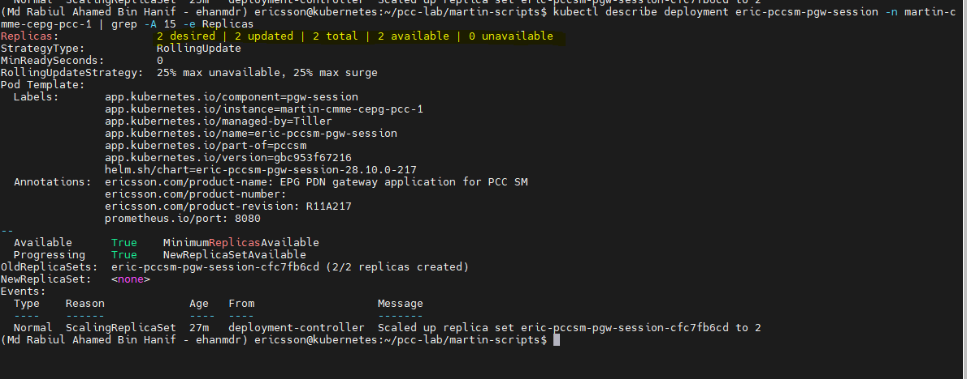

Section 3
Focus on the Statefulset called cp. Find a way to identify the following:
- How many containers is/are inside each pod and which image is/are they using?
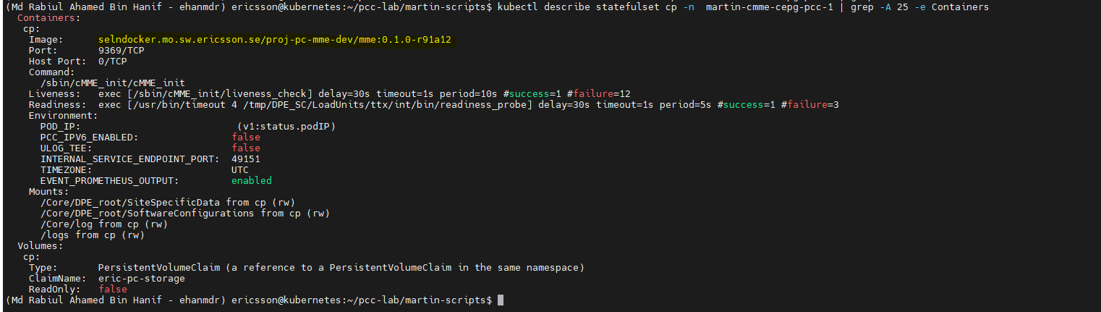
- How many volumes are attached to each pod?
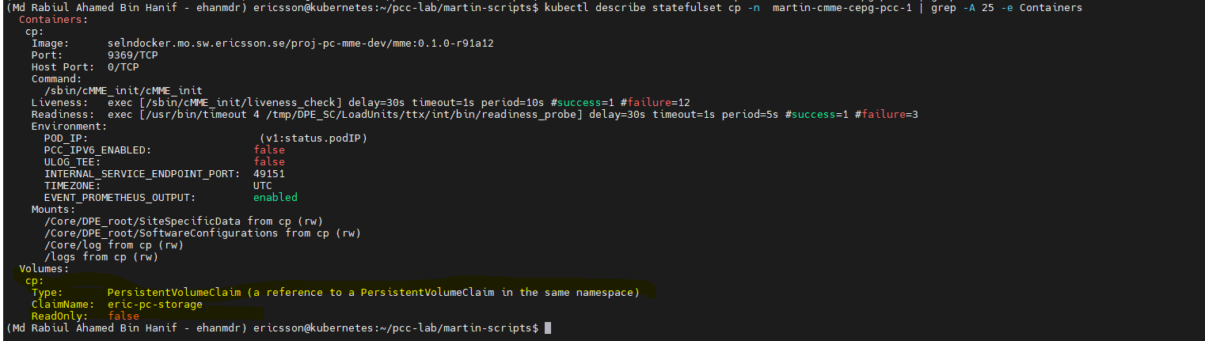
- How many replicas are set for this Statefulset ?
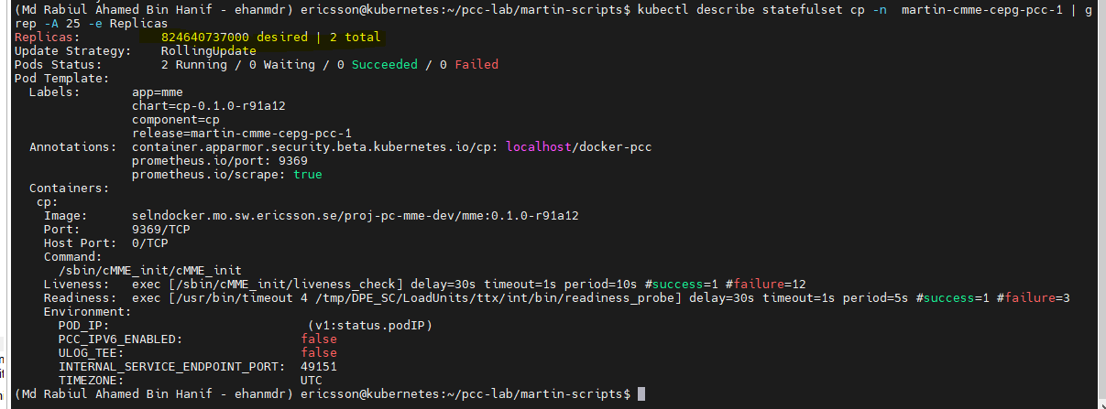
- What is the difference between the replicaset names used by a deployment (Section 1 & 2 above) and a Statefulset (this question)
We forget to answer this question after deleting all servicer then we notice!!!

Section 4
- If you want to display all the releases made by helm on this cluster, which helm command would you use?
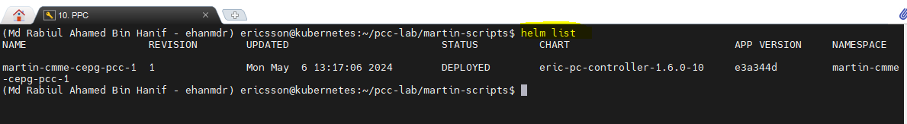
- In the script used in the preparation section, you should see a value.yaml file being used. Can you tell which ethernet interface on the VM the mme network attachment mme-rp-pcc-1-4g-ext1 will use ? (knowing that would allow you to do network capture)
Get the path for cat /home/ericsson/5gc_files_pkg/config/martin-cmme-cepg-pcc-1/
cat /home/ericsson/5gc_files_pkg/config/martin-cmme-cepg-pcc-1/values.yaml
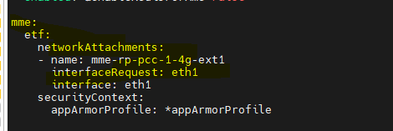

Section 5
Preparation: This PCC-PCG version comes with a GUI/HTTP based application called an “Embedded CNOM”. CPI documentations state the following:

Open a web browser. Ericsson recommends using the latest version of Google Chrome or Mozilla Firefox.

Enter the Embedded CNOM URL or IP-adress followed by the port configured for the Embedded CNOM in the address bar. use port forwarding to your kubernetes node here
The default port configured for the Embedded CNOM in the PCC is 8585.

Note:
A security exception must be granted in the web browser if an unsigned certificate is used.

On the login page, enter the <Username> and the <Password> in the respective fields and click Sign in. After initial installation, the sec_admin user with the SECURITY_ADMIN role is automatically created with the default password sec_admin.
Note: After initial login, the system may prompt the user to change the default password.
- On what IP:port in your lab this CNOM server can be reached at? Show your work.
http://1098.183.191:8585
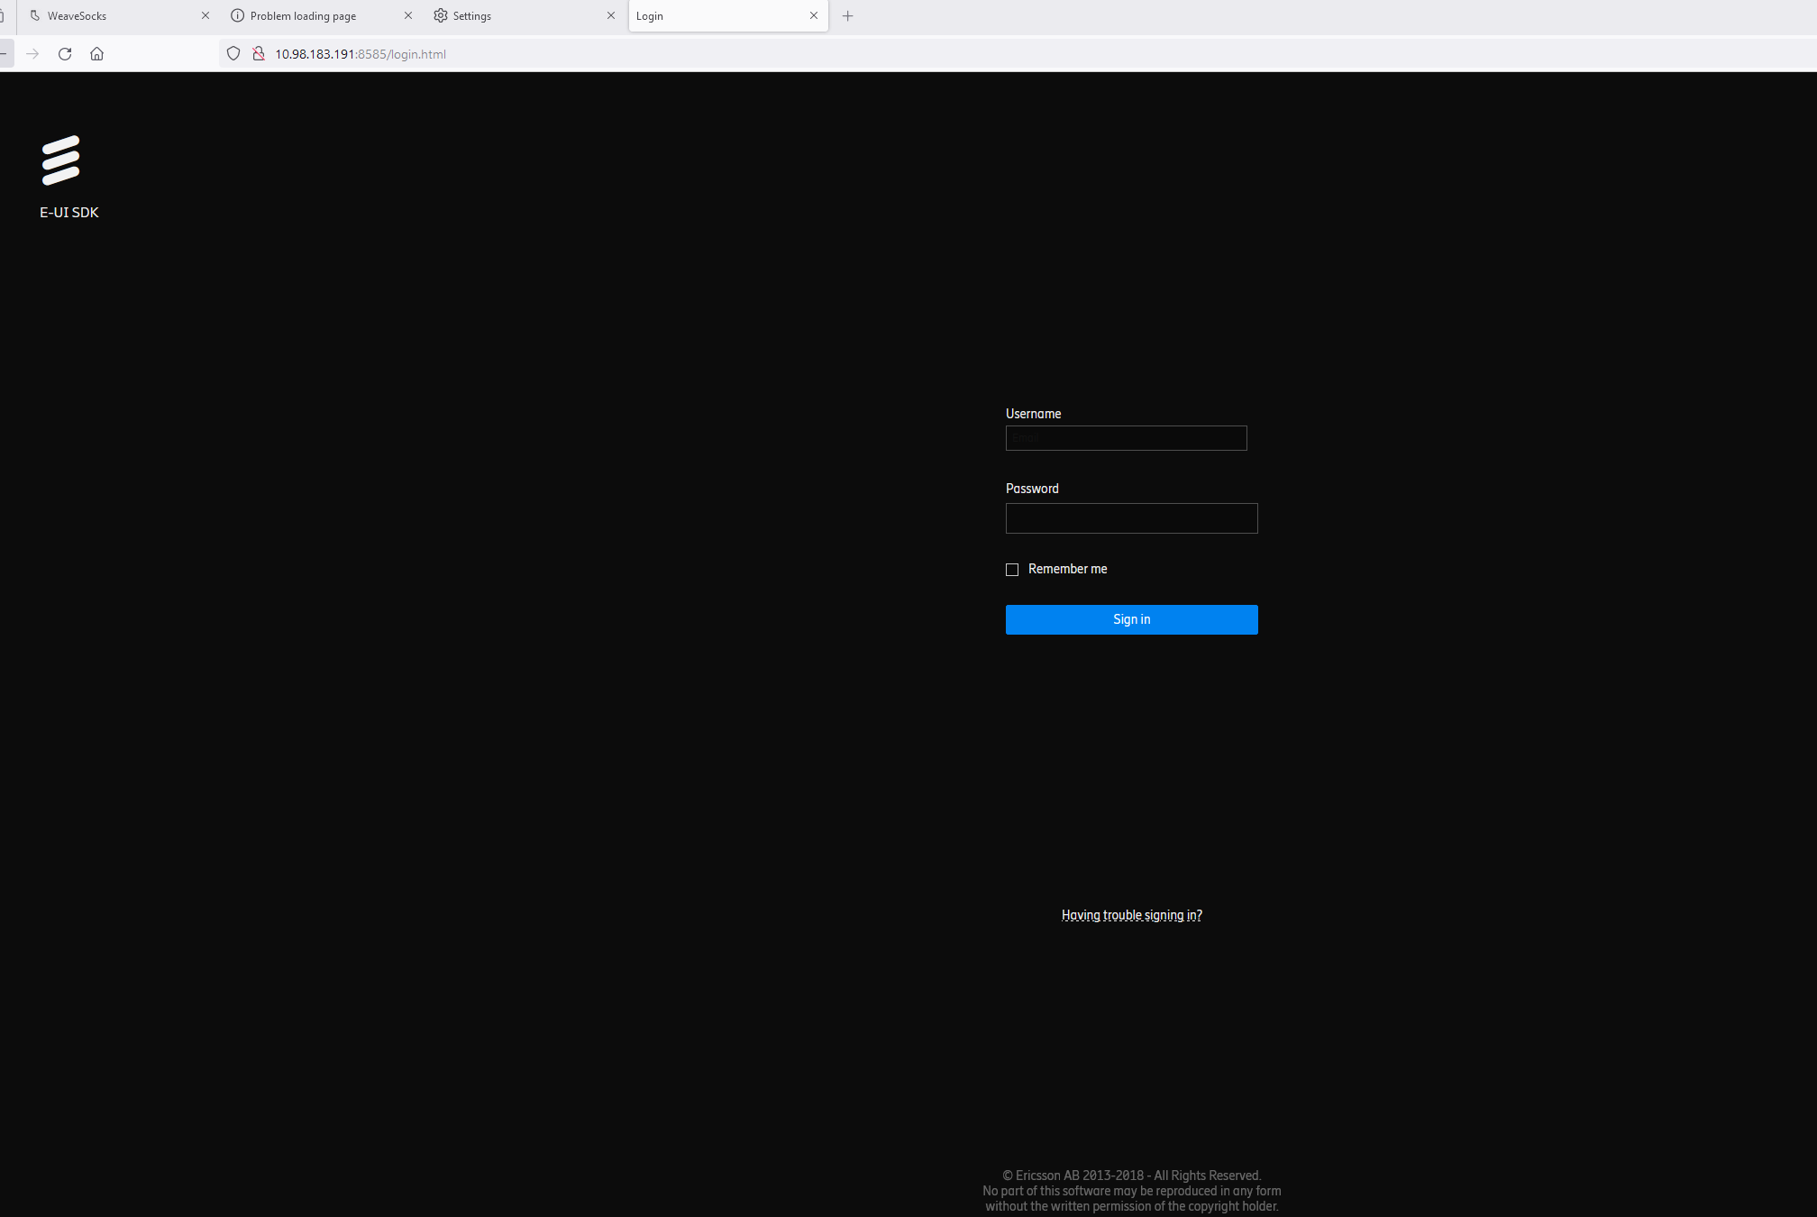
- After you are logged in the CNOM, provide a screen capture showing the ip or url you used.
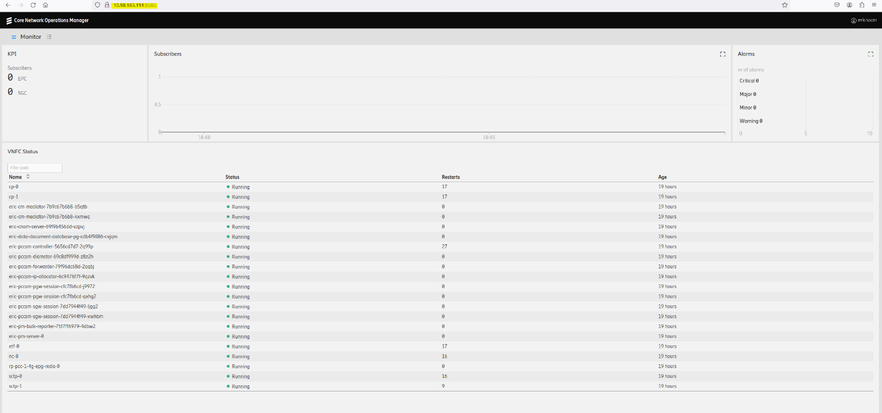
- OPTIONAL: if you are unable to make your port forwarding to work, which curl command would you use to prove the cnom server is listening and working correctly on your cluster ?

Section 6
- If this HELM release created some permanent volumes, what size are you expecting them to be ?
- Which resources on your release are using those permanent volumes?

- Your VM is also your storage node. Find where the volumes are physically located on your control-plane-worker-storage node.
- Using HELM command(s) only, delete the release created in the Preparation 2 section. Confirm the deletion with kubectl commands.
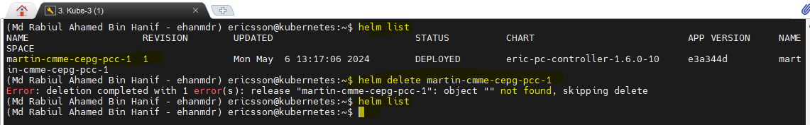

Section 7
A customer sends you the following output by email (also provided in the lab installation folder), they have a similar lab than you. However, you have no access to that cluster, answer the following inquiries if you can.
NOTE: If you cannot answer something below with the information you already have, what questions would you ask the customer to efficiently get to the answer?
- How can you tell this deployment was initiated via helm and not via manual kubectl create commands?
- By looking at the labels and the tiller
- deployment was initiated by HELM.
- Tiller is helm server-side component. It is responsible to deploy and managing helm.

- Which image is used by each container?
the image which has been used is
Image: selndocker.mo.sw.ericsson.se/proj-pc-epg-rel/backend:28R11A217
- Customer is saying this PCC was instantiated a week prior to sending you the email, can you confirm or deny? Can you tell at what date/time customer ran the kubectl describe command? *Hint* Do not get sidetracked by when or if you received an email, Trust the logs.
- Fri, 10 Jul 2020 18:36:40 +0000
It can be confirmed from logs after seeing the Start Date and the Restart Count of the deployment.
- We are not sure about the dates from events we can say that.
- 34 mins prior to send email ran the describe command.
- It means for example if email came today at 10AM.
- Today is the date: 10AM-34mins =9.26AM ran the describe command.
ericsson@kubernetes:~$ kubectl describe po -n martin-cmme-cepg-pcc-1 eric-pccsm-controller-5656cd7d7-px2gm
Name: eric-pccsm-controller-5656cd7d7-px2gm
Namespace: martin-cmme-cepg-pcc-1
Priority: 0
PriorityClassName: <none>
Node: kubernetes/10.81.10.93
Start Time: Fri, 10 Jul 2020 18:36:29 +0000
Labels: app.kubernetes.io/component=controller
app.kubernetes.io/instance=martin-cmme-cepg-pcc-1
app.kubernetes.io/managed-by=Tiller
app.kubernetes.io/name=eric-pccsm-controller
app.kubernetes.io/part-of=pccsm
app.kubernetes.io/version=gbc953f67216
helm.sh/chart=eric-pccsm-controller-28.10.0-217
pod-template-hash=5656cd7d7
Annotations: ericsson.com/product-name: PCC SM controller application for cloud
ericsson.com/product-number:
ericsson.com/product-revision: R11A217
k8s.v1.cni.cncf.io/networks-status:
[{
"name": "default-cni-network",
"interface": "eth0",
"ips": [
"10.244.0.10"
],
"mac": "0a:58:0a:f4:00:0a",
"default": true,
"dns": {}
}]
Status: Running
IP: 10.244.0.10
Controlled By: ReplicaSet/eric-pccsm-controller-5656cd7d7
Containers:
controller:
Container ID: docker://868f3ab3fde8837c004f37854066dc4af510cda5a3e7b1dbd3b08d9528ed3a94
Image: selndocker.mo.sw.ericsson.se/proj-pc-epg-rel/backend:28R11A217
Image ID: docker://sha256:64760ef3a5654f1d3500b4e73f4e0942df776f8f581190a27d61eacfe4b3b3c9
Port: <none>
Host Port: <none>
State: Running
Started: Fri, 10 Jul 2020 18:36:40 +0000
Ready: True
Restart Count: 0
Environment:
NUM_VCPUS: 2
Mounts:
/etc/localtime from tz-config (rw)
/var/run/secrets/kubernetes.io/serviceaccount from default-token-cfzr4 (ro)
confd:
Container ID: docker://82fd4d4cda3b94b2767040c1a21d524c44b5b54198a43df4e4b38096f86c167c
Image: selndocker.mo.sw.ericsson.se/proj-pc-epg-rel/confd:28R11A217
Image ID: docker://sha256:e7ca021cbed425381ff5860319f2673c349afff97d9daa1e2858c1ea3add97a6
Port: <none>
Host Port: <none>
State: Running
Started: Fri, 10 Jul 2020 18:36:43 +0000
Ready: True
Restart Count: 0
Environment:
CONFIG_MOUNT_PATH: <set to the key 'config-mount-path' of config map 'eric-pccsm-controller-config'> Optional: false
Mounts:
/etc/ericsson/config from controller-config (rw)
/etc/localtime from tz-config (rw)
/var/run/secrets/kubernetes.io/serviceaccount from default-token-cfzr4 (ro)
Conditions:
Type Status
Initialized True
Ready True
ContainersReady True
PodScheduled True
Volumes:
tz-config:
Type: HostPath (bare host directory volume)
Path: /etc/localtime
HostPathType:
controller-config:
Type: ConfigMap (a volume populated by a ConfigMap)
Name: eric-pccsm-controller-config
Optional: false
default-token-cfzr4:
Type: Secret (a volume populated by a Secret)
SecretName: default-token-cfzr4
Optional: false
QoS Class: BestEffort
Node-Selectors: <none>
Tolerations: node.kubernetes.io/not-ready:NoExecute for 300s
node.kubernetes.io/unreachable:NoExecute for 300s
Events:
Type Reason Age From Message
---- ------ ---- ---- -------
Normal Scheduled 34m default-scheduler Successfully assigned martin-cmme-cepg-pcc-1/eric-pccsm-controller-5656cd7d7-px2gm to kubernetes
Normal Pulled 34m kubelet, kubernetes Container image "selndocker.mo.sw.ericsson.se/proj-pc-epg-rel/backend:28R11A217" already present on machine
Normal Created 34m kubelet, kubernetes Created container
Normal Started 34m kubelet, kubernetes Started container
Normal Pulled 34m kubelet, kubernetes Container image "selndocker.mo.sw.ericsson.se/proj-pc-epg-rel/confd:28R11A217" already present on machine
Normal Created 34m kubelet, kubernetes Created container
Normal Started 34m kubelet, kubernetes Started container
ericsson@kubernetes:~$

Section 8
- Adjust the prefix yourname with your first name or signum in all the below sub questions.
- Make your own copy of the script:
cd ~/pcc-lab/martin-scripts && cp create_student_cMME_cEPG_pcc1.sh ../create_Rabiul_student.sh && cd ..
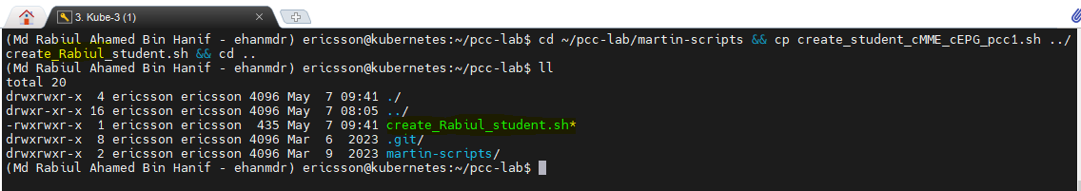

- Look at the script your just created (create_yourname_student.sh). Understand what it does.
The helm install command install the helm chart into the namespace martin-cmme-cepg-pcc-1, In this command the helm chart is located in location ~/PCC_1_Drop_13/eric-pc-controller-1.6.0-10.tgz. And it will use values.yaml file for the installation provided by the user.
- Modify the script create_rabiul_student.sh to create a new helm release :
  - name the release rabiul-student-release
  - create the release in a namespace called rabiul-student-namespace
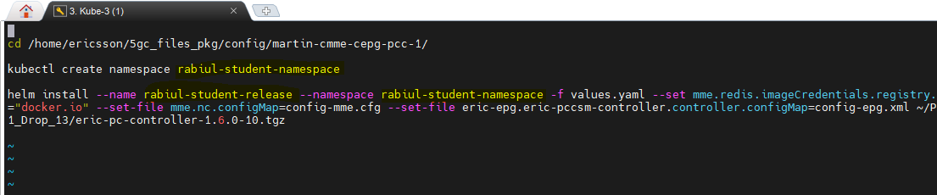
- Disable the epg and mme NOT from the value.yaml file, but from the helm command line. (you will need to look at the helm charts and investigate if there are variables in the value file that could be used to perform this task)
helm install –name rabiul-student-release --namespace aruna-student-namespace -f values.yaml --set tags.mme=false --set tags.epg=false --set mme.redis.imageCredentials.registry.url="docker.io" --set-file mme.nc.configMap=config-mme.cfg --set-file eric-epg.eric-pccsm-controller.controller.configMap=config-epg.xml ~/PCC_1_Drop_13/eric-pc-controller-1.6.0-10.tgz
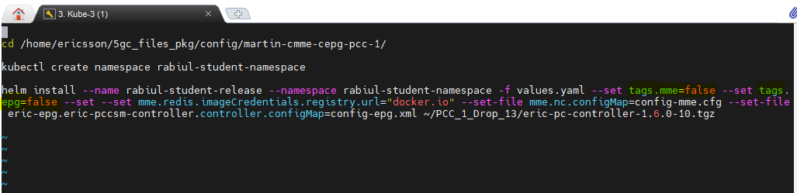:
- Deploy your slimed down release. Provide an output to show the command used and other relevant information after you were successful. (script/helm commands/pods/services/etc.)
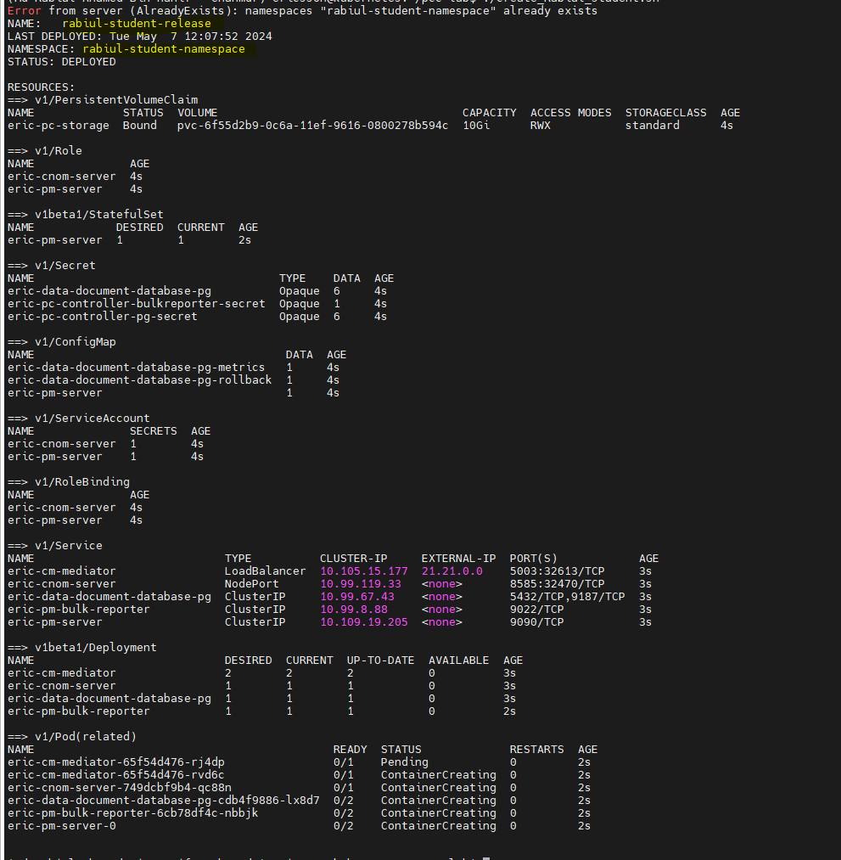
- Log in to the cnom server you just deployed. Show your work and the full url you used.
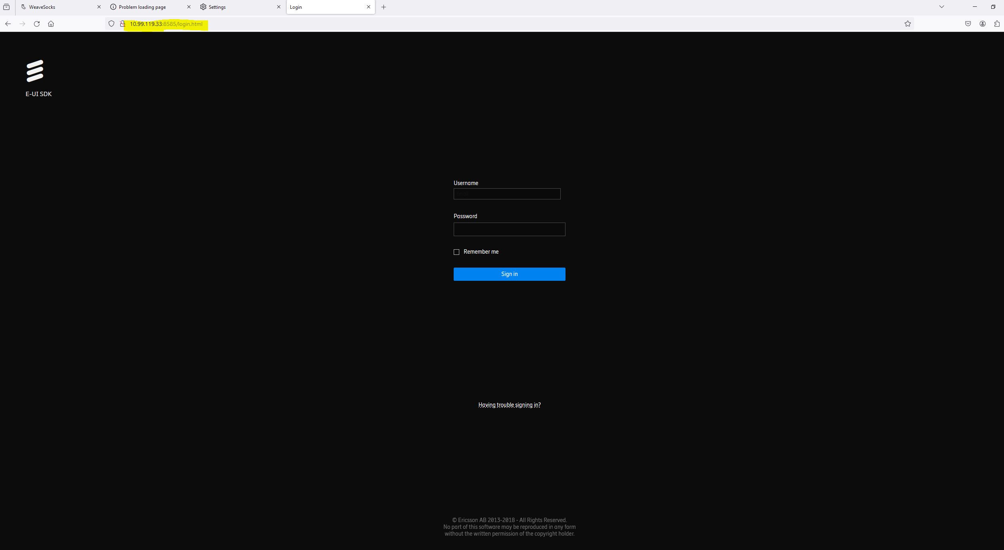

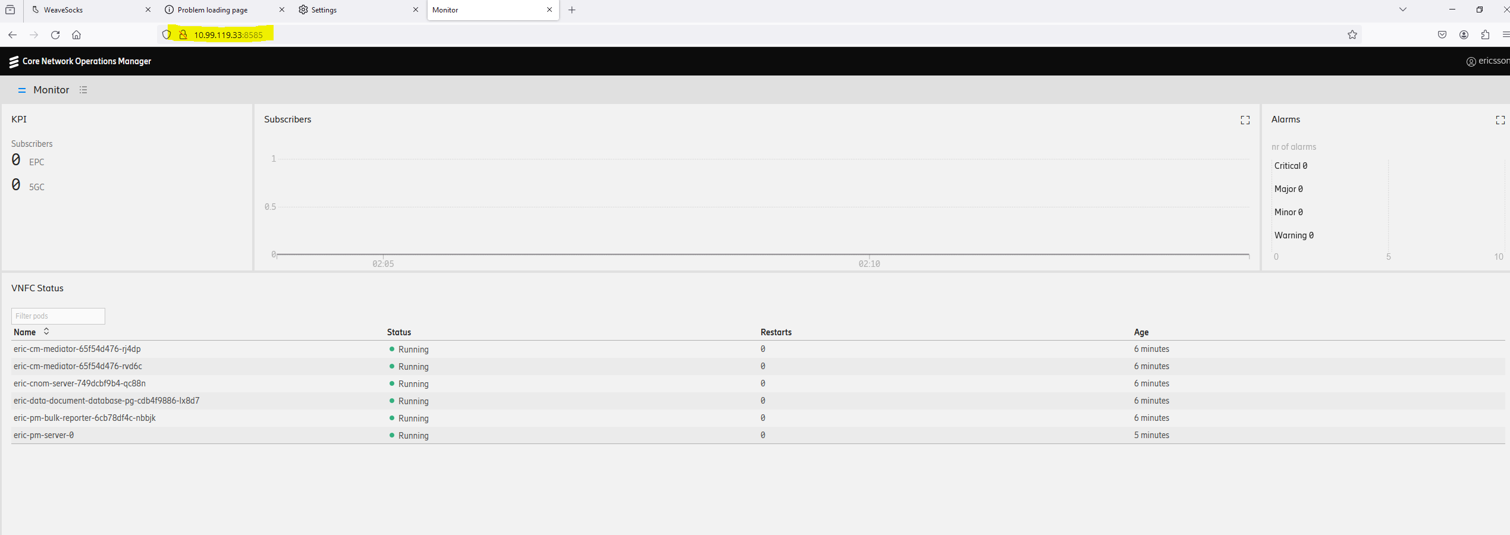

Section 9
- Gracefully delete all the components you created in above question with the least number of commands. Since you used your own name for your latest deployment, you can’t use the clean-up procedure from the import document
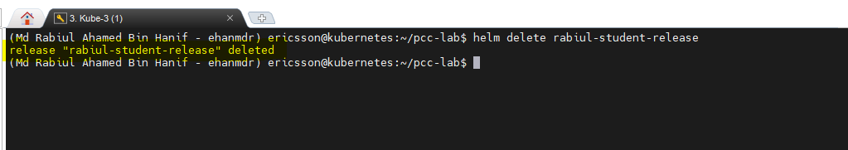
- Reset Kubernetes cluster as per import documentation
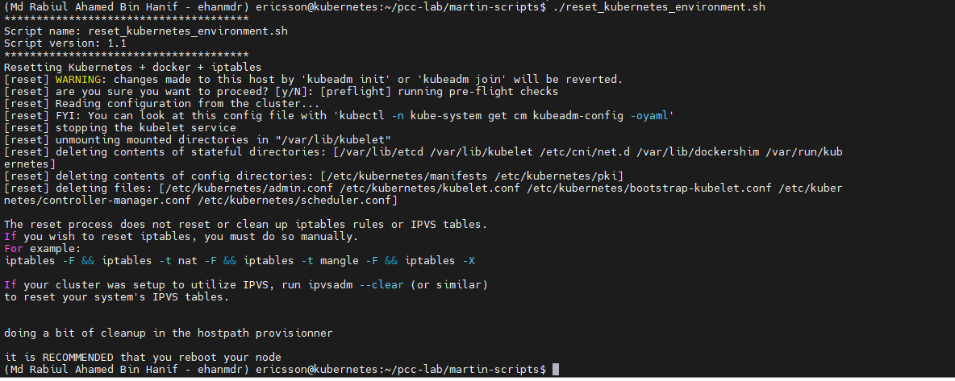
- Poweroff all VMs, as per import documentation
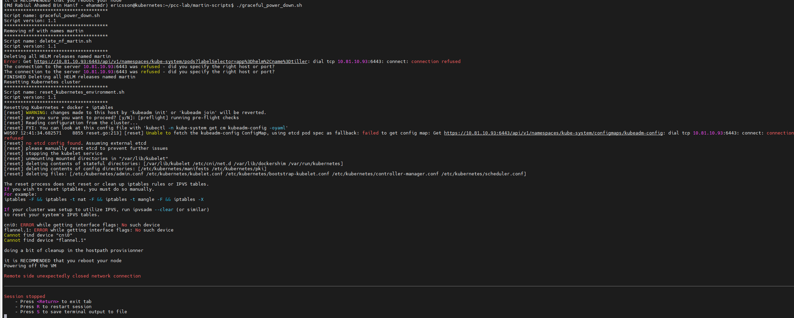

- Send all your answers to your instructor via email.
All answer will send to the vikrant.v.kumar@ericsson.com

Conclusion:
- Send all your answers by email to your instructors. Ensure the title of the email is the name of this exercise.
- If the file is too big, use zip to compress it.

