Warm-up #2
Cloud Native Operations : Kubernetes and Helm

Martin Chabot

Group Exercises #2 Warm-up questions

Instructions
- Be mindful of the words used throughout this document.
- Work as a team, help each other’s and try not to do all the exercises on your own.
- Every question should be discussed with your peers to ensure all the options have been looked at.
- Some answers will vary between labs. Some answer will be the same. Don’t cut’n paste someone else’ answer, find the answer from your own lab.
- Cut ’n paste the command you used AND the output you received to answer each question in this word document. If the output is long, highlight the section you want the instructor grading your exercises to focus on.
- Some of the questions may be tricky, sometimes an error output may be a valid answer.

Example of a good answer:
Question: What ip address the pod busybox1 has?

Preparation:
- Power up FRR VM in VirtualBox
- Power up Kubernetes PCC VM in VirtualBox.
- Connect to VM via SecureCRT/Putty/MobaXterm as per import documentation.
- Initialize the Kubernetes cluster, as per import documentation no more, no less. (do not start the PCC application yet).

Section 0
Your name: Md Rabiul Ahamed Bin Hanif
Your team leader is: Arunakumari Yedurupaka

Section 1
    - Which Kubernetes / Helm / Docker version is installed on this lab
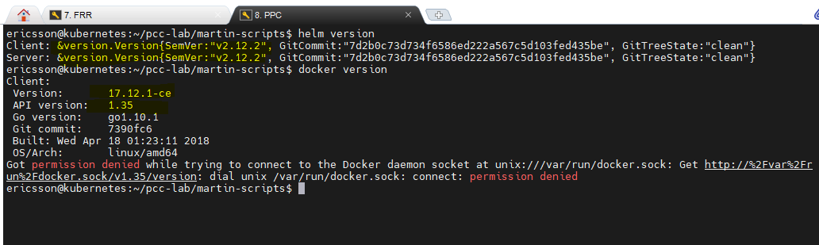
    - On your previous lab, you were able to list all the pods in all namespaces with the command “kubectl get pods -A”. Can you list all the pods in this lab with the same command?
Explain #1 what you see #2 what could be the reasons and #3 any workaround you may think of.
- Unknown shorthand flag was seen.
- Ensure you're using a version of kubectl that supports the -A flag. This flag was introduced in Kubernetes 1.14. If you're using an older version, you might not have support for it.
- Work --all-namespaces

Section 2
    - How many node(s) this cluster has?
- Just one node
    - Which ip(s) each control-plane(s) and worker(s) node is/are reachable on ?
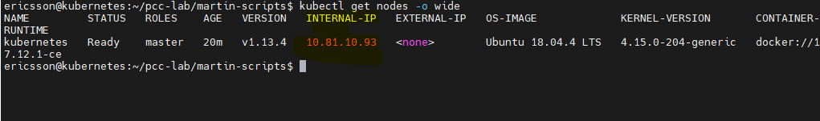

Section 3
- How much cpu and memory each control-plane(s) and worker(s) in the cluster is/are allowed to use ?
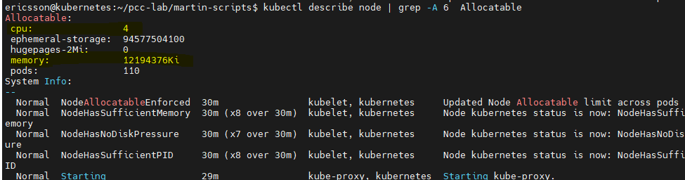
- Which container runtime is used in this lab ?
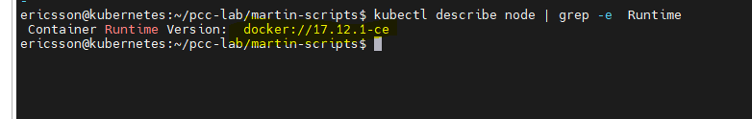

Section 4
- As per the preparation section, you used the init script to start all the components of the cluster (kubernetes/helm/calico/flannel/metallb). Which command(s) would you use to verify that all those components (pods) are all ready and in a healthy state?
- All pods are ready and state is healthy
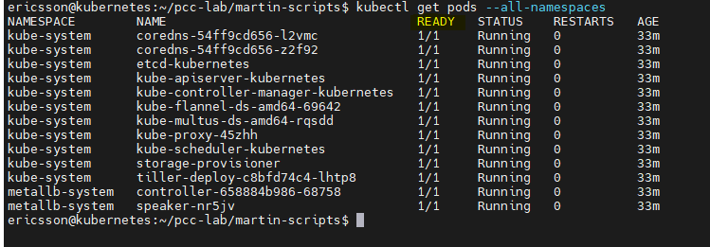

Section 5
- Personalize Lab Environment
  - This lesson will change the prompt of your lab to personalize it to you. Log in to your pcc-pcg lab using the ssh session you created during your lab installation. Process the following script and answer the questions:
    - wget -qO /tmp/prompt.sh https://raw.githubusercontent.com/martin-eric/cn-class/main/prompt_setup.sh && bash /tmp/prompt.sh && rm -rf /tmp/prompt.sh
- Run the command I put my name and signame.

  - Logout and log back into all your pcc-pcg sessions. Notice your prompt should reflect your name and signum.
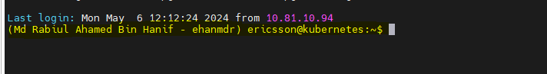

Conclusion:
- Send all your answers by email to your instructors. Ensure the title of the email is the name of this exercise.
- If the file is too big, use zip to compress it.

