Timeseries Analysis

# Introduction

In this practical, you will use a computer programming language called Python to perform timeseries analysis to explore how CO2 concentrations in our atmosphere have changed through time. You will do this by working through an interactive notebook exercise that combines the instructions for this class with snippets of computer code that you will executed in order as you work through the exercises.

This laboratory session is **not** designed to teach you how to be a computer programmer! That would take a little longer than a two hour class. Rather you will **use** code that is already written and tested in order to better understand how we can analyse time series. Hopefully you will also get an appreciation for how powerful computer models can be in helping us to analyse data and automate workflows. The principles involved are used across a wide range of modelling packages that you might encounter in your professional lives.

## Intended Learning Outcomes

In the IPython notebook you will open (instructions below) are step-by-step instructions to introduce the IPython environment, perform timeseries analysis, and to generate plots and figures that could be used in project work. The aims of this lab are:

* Understand what a time series is
* Familiarise yourself with important concepts in time series analysis
* Examine the changing CO2 concentrations in the Earth's atmosphere through time
* Get an introduction to the use of progamming languages such as Python for performing data analysis

# Download and Run the IPython Notebook

## Open the notebook

The notebook file **MaunaLoaTimeSeries.ipynb** is hosted in an online repository (Github) and can be accessed an run using an online computing environment called MyBinder. Please click on the link on Moodle to open the notebook.

If you have Anaconda installed, the files can also be found in the lab folder on Moodle and opened on your own computer (or a Glasgow Anywhere remote desktop). Download this file to a location on your personal space where you usually store your coursework and put it in a new folder that will contain all of your work for this lab. The launch Jupiter Notebook

* *Click Start*  *and navigate to* ***Anaconda3 -> Jupyter Notebook***
* *Navigate to the folder with the MaunaLoaTimeSeries.ipynb and click on it to open it.*

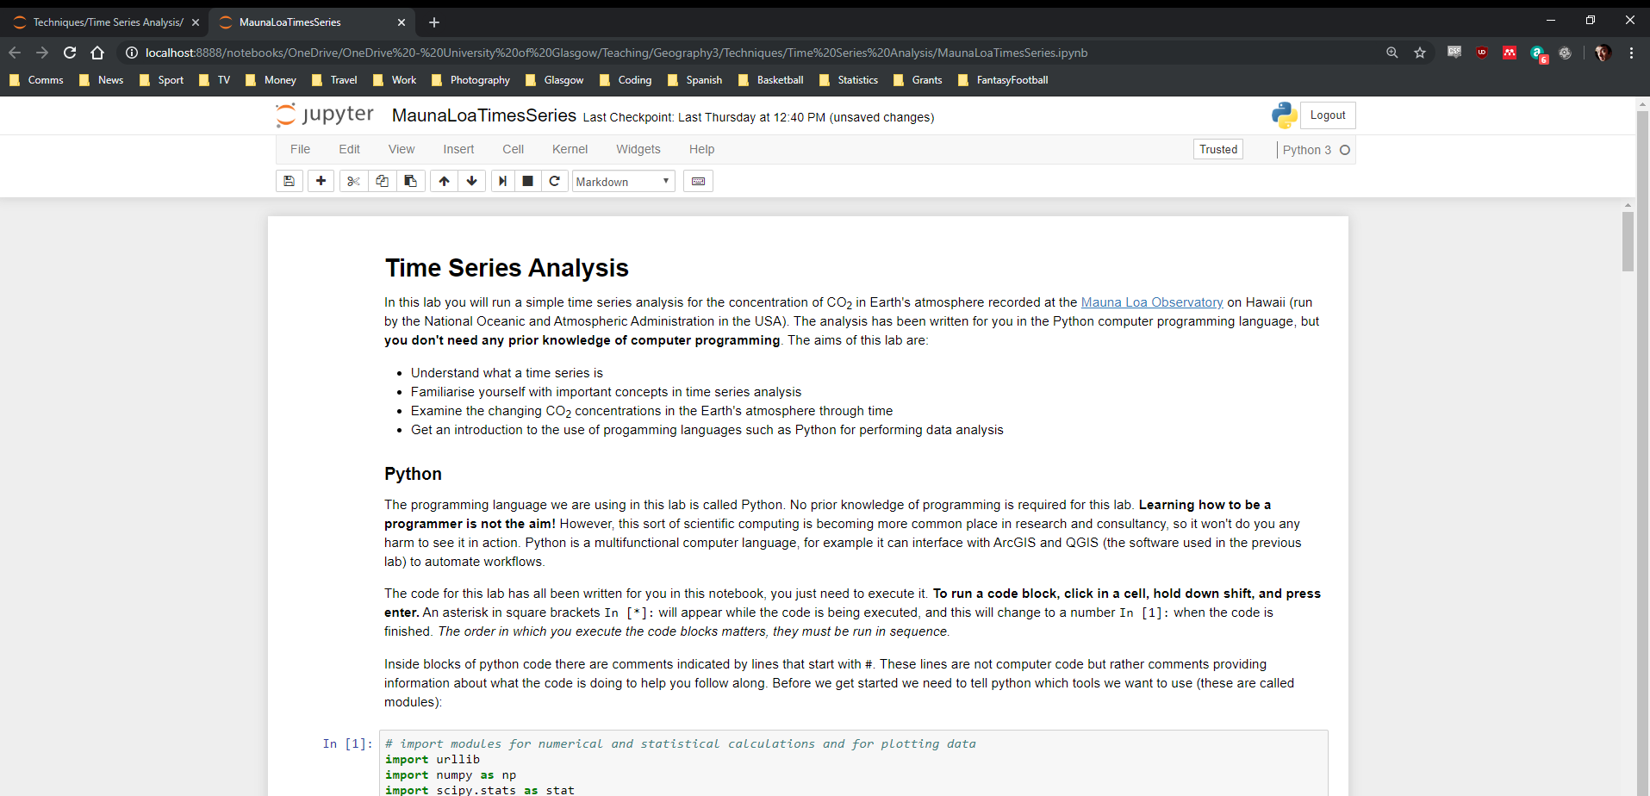

Figure 1: The Jupyter notebook environment with instructions for Mauna Loa Time Series practical class

# Work through the exercises

The IPython Notebook (Figure 1) is a document that combines text and computer code. Your task is to **carefully read the text boxes sequentially and run each of the blocks of Python code** that have been provided in the IPython notebook.

To run a code block in the IPython notebook, click in a code cell, hold down **shift**, and press **enter**. An asterisk in square brackets In [*]: will appear while the code is being executed, and this will change to a number In [1]: when the code is finished. The order in which you execute the code blocks matters, they must be run in sequence. As you get more familiar with this environment, feel free to experiment with typing your own code into a cell and running that, but you will be given explicit instructions when you are required to change anything.