Department of Information & Communication Technology
Islamic University, Kushtia-7003

Lab Report
on
Signals and Systems Laboratory
This Lab Report is submitted for the partial requirement of
ICT-2108 (Signals and Systems Laboratory)
Date of Submission: [DD-MM-YYYY]
Submitted by | Submitted to
Name: [Your Name]  Roll: [Your Roll]  Reg. No: [Your Reg. No]  Semester: 2nd Year (1st Semester)  Session: 2019-2020 | Dr. Md. Sadek Ali  Associate Professor  Department of Information &  Communication Technology  Islamic University, Kushtia-7003

EXPERIMENT NO: 11
NAME OF THE EXPERIMENT: Computation of the Discrete Fourier Transform (DFT) and the Power Spectral Density (PSD) of a sampled signal.
AIM:
- To compute the DFT of a sampled signal using MATLAB.
- To compute and plot the power spectral density (PSD) of the sampled signal and verify the result.
Objectives:
After completing this experiment, we are able to know about this:
- How a continuous-time signal is sampled at a given sampling rate.
- How to compute the DFT of a sampled signal and identify its frequency components.
- How to compute the power spectral density from the DFT coefficients.
- How to verify the result using Parseval’s theorem.
- Implement the course concept using MATLAB.
Problem Statement:
The signal x(t) is defined below. The signal is sampled at a sampling rate of 1000 samples per second. Find the DFT of the sampled signal and also compute the power spectral density. Verify the result.
x(t) = cos(2π × 47t) + cos(2π × 219t), 0 ≤ t ≤ 10
x(t) = 0, otherwise
THEORY:
Sampling: Sampling is the process of converting a continuous-time signal x(t) into a discrete-time sequence x[n] by taking its values at equally spaced instants t = nTₛ, where Tₛ = 1/fₛ is the sampling period and fₛ is the sampling frequency. For the given signal, fₛ = 1000 Hz so Tₛ = 0.001 s. According to the Nyquist sampling theorem, fₛ must be at least twice the highest frequency present in the signal. Here the highest frequency is 219 Hz and fₛ = 1000 Hz > 2 × 219 Hz = 438 Hz, so no aliasing occurs.
Discrete Fourier Transform (DFT): The DFT converts a finite sequence of N samples from the time domain to the frequency domain. For a sequence x[n] of length N, the DFT is defined as
X[k] = Σ x[n] e^(−j2πkn/N), k = 0, 1, 2, …, N−1 (sum over n = 0 to N−1)
and the inverse DFT is
x[n] = (1/N) Σ X[k] e^(j2πkn/N), n = 0, 1, 2, …, N−1
The k-th DFT bin corresponds to the frequency fₖ = k·fₛ/N, so the frequency resolution is Δf = fₛ/N. In MATLAB the DFT is computed efficiently with the Fast Fourier Transform function fft().
Power Spectral Density (PSD): The power spectral density describes how the power of a signal is distributed over frequency. Using the DFT coefficients, the (periodogram) estimate of the PSD is
P[k] = |X[k]|² / (N · fₛ) (W/Hz)
Since x[n] is real, the spectrum is symmetric about fₛ/2, so only the first half of the spectrum (0 to fₛ/2) is plotted. The total average power of the signal is obtained by summing the PSD over all frequency bins:
P_total = Σ P[k] · Δf = (1/N²) Σ |X[k]|²
Parseval’s theorem states that the power computed in the time domain equals the power computed in the frequency domain: (1/N) Σ |x[n]|² = (1/N²) Σ |X[k]|². We use this relation to verify the result.
Calculation:
Here, the sampled signal is
x[n] = cos(2π × 47 × n/1000) + cos(2π × 219 × n/1000)
Where,
- Sampling frequency, fₛ = 1000 Hz; Sampling period, Tₛ = 0.001 s
- Time vector, t = 0 : 1/fₛ : 10 − 1/fₛ; number of samples, N = 10 × 1000 = 10000
- Frequency resolution, Δf = fₛ/N = 1000/10000 = 0.1 Hz
- Expected DFT peaks: k = 47/0.1 = 470 and k = 219/0.1 = 2190 (and the mirror bins 9530 and 7810)
- Expected peak magnitude: each cosine of amplitude 1 gives |X[k]| = N/2 = 5000
- Expected peak PSD: (5000)²/(10000 × 1000) = 2.5 W/Hz at each of 47 Hz and 219 Hz
- Expected total power: 0.5 + 0.5 = 1 W
MATLAB Code:
clc; clear all; close all;

fs = 1000; % sampling rate (samples/second)
Ts = 1/fs; % sampling period
t = 0:Ts:10-Ts; % time vector, 0 <= t <= 10
N = length(t); % number of samples

x = cos(2*pi*47*t) + cos(2*pi*219*t); % sampled signal

% ---- DFT ----
X = fft(x); % N-point DFT
mag = abs(X); % magnitude spectrum
f = (0:N-1)*fs/N; % frequency axis (Hz)

% ---- Power Spectral Density ----
psd = (mag.^2)/(N*fs); % periodogram PSD (W/Hz)

% ---- Plotting (first half of the spectrum) ----
half = 1:N/2;
figure(1);
subplot(2,1,1); plot(t(1:300), x(1:300));
title('Sampled signal x(t)'); xlabel('Time (s)'); ylabel('Amplitude'); grid on;
subplot(2,1,2); plot(f(half), mag(half));
title('Magnitude spectrum |X(k)|'); xlabel('Frequency (Hz)'); ylabel('|X(k)|'); grid on;

figure(2);
plot(f(half), psd(half));
title('Power Spectral Density'); xlabel('Frequency (Hz)'); ylabel('PSD (W/Hz)'); grid on;

% ---- Peak detection ----
[pk, loc] = findpeaks(mag(half), 'MinPeakHeight', 1000);
fprintf('Peak frequencies = %g Hz and %g Hz\n', f(loc(1)), f(loc(2)));
fprintf('Peak magnitudes = %g\n', pk);

% ---- Verification (Parseval's theorem) ----
P_time = mean(x.^2);
P_freq = sum(abs(X).^2)/N^2;
fprintf('Power (time domain) = %.4f W\n', P_time);
fprintf('Power (frequency domain) = %.4f W\n', P_freq);
Algorithm:
- Start.
- Define the sampling rate fₛ = 1000 Hz and create the time vector t from 0 to 10 s with step 1/fₛ.
- Generate the sampled signal x = cos(2π·47t) + cos(2π·219t).
- Compute the DFT of x using the fft() function.
- Compute the magnitude |X[k]| and the frequency axis f = k·fₛ/N.
- Compute the PSD using P[k] = |X[k]|²/(N·fₛ).
- Plot the signal, the magnitude spectrum and the PSD against time/frequency.
- Find the peak frequencies and verify the result using Parseval’s theorem.
- Stop.

Output:
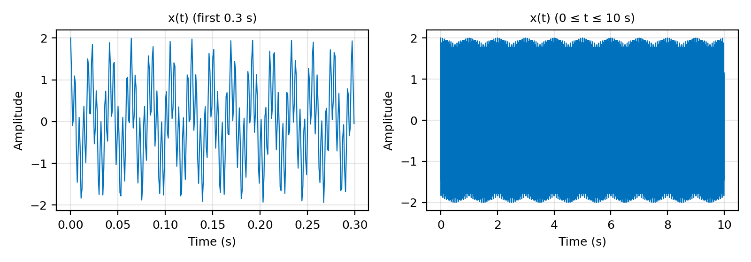
Figure 1: The sampled signal x(t).
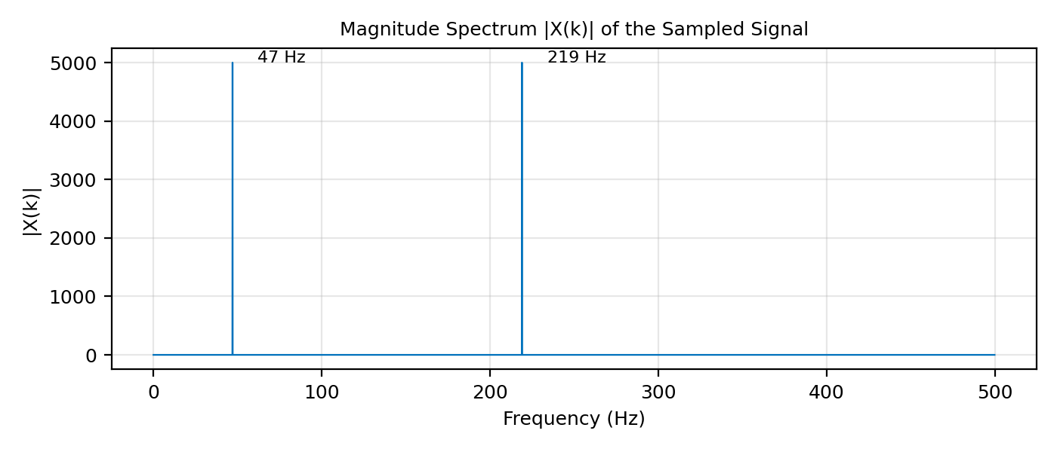
Figure 2: Magnitude spectrum (DFT) of the sampled signal.
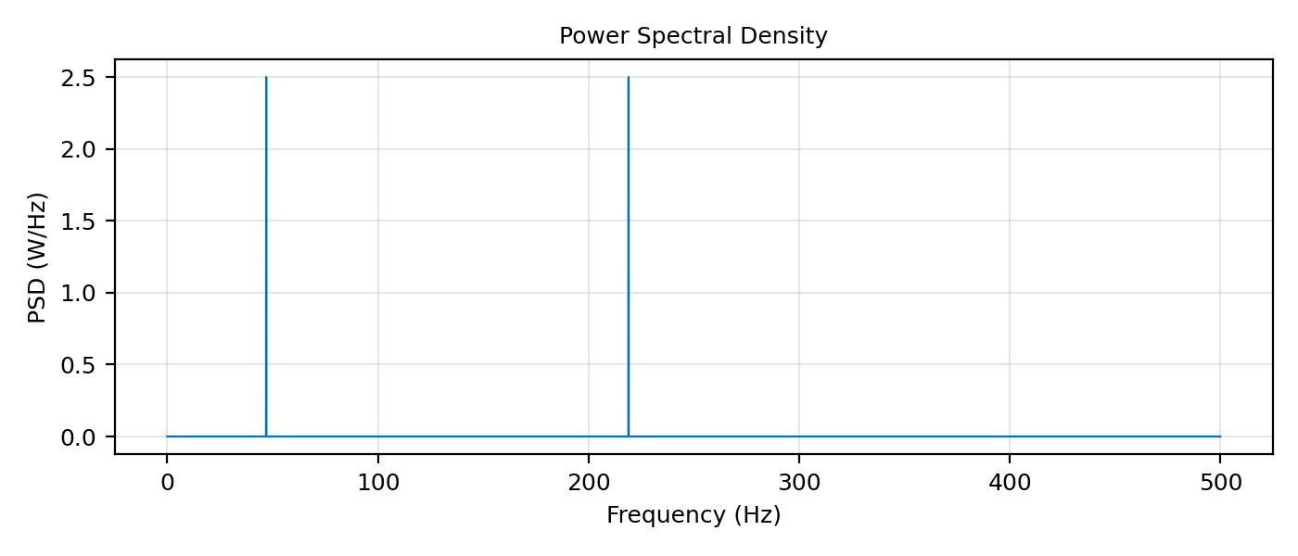
Figure 3: Power spectral density of the sampled signal.
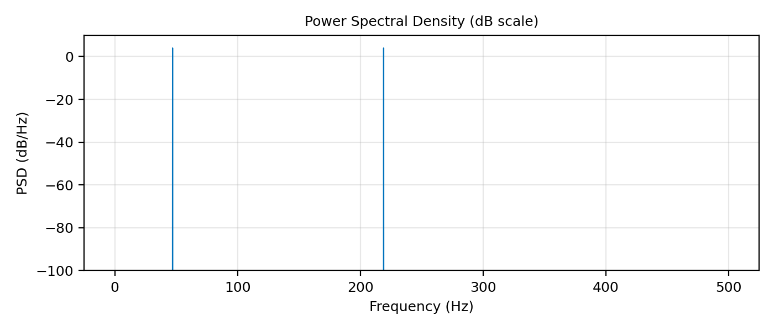
Figure 4: Power spectral density in dB scale.
Command Window Output:
Peak frequencies = 47 Hz and 219 Hz
Peak magnitudes = 5000 5000
Power (time domain) = 1.0000 W
Power (frequency domain) = 1.0000 W

Frequency | DFT bin k | |X[k]| | PSD (W/Hz)
47 Hz | 470 | 5000 | 2.5
219 Hz | 2190 | 5000 | 2.5

Result and Discussion:
- The DFT of the sampled signal shows exactly two sharp peaks at 47 Hz and 219 Hz, which are the frequencies of the two cosine components of x(t).
- Each peak has a magnitude of N/2 = 5000 (N = 10000 samples), as predicted by the calculation.
- The 10 s record contains an exact integer number of cycles of both tones (470 and 2190 cycles), so there is no spectral leakage and the peaks are clean.
- The sampling rate of 1000 Hz is greater than twice the highest frequency (2 × 219 = 438 Hz), so there is no aliasing.
- The PSD has the same two peaks, each of 2.5 W/Hz. Summing the PSD over frequency gives a total power of 1 W (0.5 W per cosine), which matches the time-domain power. Thus Parseval’s theorem is verified.
- The frequency resolution is Δf = 0.1 Hz; a longer observation time would give a finer resolution.

