Week 3 – Assignment 2.

|  |  |
| --- | --- |
| **Students name** | Dilnaza Maratova, Milana Aligaziyeva, Dana Orenkyzy, Azim Kassymbayev |

**Task 1.**

**Exercise 1.**

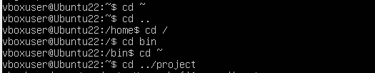

Working with cd command

**Exercise 2-4.**



Creating a project and a python file (program.py) in order to be able to edit.

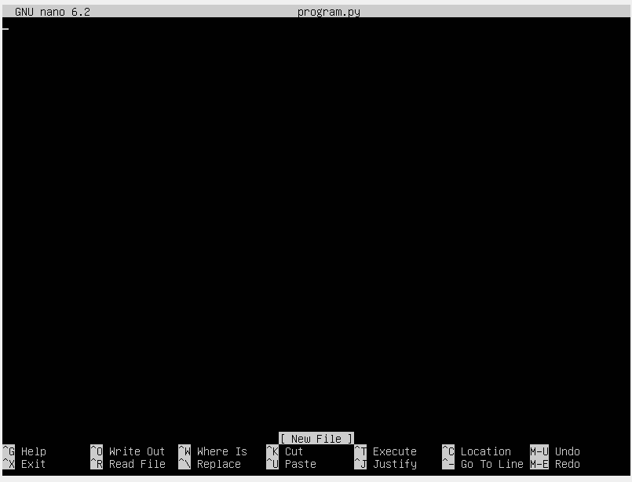

Here opens the python text editor GNU nano 6.2 named program.py.

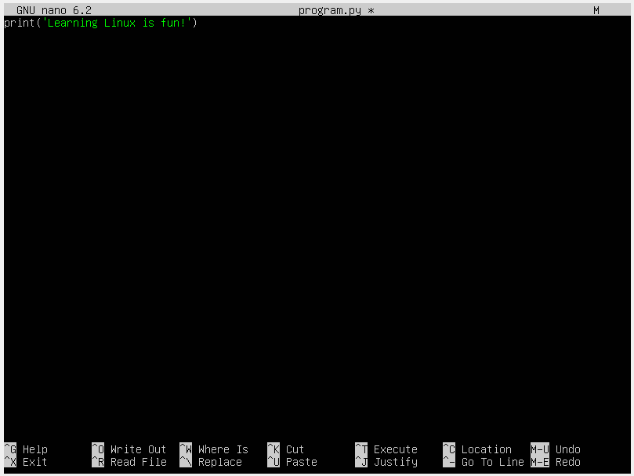

We edit it and write “print(‘Learning Linux is fun!’) then save it in our python file by pressing Ctrl + Y.



Then we go back to the command prompt and calling our file by “python3 program.py” and see the results.

**Task 2.**

