REPORT FOR ASSIGMENT 02: INSTALLING VIRTUAL MACHINES FOR ORACLE VIRTUALBOX.

|  |  |  |
| --- | --- | --- |
| **Student Name Surname** | **Student ID** | **Date** |
| Dilnaza Maratova | 211128 | 12/12/2022 |

SCREENSHOTS 1, 2, 3, 4, 5.

**4.1.2. Download VirtualBox and Extensions Pack**

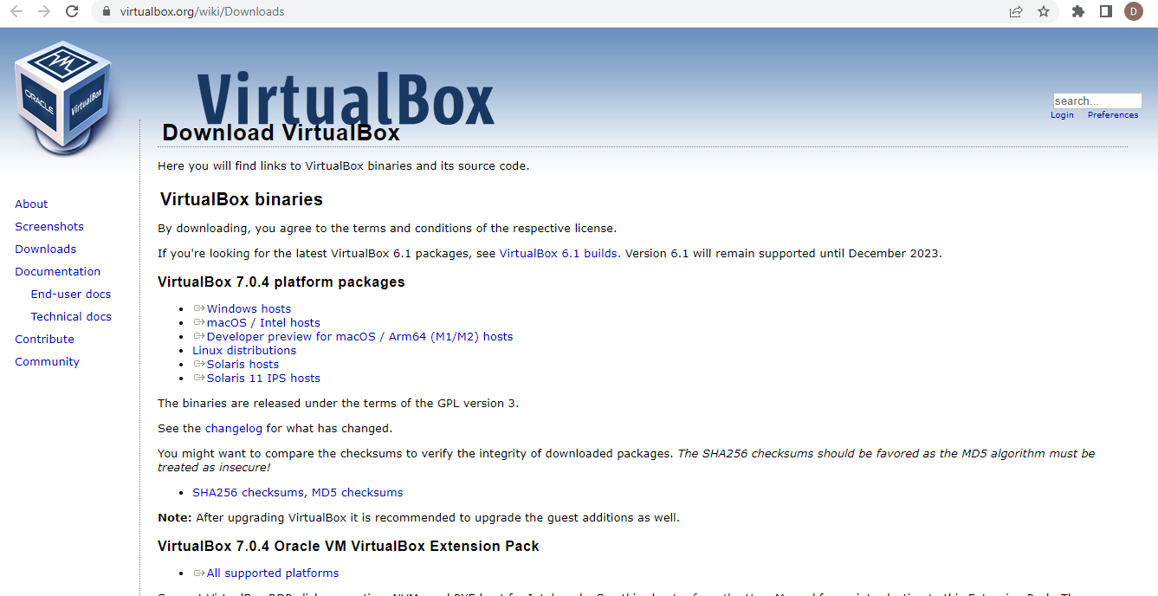

**4.1.3. Install VirtualBox**

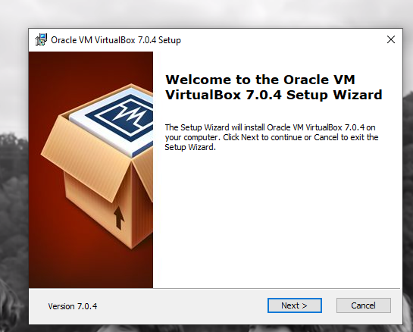

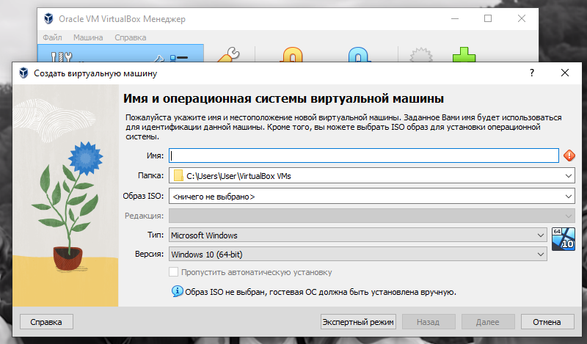

**4.2. Download and install Ubuntu 22.04.1 LTS**

