Report for assignment 6: Linux/UNIX Shell Environment Variables

|  |  |  |
| --- | --- | --- |
| **Student Name Surname** | **Student ID (nV)** | **Date** |
| Dana Orenkyzy, Dilnaza Maratova, Milana Aligaziyeva |  | 23.01.2023 |

3.1. Table. Shell Environment Variables Analyze.

|  |  |  |  |
| --- | --- | --- | --- |
| Variable | Short Description | Type:ro-wr | Your Linux Value |
| PATH | Path specifies directories that system runs |  | /home/vboxuser |
| HOME | The location of the currently user’s home directory |  | ~ |
| TERM | This file specifies instructions to achieve some commands like display color |  | xterm |
| PS1 | Default interaction prompt |  | Export PS1 |
| PS2 | Continuation interactive prompt |  | Export PS2 |
| LOGNAME | Login User Name (account) | WR | stud |
| MAIL | Intelligent mail processing system |  | mail-f/var/mail/user |
| MAILCHEK | Specifies how often bash checks for email |  | $mail_check |
| HOSTNAME | Show or set the system’s host name |  | localhost |
| HOSTTYPE | A string where the bash is running on |  | Linux |
| HISTSIZE | Max number of commands |  | Export |
| HISTFILE | The name of the file where command history is saved |  | Unset histfile |
| TMOUT | Default timeout for the read builtin |  | Logout |
| IGNOREEOF | If “IGNOREOF=10” executed |  | Exit |
| IFS | Internal Field Separator – splits after expansion |  | Read command |
| SECONDS | The number of seconds are indicated |  | Show seconds |
| OSTYPE | Auto set to a string on which bash is executed |  | GNU/Linux |
| PWD | The current directory that was set by cd command |  | /home/vboxuser |
| OLDPWD | The previous directory that was set by cd command |  | /home/vboxuser/project |
| EDITOR | Default variable for some app to invoke the editor |  | Gedit filename |
| RANDOM | Random int is generated between 0 and 32767 |  | 456 |
| SHLVL | incremented by one each time an instance of bash is started |  | 3 |
| SHELL | The full pathname of the shell |  | Shell |
| PROMPT_COMMAND | Define a command that is executed every time before showing PS1.  For PS1, PS2, PS3, and PROMPT_COMMAND, dynamically calculated escape sequences exist, such as:  \w - current directory, full path;  \W - current directory, without path;  \u - username; \h - hostname;  \$ - $ for user and # for root;  \t is the time of day; \d - current date;  \s - the current shell; and others. | WR | “Is -l” |
| EUID | Expands to the effective user ID | RO | uid |
| PPID | The process ID of the shell’s parent | RO | 2346 |
| GROUPS | An array variable with list of group where is a member |  | Vboxuser |

3.2. Screenshot with Your Config-file content and working Clock.

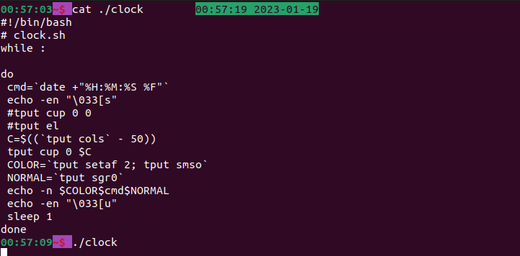

3.3. Text Copy for Your Variant Nr of Task.

V00.

1. Hello, Username, calendar for the previous, current, next month

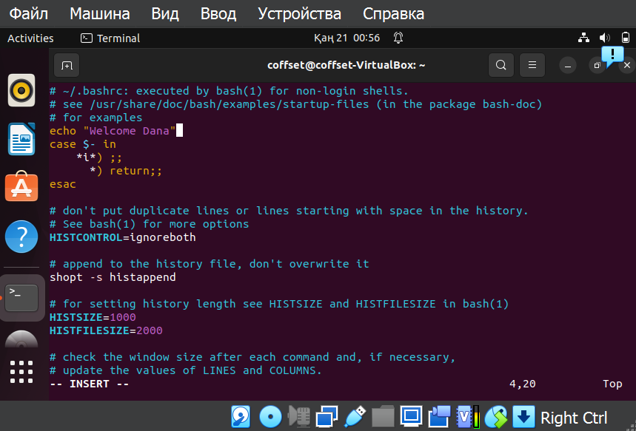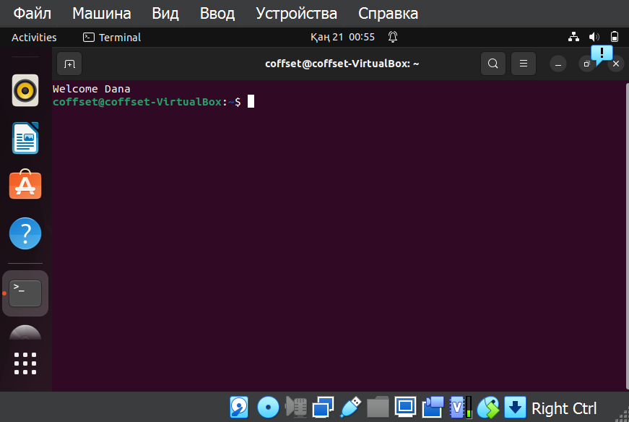

b)

v05.

c)

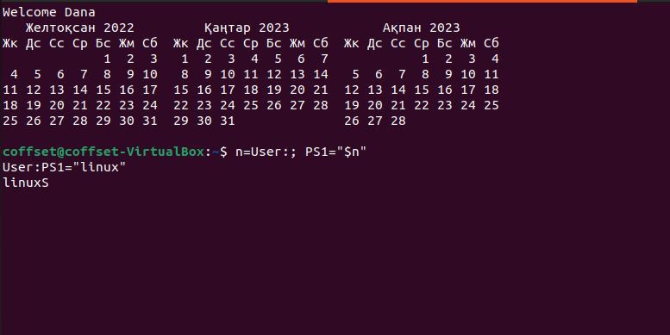

d)

e) export PS1=”\e[0;00m[\u@\h \W]\$ \e[m “

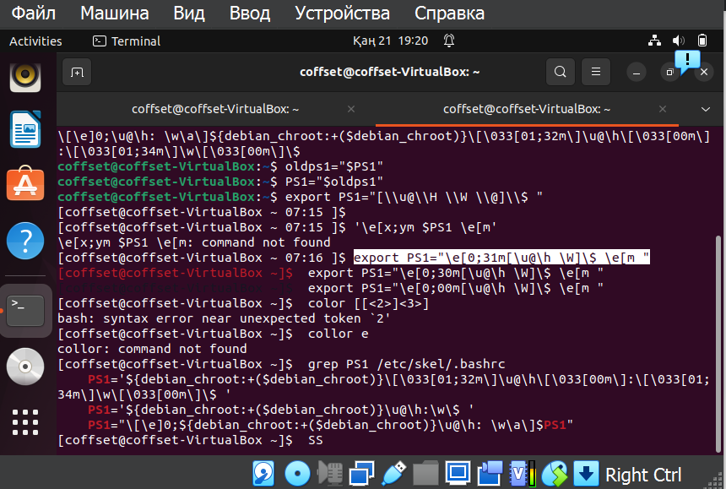

f) export PS1=”\e[0;32m[\u@\h \W]\$ \e[m “

