Server Statistics (systemD)
User Manual

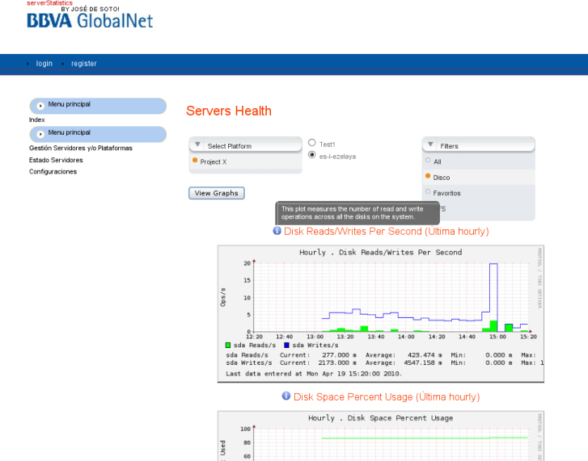

Doc. version: 1.0.
Date: Monday, April 19 2010
Contact: José de Soto García
Email: josedesoto@bbvaglobalnet.com

Configure to Work

NOTE: If you install web2py in /opt, the application name is serverStatistics and you generate the private key from root user. This application must work properly.

NOTE: Be careful with privileges. Maybe the daemon can't read or write in the database folder. You can check it in /var/log/systemd.log

Some variables must be changed in controllers/systemas.py and daemon/conf.py:

#Absolute path to the server web2py
path_systemd_server="/opt/web2py"

#Relative path from the server to the application software
client_software='applications/serverStatistics/software/client'
server_software='applications/serverStatistics/software/server'

#Admin user configuration access
ssh_user_admin='root'
rsa_private_key_admin=r"/root/.ssh/id_rsa" # r is needed

#Another user without privileges (not dev yet)
ssh_user='none'
rsa_private_key=r"none"

#Relative path to the database orca (where the graphs are stored)
orca_path='applications/serverStatistics/orca'

#Where we want to install orca in the client
path_client_systemd='/opt/systemd'

#Relative path to the database
database_sqlite3='applications/serverStatistics/databases/serverStatistics.db'

With all the previous changes SystemD must work properly. if you want systemD to have full access to other servers and also to servers statistics The installation of some packages are required as well the need to generate a private key to allow access.

Packages:
python-paramiko-1.7.6 (to use ssh access)
librrds-perl (to generate the graphs from rrds files)

To generate Private Key:
#ssh-keygen (when password is asked, don't introduce anything)

We will have:
Private Key: id_rsa (keep it in secret)
Public Key: id_rsa.pub

To allow access to systemD to the servers:
#mkdir -p /root/.ssh
#vi /root/.ssh/authorized_keys (we paste the public key)

We test if it work:
#ssh root@ip_cliente (we answer yes to accept the fingerprint)

To make the daemon work, we must create the following files:
#cd /var/log/
#touch systemd.log
#touch systemd.err
#chmod 666 systemd.log
#chmod 666 systemd.err
#cd var/run/
#touch systemd.pid
#chmod 666 systemd.pid

To make Orca work
#vi /opt/web2py/applications/serverStatistics/applications/serverStatistics/software/server/orca/bin/orca
my $prefix= "/opt/web2py/applications/serverStatistics/software/server/orca";

To make Orca work, we must change the previous variable, and introduce the absolute path to the Orca folder

To make Orca client work
After store a server you must start Orca client manual.
RedHat, Centos, Fedora:
#/etc/rc3.d/S99procallator start
Others:
#/usr/bin/perl -w # -*- perl -*- /opt/systemd/bin/procallator

Testing connectivity

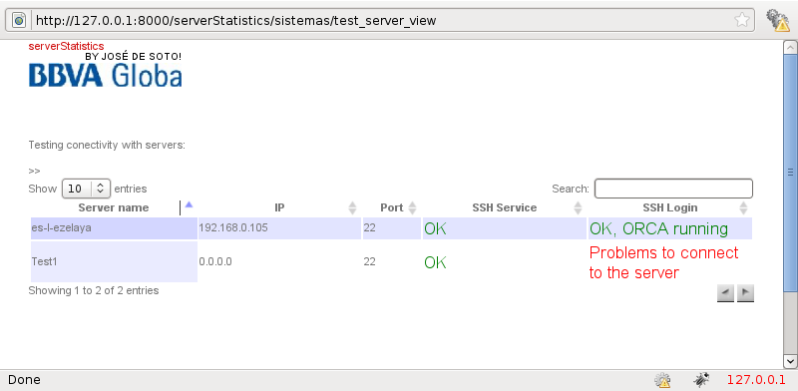

Introducing new server

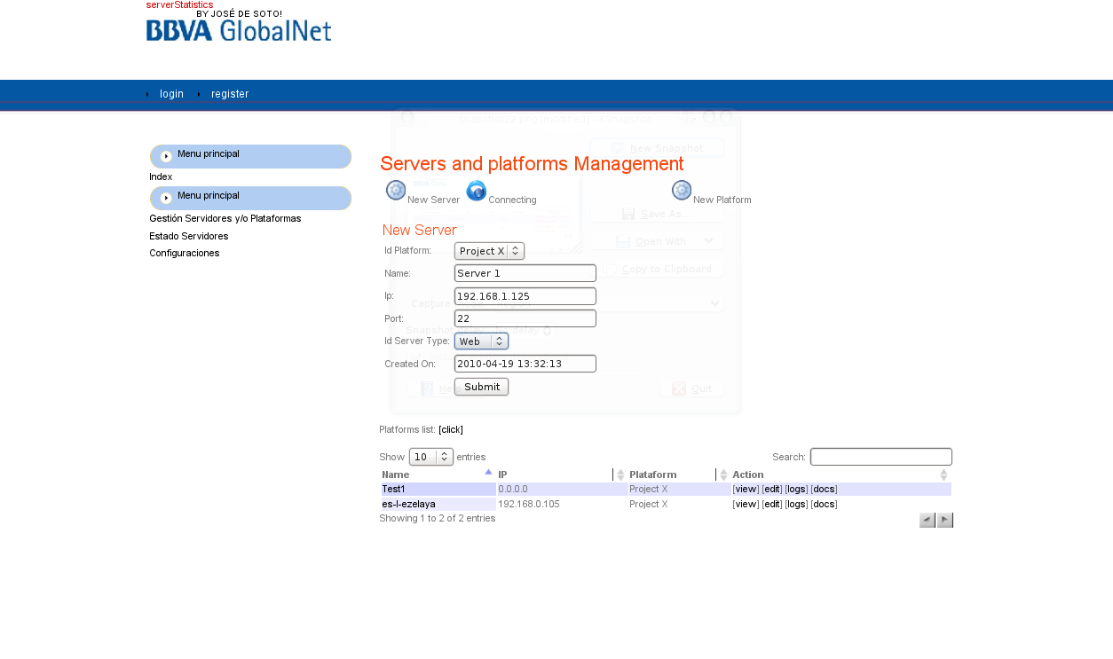
Access to the Statistic

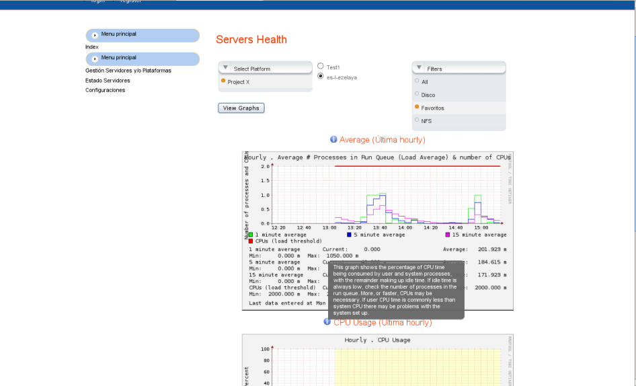

References

www.orcaware.com/orca/
trentrichardson.com/Impromptu/index.php
www.mypocket-technologies.com/jquery/SelectBoxPlugin/
www.freecsstemplates.org
ukablog.codigoabierto.info/articulos/Demonizar%20un%20script%20en%20Python.html

