Name – Md Ishrar
Course – AIML
Batch – B2
Subject - fuzzy Logic
Roll - 12019051623

Lab 2 Experiment

%% Basic Membership Functions in Fuzzy Logic
clc; clear; close all;

x = 0:0.01:10; % Universe of discourse

%% 1. Triangular Membership Function (trimf)
% Parameters: [a b c] — left, peak, right
mf_tri = trimf(x, [2 5 8]);

figure;
subplot(3,2,1);
plot(x, mf_tri, 'b', 'LineWidth', 2);
title('Triangular MF');
xlabel('x'); ylabel('\mu(x)');
ylim([-0.1 1.1]); grid on;

%% 2. Trapezoidal Membership Function (trapmf)
% Parameters: [a b c d] — left foot, left shoulder, right shoulder, right foot
mf_trap = trapmf(x, [1 3 7 9]);

subplot(3,2,2);
plot(x, mf_trap, 'r', 'LineWidth', 2);
title('Trapezoidal MF');
xlabel('x'); ylabel('\mu(x)');
ylim([-0.1 1.1]); grid on;

%% 3. Gaussian Membership Function (gaussmf)
% Parameters: [sigma mean]
mf_gauss = gaussmf(x, [1 5]);

subplot(3,2,3);
plot(x, mf_gauss, 'g', 'LineWidth', 2);
title('Gaussian MF');
xlabel('x'); ylabel('\mu(x)');
ylim([-0.1 1.1]); grid on;

%% 4. Generalized Bell Membership Function (gbellmf)
% Parameters: [a b c] — width, slope, center
mf_bell = gbellmf(x, [2 4 5]);

subplot(3,2,4);
plot(x, mf_bell, 'm', 'LineWidth', 2);
title('Generalized Bell MF');
xlabel('x'); ylabel('\mu(x)');
ylim([-0.1 1.1]); grid on;

%% 5. Sigmoid Membership Function (sigmf)
% Parameters: [a c] — slope, inflection point
mf_sig = sigmf(x, [2 5]);

subplot(3,2,5);
plot(x, mf_sig, 'c', 'LineWidth', 2);
title('Sigmoid MF');
xlabel('x'); ylabel('\mu(x)');
ylim([-0.1 1.1]); grid on;

%% 6. Z-shaped, Pi-shaped, S-shaped MFs
mf_z = zmf(x, [3 7]); % Z-shaped (decreasing)
mf_s = smf(x, [3 7]); % S-shaped (increasing)
mf_pi = pimf(x, [1 4 6 9]);% Pi-shaped (bell using S and Z)

subplot(3,2,6);
plot(x, mf_z, 'b--', x, mf_s, 'r-', x, mf_pi, 'g:', 'LineWidth', 2);
legend('Z-MF','S-MF','Pi-MF');
title('Z / S / Pi MFs');
xlabel('x'); ylabel('\mu(x)');
ylim([-0.1 1.1]); grid on;

sgtitle('Basic Fuzzy Membership Functions');

%% ---- Manual Implementation (No Toolbox Required) ----

fprintf('\n--- Manual Membership Function Values at x=5 ---\n');

% Triangular
x0 = 5; a=2; b=5; c=8;
if x0 <= a || x0 >= c
mu_tri = 0;
elseif x0 <= b
mu_tri = (x0 - a) / (b - a);
else
mu_tri = (c - x0) / (c - b);
end
fprintf('Triangular MF at x=5: %.4f\n', mu_tri);

% Gaussian
sigma = 1; c_g = 5;
mu_gauss = exp(-((x0 - c_g)^2) / (2 * sigma^2));
fprintf('Gaussian MF at x=5: %.4f\n', mu_gauss);

% Sigmoid
a_s = 2; c_s = 5;
mu_sig = 1 / (1 + exp(-a_s * (x0 - c_s)));
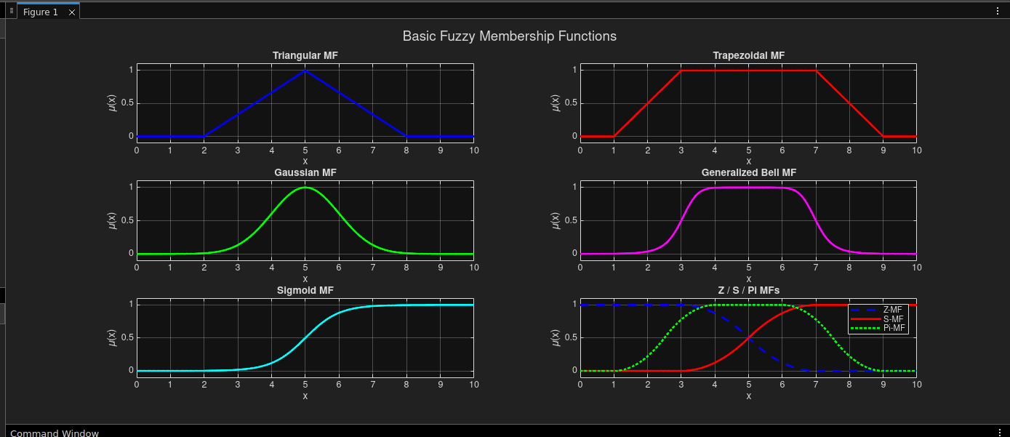
fprintf('Sigmoid MF at x=5: %.4f\n', mu_sig);

