Name – Md Ishrar
Course – AIML
Batch – B2
Course – Fuzzy Logic

%% Fuzzy Set Operations: Complement, Union, Intersection
clc; clear; close all;

x = 0:0.01:10; % Universe of discourse

%% Define Two Fuzzy Sets (Membership Functions)
A = trimf(x, [1 4 7]); % Fuzzy Set A — Triangular
B = gaussmf(x, [1.5 6]); % Fuzzy Set B — Gaussian

%% ============================================================
%% 1. COMPLEMENT → A' = 1 - A
%% ============================================================
A_comp = 1 - A;
B_comp = 1 - B;

%% ============================================================
%% 2. UNION → A ∪ B = max(A, B)
%% ============================================================
A_union_B = max(A, B);

%% ============================================================
%% 3. INTERSECTION → A ∩ B = min(A, B)
%% ============================================================
A_inter_B = min(A, B);

%% ============================================================
%% PLOTTING ALL OPERATIONS
%% ============================================================

figure('Color','white','Position',[100 100 1000 700]);

%--- Original Sets ---%
subplot(3,2,1);
plot(x, A, 'b', 'LineWidth', 2); hold on;
plot(x, B, 'r', 'LineWidth', 2);
legend('Set A (Triangular)','Set B (Gaussian)');
title('Original Fuzzy Sets A and B');
xlabel('x'); ylabel('\mu(x)');
ylim([-0.1 1.2]); grid on;

%--- Complement of A ---%
subplot(3,2,2);
plot(x, A, 'b--', 'LineWidth', 1.5); hold on;
plot(x, A_comp, 'b', 'LineWidth', 2);
legend("Set A", "Complement A' = 1 - A");
title("Complement of A: \mu_{A'} = 1 - \mu_A");
xlabel('x'); ylabel('\mu(x)');
ylim([-0.1 1.2]); grid on;

%--- Complement of B ---%
subplot(3,2,3);
plot(x, B, 'r--', 'LineWidth', 1.5); hold on;
plot(x, B_comp, 'r', 'LineWidth', 2);
legend("Set B", "Complement B' = 1 - B");
title("Complement of B: \mu_{B'} = 1 - \mu_B");
xlabel('x'); ylabel('\mu(x)');
ylim([-0.1 1.2]); grid on;

%--- Union ---%
subplot(3,2,4);
plot(x, A, 'b--', 'LineWidth', 1.5); hold on;
plot(x, B, 'r--', 'LineWidth', 1.5);
plot(x, A_union_B, 'k', 'LineWidth', 2.5);
fill(x, A_union_B, 'y', 'FaceAlpha', 0.3, 'EdgeColor','none');
legend('Set A','Set B','A \cup B = max(A,B)');
title('Union: \mu_{A \cup B} = max(\mu_A, \mu_B)');
xlabel('x'); ylabel('\mu(x)');
ylim([-0.1 1.2]); grid on;

%--- Intersection ---%
subplot(3,2,5);
plot(x, A, 'b--', 'LineWidth', 1.5); hold on;
plot(x, B, 'r--', 'LineWidth', 1.5);
plot(x, A_inter_B, 'k', 'LineWidth', 2.5);
fill(x, A_inter_B, 'c', 'FaceAlpha', 0.4, 'EdgeColor','none');
legend('Set A','Set B','A \cap B = min(A,B)');
title('Intersection: \mu_{A \cap B} = min(\mu_A, \mu_B)');
xlabel('x'); ylabel('\mu(x)');
ylim([-0.1 1.2]); grid on;

%--- All Together ---%
subplot(3,2,6);
plot(x, A, 'b--', 'LineWidth', 1.5); hold on;
plot(x, B, 'r--', 'LineWidth', 1.5);
plot(x, A_comp, 'b', 'LineWidth', 2);
plot(x, A_union_B, 'g', 'LineWidth', 2);
plot(x, A_inter_B, 'm', 'LineWidth', 2);
legend("A","B","A' (Complement)","A∪B (Union)","A∩B (Intersection)");
title('All Operations Combined');
xlabel('x'); ylabel('\mu(x)');
ylim([-0.1 1.2]); grid on;

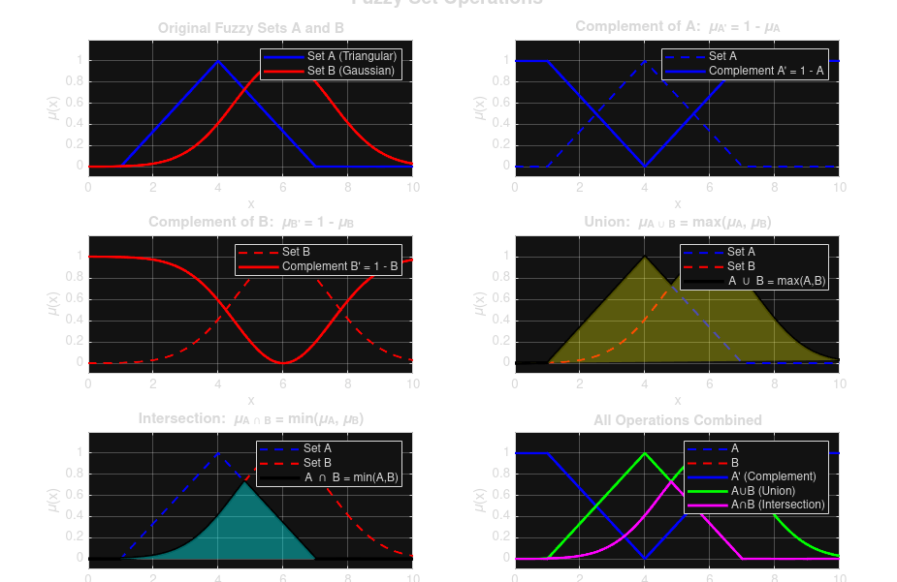
sgtitle('Fuzzy Set Operations', 'FontSize', 14, 'FontWeight', 'bold');

