Name - Md Ishrar
Course - AIML
Enrollment Number – 12019051623

Lab – 5

Code -

%% Fuzzy SVM - Full Single File Implementation
% Save as: fuzzySVM_main.m

clc; clear; close all;

%% 1. Load and Prepare Data
load fisheriris
X = meas(:, 1:2);
y = grp2idx(species);

% Keep only 2 classes for binary classification
idx = y <= 2;
X = X(idx, :);
y = y(idx);
y(y == 1) = -1;
y(y == 2) = 1;

fprintf('Dataset: %d samples, %d features\n', size(X,1), size(X,2));
fprintf('Class -1: %d samples | Class +1: %d samples\n', sum(y==-1), sum(y==1));

%% 2. Compute Fuzzy Memberships
classes = unique(y);
s = zeros(size(y));
delta = 0.1;

for c = 1:length(classes)
idx_c = y == classes(c);
Xc = X(idx_c, :);
center = mean(Xc, 1);
dists = sqrt(sum((Xc - center).^2, 2));
r = max(dists);
s(idx_c) = 1 - dists / (r + delta);
end

s = max(s, delta);
s = min(s, 1.0);

fprintf('\nMembership Stats:\n');
fprintf(' Min: %.4f | Max: %.4f | Mean: %.4f\n', min(s), max(s), mean(s));

%% 3. Train Fuzzy SVM
C = 1.0;

model = fitcsvm(X, y, ...
'KernelFunction', 'rbf', ...
'BoxConstraint', C, ...
'Weights', s, ...
'Standardize', true, ...
'KernelScale', 'auto');

%% 4. Evaluate Model
yPred = predict(model, X);
acc = sum(yPred == y) / numel(y) * 100;

fprintf('\n--- Results ---\n');
fprintf('Accuracy : %.2f%%\n', acc);
fprintf('Support Vectors: %d\n', size(model.SupportVectors, 1));

cm = confusionmat(y, yPred);
fprintf('\nConfusion Matrix:\n');
fprintf(' Pred -1 Pred +1\n');
fprintf('Actual -1 %5d %5d\n', cm(1,1), cm(1,2));
fprintf('Actual +1 %5d %5d\n', cm(2,1), cm(2,2));

%% 5. Visualize: Membership Values
figure('Name', 'Fuzzy SVM Results', 'Position', [100 100 1200 450]);

subplot(1, 3, 1);
gscatter(X(:,1), X(:,2), y, 'rb', 'ox', 8);
hold on;
scatter(X(:,1), X(:,2), 60, s, 'filled', 'MarkerEdgeColor', 'k', 'LineWidth', 0.5);
colorbar;
colormap(gca, 'parula');
title('Fuzzy Memberships (color = s value)');
xlabel('Feature 1'); ylabel('Feature 2');
legend('Class -1', 'Class +1', 'Location', 'best');
grid on;

%% 6. Visualize: Decision Boundary
subplot(1, 3, 2);

x1range = linspace(min(X(:,1)) - 0.5, max(X(:,1)) + 0.5, 300);
x2range = linspace(min(X(:,2)) - 0.5, max(X(:,2)) + 0.5, 300);
[xx1, xx2] = meshgrid(x1range, x2range);
XGrid = [xx1(:), xx2(:)];

[~, scores] = predict(model, XGrid);
scoreGrid = reshape(scores(:, 2), size(xx1));

contourf(xx1, xx2, scoreGrid, 50, 'LineStyle', 'none');
colormap(gca, 'jet'); colorbar;
hold on;
contour(xx1, xx2, scoreGrid, [0 0], 'k-', 'LineWidth', 2);
gscatter(X(:,1), X(:,2), y, 'rb', 'ox', 8);

sv = model.SupportVectors;
if ~isempty(model.Mu)
sv = sv .* model.Sigma + model.Mu;
end
scatter(sv(:,1), sv(:,2), 100, 'k', 'square', 'LineWidth', 2);

title('Decision Boundary');
xlabel('Feature 1'); ylabel('Feature 2');
legend('Class -1', 'Class +1', 'Support Vectors', 'Location', 'best');
grid on;

%% 7. Visualize: Membership Distribution
subplot(1, 3, 3);

s_neg = s(y == -1);
s_pos = s(y == 1);

histogram(s_neg, 15, 'FaceColor', 'r', 'FaceAlpha', 0.6, 'EdgeColor', 'k');
hold on;
histogram(s_pos, 15, 'FaceColor', 'b', 'FaceAlpha', 0.6, 'EdgeColor', 'k');
xlabel('Membership Value (s)');
ylabel('Count');
title('Membership Distribution by Class');
legend('Class -1', 'Class +1');
grid on;

sgtitle(sprintf('Fuzzy SVM | Accuracy: %.2f%% | SVs: %d', ...
acc, size(model.SupportVectors, 1)), 'FontSize', 13, 'FontWeight', 'bold');

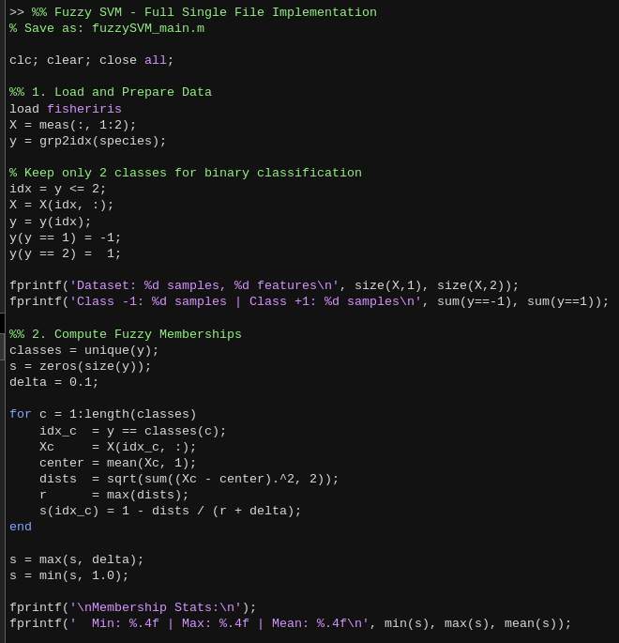

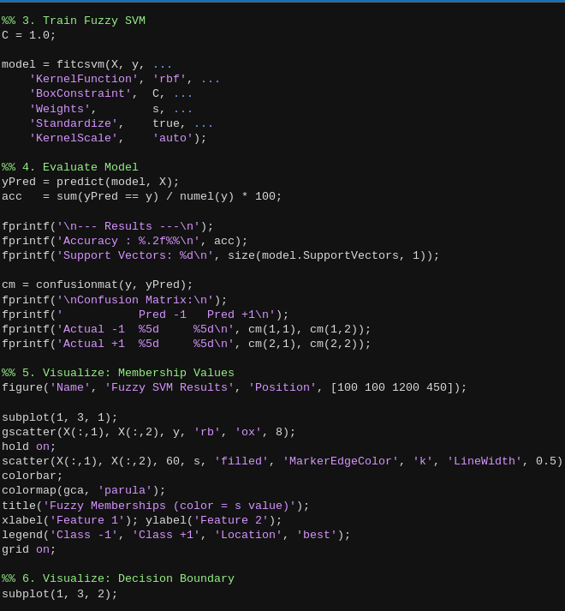

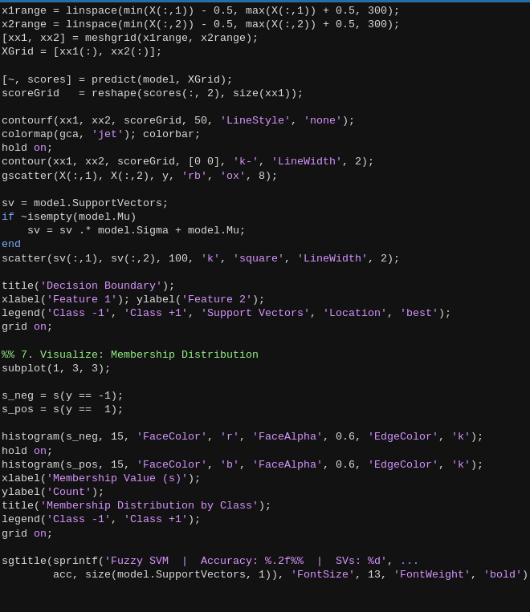

Output :

