PROGREE DATA ANALYTICS INTERNSHIP
TASK 2
Exploratory Data Analysis & Integrity Cleaning Pipeline

1. Objective
This task loads a large raw industry dataset into Python/Pandas, diagnoses data abnormalities, performs systematic missing-value treatment, applies outlier filtering, and plots descriptive variable distributions to identify key patterns.

2. Dataset & Authentic Source
The internship instructions did not provide a dataset, so the analysis uses the Online Retail II dataset from the UCI Machine Learning Repository. The uploaded workbook contains 1,067,371 transaction records across two yearly sheets.
Official source: UCI Machine Learning Repository — Online Retail II. Citation: Chen, D. (2012). Online Retail II. DOI: 10.24432/C5CG6D.

3. Raw Dataset Loading
Both raw sheets were loaded with Pandas and combined into one dataset containing 1,067,371 rows and 8 columns.

4. Data Abnormality Diagnosis
Issue | Count | Treatment / Interpretation
Missing Description | 4,382 | Imputed from StockCode where possible; remaining values labelled UNKNOWN_DESCRIPTION.
Missing CustomerID | 243,007 | Labelled UNKNOWN_CUSTOMER; no artificial customer identity created.
Duplicate rows | 34,335 | Identified during integrity audit.
Cancellation invoices | 19,494 | Invoice numbers beginning with C; excluded from positive-sales view.
Negative Quantity | 22,950 | Diagnosed and excluded from positive-sales descriptive view.
UnitPrice <= 0 | 6,207 | Excluded from positive-sales descriptive view.

5. Systematic Missing-Value Treatment
There were 4,382 missing Description values. 4,019 were filled using the most frequent valid Description for the same StockCode. Remaining unresolved descriptions were labelled UNKNOWN_DESCRIPTION. Missing CustomerID values were labelled UNKNOWN_CUSTOMER rather than assigning fabricated IDs.

6. Outlier Filtering Treatment
The business-cleaned positive-sales view contains 1,041,670 rows. IQR filtering was applied to Quantity, UnitPrice and Revenue using Q1 − 1.5×IQR and Q3 + 1.5×IQR.
Variable | Q1 | Q3 | Upper Bound | Outliers
Quantity | 1.00 | 10.00 | 23.50 | 111,341 (10.69%)
UnitPrice | 1.25 | 4.13 | 8.45 | 81,633 (7.84%)
Revenue | 3.90 | 17.70 | 38.40 | 85,726 (8.23%)
The combined IQR-filtered view contains 826,813 rows; 214,857 rows (20.63%) were removed from this descriptive outlier view. Extreme retail observations are not automatically assumed to be errors.

7. Descriptive Distributions & Key Patterns
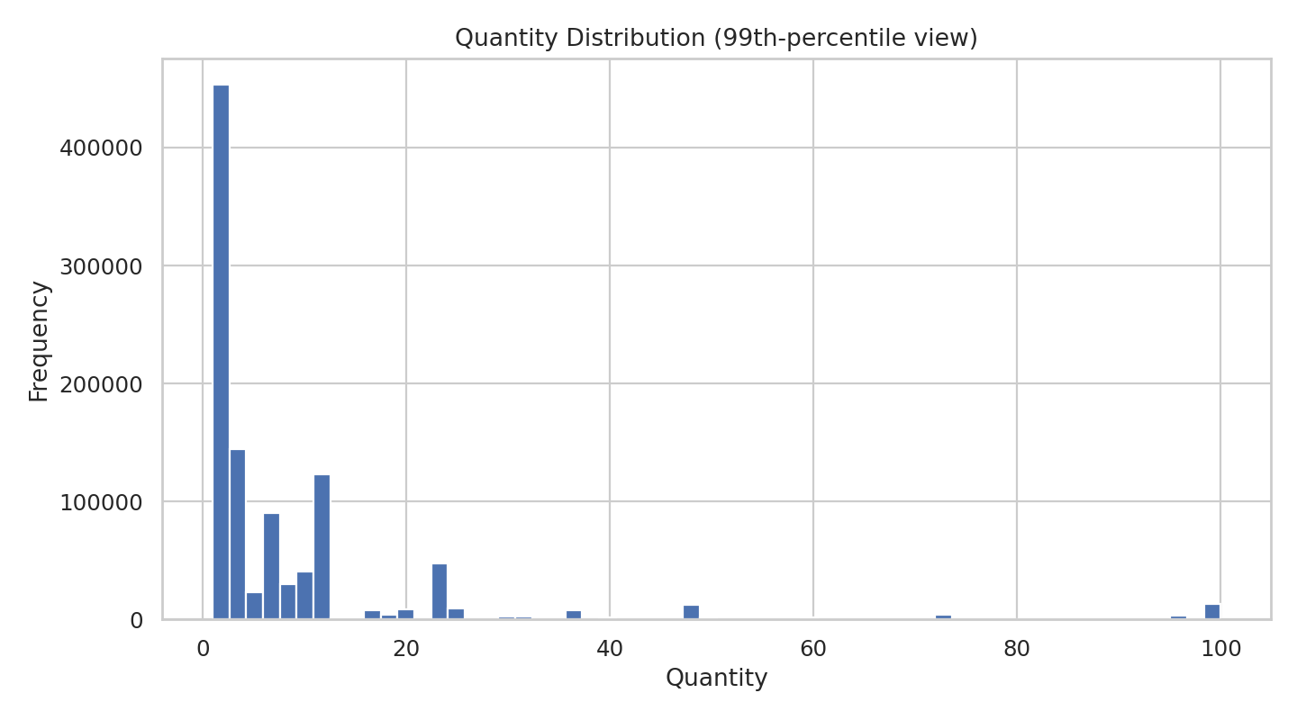
Quantity is strongly right-skewed, with a long upper tail caused by a relatively small number of very large quantities.
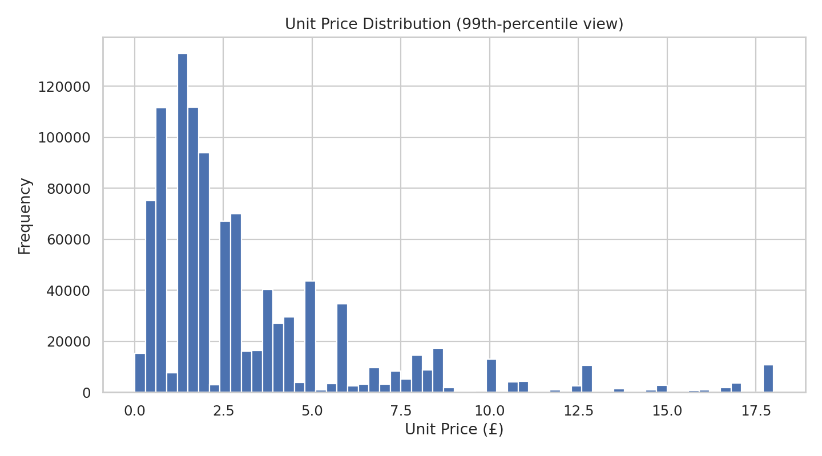
Unit Price is strongly right-skewed, with most observations concentrated at lower prices and a small number of high-price transactions.
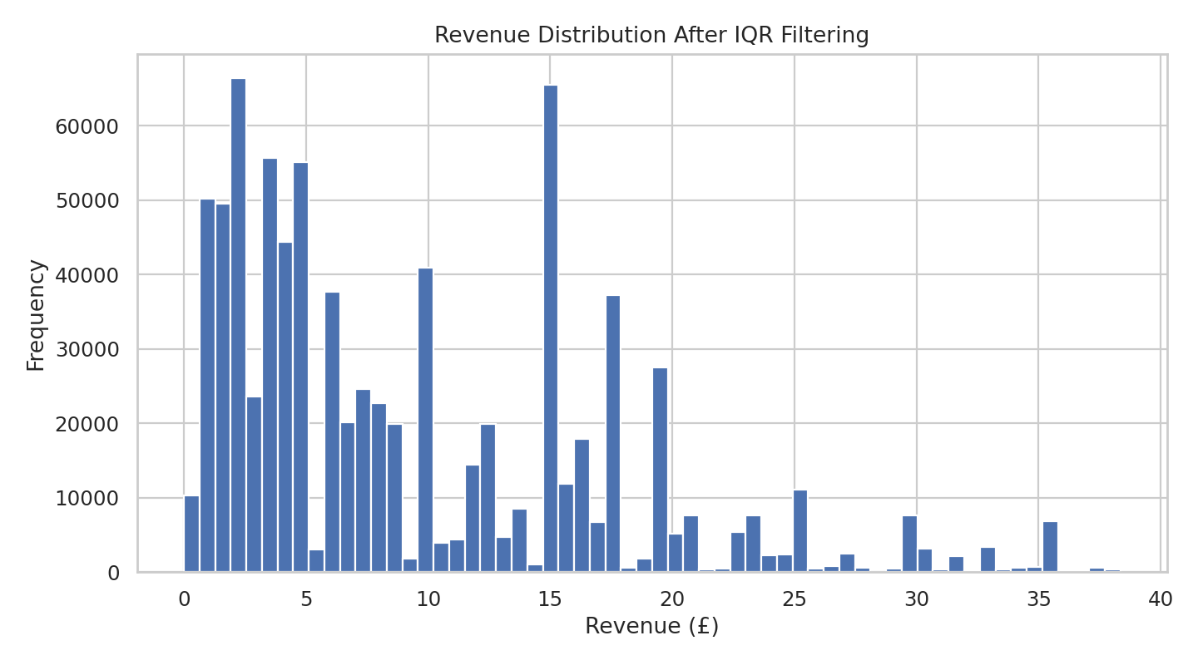
After IQR filtering, the Revenue distribution is less dominated by extreme transaction values.
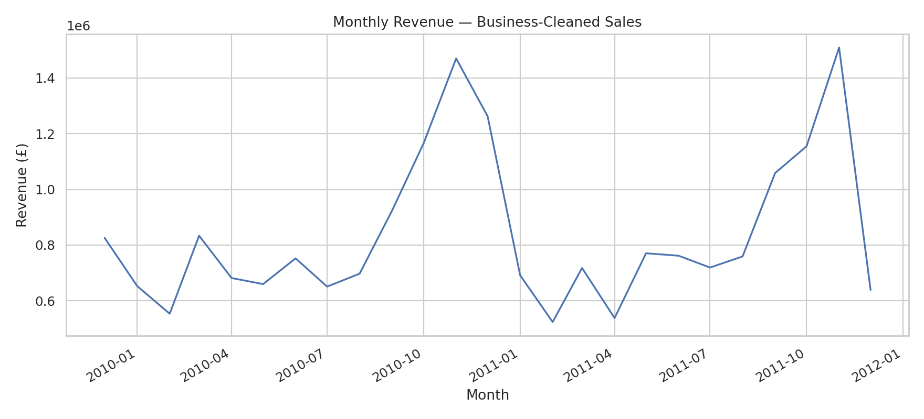
The highest monthly revenue in the business-cleaned sales view occurred in November 2011, at approximately £1,509,496.33.
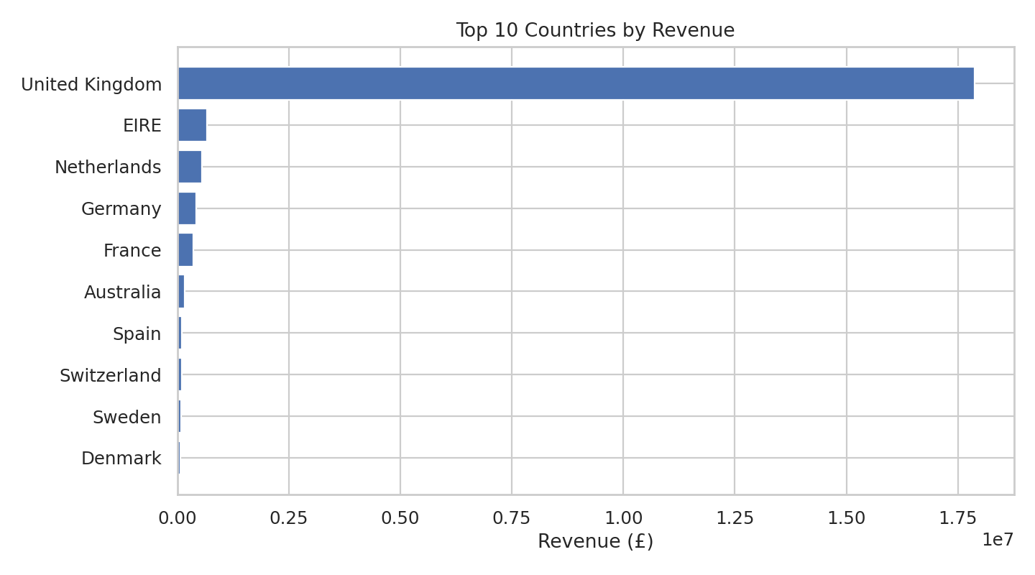
The United Kingdom is the dominant country by recorded revenue, with approximately £17,870,977.78 in the business-cleaned sales view.

8. Conclusion
The completed pipeline follows the Task 2 requirements: large raw dataset loading, data-abnormality diagnosis, systematic missing-value treatment, documented IQR outlier filtering, descriptive distribution plots, and key pattern extraction.

9. Deliverables
- Progree_Task_2_Final.ipynb — reproducible Python/Pandas pipeline
- data_quality_audit.csv — integrity audit
- outlier_treatment_summary.csv — IQR treatment
- descriptive_statistics.csv — descriptive statistics and skewness
- monthly_revenue.csv — monthly trend
- top_countries_by_revenue.csv — country pattern
- top_products_by_revenue.csv — product pattern
- 01–05 PNG charts — descriptive visualizations

