Matthew Jeffreys

<https://github.com/mdj20/Cs1632_d2>

CS 16932 - DELIVERABLE 2: Unit Testing and Code Coverage

I was enrolled in Software Engineering for the summer term of 2015, a class that included several units on testing. Specifically, we were tasked with unit testing our projects with jUnit, when applicable. Therefore, this cs1632 deliverable was very familiar, however not completed without its share of issues.

The first issues that I encountered involved design aspects of the program. Attempting to emulate proper object oriented principles, I designed the game with scalability in mind. I imagined the program as a small prototype of a much larger system, and therefore kept the game data separate from the game running code. If a team of developers would like to expand the city to a grid of 100x100, they would only need to modify the data. This resulted in the design of overly specific classes used only for data modeling. Information about streets, and locations throughout the city, were isolated in their own modular classes. Conversely, code that utilized these game data classes, oftentimes only accepted those entire classes as arguments to methods. What resulted was a perhaps too tightly coupled program, which limited its testing potential. In retrospect, it may have been wiser to utilize classes that passed primitives as their data values.

A secondary, albeit less serious obstacle involved the jUnit testing itself. As I wrote my tests, I discovered that few of the assert methods, described online and elsewhere, were not available to me during testing. For example, the method assertArrayEquals() would not accept boolean arrays for comparison. This problem was easily circumvented by including a section of code within the test that would check for any deviation within the arrays. However, I remain puzzled as to why those method were not available to me.

Overall, this was a nice assignment that allowed me to become more familiar with a concept that I hope to be using professionally in the future.

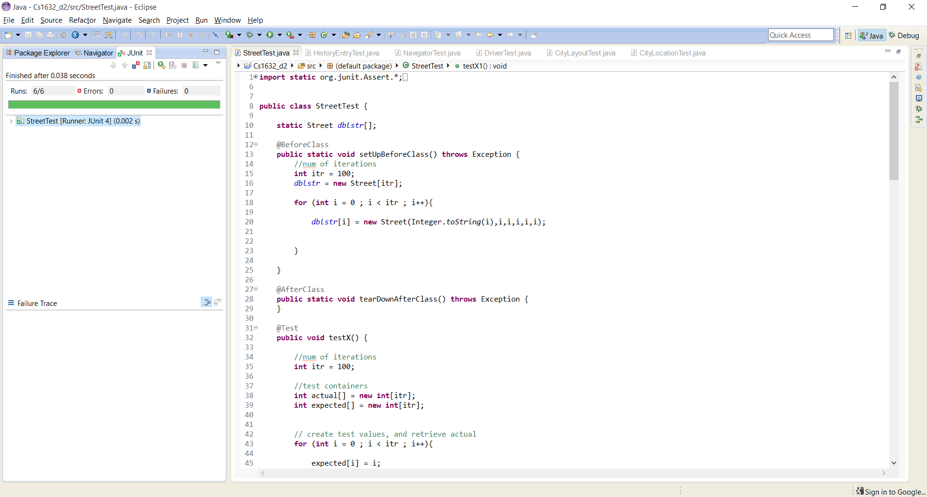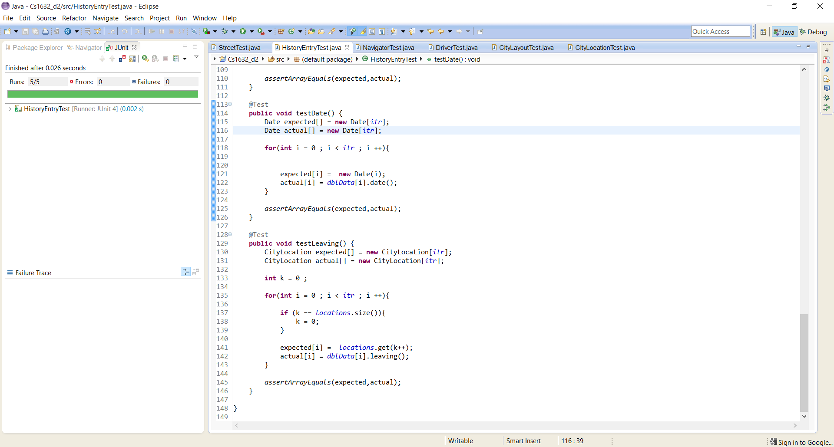

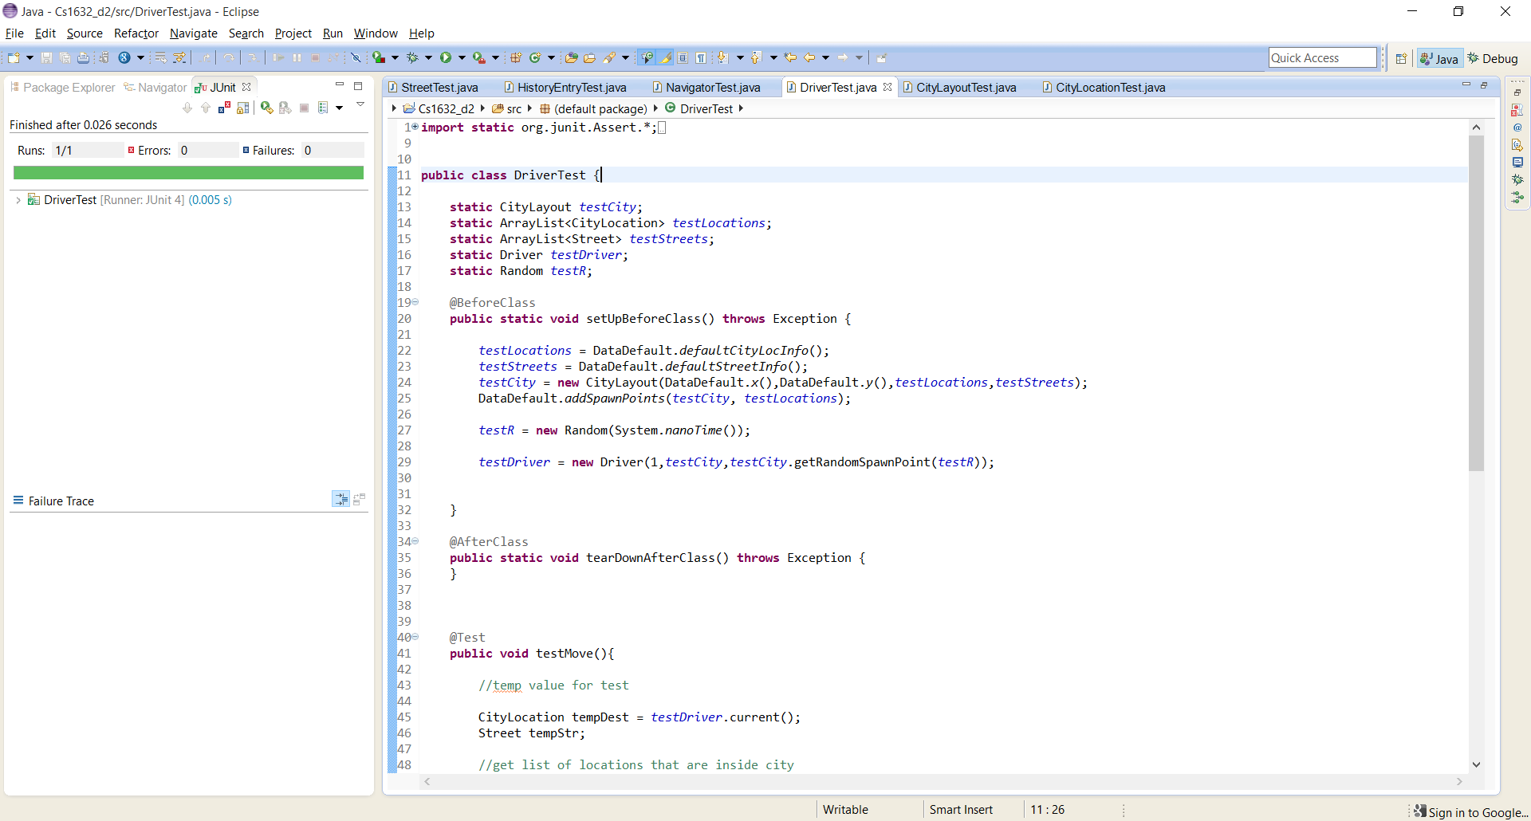

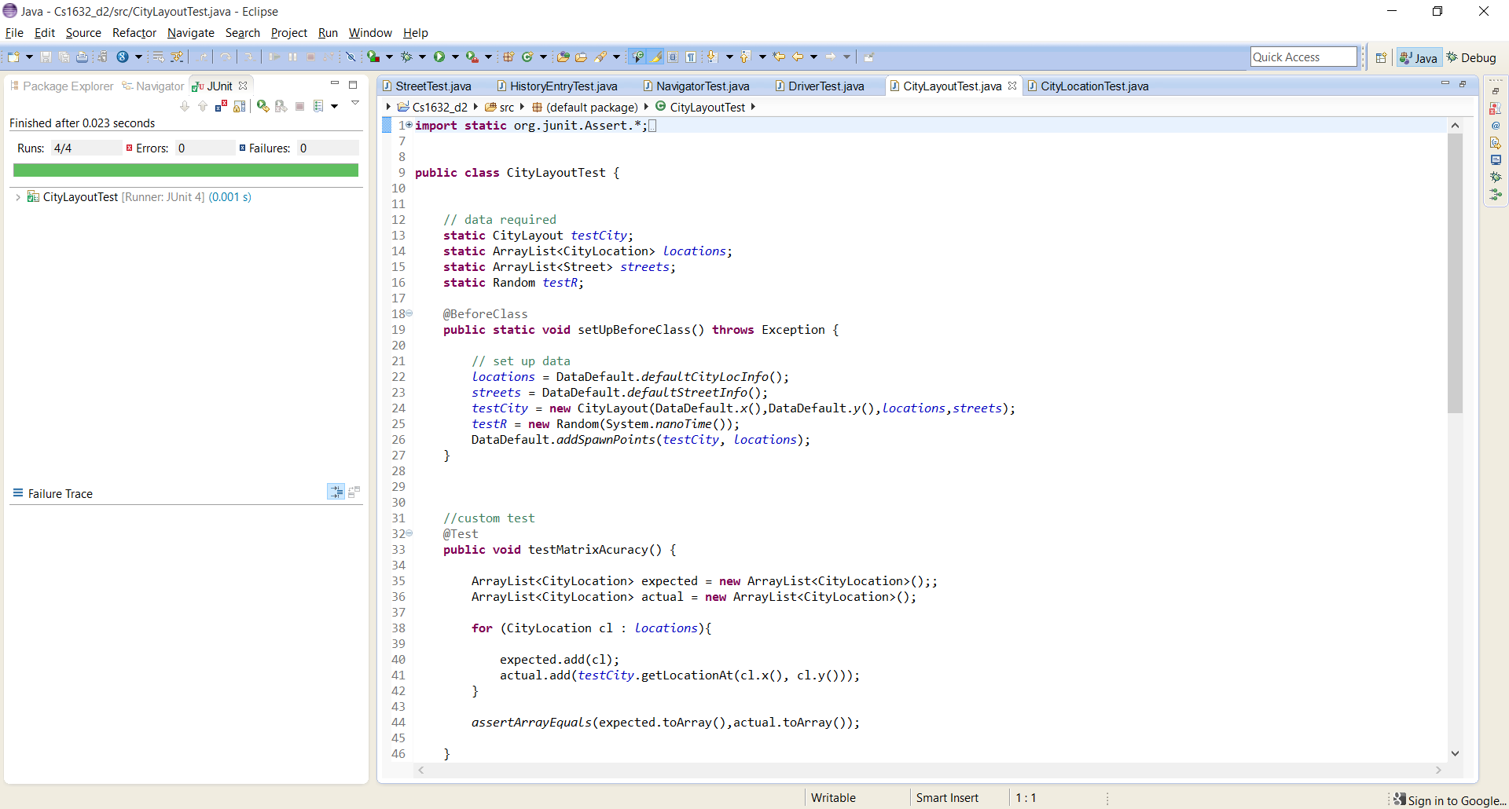



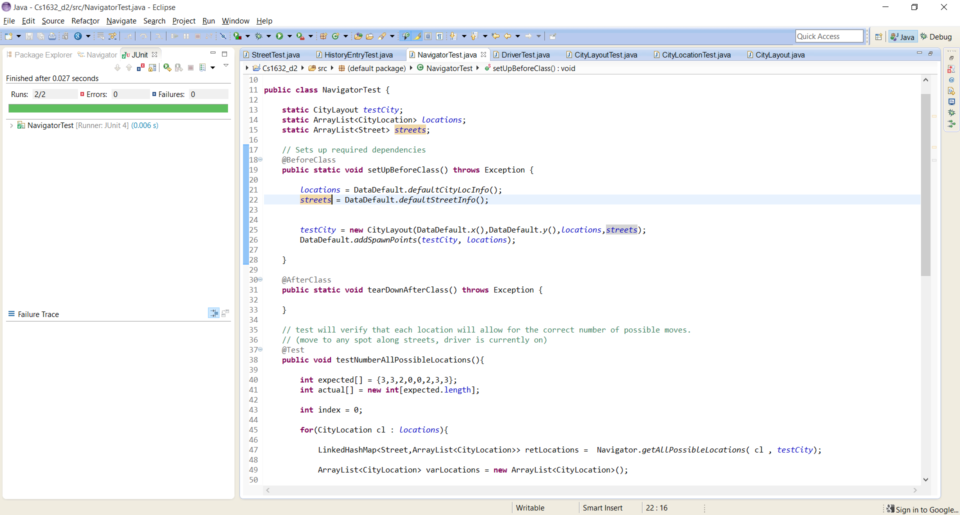

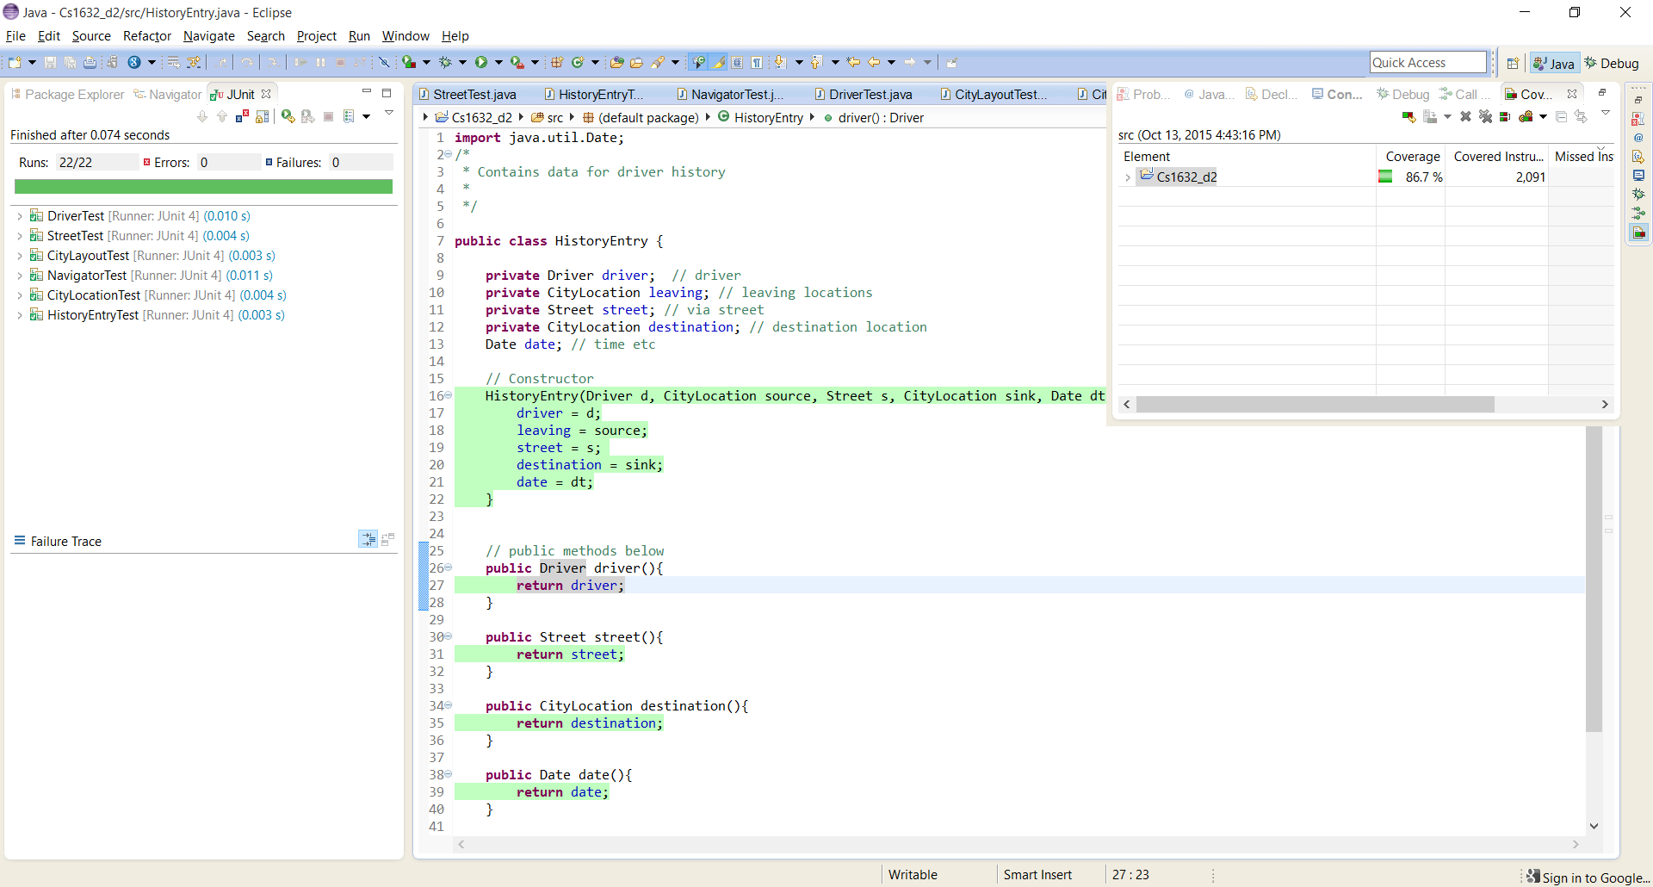

Coverage Total 86.7%