Myth-Weavers

Ryan Rahuba

And

Matthew Jeffreys

CS 1632 – DELIVERABLE 3: Web Testing with BDD

**SUMMARY:**

For Deliverable 3, we decided to test Myth-Weavers for several reasons. First, it is a website that I, Ryan, am already a member of and am fairly familiar with its content and layout. Second, it is free to join. And third, at its core it is a simple web forum and has little javascript. We felt that its modular nature would test well.

The features of Myth-Weavers provided many options to test. After some discussion the features we decided to test were the Log In and Navigation, tested by myself, and messaging/in-site mail and user profile data, tested by Matt.

**ISSUES:**

One issue we faced when writing tests was the optional nature of many attributes of HTML objects and the limited function calls of Selenium Webdriver’s By object. When writing the tests manually it was difficult as many of the HTML objects did not have id, name, or any of the other tags used to find elements with the By object. This is where the Selenium IDE came in handy as it’s select function allowed you to choose any HTML object and it generated the code for you. Also, testing the login functionality with combinations of correct/incorrect username and password was difficult as Myth-Weavers has a lockout feature that prevents you from using the log in after 5 failed attempts.

Other issues and complications involved inconsistencies with Junit code generation. Throughout my (Matthew) testing, I discovered

**//Matt’s issues//**

Code can be found here: <https://github.com/mdj20/cs1632_d3>

Web site under test: <http://www.myth-weavers.com/forumhome.php>

**//Screen shots//**

Matthew Jeffreys’ screen Shot:

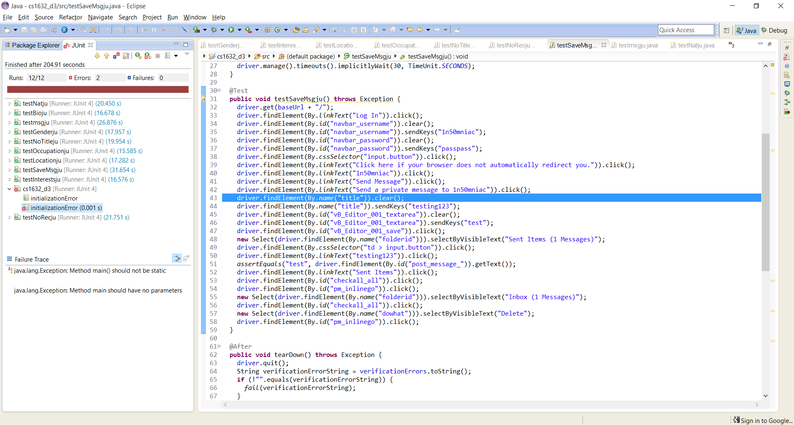

**USER STORIES:**

As a User

I would like to Login to my account

So that I can view my account information

Scenarios:

Given a correct user name and password

When I login

Then my credentials should be accepted

Given an incorrect user name and a correct password

When I login

Then my credentials should be rejected

Given a correct user name and incorrect password

When I login

Then my credentials should be rejected

Given an incorrect user name and password

When I login

Then my credentials should be rejected

As a User

I would like to have a Navigation Bar

So that I may see all areas of the website

And be able to go to them

Scenarios:

Given that I am logged into a valid account

When I click on my username

Then I will be directed to an account page

Given that the page is loaded

And I am logged in

When I view the navigation bar

Then I will see a link to my saved character sheets

Given that the page is loaded

And that I am logged in

When I view the navigation bar

Then I will see a link for my saved dungeon maps

Given that the page is loaded

When I click on the Shop link

Then I will be directed to a page where I may make purchases

Given that the page is loaded

When I click on the Wiki link

Then I will be directed to the site’s Wiki page

Given that the page is loaded

When I click on the Games link

Then I will be redirected to a list of current games

And advertisements for future games

As a User

I would like to be able to send/receive messages with other users

So that I can effectively communicate

Scenarios:

When receiving a message.

I should be able to

Then my credentials should be accepted

**Matt’s Scenarios**

As a User

I would like to be able to supplement my account (or profile) with personal info

So that others can learn about me

Scenarios:

**Matt’s Scenarios**