TERM PAPER 1
Does the Invisible Hand Matter for Economic Decisions? Empirically examine and discuss its role, transmission mechanism and implications for economic outcomes.
Applying it in Current Context:- A Study of India's Short-Term Electricity Market (Power Exchange Market)
Submitted by
MD JAFAR
Roll No.: HS26H024
Course Title: History of Economic Thought
Course Code: HS5704
Date of Submission: 14th September 2026

1. Introduction
Adam Smith's invisible hand describes how a price, can help us to use scarce resources to it’s most valuable use without a central authority, Just among the self-interest bids and offers of many independent buyers and sellers. India's short-term electricity market such as the Indian Energy Exchange (IEX), Power Exchange India Limited (PXIL) and Hindustan Power Exchange (HPX)(where Real time and Day-ahead power exchange happen) is one of the few Indian markets where this mechanism works almost exactly as the book says: every day hundreds of generators and buyers i.e. distribution companies, industrial consumers, traders submit price-quantity bids for every hourly block of the following day, and a single market-clearing price is calculated for each block based on the where the demand and supply intersect each other — a daily execution of Walrasian price discovery. In this paper we have to find out if this price signal actually does the coordinating task as economic theory says and what happens when the regulator intervenes in it, we try to found it using recent Indian experience as the empirical case.
My motivation for this choice is that India's power exchanges in recent decade have gone from a marginal trading platform to a genuine price-discovery mechanism whose signal is watched by generators, discoms and regulators also, so its become the site of two very different types of government intervention that I treat as natural comparison in this term paper. The first is a price cap:- After facing a coal-shortage-driven price spike in 2022, the Central Electricity Regulatory Commission (CERC) capped the maximum price that could be cited on exchanges, first at ₹12 per unit (down from an earlier ₹20 ceiling) and more recently at ₹10 per unit, making it a direct administrative Intervention in the price signal. The second is market coupling:- since 2024,Instead of allowing each exchange to discover its own price independently, CERC has been pushing to aggregate the buy and sell bids of all three power exchanges in to a single, unified national clearing price. this reform is not intended to suppress the price mechanism but to complete it, by taking away the fragmentation that gives liquidity advantage to a dominant exchange even when a rival offering a better price. As of today in 2026 this reform is being actively resisted by IEX, the dominant player, via lawsuit that has gone up to the Supreme Court of India.
Theoretically, two ideas of which we already familiar from other applications of the invisible-hand hypothesis: the price mechanism as an aggregator of dispersed information about scarcity (Hayek, 1945), and the standard result that a binding price ceiling does not eliminate excess demand, its just changes the form in which the resulting scarcity rent is captured i.e. its done through rationing, non-price allocation or displacement into an closest, less regulated market segment. In this term paper we like examine three interlinked questions: (i) does the day-ahead market price actually track underlying fuel-supply and demand shocks in the manner an efficient price-discovery mechanism should; (ii) when CERC imposes a price ceiling, does the suppressed scarcity value disappear or resurface elsewhere in the market; and (iii) how does the regulator's approach differ when the problem is not a price spike but a persistently concentrated, illiquid market structure, and what does the dominant player's resistance to that kind of intervention reveal us who benefits from an incomplete invisible hand.

2. Empirical Data and Methods
I collected Data from CERC's Annual Reports on the Short-Term Power Market in India ( from 2022-24), IEX's monthly power-market update press releases and stock-exchange filings, Grid-India's shadow-pilot reports on market connection ( it submitted to CERC in January and June 2025), and financial and trade press coverage (Business Standard, Mercom India, Saur Energy, Powerline, Kotak-CNBC-Awaaz reporting on the Supreme Court proceedings) of exchange trading volumes, day-ahead market clearing prices, and the market related lawsuit through 2026.
I have used four methods here, First, a descriptive monthly time-series data of the IEX day-ahead market (DAM) average clearing price, spanning from January 2017 (about ₹2.50 per unit) to 2025-26, it is used to test whether the price responds visible to independently reported supply shocks (i.e. the 2021-22 domestic and imported coal shortage) and demand shocks (i.e. peak load in summer, lighting and heating load in festive-season, post-monsoon agricultural pumping load), in the way an efficient price-discovery mechanism should have responded. Second, Study of an event that built around CERC's price-cap interventions like the initial ₹0-₹12/unit band imposed in April 2022 (down from a previous ₹20 ceiling), it’s repeated three-month extensions through December 2022, and its latter revision to a ₹10/unit ceiling, I am comparing prices and participation, in the capped Day-Ahead Market against prices in the separate, uncapped High-Price Day-Ahead Market (HP-DAM) that CERC itself introduced in February 2023 for generators who unable to recover costs at the ceiling price. This comparison is used to test whether a price cap eliminates scarcity value or merely displaces it into a parallel market segment. Third, market concentration among the three power exchanges is evaluated using IEX's own reported market share (consistently above 85 percent of exchange-traded volume through 2022-26), and this is set against the regulatory history of “market coupling” i.e. CERC's 2024 shadow pilot, its July 2025 order to start the coupling process, the Appellate Tribunal for Electricity's dismissal of IEX's appeal in February 2026, and the Supreme Court's refusal, in hearings through mid-2026 and stay CERC's implementation — to examine how a regulator responds to concentration in a price-discovery market.
Fourth, we also checked how much concentrated the exchanges themselves are using the Herfindahl-Hirschman Index (HHI), which is simply calculated as,
HHI = Σ(sᵢ)²
where sᵢ = Exchange i market share (in percentage) out of total exchange-traded volume of electricity.
the sum of all the shares is 100, the index can range from close to 0 (i.e. lots of equal-sized players) up to 10,000 (a pure monopoly), and over 2,500 is generally consider highly concentrated. We use press-reported shares for IEX, PXIL and HPX at two time points, once just after HPX enter in market in 2022 and again more recently in 2026, to check just how concentrated this market is.
Fifth, so that the price-responsiveness claim above rests on more than a visual reading of the price series, I estimate a single ordinary-least-squares regression on the full IEX DAM monthly average clearing-price series, January 2017 to March 2026 (n = 111 months), of the form,
MCP_{t} = β₀ + β₁Trend_{t} + β₂Cap_{t} + β₃CoalShock_{t} + β₄Summer_{t} + ε_{t}
where MCP_{t} is the IEX DAM average clearing price (Rs./unit) in month t; Trend_{t} is a simple month counter (1, 2, …, 111) capturing the long-run drift in prices; Cap_{t} is a dummy equal to 1 for every month from April 2022 onward, when CERC's price-ceiling regime has been in force, and 0 before; CoalShock_{t} is a dummy equal to 1 for the acute 2021-22 domestic and imported coal-shortage window (October 2021 to April 2022), used as the supply-shock test; and Summer_{t} is a dummy for the April-June peak-demand months, used as the seasonal demand-shock test. The model is estimated by ordinary least squares on the monthly series in my Google Sheet.
My google sheet analysis on this topic:- https://docs.google.com/spreadsheets/d/15n51fP-N_mFmpstePn0rSqvUctWH-nxwQqbcvXwSKI4/edit?usp=sharing
The main limitation here is that exchange-traded volumes, while a growing share of Indian power procurement remain a minority of total electricity supplied and most of which is still contracted through long-term power purchase agreements outside the exchange, so the price series analysed here characterises the marginal, short-term segment of the market rather than the whole sector and the market-coupling case is still an ongoing and unresolved regulatory dispute so its ultimate effect on prices and concentration can be described only qualitatively, from the shadow-pilot findings and lawsuit record that is available so far, rather than measured after the fact.

3. Findings
We find price responsiveness to supply and demand shocks:- The IEX day-ahead price has tracked independently verifiable fuel and demand conditions exceedingly tightly, like some times it goes as low as Rs. 2.50/unit in January 2017 and Rs. 2.46/unit in March 2020 with sufficient domestic coal supply and low demand after that it jumped during the 2021-22 domestic and imported coal shortage. it reached Rs. 8.01/unit in October 2021 and touched the pre-cap ceiling of Rs. 20/unit at various points in April 2022 before falling. after coal supply improved the average price reached Rs. 3.83/unit in October 2022 (52% Year-over-Year decline), and by early to mid 2025 the exchange was trading at moderate levels again, with monthly average clearing prices ranging between Rs.2.4-Rs6.8/unit generally depending on the hour-block. I found this pattern:- price rising sharply with fuel scarcity and high seasonal demand, and falling equally sharply once supply eases. It is exactly what an efficient price-discovery mechanism would deliver and it is indeed the clearest evidence in this case that the invisible hand is doing real allocative work. it signals, in near real time, when generation capacity is scarce and when it is Sufficient, using this signals discoms and industrial consumers use to decide how much to buy on the exchange versus how much under long-term contracts.
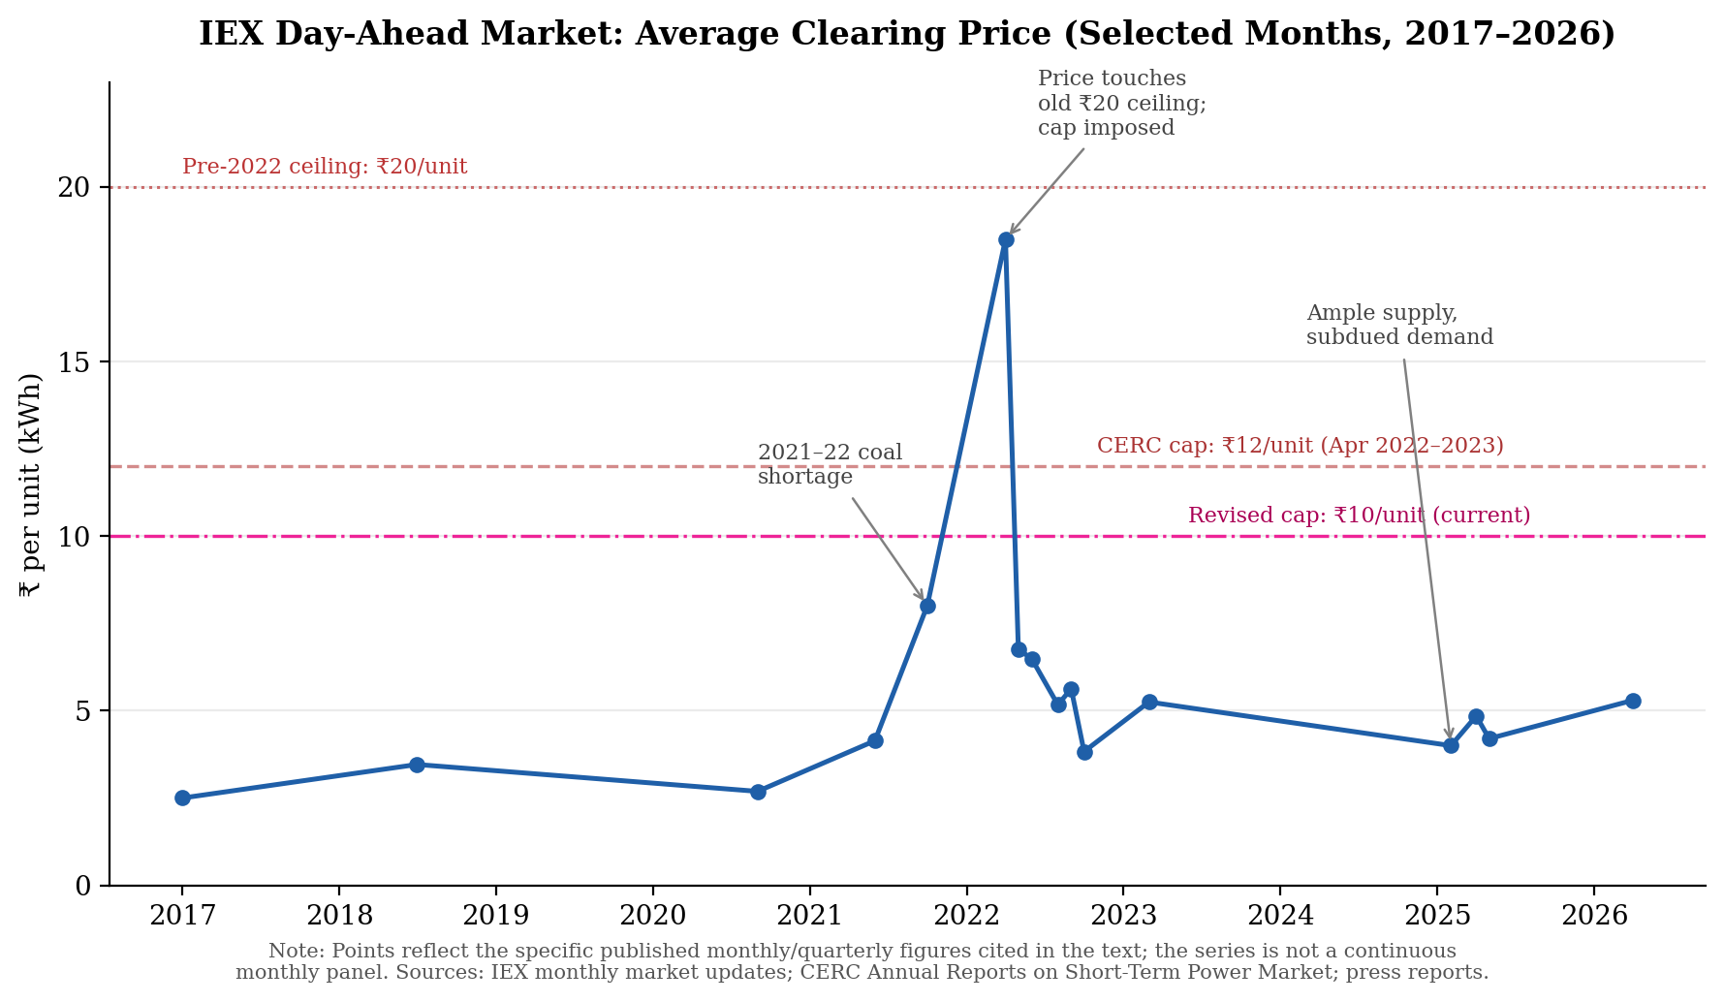
Figure 1:- IEX Day-ahead Market average clearing price at selected points, 2017–2026, against the successive CERC price ceilings.
The regression confirms the shock story, with caveats:- The ordinary-least-squares estimate of the model set out in Section 2, run on the full 111-month IEX DAM series, is
MCP_{t} = 3.82 − 0.018·Trend_{t} + 2.46·Cap_{t} + 2.68·CoalShock_{t} + 0.41·Summer_{t}
with n = 111, R² = 0.46 (adjusted R² = 0.44) and an overall F(4, 106) = 22.83 (p < 0.001). Coefficient-level results are:
Variable | Coefficient | Std. Error | t-stat | p-value
Intercept | 3.823 | 0.234 | 16.31 | < 0.001
Trend | -0.018 | 0.006 | -2.95 | 0.004
Cap (post-Apr 2022) | 2.461 | 0.397 | 6.20 | < 0.001
CoalShock (Oct 2021-Apr 2022) | 2.681 | 0.414 | 6.48 | < 0.001
Summer (Apr-Jun) | 0.412 | 0.220 | 1.87 | 0.064

The CoalShock coefficient (+Rs.2.68/unit, p < 0.001) is the cleanest evidence for the price-responsiveness claim made above: holding the long-run trend, the cap regime and seasonality fixed, the average clearing price during the acute 2021-22 coal-shortage window was about Rs.2.68/unit higher than in an otherwise identical month, an economically large and statistically significant effect that is consistent with a market genuinely pricing scarcity in near real time. The Summer dummy is positive (+Rs.0.41/unit) but only marginally significant (p = 0.064), suggesting the price series responds more sharply to an acute fuel-supply shock than to routine seasonal demand, plausibly because a large share of India’s summer peak load is still served through long-term contracts rather than the exchange. The Trend coefficient is small and negative (-Rs.0.018/unit per month, roughly -Rs.0.22/unit a year, p = 0.004): net of the cap and coal-shock effects, the exchange price has actually drifted down slightly over the full sample, consistent with the qualitative story of prices normalising once coal supply improved and additional capacity, including renewables, entered the grid.
The Cap dummy (+Rs.2.46/unit, p < 0.001) needs careful reading and should not be taken as evidence that the ceiling itself pushed prices up. Because the ceiling regime happens to begin almost exactly at the coal-shortage window, this coefficient is largely picking up the fact that the whole post-April-2022 period has cleared at a persistently higher average than the pre-2022 trend would predict, not a causal price-raising effect of an administrative price ceiling. Read together with the HP-DAM comparison in Figure 2, the more defensible interpretation is the one this paper has been building toward qualitatively: the ceiling has held the visible, capped DAM price down, while the scarcity value this coefficient is detecting has resurfaced in the uncapped High-Price Day-Ahead Market instead of disappearing.
One caveat is worth flagging: a Durbin-Watson statistic of 0.90 indicates strong positive autocorrelation in the residuals, typical of a monthly price series, which means the standard errors above are likely understated. The coefficients and their signs remain informative, but this is a descriptive conditional-mean model of the price series, not a causal estimate of any single intervention.
The price cap and the re-emergence of the suppressed signal:- In 2022 CERC intervened to control high price rather than let the spike in price decide its course. CERC puted the maximum quotable price cap at Rs.12/unit from April 2022 (later revised down to Rs.10/unit), repeatedly extended the cap throughout the year as coal supply concerns bled into the festivities and winter season. But rationally thinking it was for consumer protection:- an unbounded price would raise discom procurement costs and at the end it would raise retail electricity bills. However, scarcity did not vanish, as Rs.10-12/unit is below the marginal cost of the most expensive gas-based and imported-coal-based generators at times of real tightness, these plants simply stopped bidding into the capped Day-Ahead Market. After that CERC's response was to open a separate High-Price Day-Ahead Market (HP-DAM) in February 2023 in order to allow these higher-cost generators to trade outside the ceiling. So These two segments have since traded at mostly different prices:- i.e. in April 2026, the uncapped HP-DAM cleared at an average of about Rs.19.6/unit, it is almost double the official Rs. 10 ceiling, while the capped Day-Ahead Market cleared at merely Rs.5.3/unit during the same period. This tells us, that a price ceiling does not eliminate the value of scarce capacity, it is rather shifted to a smaller, parallel, less scrutinised market segment.
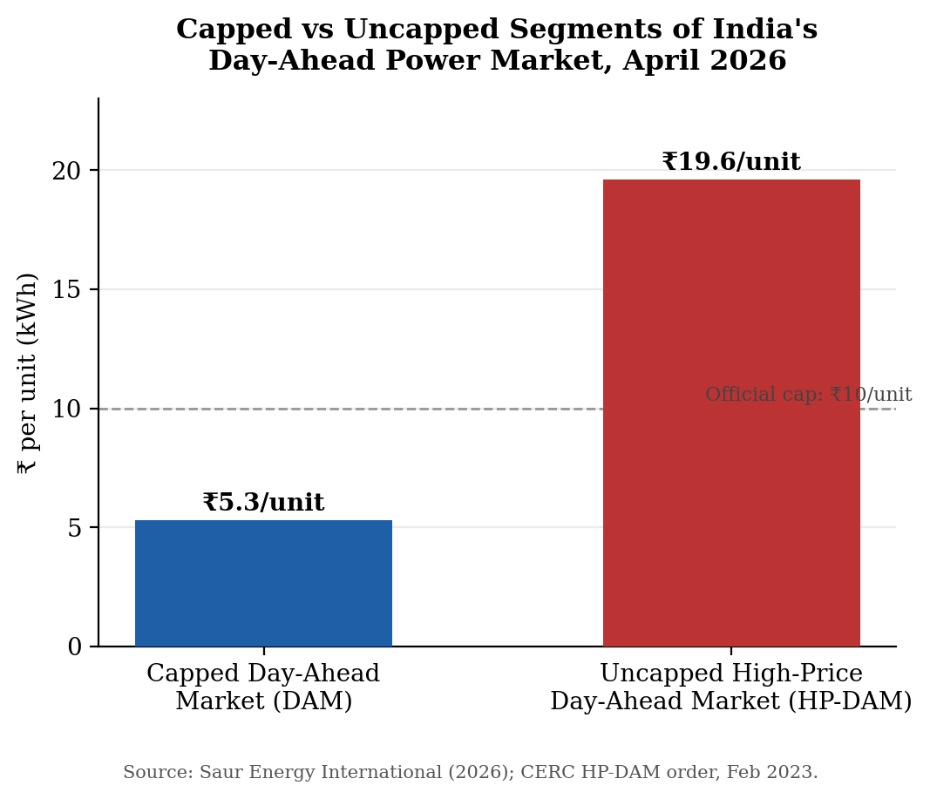
Figure 2: The suppressed High-Price Day-Ahead Market vs. the caped Day-Ahead Market, April 2026 – the suppressed scarcity value seeps out in the parallel market.
Concentration in exchange-based price discovery, and a different type of intervention: - Despite having three licensed power exchanges in India, IEX has consistently hold 84% of total exchange-traded volume in 2026, while PXIL and the newer HPX (launched in 2022) market share are 11% and 5% respectively. This reflects the liquidity-driven concentration. CERC's response to this concentration has been pursuing "market coupling" , Combining the bids of all three exchanges into a single national Uniform Market Clearing Price based on shadow-pilot data collected by Grid-India across 2024-2025. This is an intervention designed to complete the price mechanism rather than override it, so by removing the fragmentation that allows a large exchange's existing liquidity to be a barrier to entry even when a rival could offer an identical or better price. The reform has faced intense resistance by IEX, because it’s profitability rests on its dominant share’s exchange trading fees. So IEX challenged CERC's July 2025 order at the Appellate Tribunal for Electricity (dismissed in February 2026) and latter at the Supreme Court which has twice declined to grant an interim stay (May and July 2026) while agreeing to hear the considerable appeal. CERC has advised the Court that it expects to implement coupling within weeks of the most recent hearing. IEX has separately argued, based on the shadow-pilot findings, that the estimated economic gain from coupling is under 0.013% ,while continuing to report double-digit year-on-year growth in both trading volumes and profit through 2026, its highlight the commercial stakes in keeping the market uncoupled for the incumbent.
Now I will explain during my research I found how concentrated is this market, really is?:- Right after the entry of HPX in mid-2022, reports suggested that IEX had around 95% and PXIL had 5% market share, so it give us a value of 95² + 5² = 9,050 after using the HHI formula, which is almost the maximum value of 10,000, this figure show us a near-monopoly scenario for now. However, by 2026, when the HPX has gained sufficient traction and IEX’s share diluted to around 84–90%, assuming an 87% share for IEX, 8% for PXIL, and 5% for HPX, the value comes out to be 87² + 8² + 5² ≈ 7,658, but still both values are well beyond the value of 2,500 that show us a highly concentrated market. Thus, the market for electricity exchanges in India is concentrated i found out in this empirical research, and the above move by CERC to couple markets aims to address this exact issue, its not directly limiting the maximum share for the dominant exchange, but indirectly mandating the same price, which is discovered by IEX, it can be used in other exchanges as well.

4. Conclusion and Discussion
So my conclusion is that India's electricity market in the short term provides a case where the invisible hand can be observed to operate, suppressed, and actively enhanced, almost simultaneously. The day-ahead price has tracked real conditions of fuel supply-demand closely enough to show that decentralised bidding does distribute scarce generation capacity as the theory says it does, Price rising during the 2021–22 coal shortage and falling as supply was eased. Meanwhile, CERC's price cap shows that suppressing this signal in the name of consumer protection does not make the underlying scarcity go away, it reappears, almost undisguised, in the parallel High-Price Day-Ahead Market, where prices in 2026 have run to almost double the official ceiling, while the capped segment trades far below it. And the ongoing dispute about market-coupling shows a third possibility, a regulator attempting to perfect the price mechanism against the resistance of an incumbent whose commercial prospects depend upon the mechanism being incomplete.
It follow two implications. First, price ceilings — whatever their short-run political appeal its appear to be a comparatively blunt tool in Indian market:- i.e. in our electricity case the suppressed price reappeared as a parallel high-price segment in service of the same generators the cap was supposed to restrain, in that cases leaving the underlying scarcity fundamentally unaddressed and adding layers of administrative complexity. Second, and more positively, our electricity case suggests that some concentration in a marketplace for price-discovery can be a result of liquidity-driven network effects, not anti-competitive behaviour and these can probably be addressed by improving the market's technical architecture rather than capping any individual participant's share, provided the reform can survive the lawsuit of incumbents whose profits depend upon the status quo. the electricity market reinforces a common thread: the effectiveness of the invisible hand in India depends less on whether markets are formally open or prices formally free, and more on the surrounding infrastructure i.e. coupled price-discovery platforms. it allows the signal to multiply completely and quickly reach to those that most need to see it, it will be best to focus on an infrastructure question that is ultimately more suitable for policy than any attempt to manage the price itself.

References
- Central Electricity Regulatory Commission (CERC): Annual report on Short Term Power Market in India 2022-24; order, dated 1 April 2022, concerning price bidding range; suo motu orders, dated 26 December 2022 and 6 February 2023, regarding deviation charges; and order dated 23 July 2025, regarding market coupling.
- Grid Controller of India (Grid-India). Shadow Pilot Reports on Market Coupling submitted to CERC, 16 January 2025 and 30 June 2025.
- Appellate Tribunal for Electricity (APTEL). Order in Appeal No. 298 of 2025, Indian Energy Exchange v. CERC , dismissed in February 2026.
- Indian Energy Exchange Ltd (IEX). Monthly Power Market Update press releases and stock-exchange filings, various months,2017-26.
- Mercom India (2023, 2026). Reports on High-Price Day-Ahead Market approval and pricing; "APTEL Dismisses IEX's Appeal Against CERC's Market Coupling Directions.”
- Saur Energy International (2026). "CERC's Price Cap Could Be a Brake Energy Storage Can Do Without.”
- Business Standard (2022). “Power Exchanges Clock Growth Despite Pending Discom Dues Worth Rs 1.32 Trn,” 1 September 2022 (this is where we got the IEX/PXIL shares used for the 2022 HHI number).
- Business Standard (2022). "Hindustan Power Exchange Backed by BSE, PTC to Commence Operations," 7 July 2022.
- Industry research note (2026). "Top Energy Trading Platforms in India," used for the market-share estimates for IEX, PXIL and HPX in the 2026 HHI calculation.
- Business Standard, ICICI Direct, Powerline, Kotak Securities/CNBC-Awaaz (2017-26). Reports on IEX day-ahead market clearing prices; CERC price-cap orders; Supreme Court litigation on market coupling.
- Smith, A. (1776). An Inquiry into the Nature and Causes of the Wealth of Nations .
- Hayek, F. A. (1945). “The Use of Knowledge in Society.” American Economic Review , 35 (4), 519-530.

