TAMUG Data Cleaning
Author: Michael Johnson
Last Modified: 2017-06-19 00:04:23

Housekeeping
# Clear workspace
rm(list = ls())
# Load libraries
library(tidyverse); library(readxl); library(forcats); library(stringr); library(RColorBrewer)
# Set global options
# knitr::opts_knit$set(root.dir = "~/GitHub/2017-06-14-TAMUG/")
knitr::opts_chunk$set(echo=TRUE, message=FALSE, error=FALSE,
warning=FALSE, comment=NA,
fig.width = 6, fig.height = 4)
thm <- theme_classic()
scl <- scale_fill_manual(values = c(
"#004056", # dark blue
"#00D0A3", # light green
"#0093CA", # light blue
"#009B78", # dark green
"#E7877C", # light red
"#939393", # medium gray
"#B62D0F", # dark red
"#C9C9C9", # light gray
"#0682AB", # medium blue
"#009B78", # medium green
"#5C5C5C", # dark gray
"#45BC9C" # another light green
))

APPLICANTS

Load applicants data
# Load files
app <- list(app15 = read_excel("data/enrollment/GV_Applicant_2015.xlsx",
sheet = "Export Worksheet",
col_types = rep("text", 29)) %>%
add_column(YEAR = "2015"),
app16 = read_excel("data/enrollment/GV_Applicant_2016.xlsx",
sheet = "Export Worksheet",
col_types = rep("text", 29)) %>%
add_column(YEAR = "2016"),
app17 = read_excel("data/enrollment/GV_Applicant_2017.xlsx",
sheet = "Export Worksheet",
col_types = rep("text", 29)) %>%
add_column(YEAR = "2017")) %>%
# Combine multiple years and label data source (note: column names are identical)
bind_rows() %>% add_column(DATASET = "Applicants") %>%
rename(SOURCE = SOURCE1, # Rename to match other datasets
ADDRESS = ADDR_LINE_1,
TERM = APTERM,
HS_CODE = HS_CD) %>%
select(-ADDR_LINE_2, -APPLEVEL, -APPCOLL) %>% # Dont need second address line
mutate(ZIP = str_sub(ZIP, 1, 5), # Don't need second set of digits
HIGHEST_SAT = as.integer(HIGHEST_SAT),
HIGHEST_ACT = as.integer(HIGHEST_ACT),
HS_PERCENTILE = as.integer(HS_PERCENTILE),
HS_DECILE = cut(HS_PERCENTILE, breaks = 10, na.rm = T),
STATUS = if_else(!is.na(FIRST_ENROLL_TERM), "Enrolled", "Applicant"))
# Deduplicate
app <- distinct(app, TNUM, UIN, PIDM, .keep_all = T)

Explore applicants data
# Year/status
xtabs( ~ STATUS + YEAR, data = app)
YEAR
STATUS 2015 2016 2017
Applicant 1360 1301 1396
Enrolled 676 563 83
ggplot(app, aes(x = YEAR, fill = STATUS)) + geom_bar() + scl + thm
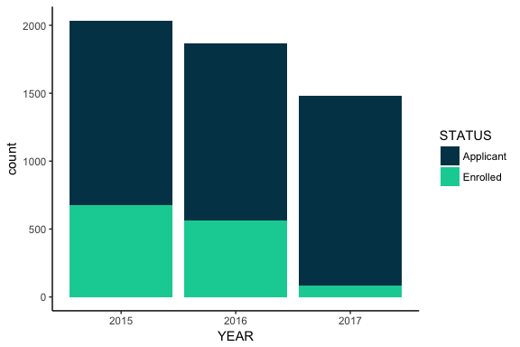
# App number
xtabs( ~ APNO + YEAR, data = app)
YEAR
APNO 2015 2016 2017
1.0 1221 1176 962
2.0 669 563 414
3.0 131 117 87
4.0 8 7 13
5.0 4 0 1
6.0 3 1 2
ggplot(app, aes(x = YEAR, fill = APNO)) + geom_bar() + scl + thm
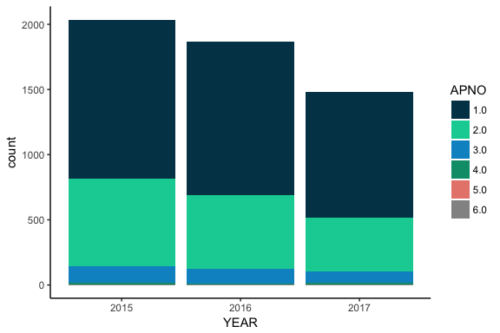
# Decision
xtabs( ~ DECISION + YEAR, data = app)
YEAR
DECISION 2015 2016 2017
AA 7 15 16
AB 19 23 23
AD 10 5 5
AP 116 243 144
AR 547 599 673
AS 309 0 0
AT 59 25 48
AY 0 1 0
CA 8 12 8
CB 7 15 8
CD 2 3 3
CP 2 51 12
CR 115 248 109
CS 48 0 0
CT 12 20 6
DA 307 209 101
ND 365 361 0
RF 1 1 19
RL 0 0 1
WD 55 14 14
XT 47 19 13
ggplot(app, aes(x = YEAR, fill = DECISION)) + geom_bar() + thm
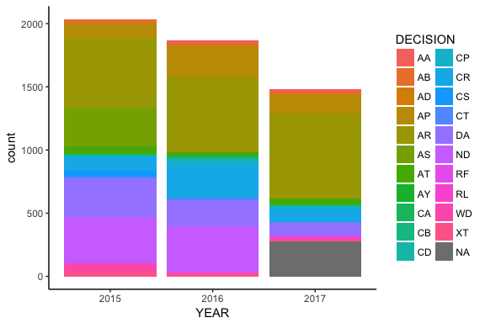
# First enrolled term
xtabs( ~ TERM + FIRST_ENROLL_TERM, data = app)
FIRST_ENROLL_TERM
TERM 201522 201532 201612 201622 201632 201712 201722 201732
201522 86 4 0 0 0 0 0 0
201532 0 580 1 0 4 0 0 1
201622 0 0 0 80 3 0 0 0
201632 0 0 0 0 475 5 0 0
201722 0 0 0 0 0 0 58 1
201732 0 0 0 0 0 0 0 24
ggplot(app, aes(x = FIRST_ENROLL_TERM, fill = TERM)) + geom_bar() + scl + thm
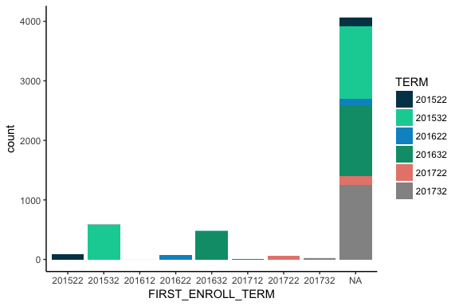
# Last enrolled term
xtabs( ~ TERM + LAST_ENROLL_TERM, data = app)
LAST_ENROLL_TERM
TERM 201522 201532 201612 201622 201632 201712 201722 201732
201522 5 15 21 1 4 8 2 34
201532 0 56 155 7 38 40 10 280
201622 0 0 0 8 6 29 0 40
201632 0 0 0 0 47 128 7 298
201722 0 0 0 0 0 0 58 1
201732 0 0 0 0 0 0 0 24
ggplot(app, aes(x = YEAR, fill = LAST_ENROLL_TERM)) + geom_bar() + scl + thm
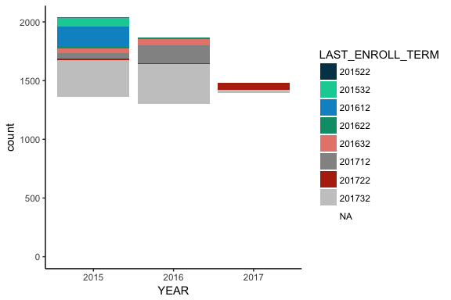
# Application term
xtabs( ~ TERM + YEAR, data = app)
YEAR
TERM 2015 2016 2017
201522 236 0 0
201532 1800 0 0
201622 0 193 0
201632 0 1671 0
201722 0 0 207
201732 0 0 1272
ggplot(app, aes(x = YEAR, fill = TERM)) + geom_bar() + scl + thm
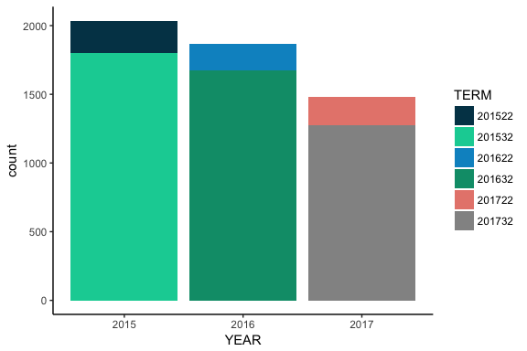
# Department
xtabs( ~ APPDEPT + YEAR, data = app)
YEAR
APPDEPT 2015 2016 2017
GACD 389 0 0
LIST 122 484 160
MARA 145 152 163
MARB 625 632 600
MARE 229 326 274
MARS 116 108 123
MART 201 162 159
MASE 209 0 0
ggplot(app, aes(x = YEAR, fill = APPDEPT)) + geom_bar() + scl + thm
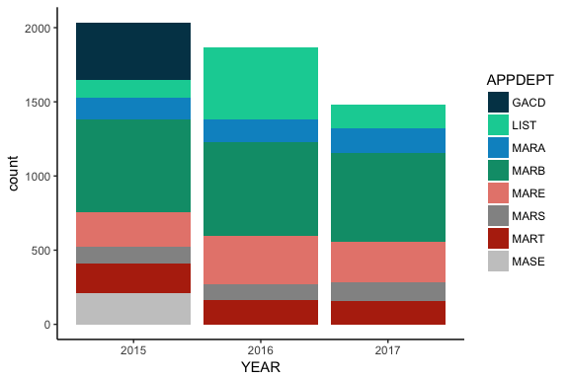
# Major
xtabs( ~ APPMJR + YEAR, data = app)
YEAR
APPMJR 2015 2016 2017
GACD 470 452 13
MARA 145 152 163
MARB 600 604 576
MARF 25 28 24
MARR 229 326 274
MARS 69 59 75
MART 201 162 159
MAST 38 25 54
OCRE 42 38 29
OCSL 209 0 0
USGA 8 18 112
ggplot(app, aes(x = YEAR, fill = APPMJR)) + geom_bar() + scl + thm
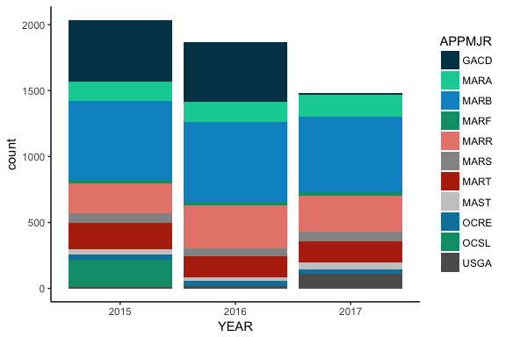
# Student type
xtabs( ~ APPTYPE + YEAR, data = app)
YEAR
APPTYPE 2015 2016 2017
FR 1721 1642 1289
TR 315 222 190
ggplot(app, aes(x = YEAR, fill = APPTYPE)) + geom_bar() + scl + thm
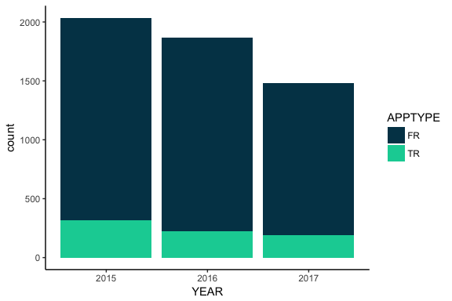
# State
xtabs( ~ STATE + YEAR, data = app)
YEAR
STATE 2015 2016 2017
AE 0 1 0
AK 1 0 1
AL 5 3 2
AP 1 0 1
AR 3 3 6
AZ 3 5 7
CA 21 24 18
CO 8 7 8
CT 6 6 2
DE 0 2 2
FL 25 19 16
GA 7 10 8
HI 0 1 2
IA 3 5 1
ID 0 1 1
IL 11 9 7
IN 2 4 4
KS 2 2 3
KY 1 4 0
LA 28 30 37
MA 2 3 1
MD 4 6 5
ME 0 0 2
MI 5 6 4
MN 1 1 4
MO 3 8 5
MS 7 4 5
MT 0 1 1
NC 1 4 7
NE 0 2 3
NH 2 0 1
NJ 8 8 6
NM 2 6 3
NV 2 1 4
NY 9 10 5
OH 7 1 5
OK 8 4 9
OR 2 1 2
PA 7 8 7
PR 4 5 0
RI 2 2 0
SC 7 2 5
SD 1 0 0
TN 6 2 4
TX 1438 1517 1226
UT 0 0 2
VA 15 9 12
VI 1 1 0
VT 0 1 0
WA 4 10 5
WI 4 0 1
WV 1 0 0
# State code?? - mostly same values, possibly ignore
xtabs( ~ APSTCODE + YEAR, data = app)
YEAR
APSTCODE 2015 2016 2017
C 1 1 20
D 2035 1863 1183
I 0 0 276
# SAT score
ggplot(app, aes(HIGHEST_SAT, fill = YEAR)) + geom_histogram(stat = "count") + thm + scl
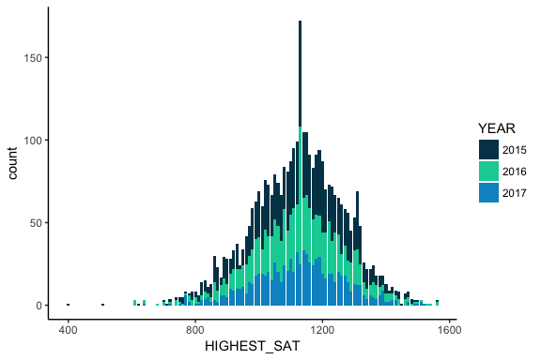
# ACT score
ggplot(app, aes(HIGHEST_ACT, fill = YEAR)) + geom_histogram(stat = "count") + thm + scl
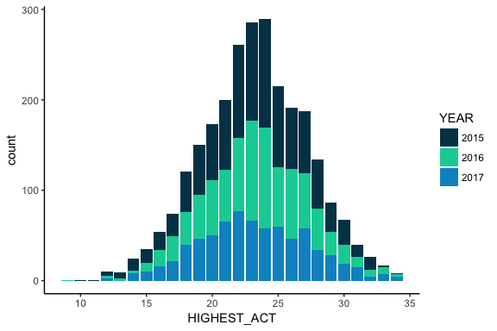
# Academic decile
ggplot(app, aes(HS_DECILE, fill = YEAR)) + geom_histogram(stat = "count") + thm + scl
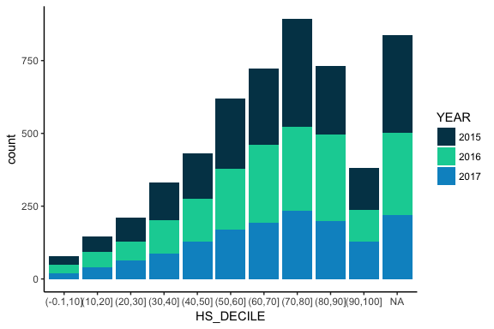
# Academic characteristics - medians
app %>% select(YEAR, HIGHEST_SAT, HIGHEST_ACT, HS_PERCENTILE) %>% group_by(YEAR) %>% summarise_all(median, na.rm = T)
# A tibble: 3 x 4
YEAR HIGHEST_SAT HIGHEST_ACT HS_PERCENTILE
<chr> <dbl> <dbl> <int>
1 2015 1130 23 67
2 2016 1130 23 69
3 2017 1130 23 68

INQUIRIES

Load inquiries data
# Load files
inq <- list(inq15 = read_excel("data/enrollment/GV_Recruit_2015.xlsx",
sheet = "Export Worksheet") %>% add_column(YEAR = "2015"),
inq16 = read_excel("data/enrollment/GV_Recruit_2016.xlsx",
sheet = "Export Worksheet") %>% add_column(YEAR = "2016"),
inq17 = read_excel("data/enrollment/GV_Recruit_2017.xlsx",
sheet = "Export Worksheet") %>% add_column(YEAR = "2017")) %>%
# Combine multiple years and label data source (note: column names are identical)
bind_rows() %>% add_column(DATASET = "Inquiries") %>%
rename(PREV_COLL_CD = PREV_COLL_NAME, # Rename to match other dataset
PREV_COLL_NAME = PREV_COLL_NAME_1,
ADDRESS = ADDRESS_LINE_1) %>%
select(-ADDRESS_LINE_2) %>% # Don't need second line of address (mostly blank)
mutate(ZIP = str_sub(ZIP, 1, 5), # Only need first 5 digits of zip
STATUS = "Inquiry",
HIGHEST_SAT = as.integer(HIGHEST_SAT),
HIGHEST_ACT = as.integer(HIGHEST_ACT),
HS_PERCENTILE = as.integer(HS_PERCENTILE),
HS_DECILE = cut(HS_PERCENTILE,
breaks = 10, na.rm = T))
# Deduplicate
inq <- distinct(inq, TNUM, UIN, .keep_all = T)

Explore inquiries data
# Year
xtabs( ~ YEAR, data = inq)
YEAR
2015 2016 2017
51826 57077 13415
ggplot(inq, aes(YEAR)) + geom_bar() + thm
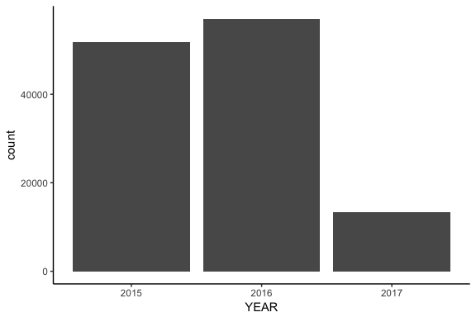
# Term
xtabs( ~ TERM + YEAR, data = inq)
YEAR
TERM 2015 2016 2017
201532 51826 0 0
201632 0 57077 0
201732 0 0 13415
ggplot(inq, aes(x = YEAR, fill = TERM)) + geom_bar() + thm + scl
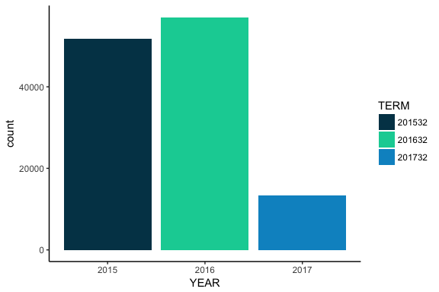
# State
xtabs( ~ STATE + YEAR, data = inq)
YEAR
STATE 2015 2016 2017
AE 1 3 1
AK 82 37 5
AL 114 121 40
AP 1 2 4
AR 87 99 61
AZ 631 651 134
CA 7355 6893 1085
CO 334 344 81
CT 871 925 113
DC 37 26 1
DE 138 80 12
FL 2993 3010 581
FM 0 1 0
GA 1836 1855 465
GU 0 0 1
HI 185 162 6
IA 49 48 24
ID 82 78 10
IL 276 328 83
IN 1254 1142 212
KS 72 115 25
KY 94 110 24
LA 175 229 160
MA 1713 1728 155
MD 1040 1298 199
ME 352 191 13
MI 170 172 49
MN 136 130 32
MO 91 134 63
MS 43 63 37
MT 59 65 5
NC 1960 2068 482
ND 12 5 3
NE 32 38 14
NH 240 373 23
NJ 1837 2272 440
NM 100 96 17
NV 280 277 32
NY 3052 3446 484
OH 752 628 97
OK 115 114 86
OR 499 536 79
PA 2923 2769 524
PR 76 63 2
RI 231 224 15
SC 929 897 208
SD 11 12 1
TN 191 233 49
TX 14963 19528 6656
UT 49 50 13
VA 1877 1987 287
VI 0 1 0
VT 157 154 9
WA 1007 962 80
WI 99 92 30
WV 79 59 11
WY 8 9 2
# Academic characteristics - medians
inq %>% select(YEAR, HIGHEST_SAT, HIGHEST_ACT, HS_PERCENTILE) %>% group_by(YEAR) %>% summarise_all(median, na.rm = T)
# A tibble: 3 x 4
YEAR HIGHEST_SAT HIGHEST_ACT HS_PERCENTILE
<chr> <dbl> <dbl> <dbl>
1 2015 1250 26 87
2 2016 1210 25 86
3 2017 1200 24 83
# SAT
ggplot(inq, aes(HIGHEST_SAT, fill = YEAR)) + geom_histogram(stat = "count") + thm + scl
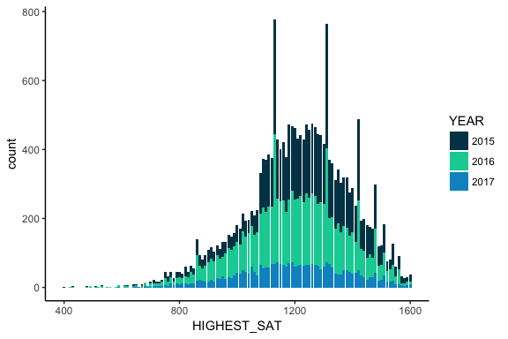
# ACT
ggplot(inq, aes(HIGHEST_ACT, fill = YEAR)) + geom_histogram(stat = "count") + thm + scl
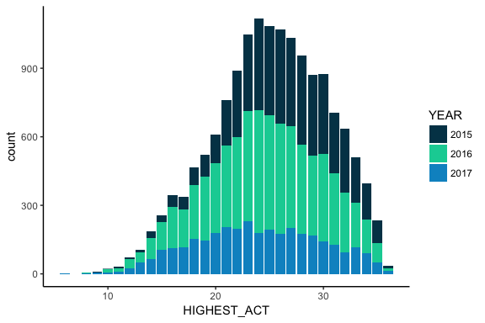
# High school percentile
ggplot(inq, aes(HS_DECILE, fill = YEAR)) + geom_histogram(stat = "count") + thm + scl
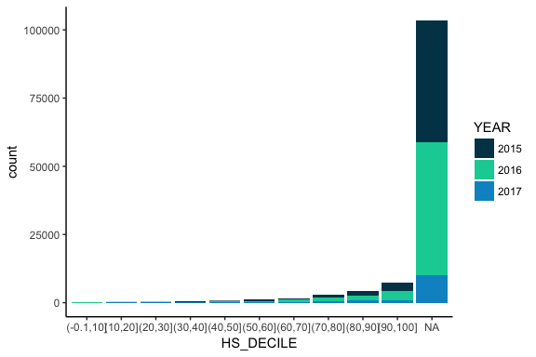

PROSPECTS

Load prospects data
# Load files
prs <- list(prs1 = read_excel("data/enrollment/288521-S01.xlsx",
sheet = "288521-S01.xlsx",
col_types = rep("text", 86)),
prs2 = read_excel("data/enrollment/298125-S01.xlsx",
sheet = "298125-S01.xlsx",
col_types = rep("text", 86)),
prs3 = read_excel("data/enrollment/SAT Fall 2015.xlsx",
sheet = "231720-S01.xlsx",
col_types = rep("text", 86)),
prs4 = read_excel("data/enrollment/SAT Winter 2016 TX.xlsx",
sheet = "248076-S01.xlsx",
col_types = rep("text", 86)),
prs5 = read_excel("data/enrollment/SAT WInter 2016.xlsx",
sheet = "248077-S01.xlsx",
col_types = rep("text", 86))) %>%
# Combine multiple years and label data source
bind_rows(.id = "FILE") %>%
add_column(DATASET = "Prospects") %>%
rename(LNAME = LAST_NAME,
FNAME = FIRST_NAME,
ADDRESS = STREET1,
CIPMJR = Major1) %>%
filter(COUNTRY == "UNITED STATES" | COUNTRY == "United States") %>%
select(-STREET2, -STREET3, -MI, -RUN_NO, -ORDER_NO, -COUNTRY, -PROVINCE, -TBD, -GPA, # Checked distros, not useful
-HOMESCHOOL, -LOW_SES, -HS_CLUSTER, -EN_CLUSTER, -NHRP, -PLTW, -NAME_SOURCE, -UPDATE_DATE, -Major2, -Major3,
-num_range("AP", 1:10), -num_range("SATSUB", 1:10)) %>%
mutate(ZIP = str_sub(ZIP, 1, 5),
CIPMJR = str_split_fixed(CIPMJR, "\\.", 2)[,1], # Extract program family
STATUS = "Prospect",
DATASET = fct_recode(DATASET, # Combine factor levels
"Prospects - Fall 2016" = "prs1",
"Prospects - Fall 2016" = "prs2",
"Prospects - Winter 2016" = "prs5",
"Prospects - Winter 2016" = "prs4",
"Prospects - Fall 2015" = "prs3"),
DATASET = factor(DATASET, levels = c("Prospects - Fall 2015",
"Prospects - Winter 2016",
"Prospects - Fall 2016")))
prs <- distinct(prs, STUDENT_ID) # 4 duplicate records
# Notes: have to change case of city names to all proper, also email addresses
# extract age from DOB
# combine fall 2015 and winter 2016

Explore prospects data

Combining student-level datasets
enr <- bind_rows(app, inq, prs)
write_csv(enr, "data/student_master.csv", na = "")

Events data
# Events data (multiple tabs) -- Note no data for Dec 2015 or Dec 2017
shts <- c("Sep 2015", "Oct 2015", "Nov 2015", "Jan 2016", "Feb 2016", "March 2016", "April 2016", "May 2016", "June 2016", "July 2016", "August 2016", "September 2016", "October 2016", "November 2016", "December 2016", "January 2017", "February 2017", "March 2017", "April 2017", "May 2017", "June 2017", "July 2017", "August 2017", "September 2017", "October 2017", "November 2017", "January 2018", "February 2018")
# Gather sheets
events <- lapply(shts, function(x){
nm = paste(str_sub(x, 1, 3), str_sub(x, -4, -1), sep = "-")
read_excel("data/enrollment/Counselor Travel & Campus Visit Schedule.xlsx",
sheet = x, col_types = rep("text", 8)) %>%
add_column(DATASET = nm)
}) ; rm(shts)
# Combine sheets
events <- bind_rows() %>% filter(!is.na(events[,1]))

Output files
write_csv(app, "data/applicants.csv", na = "")
write_csv(inq, "data/inquiries.csv", na = "")
write_csv(prs, "data/prospects.csv", na = "")
write_csv(events, "data/events.csv", na = "")

