Mark Joiner

Assignment 1

CSD 325

1/12/25

Screenshot of directory: 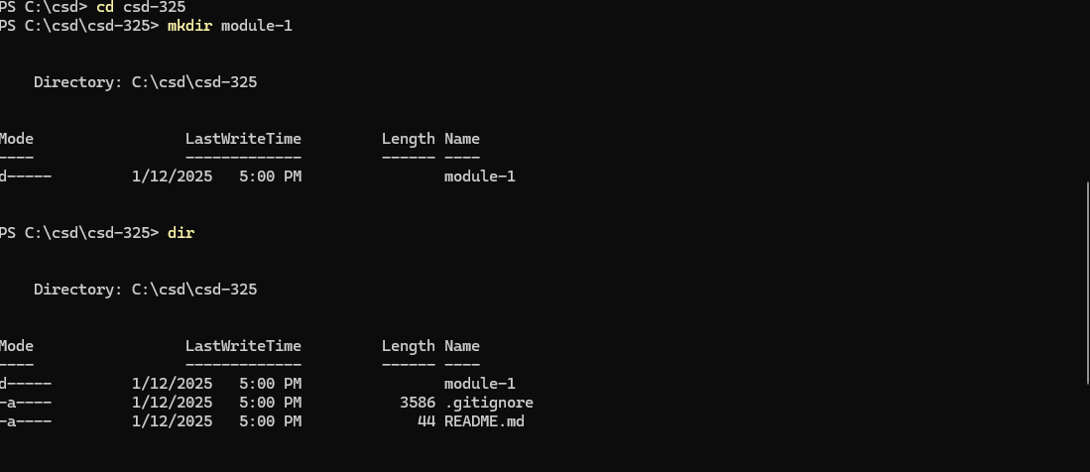

Screenshot of Module-1 on GitHub:

URL of my repository:

https://github.com/mdjoiner2/csd-325.git