INDUSTRY PROJECT REPORT
Retail Sales Performance Analysis
Using Python & Power BI

Industry Project Title | Integrated Retail Sales Performance Tracking and Analysis  (TCS iON AIP 135)
Name of the Company | Tata Consultancy Services (TCS iON)
Name of the Institute | Viswakarma University
Submitted By | Mohammad Junaid Shaikh  Computer Science Department

Start Date | End Date | Total Effort (hrs.) | Project Environment | Tools Used
2025 | 2026 | 120+ | Python, Power BI | Python, Power BI, DAX, Excel

Academic Year: 2025–2026
GitHub: https://github.com/mdjunaid23/TCS_industry-_project_4thsem

TABLE OF CONTENT
- Acknowledgements
- Abstract
- Objective and Scope
- Problem Statement
- Existing Approaches
- Approach / Methodology – Tools and Technologies Used
- Workflow
- Dataset Description
- Implementation – Data Collection, Processing Steps, Diagrams
- Solution Design / Dashboard Development
- Key Performance Indicators (KPIs)
- Data Analysis
- Business Insights
- Challenges & Opportunities
- Limitations
- Reflections on the Project
- Recommendations
- Outcome / Conclusion
- Enhancement Scope / Future Scope
- Test Design Document
- Link to Code and Executable File
- References

Acknowledgements
I would like to express my sincere gratitude to Tata Consultancy Services (TCS iON) for providing this valuable industry project opportunity through the AIP 135 program. I am thankful to Viswakarma University and the Computer Science Department for their continuous guidance and support throughout this project.
I also extend my thanks to my project mentors and faculty members whose insights helped shape this work, and to the open-source community behind Python, Pandas, and Power BI whose tools made this analysis possible.

Abstract
This project presents the development of an interactive Retail Sales Performance Dashboard using Power BI to analyze and visualize retail transaction data. The primary objective is to transform raw sales data into meaningful insights that support effective business decision-making. The dataset consists of transactional details such as product categories, customer demographics, sales amounts, and purchase dates.
Data preprocessing techniques were applied using Python (Pandas), including data cleaning, feature engineering, and transformation. New attributes such as Age Group segmentation and Month extraction were created to enable better analysis. The dashboard provides key performance indicators (KPIs) such as total sales, total transactions, quantity sold, and average sales. Various visualizations including line charts, bar charts, pie charts, and donut charts were used to represent sales trends, product performance, and customer behavior.
The analysis reveals important insights such as declining sales trends over time, strong performance of Electronics and Clothing categories, balanced gender contribution, and higher purchasing activity among the 36–50 age group. Overall, this project demonstrates how data analytics and visualization tools can be effectively used to monitor business performance, identify trends, and support strategic planning in the retail sector.

Objective and Scope
The key objectives of this project are:
- To analyze retail sales data and identify patterns
- To study customer purchasing behavior
- To evaluate product category performance
- To visualize key performance indicators (KPIs)
- To develop an interactive dashboard using Power BI
- To apply Python-based data preprocessing for data quality assurance
Scope: This project covers transactional retail data analysis, data cleaning using Python, feature engineering, and dashboard development in Power BI. The scope does not include real-time data integration, predictive modeling, or regional/store-level analysis.

Problem Statement
In today's highly competitive retail industry, organizations rely on data-driven insights to enhance business performance and make informed decisions. Traditional reporting systems are often static and fail to provide real-time insights, leading to inefficiencies in decision-making. There is a growing need for an interactive, visually driven system that enables stakeholders to quickly understand sales trends, customer behavior, and product performance — without requiring deep technical expertise.

Existing Approaches
Current approaches used in retail sales reporting include:
- Static Excel reports – manually updated, limited interactivity
- Basic BI dashboards – lack advanced filtering and KPI tracking
- ERP-based reporting – complex to configure and costly
- Manual analysis – time-consuming and prone to human error
This project addresses these gaps by using Power BI for interactive visualization combined with Python for robust data preprocessing.

Approach / Methodology – Tools and Technologies Used
The project followed a structured data analytics pipeline:

Tools & Technologies
Tool / Technology | Purpose
Python (Pandas) | Data cleaning, transformation, feature engineering
Power BI | Interactive dashboard development and visualization
DAX | KPI measures and calculated columns
Excel / CSV | Data source and intermediate data format
GitHub | Version control and code repository

Workflow
- Step 1: Data Collection – Retail transaction CSV dataset
- Step 2: Data Cleaning – Remove duplicates, handle missing values (Python/Pandas)
- Step 3: Feature Engineering – Add Month and Age Group columns
- Step 4: Data Import – Load cleaned data into Power BI
- Step 5: Data Modeling – Create relationships and DAX measures
- Step 6: Dashboard Design – Build KPI cards, charts, and slicers
- Step 7: Analysis & Insights – Interpret visualizations
- Step 8: Documentation – Prepare project report

Dataset Description
The dataset used in this project contains retail transaction data with the following attributes:
Attribute | Description
Transaction ID | Unique identifier for each transaction
Date | Date of the transaction
Customer ID | Unique customer identifier
Gender | Customer gender (Male/Female)
Age | Customer age
Product Category | Category of product purchased
Quantity | Number of units purchased
Price per Unit | Unit price of the product
Total Amount | Total transaction value
Dataset Characteristics:
- Structured transactional dataset
- Contains both customer and product-level information
- Suitable for trend analysis, segmentation, and aggregation

Implementation – Data Collection, Processing Steps

4.1 Data Preparation
- The dataset was imported into Power BI
- Data quality checks were performed (missing values and duplicates)
- Derived columns were created: Age Group (18–25, 26–35, 36–50, 50+) and Month

4.2 Data Transformation & Modeling
- Age values were categorized into meaningful groups
- Time-based features were derived for trend analysis
- Key measures were created using DAX:
- Total Sales = SUM(Total Amount)
- Total Transactions = COUNT(Transaction ID)
- Average Sales = Total Sales / Total Transactions

4.3 Python Data Cleaning & Transformation
The dataset was pre-processed using Python and the Pandas library:
Step 1: Load Dataset
import pandas as pd
df = pd.read_csv("Retail_Sales_Dataset.csv")
Step 2: Data Cleaning
df = df.drop_duplicates()
df = df.fillna(method='ffill')
df['Date'] = pd.to_datetime(df['Date'])
Step 3: Feature Engineering
df['Month'] = df['Date'].dt.strftime('%b')
def age_group(age):
if age <= 25: return '18-25'
elif age <= 35: return '26-35'
elif age <= 50: return '36-50'
else: return '50+'
df['Age Group'] = df['Age'].apply(age_group)
Step 4: Save Cleaned Dataset
df.to_csv('_Retail_Sales_Dataset(1).csv', index=False)
Output: Data cleaning and transformation completed successfully.

Solution Design / Dashboard Development
The Power BI dashboard includes the following components:
- KPI Cards – Summary metrics (Total Sales, Transactions, Quantity, Average Sales)
- Line Chart – Sales trend over time
- Bar Chart – Product category performance
- Pie Chart – Gender distribution
- Donut Chart – Age group contribution
- Slicer – Age Group filter for interactivity

Design Considerations
- Clean and structured layout
- Consistent color theme throughout the dashboard
- Interactive filters for dynamic data exploration
- Easy-to-understand visual representation

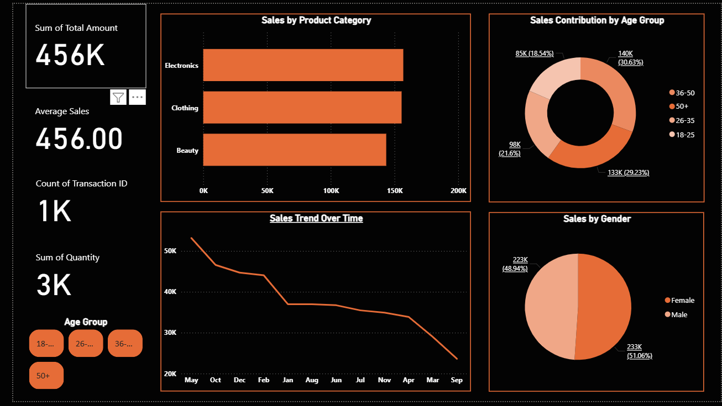

Key Performance Indicators (KPIs)
KPI | Value
Total Sales | 456K
Total Quantity Sold | 3K
Total Transactions | 1K
Average Sales | 456
These KPIs provide a quick overview of overall business performance.

Data Analysis

6.1 Sales Trend Analysis
The sales trend shows a gradual decline over time. The initial months demonstrate higher sales compared to later months.
Interpretation:
- Possible seasonal variation
- Reduced demand in later periods
- Need for improved marketing strategies

6.2 Product Category Analysis
- Electronics and Clothing categories generate the highest revenue
- Beauty category contributes the least
- High-value and essential products are more preferred by customers

6.3 Gender Analysis
- Male customers contribute approximately 51%
- Female customers contribute approximately 49%
- The customer base is well-balanced across genders

6.4 Age Group Analysis
- The 36–50 age group contributes the highest (~30%)
- The 50+ group also contributes significantly
- The 18–25 group has the lowest contribution
- Middle-aged customers are the primary revenue contributors

Business Insights
- Sales performance shows a declining trend over time
- Electronics and Clothing are the top-performing categories
- Younger customers (18–25) show lower engagement
- Customer distribution is balanced across gender

Challenges & Opportunities

Challenges
- Handling missing and inconsistent data in the raw dataset
- Designing an intuitive dashboard layout for non-technical stakeholders
- Creating meaningful DAX measures for accurate KPI calculation

Opportunities
- Integration of real-time data for live monitoring
- Expansion to regional and store-level analysis
- Application of machine learning for predictive analytics

Limitations
- The dataset is not real-time
- External factors such as competition and market trends are not included
- No region-wise analysis is available
- Predictive analytics is not implemented in the current version

Reflections on the Project
This project provided a comprehensive hands-on experience in the full data analytics pipeline — from raw data collection to interactive dashboard development. Working with Python for data preprocessing and Power BI for visualization enhanced my understanding of how these tools complement each other in real-world business scenarios.
The project also reinforced the importance of data quality, as the insights generated are only as reliable as the underlying data. I gained practical skills in DAX formula writing, Power BI dashboard design, and Python-based feature engineering.

Recommendations
- Target younger customers (18–25) through focused marketing campaigns
- Promote underperforming categories such as Beauty with special offers
- Introduce seasonal discounts during low-performing months
- Optimize inventory for high-demand product categories
- Explore loyalty programs to retain the high-spending 36–50 age group

Outcome / Conclusion
This project successfully demonstrates the application of data analytics and visualization in retail sales performance monitoring. The Power BI dashboard provides clear visualization of sales trends, insights into customer behavior, and identification of high-performing product categories. Overall, the system enhances decision-making and business efficiency, serving as a strong foundation for advanced analytics implementations.

Enhancement Scope / Future Scope
- Integration of real-time data sources via APIs
- Implementation of predictive analytics models (forecasting, demand prediction)
- Customer segmentation using machine learning clustering algorithms
- Region-wise and store-level analysis for granular insights
- Automated report generation and email scheduling

Test Design Document

Test Case TC01
Application | Power BI Dashboard
Test Case | Verify sales trend visualization
Expected Result | Accurate month-wise representation
Actual Result / Status | Correct – Passed
Defect | None

Test Case TC02
Description | Verify product category performance
Step | Load dataset and open dashboard
Expected Result | Bar chart displays correct values per category
Result | Passed

Test Scenario
Req ID | REQ01
Scenario | Dashboard visualization
Condition | KPIs and charts visible with correct data
Expected | Accurate visualization
Priority | High

Link to Code and Executable File
GitHub Repository:
https://github.com/mdjunaid23/TCS_industry-_project_4thsem
The repository contains:
- Python data cleaning script (data_cleaning.py)
- Cleaned dataset CSV file
- Power BI dashboard file (.pbix)
- Project documentation

References
[1] McKinney, W. (2022). Python for Data Analysis (3rd ed.). O'Reilly Media.
[2] Géron, A. (2022). Hands-On Machine Learning with Scikit-Learn, Keras, and TensorFlow (3rd ed.). O'Reilly Media.
[3] Microsoft Corporation. (2024). Power BI Documentation. https://docs.microsoft.com/en-us/power-bi/
[4] Scikit-learn Developers. (2024). Scikit-learn: Machine Learning in Python. https://scikit-learn.org/
[5] Pandas Development Team. (2024). Pandas Documentation. https://pandas.pydata.org/docs/
[6] GitHub Repository: https://github.com/mdjunaid23/TCS_industry-_project_4thsem

