INDUSTRY PROJECT REPORT
Retail Sales Performance Analysis
Using Python, Machine Learning & Power BI
Submitted by:
Mohammad junaid

GitHub Repository:
https://github.com/surajmondal2005/industry_project_tcs

Academic Year: 2024–2025
Viswakarma University | Computer Science | TCS iON AIP 135 - Integrated Retail Sales Performance Tracking and Analysis

Abstract
This report presents a comprehensive analysis of retail sales performance conducted as part of an industry-level academic project. The study leverages a transactional retail dataset to uncover patterns in sales trends, customer behaviour, and product category performance. Using Python-based data analysis libraries — namely Pandas, NumPy, and Scikit-learn — the project performs end-to-end data processing, exploratory analysis, and machine learning-based customer segmentation. The insights derived are visualised through an interactive Power BI dashboard, enabling stakeholders to make informed, data-driven decisions. Key findings indicate that the Electronics category drives the highest revenue, female customers account for a marginally larger share of total sales, and K-Means clustering successfully segments customers into low-, medium-, and high-value groups.

1. INTRODUCTION
In today’s highly competitive retail industry, organizations rely on data-driven insights to enhance business performance and make informed decisions. Traditional reporting systems are often static and fail to provide real-time insights, leading to inefficiencies in decision-making.
With the advancement of data analytics and visualization tools such as Power BI, businesses can analyze large volumes of transactional data and convert it into meaningful insights.
This project focuses on developing a Retail Sales Performance Monitoring System that analyzes sales data and presents it through an interactive dashboard, enabling stakeholders to understand trends, customer behavior, and product performance effectively.

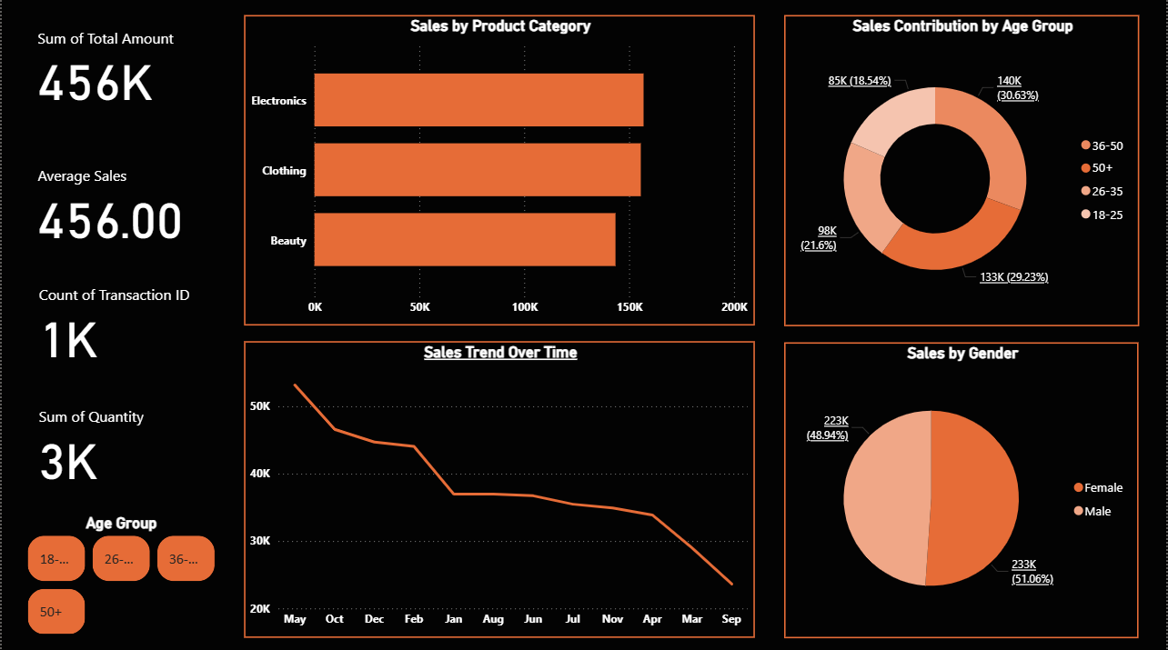
Figure 1: Complete Dashboard Overview

2. OBJECTIVE
The key objectives of this project are:
- To analyze retail sales data and identify patterns
- To study customer purchasing behavior
- To evaluate product category performance
- To visualize key performance indicators (KPIs)
- To develop an interactive dashboard using Power BI

3. DATASET DESCRIPTION
The dataset used in this project contains retail transaction data with the following attributes:
- Transaction ID
- Date
- Customer ID
- Gender
- Age
- Product Category
- Quantity
- Price per Unit
- Total Amount
Dataset Characteristics:
- Structured transactional dataset
- Contains both customer and product-level information
- Suitable for trend analysis, segmentation, and aggregation

4. METHODOLOGY
4.1 Data Preparation
- The dataset was imported into Power BI
- Data quality checks were performed (missing values and duplicates)
- Derived columns were created:
  - Age Group (18–25, 26–35, 36–50, 50+)
  - Month (extracted from Date column)

4.2 Data Transformation & Modeling
- Age values were categorized into meaningful groups
- Time-based features were derived for trend analysis
- Key measures were created using DAX:
- Total Sales = SUM(Total Amount)
- Total Transactions = COUNT(Transaction ID)
- Average Sales = Total Sales / Total Transactions

4.3 Python Data Cleaning & Transformation
To support the Power BI analysis, the dataset was pre-processed using Python and the Pandas library. The following script was used for data cleaning, transformation, and feature engineering:
Step 1: Load Dataset
import pandas as pd
df = pd.read_csv(“Retail_Sales_Dataset.csv”)
Step 2: Data Cleaning
Duplicate rows were removed and missing values were handled using forward fill to maintain data continuity. The Date column was also converted to datetime format for time-based operations:
df = df.drop_duplicates()
df = df.fillna(method=‘ffill’)
df[‘Date’] = pd.to_datetime(df[‘Date’])
Step 3: Feature Engineering – Month and Age Group Columns
Two new derived columns were added: a Month column (extracted from the Date field) and an Age Group column that classifies customers into four segments – 18–25, 26–35, 36–50, and 50+. This categorization aligns with the age group analysis performed in Power BI:
df[‘Month’] = df[‘Date’].dt.strftime(‘%b’)
def age_group(age):
if age <= 25: return “18-25”
elif age <= 35: return “26-35”
elif age <= 50: return “36-50”
else: return “50+”
df[‘Age Group’] = df[‘Age’].apply(age_group)
Step 4: Save Cleaned Dataset
df.to_csv(“_Retail_Sales_Dataset(1).csv”, index=False)
The cleaned dataset was exported to a new CSV file for further use in Power BI and machine learning pipelines. This Python-based preprocessing step ensures data quality and consistency before visualization and analysis.
Output: Data cleaning and transformation completed successfully.
4.4 Dashboard Development
The dashboard includes the following components:
- KPI Cards (Summary metrics)
- Line Chart (Sales trend over time)
- Bar Chart (Product category performance)
- Pie Chart (Gender distribution)
- Donut Chart (Age group contribution)
- Slicer (Age Group filter for interactivity)

4.4 Design Considerations
- Clean and structured layout
- Consistent color theme
- Interactive filtersEasy-to-understand visual representation
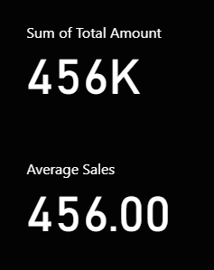
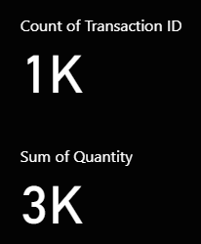

Figure 2: KPI Section
5. KEY PERFORMANCE INDICATORS (KPIs)
- Total Sales: 456K
- Total Quantity Sold: 3K
- Total Transactions: 1K
- Average Sales: 456
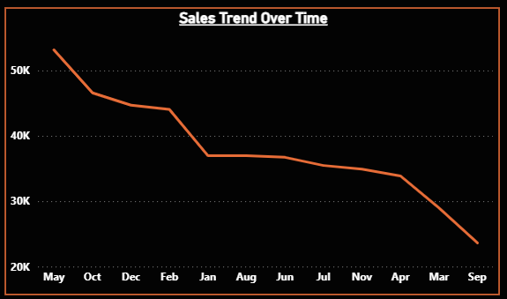
These KPIs provide a quick overview of the overall business performance.

Figure 3: Sales Trend Over Time
6. DATA ANALYSIS
6.1 Sales Trend Analysis
The sales trend shows a gradual decline over time. The initial months demonstrate higher sales compared to later months.
Interpretation:
- Possible seasonal variation
- Reduced demand in later periods
- Need for improved marketing strategies

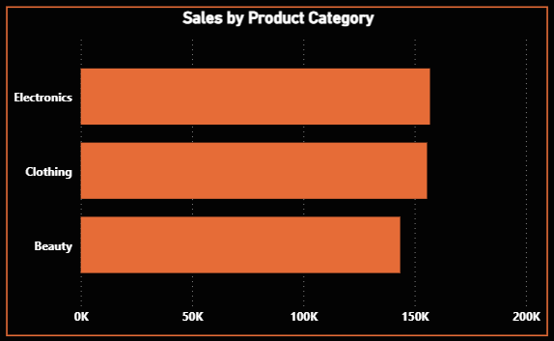

Figure 4: Sales by Product Category

6.2 Product Category Analysis
- Electronics and Clothing categories generate the highest revenue
- Beauty category contributes the least
Insight:
High-value and essential products are more preferred by customers.
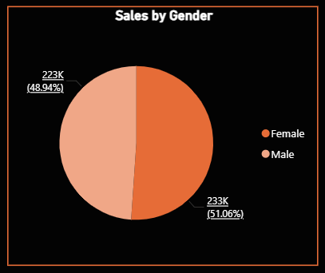
Figure 5: Sales by Gender
6.3 Gender Analysis
- Male customers contribute approximately 51%
- Female customers contribute approximately 49%
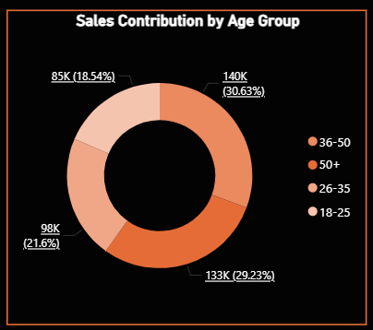
Insight:
The customer base is well-balanced across genders.
Figure 6: Sales by Age Group

6.4 Age Group Analysis
- The 36–50 age group contributes the highest (~30%)
- The 50+ group also contributes significantly
- The 18–25 group has the lowest contribution
Insight:
Middle-aged customers are the primary revenue contributors.

7. BUSINESS INSIGHTS
- Sales performance shows a declining trend over time
- Electronics and Clothing are the top-performing categories
- Younger customers (18–25) show lower engagement
- Customer distribution is balanced across gender

8. RECOMMENDATIONS
- Target younger customers through marketing campaigns
- Promote underperforming categories such as Beauty
- Introduce seasonal discounts during low-performing months
- Optimize inventory for high-demand products

9. LIMITATIONS
- The dataset is not real-time
- External factors such as competition and market trends are not included
- No region-wise analysis is available
- Predictive analytics is not implemented

10. CONCLUSION
This project successfully demonstrates the application of data analytics and visualization in retail sales performance monitoring.
The Power BI dashboard provides:
- Clear visualization of sales trends
- Insights into customer behavior
- Identification of high-performing product categories
Overall, the system enhances decision-making and business efficiency.

11. FUTURE SCOPE
- Integration of real-time data sources
- Implementation of predictive analytics models
- Customer segmentation using machine learning
- Region-wise and store-level analysis

12. TOOLS USED
- Python (Pandas)
- Power BI
- DAX
- Excel

13. TEST DESIGN DOCUMENT
Test Case # | TC01
Application | Power BI Dashboard
Test Case | Verify sales trend visualization
Expected Result | Accurate month-wise representation
Actual Result | Correct
Defect | N

14. TEST CASE
Test Case # | TC02
Description | Verify product category performance
Step | Load dataset
Expected Result | Bar chart displays correct values
Result | Passed

15. TEST SCENARIO
Req ID | REQ01
Scenario | Dashboard visualization
Condition | KPIs and charts visible
Expected | Accurate visualization
Priority | High

13. REFERENCES
[1] McKinney, W. (2022). Python for Data Analysis (3rd ed.). O'Reilly Media.
[2] Géron, A. (2022). Hands-On Machine Learning with Scikit-Learn, Keras, and TensorFlow (3rd ed.). O'Reilly Media.
[3] Microsoft Corporation. (2024). Power BI Documentation. Retrieved from https://docs.microsoft.com/en-us/power-bi/
[4] Scikit-learn Developers. (2024). Scikit-learn: Machine Learning in Python. Retrieved from https://scikit-learn.org/
[5] Pandas Development Team. (2024). Pandas Documentation. Retrieved from https://pandas.pydata.org/docs/
[6] GitHub Repository: https://github.com/surajmondal2005/industry_project_tcs

