iCARE++: A SCALABLE MACHINE LEARNING-DRIVEN CLINICAL COMPETENCY ASSESSMENT AND ADAPTIVE LEARNING SYSTEM FOR NURSING STUDENTS

Linux Mandrake Sale Adona
Andre Asumbrado Cachola
Xyreel Castromero Laguras

Bachelor of Science in Information Technology
2026
iCARE++: A SCALABLE MACHINE LEARNING-DRIVEN CLINICAL COMPETENCY ASSESSMENT AND ADAPTIVE LEARNING SYSTEM FOR NURSING STUDENTS
A Capstone Project
presented to
The Faculty Committee of the College of Informatics and Computing Sciences
Batangas State University
The National Engineering University
ARASOF – Nasugbu Campus
In partial fulfillment
of the requirements of the degree
Bachelor of Science in Information Technology
Business Analytics Track

By
Linux Mandrake Sale Adona
Andre Asumbrado Cachola
Xyreel Castromero Laguras
2026
TABLE OF CONTENTS
Chapter Page
I. THE PROBLEM AND ITS BACKGROUND 7
Introduction 7
Background of the Study 10
Objectives of the Study 11
Significance of the Study 14
Scope and Limitation of the Study 15
Definition of Terms 19
II. REVIEW OF LITERATURE AND STUDIES 24
Conceptual Literature 24
Research Literature 30
Technical Background 35
Theoretical Framework 40
Conceptual Framework 44
Synthesis 48
III. DESIGN AND METHODOLOGY 52
Research Design and Methods 52
Design Stage of the Process 54
Planning Phase 56
Designing Phase 57
Development Phase 58
Testing Phase 59
Deployment Phase 60
Development Process 61
Testing Process 61
Debugging Process 62
Validation Process 62
Programming Procedure 63
System Architecture 63
Requirements Analysis 69
Use Case Diagram 71
Context Diagram 72
Data Flow Diagram 73
Entity Relationship Diagram 74
Software and Hardware Needed in the Development 76
Software Requirements 76
Hardware Requirements 78
Instrumentation 80
Preparation and Evaluation 89
Ethical Considerations 93
References 95

LIST OF TABLES
Table Page
I Software Needed in the Development 76
II Hardware Needed in the Development 78
III Benchmarking Tools and Corresponding Metrics per Evaluation Area 82
IV System Functionality Evaluation Criteria for LayRate 90
V Guideline Interval for Performance Rating Scale 92

LIST OF FIGURES
Figure Page
1 Zone of Proximal Development 41
2 Conceptual Framework. 47
3 Agile Methodology 55
4 System Architecture 63
5 Requirements Analysis 69
6 Use Case Diagram 71
7 Context Diagram 72
8 Data Flow Diagram 73
9 Entity Relationship Diagram 74

CHAPTER I

THE PROBLEM AND ITS BACKGROUND

INTRODUCTION
Globally, information technology has reshaped healthcare worldwide, making tools like electronic health records, decision support systems, and hospital management platforms essential to daily operations [1]. Yet their adoption is often hindered by weak infrastructure, limited training, and resistance to workflow changes[2]. This tension between technological potential and institutional readiness continues to define the challenge of modern healthcare systems.
In the Philippines, digital healthcare has gained momentum but remains uneven across institutions. Given that digital platforms can improve clinical education, patient care, and data-driven decision-making when supported by proper training [3], acquiring and providing these tools for a large number of nursing students can be costly. This financial barrier is particularly evident in academic and training settings, where resources are often limited and students may have limited access to advanced systems.
Nursing, as one of the most directly affected professions, requires graduates to navigate complex digital infrastructures from their first day of clinical practice [4], [5]. Digital literacy supports safe, evidence-based care and is recognized as essential in undergraduate curricula [4]. However, literacy alone is insufficient. Competency assessment and adaptive training tools must evolve to ensure nurses are not only familiar with technology but also prepared to apply it effectively in clinical decision-making.
Empirical studies reveal that nursing students often report moderate informatics competence, with clear gaps in information literacy, digital research, and innovation [6], [7]. A substantial proportion rate themselves at novice or basic levels in simulation and virtual reality tools (72.9%), digital innovation (65.1%), and overall digital academic ability (26.8%), with no students reaching expert proficiency [6], [8]. These findings highlight competency gaps that are equally relevant in the Philippine setting, underscoring the need for advanced systems that strengthen clinical preparedness.
Simulation-based education has emerged as a promising response, consistently shown to improve clinical skills, knowledge retention, and self-confidence [9]. Its effectiveness, however, depends on the sophistication of the tools employed. Internationally, artificial intelligence has advanced simulation by introducing adaptive learning and predictive analytics, allowing platforms to provide real-time feedback and generate dynamic clinical scenarios [10] These innovations strengthen clinical reasoning in ways that static, rule-based systems cannot [11].
Systematic reviews further confirm AI’s growing role in competency development and clinical preparedness [12]. Despite these advances, the Philippine context remains limited: no locally developed AI-integrated healthcare education management platform has been validated and deployed within nursing schools. This study therefore proposes iCARE++: A Scalable Machine Learning‑Driven Clinical Competency Assessment and Adaptive Learning System for Nursing Students, developed for the College of Health Sciences at Batangas State University – TNEU ARASOF Nasugbu. By integrating predictive analytics, adaptive learning, and AI-driven decision support, iCARE++ seeks to transform nursing simulation into an intelligent, personalized, and performance-driven environment that ensures Filipino nurses are genuinely prepared for the demands of modern healthcare
.

BACKGROUND OF THE STUDY
Nursing education at Batangas State University – TNEU ARASOF Nasugbu has historically relied on manual, paper-based approaches to clinical training. Faculty assess students through direct observation, paper patient charts, and static written quiz. While observation is indispensable in a skill-based profession, the lack of a unified digital platform makes monitoring performance time-consuming and prevents early identification of at-risk learners.
In 2022, MHED: Mobile and Web Application for Healthcare Management Dedicated for Nursing Students [13], was developed as a capstone project. It introduced a digital environment where students could interact with electronic patient records and simulate documentation tasks. MHED was a meaningful first step but remained limited in scope and was not designed to scale as an institutional platform.
By 2023, MHED evolved into Intelligent Clinical Assessment and Recording (iCARE): Development of Web-Based and Mobile Healthcare System for BatStateU Nursing Students [14], a university‑level research project. iCARE expanded the system to include web‑based and mobile interfaces, clinical simulation, patient record management, and competency‑based assessment. It was validated through institutional evaluation, with reports and cost‑benefit analysis completed. Despite reaching this stage, iCARE was never fully implemented, as the developers encountered time constraints during the final phase of the Software Development Life Cycle that prevented the system from being deployed within the institution. Beyond this, iCARE retained critical limitations: it could record activity data but not learn from it, delivered uniform assessments regardless of individual gaps, and lacked predictive analytics.
Another limitation was its course‑specific design. iCARE was initially developed for NCM 110 (Nursing Informatics), focusing on digital EHR and clinical information systems. While this aligned with the course objectives, it restricted the system’s reach. Nursing students require platforms that not only teach digital documentation but also integrate with skills‑based courses, where direct faculty observation is essential and digital tools can reinforce competency development.
It is within this reality that iCARE++ emerges as a direct and necessary successor. Designed for the College of Health Sciences, iCARE++ integrates machine learning‑based performance prediction, adaptive quiz recommendations, and AI‑driven clinical decision support. Unlike its predecessors, iCARE++ is scalable across nursing courses, complementing faculty observation while providing data‑driven insights and personalized learning support. In doing so, it transforms nursing simulation into an intelligent, institution‑wide platform that prepares students for the demands of modern healthcare.

OBJECTIVES OF THE STUDY
This study aims to develop iCARE++: A Scalable Machine Learning-Driven Clinical Competency Assessment and Adaptive Learning System for Nursing Students. Specifically, the study seeks to achieve the following objectives:
- To address the identified gaps of the previous iCARE system specifically its lack of machine learning-driven student performance prediction, adaptive learning support, AI-assisted clinical decision-making, centralized data analytics, and multi-campus scalability through the development of iCARE++ as an enhanced and intelligent clinical competency assessment and adaptive learning system for nursing students.
- To design and develop iCARE++ with the following core features:
  - A machine learning-based student performance prediction module using classification algorithms for early identification of at-risk nursing students;
  - A machine learning-based student performance prediction module using classification algorithms for early identification of at-risk nursing students;
  - An AI-driven clinical decision support system module for simulated patient case management and clinical documentation training; and
  - A star schema data warehouse and analytics dashboard that consolidates student performance records, clinical training logs, and competency for multi-campus ready repository.
- Measure the performance efficiency of the developed system using benchmarking tools, specifically in terms of:
  - Response Time;
  - Throughput;
  - Scalability; and
  - Reliability.

SIGNIFICANCE OF THE STUDY
The development and deployment of iCARE++ is an AI-driven initiative designed to transform clinical simulation and competency development in nursing education at Batangas State University – TNEU ARASOF Nasugbu. The system aims to address the longstanding gaps in digital literacy preparation that its predecessors, MHED and iCARE, were unable to fully resolve. This study is expected to benefit several stakeholders, including the university, the Dean of the College of Health Sciences, faculty members, nursing students, and future researchers.
Batangas State University – TNEU ARASOF Nasugbu. The university benefits from iCARE++ as a demonstration that an institutionally developed, AI-integrated clinical simulation platform can be purpose-built, validated, and sustained within a Philippine academic institution. By adopting iCARE++, the university strengthens its position as a forward-looking institution in nursing education, with a system that can serve as a replicable model for other nursing programs seeking to integrate predictive analytics and intelligent simulation into their curricula.
Dean of the College of Health Sciences. The Dean benefits from a unified, data-driven administrative tool that replaces fragmented, manual oversight processes. Through cohort-level analytics, at-risk student reports, and a comprehensive audit log, the Dean gains the institutional visibility needed to make informed decisions on curriculum development, program evaluation, and compliance with the Philippine Data Privacy Act of 2012, enabling more responsive and evidence-based academic governance.
Faculty of the College of Health Sciences. Faculty members benefit from real-time access to student performance data within the simulation environment, where they serve as supervising head nurses. The system automatically identifies and flags at-risk students, maintains a complete audit trail of all clinical activities, and generates competency reports, giving faculty the data-driven tools needed for timely intervention, meaningful post-simulation debriefing, and accurate evaluation of individual student progress.
Nursing Students. Students benefit most directly from iCARE++, gaining access to an immersive simulation environment that replicates real hospital workflows including clinical decision support, digitized patient records, and adaptive learning modules. Machine learning-based performance prediction enables early identification of academic and clinical gaps, while the adaptive quiz recommendation engine continuously personalizes learning to each student's performance trajectory, ensuring that every student enters clinical practice with strengthened competency and genuine readiness for the demands of modern healthcare.
Future Researchers. Future researchers benefit from a locally grounded, empirically evaluated study on the development and deployment of an AI-integrated simulation platform within the Philippine nursing education context. The findings on machine learning model performance, adaptive learning implementation, and system evaluation contribute a replicable evidence base for further research on predictive analytics, intelligent simulation, and AI-driven competency development in healthcare education.

SCOPE AND LIMITATION OF THE STUDY
iCARE++ is a web-based and mobile, machine learning-powered healthcare education management system designed to serve nursing students, faculty, and administrators across higher education institutions with nursing programs. The primary cooperating institution for this study is the College of Nursing of Batangas State University – TNEU ARASOF Nasugbu. The system is designed to improve students’ overall learning experience by aligning their knowledge and skills with how real-world nurses actually operate. Its architecture supports scalable deployment across multiple campuses, enabling consistent access to intelligent learning tools regardless of geographic location. This design makes iCARE++ applicable not only within the primary institution but also to other higher education institutions in the Philippines that offer nursing programs requiring structured clinical training management.
The core functionalities of iCARE++ include machine learning-based student performance prediction using algorithms such as Random Forest and Logistic Regression, vital signs monitoring with rule-based irregularities detection, and an adaptive quiz and learning recommendation engine using content-based filtering. The system also incorporates a star schema data warehouse with an analytics dashboard, a Progressive Web Application with offline-first architecture, and a dedicated mobile application for Android and iOS deployment. Additional features include automated competency report generation in PDF format, a comprehensive audit trail and activity logging system, and a real-time notification and alert system. Together, these features address the gaps identified in the original MHED and iCARE systems by introducing intelligent, data-driven capabilities and expanded cross-platform accessibility into the nursing education workflow. Research on AI-powered systems in nursing education confirms that adaptive platforms equipped with real-time feedback mechanisms and personalized learning tools significantly enhance student engagement and clinical readiness [15].
The primary users of iCARE++ are nursing students who interact with the system as a clinical training and healthcare management platform, performing tasks such as monitoring patient vital signs, answering adaptive quiz questions, and completing assigned clinical activities. Students may access the system through the web interface on desktop browsers or through the dedicated mobile application on their personal Android or iOS devices. Secondary user is the course instructor as the head nurse, who monitor student performance through the ML-powered analytics dashboard, review competency reports, and manage simulation scenarios. The system administrator, designated as the Dean, is responsible for user account provisioning, role-based access control configuration, and data management within Batangas State University – TNEU ARASOF Nasugbu. Each user role is assigned distinct access permissions to ensure data security and operational accountability within the institution.
In addition, this study proposes a set of weekly topics under the Teaching, Learning, and Assessment (TLA) Activities to complement the integration of iCARE++ into the Nursing Informatics course (NCM 110). These topics outline recommended instructional activities, learning competencies, and assessment approaches that align with the system’s core functionalities, including adaptive quizzing, vital signs monitoring, and clinical simulation scenarios, which serve as the baseline for students’ patient assessment. They serve as a practical guide to assist faculty in incorporating iCARE++ into the course in a structured and educationally coherent manner. Rather than proposing a full syllabus, this approach supports the course rationale by aligning with nursing informatics principles and the utilization of clinical information systems in patient care management and decision-making, particularly in monitoring and enhancing students’ clinical competencies in a digital healthcare environment driven by Electronic Health Records (EHR).
However, this study also acknowledges several important limitations. First, the machine learning models implemented in iCARE++, particularly the student performance prediction module and the planned ML-based vital signs anomaly detection, require sufficient historical student activity data to achieve meaningful predictive accuracy. ML-based performance prediction models are heavily dependent on the size and quality of training datasets, and early deployment phases with limited data can reduce model reliability [16]. During the initial rollout, a cold-start condition is expected, wherein the absence of sufficient institutional training data may limit prediction accuracy. To address this, the system may use pre-trained baseline models built on publicly available educational datasets as interim solutions, though their accuracy in predicting outcomes specific to each institution’s context
cannot be fully guaranteed until adequate local data is accumulated.
Second, while iCARE++ provides both a Next.js-based web application and a dedicated React Native mobile application, each platform carries distinct accessibility considerations. The Next.js web application is accessible across modern desktop and mobile browsers and is optimized for standards-compliant environments; legacy browsers or older operating systems that lack support for modern web specifications may encounter limited functionality, particularly in features relying on real-time data synchronization and notifications [17]. The React Native mobile application targets devices running Android 6.0 or higher and iOS 12 or higher, and its full functionality requires installation through the respective app distribution channels. Devices running older operating system versions may encounter compatibility limitations. Across both platforms, real-time functionalities including live analytics, cross-institution reporting, and notifications which all require an active internet connection, and full offline functionality is restricted to data already synchronized with the server. Simultaneous offline and online modifications to the same record may also result in synchronization conflicts that require manual resolution.
Third, the vital signs anomaly detection feature in its initial version relies on rule-based clinical logic for classifying patient readings as Normal, Borderline, or Critical. This approach was adopted as a practical baseline given the current unavailability of sufficient labeled training data required for a fully ML-based model. The upgrade to a full ML-based anomaly detection model is planned as a future enhancement, contingent on the accumulation of sufficient labeled vital signs training data. Until that threshold is reached, the rule-based approach may not capture subtle or atypical clinical patterns that a trained ML model would otherwise detect [18]. This limitation is acknowledged as a priority area for continued development in subsequent iterations of the system.
Fourth, while the system’s multi-institution architecture is technically ready for adoption beyond Batangas State University – TNEU ARASOF Nasugbu, external deployment at partner institutions is subject to institutional willingness, data privacy compliance, and formal adoption agreements. All participating institutions must comply with applicable data privacy regulations, including the Philippine Data Privacy Act of 2012 (Republic Act No. 10173). Institution-specific configuration, role setup, and user training are outside the scope of this development study. The system’s broader deployment therefore depends on external administrative and regulatory factors that the research team cannot directly control. Future studies may explore formal partnerships and structured rollout plans to extend iCARE++ to additional nursing programs across the Philippines.
Fifth, the scope of this study does not extend to integration with external Electronic Health Record (EHR) systems or hospital information systems. iCARE++ is designed exclusively as an academic clinical simulation platform aimed at enhancing the digital literacy of nursing students. The system focuses on collecting and structuring simulation-based patient data into datasets used for analyzing and evaluating students’ clinical competencies within a technology-driven healthcare environment. The data utilized within the system are derived solely from simulated training scenarios and are not intended to represent or replace actual clinical records. Furthermore, the system does not support real-time data exchange with any hospital or government health information network. Any future integration with external health systems would require separate compliance reviews, data governance frameworks, and institutional agreements beyond the scope of this study.
Finally, while the React Native-based mobile application currently focuses on core student-facing modules including vital signs monitoring, adaptive quiz delivery, clinical task logging, and real-time notifications, this deliberate scoping reflects the priorities of the present study rather than the ceiling of the system's potential. Advanced administrative and analytics functions remain accessible through the web-based interface, and the expansion of the mobile application to include full faculty-level and administrative capabilities is identified as a concrete direction for future development. As iCARE++ matures through successive iterations and broader institutional adoption, its mobile platform is expected to evolve into a fully featured environment that mirrors the complete capabilities of the desktop interface, further extending the system's accessibility and impact across the Philippine nursing education landscape. Ultimately, every boundary acknowledged in this study is not a permanent constraint but a deliberate starting point from which iCARE++ is designed to grow.

DEFINITION OF TERMS
Adaptive Learning. An educational approach in which the system dynamically adjusts the content, difficulty, and sequence of learning materials based on a student's real-time performance data. In iCARE++, adaptive learning is operationalized through the quiz recommendation engine, which continuously personalizes quiz content to address each nursing student's identified knowledge gaps.
Agile Software Development. An iterative and incremental approach to software development that organizes work into short cycles called sprints, allowing teams to continuously refine and deliver functional system components throughout the development process. iCARE++ adopts the Agile methodology to accommodate the complexity of integrating machine learning, adaptive learning, and clinical simulation features.
Audit Trail. A chronological, unalterable record that documents all system activities, transactions, and data access events within a software platform. In iCARE++, the audit trail ensures institutional accountability, regulatory compliance with the Philippine Data Privacy Act of 2012, and transparent documentation of all user interactions within the system.
Clinical Competency. The demonstrated ability of a nursing student or healthcare professional to perform clinical tasks, apply evidence-based knowledge, and make sound clinical judgments in patient care settings. iCARE++ is designed to assess, monitor, and enhance the clinical competency of nursing students through simulation-based training and adaptive learning.
Clinical Decision Support System (CDSS). A software module that embeds evidence-based clinical knowledge directly into a healthcare workflow, providing patient-specific guidance, alerts, and recommendations to support decision-making, reduce errors, and standardize care processes. Within iCARE++, the CDSS module is integrated into the simulated Electronic Health Record environment to train nursing students in evidence-based clinical reasoning.
Content-Based Filtering. A machine learning technique used in recommendation systems that identifies and suggests items based on the attributes and characteristics of content previously interacted with by a user. In iCARE++, content-based filtering powers the adaptive quiz recommendation engine by matching quiz questions to the specific knowledge gaps identified in each student's performance profile.
Electronic Health Record (EHR). A digital system for systematically collecting, storing, and managing patient health information across clinical encounters, enabling real-time access to patient data and supporting coordinated, evidence-based care. In iCARE++, a simulated EHR environment serves as the primary training platform for nursing students to practice clinical documentation and patient case management.
iCARE++. A Scalable Machine Learning-Driven Clinical Competency Assessment and Adaptive Learning System for Nursing Students developed for the College of Health Sciences at Batangas State University – TNEU ARASOF Nasugbu. iCARE++ is the direct successor of the iCARE system, incorporating machine learning-based performance prediction, adaptive quiz recommendations, AI-driven clinical decision support, and a star schema analytics dashboard.
Logistic Regression. A supervised machine learning algorithm used for binary and multiclass classification tasks. It estimates the probability of a categorical outcome based on one or more input features. In iCARE++, Logistic Regression is used alongside Random Forest as one of the classification models for predicting nursing student performance and identifying at-risk learners.
Machine Learning (ML). A subset of artificial intelligence in which algorithms are trained to recognize patterns from data and generate predictions or decisions without being explicitly programmed for each specific task. In iCARE++, machine learning drives the student performance prediction module and the adaptive quiz recommendation engine, enabling the system to personalize learning experiences based on individual student data.
Next.js. An open-source React-based web framework developed by Vercel that supports server-side rendering, static site generation, file-based routing, and full-stack web application development. In iCARE++, Next.js serves as the primary web frontend framework for the faculty and administrator dashboards.
Nursing Informatics. A specialty that integrates nursing science with information and communication technologies to manage and communicate data, information, knowledge, and wisdom in nursing practice. In the context of iCARE++, nursing informatics forms the academic and curricular foundation for the system's design, particularly within the NCM 110 Nursing Informatics course at Batangas State University – TNEU ARASOF Nasugbu.
Performance Benchmarking. A systematic process of measuring and evaluating the operational performance of a software system against defined metrics and standards. In this study, iCARE++ will be benchmarked across four key metrics: Response Time, Throughput, Scalability, and Reliability, to objectively assess its readiness for real-world deployment.
PostgreSQL. An open-source object-relational database management system that supports advanced data types, full ACID compliance, and robust concurrency control. In iCARE++, PostgreSQL serves as the primary database for storing student records, patient charts, quiz histories, activity logs, and the star schema data warehouse used for analytics.
Progressive Web Application (PWA). A web application built using modern web technologies that delivers app-like experiences across devices, including offline functionality, notifications, and installability without requiring distribution through an app store. iCARE++ incorporates a PWA with offline-first architecture to ensure continuous accessibility for nursing students in low-connectivity environments.
Random Forest. An ensemble supervised machine learning algorithm that constructs multiple decision trees during training and outputs the class prediction that represents the majority vote across all trees. In iCARE++, Random Forest is used as one of the primary classification models within the student performance prediction module to identify nursing students at risk of academic or clinical failure.
React Native. An open-source mobile application framework developed by Meta that enables developers to build natively rendered Android and iOS applications using JavaScript and React. In iCARE++, React Native powers the cross-platform mobile application used by nursing students to access patient records, submit vital signs, take adaptive quizzes, and receive real-time notifications.
Role-Based Access Control (RBAC). An access control mechanism that restricts system operations and data access based on roles assigned to individual users, enforcing the principle of least privilege to protect data security and ensure regulatory compliance. In iCARE++, RBAC governs access permissions for nursing students, faculty, and the system administrator, ensuring that each user interacts only with the features and data appropriate to their designated role.
Star Schema. A type of relational database schema used in data warehousing that organizes data into a central fact table surrounded by dimension tables, optimized for analytical queries and reporting. In iCARE++, a star schema data warehouse consolidates student performance records, clinical training logs, and competency data to support the analytics dashboard and multi-campus reporting.
Zone of Proximal Development (ZPD). A foundational constructivist theory developed by Vygotsky that defines the cognitive space between what a learner can accomplish independently and what they can achieve through guided instruction. In iCARE++, the ZPD informs the design of the adaptive quiz recommendation engine and the machine learning-based performance prediction module, both of which are designed to scaffold each nursing student's progression from their current competency level toward higher clinical proficiency.

CHAPTER II

REVIEW OF LITERATURE AND STUDIES
This chapter presents a review of related literature and studies that provide the theoretical, conceptual, and technical foundation for the development of the proposed system. It examines various scholarly works, existing healthcare management technologies, clinical simulation systems, and machine learning applications relevant to the study. The review also includes the previously developed system proposed in 2023, which serves as the foundation for the current study as the proposed system is designed as an enhanced version with additional features and improvements. This chapter is organized into several sections, namely conceptual literature, related studies from both local and foreign sources, technical background, theoretical framework, conceptual framework, and the synthesis of the study, which collectively provide the necessary background and justification for the design and development of the proposed system.

CONCEPTUAL LITERATURE
The construction of the proposed system is grounded in a set of foundational concepts that define contemporary clinical training methods and healthcare information technology. These concepts collectively establish the theoretical and practical basis for understanding how intelligent digital systems can enhance clinical simulation and healthcare education management, each directly informing the design and operation of iCARE++.
An Electronic Health Record (EHR) is a digital system for systematically collecting, storing, and managing patient health information across clinical encounters, enabling real-time access to patient data and supporting coordinated, evidence-based care [19]. Despite its recognized importance, deficits in EHR access continue to prevent nursing students from becoming fully prepared for clinical practice, as current curricula provide limited opportunities for hands-on interaction with these systems even as major nursing education organizations have formally recognized EHR proficiency as an essential competency [20].
A scoping review of simulation-based EHR education confirmed that students who engaged with EHR systems in simulated settings reported increased self-confidence, improved documentation accuracy, and enhanced informatics skills [21]. This finding is particularly significant in the Philippine setting, where a study across urban, rural, and remote primary care sites found that self-efficacy was the strongest predictor of EHR adoption among healthcare workers [22], suggesting that early, structured exposure to EHR environments during nursing education is not merely beneficial but foundational to building the digital confidence modern healthcare demands.
Building on this foundation, clinical simulation serves as the primary vehicle through which nursing students develop hands-on digital competency in a controlled, risk-free environment [23]. Systematic review evidence confirms that simulation significantly improves nursing students' clinical skills, knowledge retention, and self-confidence [24]. In the Philippine context, however, technology-driven simulation remains limited and geographically concentrated, leaving nursing programs in provincial institutions significantly underserved [25]. Because of this disparity, a software-based simulation platform designed for a rural province setting is not merely a convenient alternative to physical laboratories, but a necessary institutional response.
As simulation platforms grow more sophisticated, machine learning has emerged as the technology that enables them to move beyond static content delivery toward genuinely adaptive learning experiences. Machine learning is a subset of artificial intelligence that employs algorithms capable of learning patterns from data and generating predictions without being explicitly programmed for each task [26], with Random Forest and Logistic Regression among the most validated algorithms in nursing research for applications spanning performance prediction and clinical risk stratification [27].
Its clinical viability has been demonstrated in high-stakes healthcare contexts internationally [28], yet in the Philippine setting, inadequate training and institutional resistance continue to limit its integration into healthcare practice [29], reinforcing the importance of introducing nursing students to ML-driven environments early in their education. Within iCARE++, machine learning drives student performance prediction and adaptive content recommendation, enabling the system to continuously adjust to each student's individual competency gaps.
Closely related to machine learning in clinical practice, a Clinical Decision Support System (CDSS) extends this intelligence by embedding evidence-based knowledge [30] directly into the clinical workflow, providing patient-specific guidance to support decision-making, reduce errors, and standardize care processes [31].
Well-designed CDSS implementations have been shown to significantly improve clinical action rates and reduce alert fatigue among healthcare professionals [32], and in the Philippine nursing domain specifically, ML-based decision support tools have demonstrated measurable improvement in clinical performance outcomes [33]. Incorporating CDSS-like features within iCARE++ ensures that nursing students develop familiarity with intelligent clinical alerts and evidence-based prompts before they encounter these systems in professional practice, building the decision-support literacy that modern healthcare increasingly demands.
Underpinning the security of the digital environment in which all of these competencies are developed, Role-Based Access Control (RBAC) is an access control mechanism that restricts system operations based on roles assigned to individual users [34], enforcing the principle of least privilege to protect data security and ensure regulatory compliance [35].
Access governance in healthcare has evolved significantly, with emerging architectures such as Zero Trust frameworks [36] and smart contract-based role models [37], representing the advancing standard for healthcare cybersecurity. In the Philippine setting, the Data Privacy Act of 2012 establishes robust access control not merely as a best practice but as a legal obligation for any system handling personal health information [38]. Within iCARE++, RBAC simultaneously secures the platform and familiarizes nursing students with the access governance protocols they will be expected to navigate throughout their professional careers, making it both a technical safeguard and a pedagogical tool.
Reinforcing this culture of accountability, an audit trail is a chronological record that documents all system activities, transactions, and data access events, providing a verifiable log of user interactions to ensure transparency, regulatory compliance, and data integrity [39].
In simulation-based nursing education, electronic medical records incorporating audit functionalities have been associated with improved documentation accuracy and enhanced informatics skills among participants [40], demonstrating that audit-enabled systems do more than ensure compliance — they actively shape better documentation habits. The Data Privacy Act of 2012 further reinforces the necessity of transparent and accountable health data management in the Philippine healthcare landscape [38].
Within iCARE++, the audit trail serves a dual purpose: ensuring institutional compliance while cultivating the documentation discipline and digital accountability that every future Filipino nurse will need to carry into professional practice.

RESEARCH LITERATURE
Reviewing the evolution of clinical decision support systems (CDSS), Elhaddad and Hamam [41] highlight the shift from basic alerts to sophisticated, AI-driven platforms. By evaluating modalities like machine learning and deep learning, they found that while these tools significantly improve diagnostic accuracy and reduce workload, their potential is currently limited by poor interoperability, data quality issues, and a lack of clinician trust. Ultimately, addressing these systemic barriers is essential for AI to effectively supplement, rather than complicate, nursing clinical judgment.
Recognizing the value of simulation-based education, Jung [42] argues that integrating AI is the critical next step for clinical training. By examining the practical and ethical dimensions of this technology, she highlights AI's immense potential to personalize learning scenarios and dynamically adjust simulation complexity. However, her findings indicate that these benefits are currently hindered by structural and pedagogical barriers, specifically technical infrastructure integration, data privacy concerns, and the risk of undermining students' independent critical thinking. Ultimately, overcoming these hurdles to safely unlock AI's educational potential requires close collaboration between nursing educators
The translation of machine learning into actual hospital workflows represents a critical frontier in healthcare innovation. To understand this transition, Tricco et al. [43] conducted a scoping review of ML tools actively implemented for clinical decision-making. Evaluating various real-world deployments, they noted that supervised learning models, particularly those used for risk prediction in patients vulnerable to infection, are the most widely used. Crucially, their findings indicate that successful adoption depends heavily on practical implementation strategies, namely automated clinician reminders, staff education, and the seamless relay of clinical data. Ultimately, to overcome primary barriers like time constraints and technological unreliability, these predictive tools must be directly embedded into existing electronic health systems with a strong focus on clinician usability.
Exploring the potential of AI to mitigate administrative burdens, Hirata et al. [44] investigated the effectiveness of an on-premises large language model for generating nursing care summaries. Their study followed a phased implementation methodology in a Japanese hospital, where they iteratively refined the AI's output using expert clinical feedback. The findings demonstrate a significant improvement in efficiency, with the system reducing the median time required for summary creation by approximately 40% while maintaining high clinical accuracy. Consequently, this automation of documentation workflows suggests that AI can effectively reduce nurse fatigue and allow for a greater focus on direct patient care.
Addressing the urgent need for future-ready nursing practice, Rony et al. explored the role of artificial intelligence in enhancing clinical preparedness and patient outcomes. Their methodology followed a structured three-step position paper framework consisting of a comprehensive literature search, data synthesis, and thematic analysis. The findings indicate that while AI tools like predictive analytics and clinical decision support significantly improve clinical expertise and operational efficiency, their success depends on addressing ethical challenges and data privacy through dedicated training. Consequently, integrating AI literacy into the nursing curriculum is vital to ensure that future professionals can effectively and thoughtfully leverage these technologies in practice.
Gomez-Cabello et al. [45] explored the clinical implementation of AI-based decision support systems to address the increasing complexity and demands of primary care. To map this evolving landscape, the authors conducted a scoping review of peer-reviewed literature following the PRISMA-ScR guidelines. Their findings reveal that while these systems effectively enhance diagnostic accuracy and chronic disease management, their success is heavily dependent on technical usability and seamless integration into clinician workflows. Additionally, the study identifies a significant research gap in resource-constrained settings, emphasizing that future development must prioritize clinician trust and interoperability to ensure widespread clinical adoption.
Zhang et al. [46] examined the use of non-immersive virtual reality (NIVR) to optimize nursing workflows within the high-stakes environment of infectious disease isolation wards. Utilizing a randomized controlled trial to compare NIVR simulation against traditional face-to-face instruction, the authors measured impacts on theoretical knowledge and operational efficiency. Their findings indicate that while both methods yielded comparable gains in theoretical understanding, the NIVR group achieved significantly faster completion times for ward-specific clinical tasks. Ultimately, these results suggest that advanced simulation provides a safe, repetitive environment for mastering complex procedures, directly translating to improved preparedness and efficiency in real-world clinical settings.
Swinckels et al. [47] evaluated the capacity of machine learning and deep learning to enhance early disease detection using longitudinal electronic health record data. Following a scoping review methodology based on PRISMA guidelines, they analyzed twenty studies to determine how advanced algorithms can support preventive care. Their findings indicate that these methods, particularly models that incorporate temporal data, provide superior predictive accuracy compared to traditional statistical approaches across various conditions such as diabetes and circulatory diseases. Consequently, the study emphasizes that the clinical value of artificial intelligence is fundamentally supported by the volume and completeness of digitized patient records, making structured data essential for effective clinical decision-making.
Addressing infrastructure limitations and digital literacy gaps, Elepaño et al. [48] conducted a mixed-methods pilot study to evaluate the rollout of electronic health records in Philippine primary care settings. By implementing two distinct systems across urban, rural, and remote clinics, the researchers assessed the feasibility of digitizing clinical workflows in diverse environments. Their findings demonstrate that although technical hurdles caused initial resistance, the systems eventually improved record completeness, retrieval speed, and staff satisfaction. Ultimately, the study emphasizes that successful implementation in these settings depends on hands-on training and institutional support rather than purely technical installation.
Addressing the limited local data on high-fidelity simulation, Gaspar and Banayat [3]. conducted a quantitative, correlational study among fourth-year nursing students in the Philippines. Their methodology utilized standardized evaluation tools to assess student satisfaction and self-confidence following critical care simulation scenarios. The findings indicate that students reported high levels of both satisfaction and confidence, with a significant positive correlation found between these outcomes and the quality of the simulation design. Ultimately, these results offer strong evidence that well-structured simulation environments are essential for developing the clinical competence and readiness of Filipino nursing students.
Evio and Bonito [49] conducted a descriptive-qualitative study to identify the factors influencing eHealth implementation within the Philippine Strategic Framework. By performing records reviews and key informant interviews across fifteen early-adopter municipalities, the authors evaluated the contextual and process-related drivers of digital health adoption. Their findings reveal that while eHealth significantly improves data accuracy and information access, its rollout is frequently hindered by insufficient infrastructure, limited technical training, and resistance to workflow changes. Ultimately, the study concludes that successful adoption in limited-resource settings requires implementation strategies that are sensitive to local conditions and actively involve frontline health workers in the system design.
Layog et al. [50]. examined the intersection of technology and humanistic care by investigating the relationship between AI reliance and emotional intelligence among nursing students in Iloilo. Utilizing a descriptive-correlational research design, the authors surveyed 258 student nurses to assess how the use of AI tools for academic and clinical support influences empathy and interpersonal competence. Their findings revealed a weak but statistically significant positive relationship, indicating that students maintain high levels of emotional intelligence despite increased reliance on complex algorithms. Consequently, the study suggests that machine learning can serve as a functional aid without diminishing the core interpersonal competencies required for holistic nursing practice, provided that clinical training continues to emphasize human-centered care.
Sarmiento et al. [51]. evaluated the regulatory and ethical landscape required for the safe integration of artificial intelligence within the Philippine healthcare system. By synthesizing lessons from global frameworks, such as those from the European Union and the United States, the authors provided foundational recommendations tailored to the unique socioeconomic context of the Philippines. Their findings highlight that successful AI deployment is currently hindered by a significant digital divide and a lack of localized validation for foreign-developed tools. Consequently, the study emphasizes the urgent need for a national strategy that prioritizes data privacy, algorithmic transparency, and the use of local clinical evidence to ensure AI applications genuinely serve the Filipino population.
Acacio-Claro et al. [52]. investigated the factors influencing the adoption of electronic medical records (EMRs) in Philippine rural health facilities during the COVID-19 pandemic. Their methodology involved a retrospective analysis of EMR usage logs and system data from various municipalities to track real-time engagement and documentation patterns. The findings indicate that while public health emergencies accelerated the transition to digital systems, consistent adoption was heavily dependent on user-perceived usefulness and the availability of technical onboarding support. Consequently, the study highlights that providing structured institutional assistance and ensuring system usability are critical for maintaining steady EMR usage and overcoming the limitations of paper-based records in resource-limited settings.
Dalawampu et al. [53]. assessed the readiness of nursing students in a Philippine higher education institution to utilize and adopt artificial intelligence in their academic and clinical training. The study employed a descriptive-correlational quantitative design, surveying 482 nursing students to measure their current utilization levels and their future intent to adopt AI-driven tools. The findings revealed a moderate level of both utilization and intent to adopt these technologies, while simultaneously identifying significant gaps in students' awareness of ethical usage and the risks of over-reliance. Consequently, the authors propose structured institutional guidelines to enhance digital literacy, ensuring that future nurses can responsibly integrate machine learning into clinical decision support without compromising their critical thinking skills.
Ruiz et al. [13] developed the Mobile and Web Application for Healthcare Management Dedicated to Nursing Students (MHED) to bridge the gap between traditional paper-based records and the digital demands of modern clinical practice. The researchers followed the ADDIE development methodology, encompassing analysis, design, development, implementation, and evaluation, to create a system tailored to the specific workflows of nursing education. Their findings indicate high levels of system acceptability among student and faculty evaluators, who reported that the platform improved productivity and provided a cost-effective alternative to expensive commercial healthcare software. Consequently, the study demonstrates that local, simulation-based electronic systems can effectively enhance the digital literacy and clinical preparedness of nursing students while remaining accessible to educational institutions.
Buenas et al. [14]. developed the Intelligent Clinical Assessment and Recording (iCARE) system to enhance the digital clinical training of nursing students through an integrated web and mobile platform. Utilizing the Scrum methodology for iterative development, the researchers designed a system that simulates real-world nursing workflows, including patient assessment, documentation, and performance tracking. Their findings indicate high system acceptability, with an overall rating of 4.49 out of 5.00 from student and faculty evaluators who noted significant improvements in accessibility and productivity. Ultimately, the study confirms that combining sophisticated technology with gamified elements like leaderboards and dashboards effectively bridges the gap between theoretical nursing informatics and practical clinical application.

TECHNICAL BACKGROUND
The development of iCARE++ draws upon a carefully selected set of modern technologies, frameworks, and tools that collectively support the system's technical requirements for performance, scalability, cross-platform accessibility, and maintainability. Each technology was chosen based on its suitability for the specific demands of building an AI-integrated, machine learning-driven clinical simulation platform within a nursing education context. The following section provides a detailed overview of the programming languages, frameworks, libraries, and development tools that will be used throughout the construction of iCARE++, along with a description of the specific role each technology will play in the system's overall architecture.
React is an open-source JavaScript library developed and maintained by Meta (formerly Facebook) for building user interfaces, particularly single-page applications. It uses a component-based architecture that allows developers to build reusable UI elements and efficiently update the view through a virtual DOM [54]. For the iCARE++ system, React will serve as the foundational UI library for building dynamic, component-driven dashboards, enabling real-time rendering of student performance data, analytics, and clinical monitoring interfaces for faculty and administrators.
TypeScript is an open-source, strongly typed programming language developed and maintained by Microsoft that builds on JavaScript by adding optional static type annotations, interfaces, and advanced tooling support. It compiles down to plain JavaScript, making it compatible with any environment that supports JavaScript, while enabling developers to catch type-related errors at compile time rather than runtime [55]. Within the iCARE++ development environment, TypeScript will be applied across both the Next.js web application and the React Native mobile application to enforce type safety, reduce runtime errors, and improve the maintainability of the codebase across all development layers.
Expo is an open-source platform and framework built on top of React Native that simplifies the development, building, and deployment of cross-platform mobile applications for Android and iOS. It provides a managed workflow with a rich set of pre-built APIs and libraries for accessing native device features such as the camera, notifications, and file system, without requiring native code configuration [56]. As the mobile development platform of iCARE++, Expo will enable a single codebase to run on both Android and iOS devices for nursing students, supporting notification delivery and over-the-air updates throughout the system's deployment.
React Native is an open-source mobile application framework developed by Meta that enables developers to build natively rendered Android and iOS applications using JavaScript and React. Unlike traditional hybrid approaches, React Native compiles to real native UI components, delivering performance and user experience comparable to fully native applications [57]. Underlying the Expo-based iCARE++ mobile application, React Native will power the core mobile functionality that allows nursing students to access patient records, submit vital signs, take adaptive quizzes, and receive real-time alerts directly from their devices.
Next.js is an open-source React-based web framework developed and maintained by Vercel that enables server-side rendering, static site generation, and full-stack web application development within a single unified framework. It provides built-in features such as file-based routing, API routes, image optimization, and incremental static regeneration, reducing the need for extensive manual configuration [58]. As the primary web framework of iCARE++, Next.js will deliver the server-rendered faculty and administrator interfaces, including dashboards that display student performance analytics, machine learning prediction results, and competency assessment reports.
PostgreSQL is a powerful, open-source object-relational database management system (ORDBMS) that uses and extends the SQL language combined with many features that safely store and scale complex data workloads. It supports advanced data types, full ACID compliance, extensibility through custom functions and extensions, and robust concurrency control through its Multi-Version Concurrency Control (MVCC) mechanism [59]. As the backbone of the iCARE++ data layer, PostgreSQL will store all structured data including student records, patient charts, quiz histories, activity logs, and the star schema data warehouse used for cross-institutional performance analytics.
HTML (HyperText Markup Language) is the standard markup language used to create and structure content on the web. It defines the layout of web pages through a system of elements and tags representing headings, paragraphs, links, images, forms, and other content types [60]. Throughout the iCARE++ web interface, HTML will provide the structural foundation for all content elements of the faculty and administrator dashboards, ensuring that pages are properly organized and renderable across different browsers and devices.
CSS (Cascading Style Sheets) is a stylesheet language used to describe the visual presentation of HTML documents, controlling elements such as layout, colors, fonts, spacing, and responsiveness across different screen sizes. It separates design from content, enabling consistent and maintainable styling throughout an application [61]. Across the iCARE++ web platform, CSS will work alongside Tailwind CSS to define the visual layout and responsive design of all interface pages, ensuring visual consistency and accessibility across desktop and mobile screen sizes.
Git is a free and open-source distributed version control system that tracks changes in source code during software development. It allows multiple developers to collaborate on a project simultaneously, manage branches, and maintain a full history of code modifications [62]. Throughout the development of iCARE++, Git will be adopted by the team to manage the source code of all system components, enabling safe feature branching, collaborative development, and version tracking across the entire project lifecycle.
Visual Studio Code is a free, lightweight, and highly extensible source code editor developed by Microsoft, available across Windows, macOS, and Linux platforms. It supports a wide range of programming languages and offers features such as IntelliSense code completion, an integrated terminal, built-in Git support, and a large library of extensions [63]. As the primary code editor of the iCARE++ development team, Visual Studio Code will be utilized for writing, debugging, and managing code across the frontend, backend, and machine learning components of the system.
NeoVim is a highly extensible, open-source text editor forked from Vim, designed for efficiency and modern developer workflows. It retains Vim's modal editing paradigm while introducing a fully refactored architecture, built-in Language Server Protocol (LSP) support, and a Lua-based scripting engine that allows deep customization of the editing environment [64]. Among members of the iCARE++ development team who prefer a keyboard-driven workflow, NeoVim will serve as an alternative code editor for writing and managing backend and scripting components of the system.
Tailwind CSS is a utility-first CSS framework that provides a comprehensive set of low-level, single-purpose utility classes that can be composed directly in HTML markup to build custom user interface designs without writing custom CSS [65]. Unlike traditional component-based CSS frameworks, Tailwind CSS does not impose pre-designed components, giving developers complete design flexibility while maintaining consistency through a configurable design system. Applied across the iCARE++ web interface, Tailwind CSS will enable the development team to rapidly build responsive, accessible, and visually consistent layouts for the student, faculty, and administrator dashboards without the need for custom stylesheets.

THEORETICAL FRAMEWORK
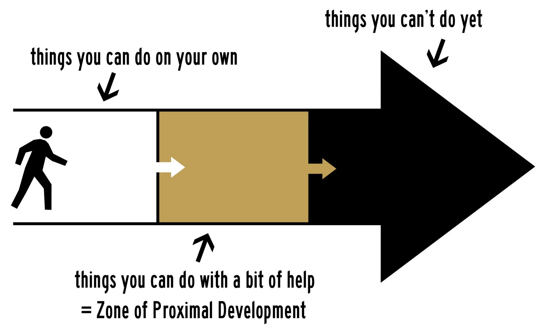
Figure 1. Zone of Proximal Development [68].
Vygotsky’s Zone of Proximal Development (ZPD) is a foundational constructivist theory in educational psychology that defines the cognitive space between what a learner can accomplish independently and what they can achieve through guided instruction from a more capable instructor or peer [66]. The theory indicates that the most significant learning gains happen precisely within this zone, where appropriately scaffolded tasks challenge the learner just beyond their current competency level without exceeding their capacity for assisted performance [66]. In the context of technology-mediated education, ZPD has been operationalized through adaptive learning systems that dynamically adjust instructional content based on real-time performance data, enabling personalized scaffolding at scale [67].
This principle directly informs the adaptive quiz recommendation engine of iCARE++, which employs content-based filtering to continuously calibrate question difficulty and topic focus in accordance with each nursing student’s evolving competency profile. The machine learning-driven student performance prediction module further reinforces this framework by identifying at-risk learners early, enabling faculty to deliver timely, targeted interventions that function as the intelligent scaffolding the ZPD prescribes [67].
Together, these system features translate the theoretical construct of the ZPD into a concrete, data-driven mechanism for guiding every nursing student progressively from their current level of clinical understanding toward the proficiency demanded by modern healthcare practice.

CONCEPTUAL FRAMEWORK
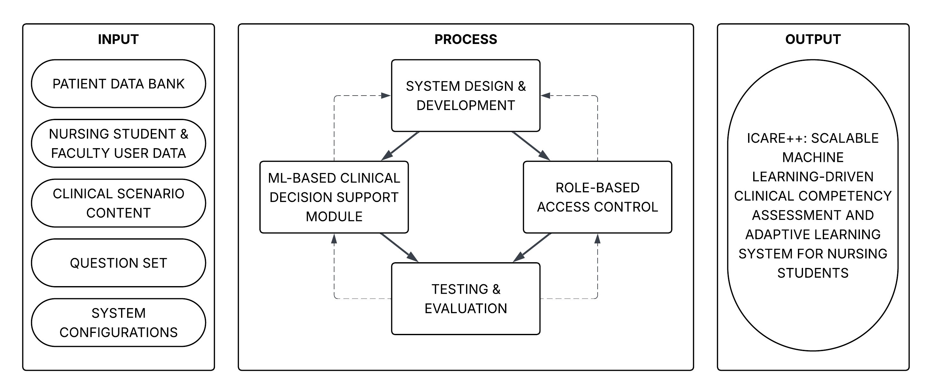
Figure 2. Conceptual Framework of the Study.
The conceptual framework of this study illustrates the logical flow between the system’s inputs, processes, and outputs using the Input-Process-Output (IPO) model as its organizing structure. This framework translates the ZPD-based theoretical foundation discussed in the previous section into a practical blueprint for the design, development, and evaluation of iCARE++: A Scalable Machine Learning-Driven Clinical Competency Assessment and Adaptive Learning System for Nursing Students at Batangas State University – TNEU ARASOF Nasugbu. Each component of the IPO model is aligned with iCARE++’s core purpose of leveraging machine learning to monitor, predict, and improve nursing student clinical competency and academic readiness.
The Input component encompasses the raw data and structured information that feed into the system. The Patient Data Bank provides the simulated clinical records used to populate patient cases within the EHR-based simulation environment. Nursing Student and Faculty User Data includes account credentials, role assignments, and accumulated performance histories that inform both system access and machine learning model training. Clinical Scenario Content constitutes the structured patient cases and assessment tasks that define the simulation experience for each student. The Question Set forms the item pool from which the adaptive quiz recommendation engine draws and calibrates content according to each student’s competency profile. System Configurations establish the institutional parameters, role-based access rules, and platform settings that govern the operational behavior of iCARE++ across all user levels. Together, these inputs form the data foundation upon which iCARE++’s predictive, adaptive, and clinical simulation functionalities are built.
The Process component represents the core development and operational modules of iCARE++. System Design and Development serves as the central process phase, establishing the architectural and functional specifications of the platform from which all other modules are derived. The ML-Based Clinical Decision Support Module processes student interaction data and patient simulation records to provide real-time clinical guidance, flag vital signs irregularities, and support simulated patient case management within the EHR environment. Role-Based Access Control governs system permissions, ensuring that nursing students, faculty, and administrators each interact exclusively with the features and data appropriate to their designated roles. Testing and Evaluation validates the completed system against defined performance benchmarks including response time, throughput, scalability, and reliability. The dashed feedback loops within the framework indicate that evaluation outcomes are recursively fed back into the design and development phase, enabling iterative refinement of the system prior to final deployment.
The Output component captures the primary deliverable produced by the system. iCARE++ provides nursing students with an immersive clinical simulation environment that includes adaptive quizzing, vital signs monitoring, AI-driven clinical decision support, and EHR-based patient case management. Faculty and administrators gain access to an ML-powered analytics dashboard with at-risk student identification, competency assessment reports, and a comprehensive audit trail for institutional accountability. The machine learning outputs of iCARE++, including student performance predictions, risk classifications, and adaptive quiz recommendations, feed back into the input layer through continuous model refinement, ensuring that the system remains responsive to each student’s evolving competency needs over time.
The conceptual framework also reflects the study’s foundation in Vygotsky’s Zone of Proximal Development, acknowledging that the system’s adaptive processes are designed to scaffold each nursing student’s progression from their current competency level toward higher clinical proficiency. The adaptive quiz recommendation engine and ML-driven performance prediction modules operationalize this scaffolding by continuously adjusting to individual student performance data, ensuring that the learning experience within iCARE++ remains appropriately challenging and educationally meaningful at every stage of a student’s development. The IPO framework thus serves not only as a conceptual map of iCARE++’s architecture but also as an evaluation guide for assessing whether the system achieves its intended clinical simulation, competency assessment, and adaptive learning objectives.

SYNTHESIS
Artificial intelligence and machine learning are significantly improving how healthcare professionals make decisions and manage their daily tasks. These technologies power clinical decision support systems that help with early disease detection, diagnostic accuracy, and predicting patient risks using electronic health data [45], [47]. Furthermore, tools like large language models can automate routine tasks, such as drafting patient summaries, which greatly reduces the documentation burden on nurses [44]. However, for these systems to be truly effective and unlock their full potential, they must be easy to use, rely on high-quality data, and fit smoothly into existing hospital workflows [41], [43].
Simulation technologies offer a highly effective way for nursing students and professionals to build confidence and practice clinical skills in a safe environment. By combining advanced educational platforms with artificial intelligence and high-fidelity scenarios, instructors can create personalized training that adapts to a learner's performance and meaningfully boosts clinical competence [42], [3]. Additionally, using virtual reality to digitally map hospital environments helps nurses adapt to new physical layouts, which notably reduces the time it takes to complete complex clinical tasks in high-stress situations [46].
The shift from paper to electronic health records is a major step forward for healthcare coordination, but it comes with distinct challenges. In the Philippines, the push to digitize the health system is often slowed down by poor infrastructure, a lack of technical skills, and initial resistance to changing old habits [48], [49]. Bridging this gap requires specialized educational tools, such as the Mobile and Web Application for Healthcare Management Dedicated to Nursing Students (MHED). By utilizing the ADDIE methodology, this system successfully simulated real-world nursing workflows and improved student productivity by reducing time spent on paper charts [13]. Building on this foundation, the Intelligent Clinical Assessment and Recording (iCARE) system further enhanced this training through an iterative Scrum methodology, incorporating gamified elements like leaderboards and real-time notifications to engage students [14].
These developments underscore that simulation-based electronic systems are cost-effective solutions for preparing students for clinical practice while fostering high levels of user acceptability [13], [14]. Despite these hurdles, staff satisfaction, retrieval speed, and record completeness improve considerably once the systems are successfully operating. Ensuring steady adoption during both normal operations and health emergencies requires sustained technical assistance, organized onboarding, and active engagement with frontline healthcare workers [48], [52], [14].
As digital tools become more common, ensuring that healthcare workers are ready to use them ethically and responsibly is a top priority. While nurses who are literate in artificial intelligence report notably higher confidence, recent assessments reveal significant gaps regarding the ethical usage of these tools and the risks of relying on them too heavily [68], [53]. Local studies suggest that even when students use complex algorithms for analytical support, their capacity for empathy remains high, highlighting the need to balance technological efficiency with human emotional intelligence [50]. To safely scale these tools and address these concerns, the healthcare sector must develop strong national policies focused on data privacy, algorithm fairness, and the local validation of foreign systems [51].

CHAPTER III

DESIGN AND METHODOLOGY
This chapter outlines the research design and the step-by-step process that will be followed in the development and evaluation of iCARE++. It describes how the system will be planned, designed, built, and assessed in relation to the objectives of the study. Every decision presented in this chapter, from choosing the research approach to determining how the system will be tested, is guided by the goal of ensuring that iCARE++ effectively addresses the gaps left by its predecessor systems, MHED and iCARE. This chapter serves as the blueprint that connects the problem identified in Chapter I, the literature reviewed in Chapter II, and the actual work to be done in producing a functioning, evaluable system.

RESEARCH DESIGN
This study will follow a descriptive-developmental research design, which is the most appropriate methodology for a capstone project that centers on both understanding a documented technological gap and producing a working system to address it. This design will allow the research to move systematically from problem identification, through system construction, to objective performance evaluation in a logical and well-supported sequence.
The descriptive aspect of this research design will cover the first objective of the study, which is to address the identified gaps of the previous iCARE system. Rather than relying on surveys, this phase will involve structured inquiries with the key stakeholders of the College of Health Sciences at Batangas State University - TNEU ARASOF Nasugbu, including the course instructor, faculty, and the Dean. The information gathered through these inquiries will establish what iCARE lacked and what specific features iCARE++ will need to deliver, ensuring that the system being built will be directly responsive to documented, real-world institutional needs rather than assumptions.
The developmental aspect will cover the second and third objectives of the study, which involve designing and building iCARE++ and then measuring its performance efficiency. The development phase will follow the Agile Software Development Life Cycle methodology, which was selected for its iterative and incremental approach to system construction. Agile is particularly suited to this project because it will allow the development team to continuously refine system features across sprint cycles, accommodate evolving requirements, and deliver functional increments of the system throughout the development period rather than waiting for a single final release. This flexibility will be essential given the complexity of integrating machine learning, adaptive learning, and clinical simulation within a single unified platform. Once the system is developed, its performance will be measured using benchmarking tools across four key metrics, specifically Response Time, Throughput, Scalability, and Reliability. These benchmarking metrics will serve as the measurable criteria for determining whether iCARE++ performs at the level required to support real-world nursing education workflows at scale.
The descriptive-developmental design was chosen because it directly fits the nature and structure of this study. The research will not simply observe and report; it will produce a concrete technological output, which makes a purely descriptive approach insufficient. At the same time, the development work will not be conducted blindly but will be grounded in a clear understanding of the problem space established through the descriptive phase. Together, these two components will form a research design that is both rigorous and practical, ensuring that iCARE++ will be built on evidence, developed iteratively, and evaluated objectively through performance benchmarking.

DESIGN STAGE OF THE PROCESS
The Software Development Life Cycle (SDLC) serves as a systematic guide that organizes the entire process of building a software system, from the earliest stages of planning all the way through to deployment and maintenance. By following a well-defined SDLC, development teams are able to manage their time and resources more effectively, reduce the likelihood of major technical setbacks, and ensure that the final product meets the quality standards it was designed to achieve. For the development of iCARE++, the research team will adopt the Agile development model as its primary SDLC framework.
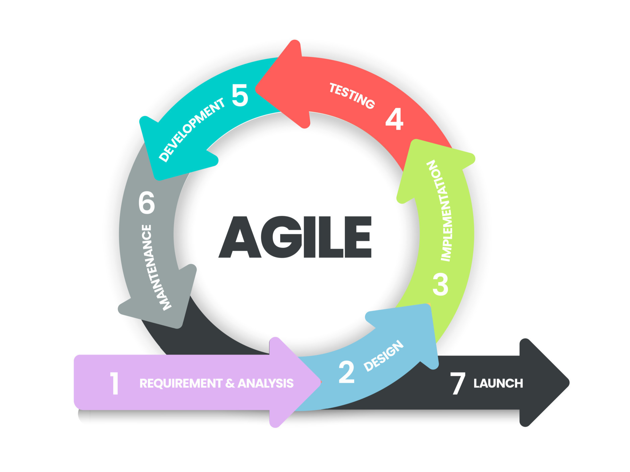
Figure 3. Agile Methodology [69].
Agile was selected because it is built around the idea that complex software systems are best developed in short, repeating cycles rather than in one long, uninterrupted sequence. Each cycle, called a sprint, will produce a working version of a specific feature or set of features, which will then be tested, reviewed, and improved before the next sprint begins. This makes Agile especially suitable for a project as technically demanding as iCARE++, where machine learning modules, adaptive learning features, and AI-driven clinical decision support tools all require repeated testing and calibration before they can perform reliably. Rather than building everything at once, the team will be able to revisit and refine each component of the system across multiple sprints, ensuring that every part works correctly before moving forward. Agile also supports continuous feedback from stakeholders at every stage of development, which will keep the system consistently aligned with the actual needs of its users, including nursing students, faculty, and the Dean at the College of Health Sciences of Batangas State University – TNEU ARASOF Nasugbu. The development of iCARE++ will be organized into seven major phases: Requirements and Analysis, Design, Implementation, Testing, Development, Maintenance, and Launch.
Requirements and Analysis Phase
During this phase, the research team will focus on gathering and documenting the specific needs that iCARE++ must address in order to be a meaningful improvement over the existing iCARE system. The researchers will conduct structured inquiries with the course instructor, faculty member, and the Dean at the College of Health Sciences of Batangas State University – TNEU ARASOF Nasugbu to identify the operational gaps and unmet needs in the current clinical training management setup. These inquiries will be designed to draw out firsthand accounts of how nursing students currently manage their clinical training activities, how faculty members monitor and assess student performance, and how the Dean oversees academic records and competency reporting within the limitations of the existing iCARE platform.
From these consultations, the team will confirm the four core system requirements that iCARE++ must deliver: a machine learning-based student performance prediction module using Random Forest and Logistic Regression for early identification of at-risk students, an adaptive quiz and learning recommendation engine using content-based filtering, an AI-driven clinical decision support and academic electronic health record module for simulated patient case management, and a star schema data warehouse with an analytics dashboard for consolidated performance reporting. The team will also review relevant technical literature to validate the algorithmic approaches selected for each module. Inquiry responses will be transcribed, analyzed, and organized into a formal list of functional and non-functional system requirements, with each requirement mapped to its corresponding module.
In addition to the system requirements, this phase will also involve a review of the existing syllabus of NCM 110 Nursing Informatics in the Bachelor of Science in Nursing program. Upon identifying the gap between the course rationale and its current weekly topic coverage, the research team will propose a revised set of weekly topics under the Teaching, Learning, and Assessment Activities that are directly aligned with the core functionalities of iCARE++, including adaptive quizzing, vital signs monitoring, and clinical simulation scenarios. These proposed topics will serve as a structured curricular intervention designed to bridge the disconnect between what NCM 110 intends to deliver and what students currently experience, ensuring that the integration of iCARE++ into the course is educationally coherent and competency-driven. Together, the inquiry findings, the literature review, and the proposed syllabus topics will ensure that every feature of iCARE++ is grounded not only in scholarly evidence but also in the lived experiences and documented needs of the College of Health Sciences community itself, establishing a comprehensive foundation for developing nursing students' digital literacy competency from the very first phase of the study.
Design Phase
This phase will involve transforming the gathered requirements into a detailed architectural plan that will guide the construction of iCARE++. The researchers will design the overall system architecture, including the database structure using a star schema configuration, the role-based access control framework that governs what each type of user including nursing students, faculty, and the Dean can access and perform within the system, and the API structure that connects the web and mobile platforms to the central backend. The user interface layouts for each user role will also be designed during this phase, ensuring that the system is structured to be both genuinely useful and easy to navigate for all intended users. Specific tasks will include producing system architecture diagrams, creating database schema blueprints, designing wireframes for the Next.js web application and React Native mobile interfaces, and documenting the data flow pathways between the machine learning modules and the rest of the system. Every architectural decision made during this phase will be guided by the goal of producing a system whose design inherently supports the development of nursing students' digital literacy, ensuring that the platform is not only technically sound but educationally purposeful from the ground up.
Implementation Phase
This phase is where the research team will begin building the initial, functioning components of iCARE++ based on the designs and specifications established in the previous phase. Implementation will be carried out across multiple sprints, with each sprint dedicated to constructing a specific module or set of features. The machine learning-based student performance prediction module will be developed by training Random Forest and Logistic Regression classification algorithms on student activity data collected within the system, enabling the platform to generate early warning indicators for at-risk nursing students. The adaptive quiz and learning recommendation engine will be built using a content-based filtering approach that automatically maps assessment items to each student's identified knowledge gaps, replacing the static quiz structure of the original iCARE system with a personalized, data-driven alternative. The AI-driven clinical decision support and academic EHR module will be developed to replicate hospital workflows within a simulation environment, allowing nursing students to encode patient vital signs, manage clinical records, and practice evidence-based decision-making in a risk-free digital setting. Specific tasks across all sprints will include writing and testing backend code, developing the Next.js web application and React Native mobile application, and verifying that all modules communicate correctly with the central data infrastructure. Each module built during this phase directly contributes to the digital literacy development of nursing students, translating the theoretical competencies defined in NCM 110 into tangible, interactive learning experiences within a technology-driven clinical environment.
Testing Phase
After each implementation sprint, the research team will conduct a series of structured tests on the newly built features to verify that everything functions correctly and performs reliably before the system proceeds further. Functional testing will be performed to confirm that each module behaves according to its specifications, performance benchmarking will be conducted to evaluate system response time, throughput, scalability, and reliability under simulated usage conditions, and security testing will be carried out to verify that the role-based access control framework and data privacy mechanisms are operating correctly and in compliance with the Philippine Data Privacy Act of 2012. The machine learning prediction models will also be assessed during this phase by evaluating their performance using standard metrics such as precision, recall, and F1-score, with model parameters recalibrated as needed based on the results. Specific tasks will include executing test cases for each module, documenting all identified bugs and errors, conducting cross-device testing across desktop browsers and both Android and iOS mobile platforms, and confirming that all system features meet the functional and non-functional requirements established in the Requirements and Analysis Phase. Ensuring that iCARE++ performs reliably across all tested conditions is not merely a technical requirement but a direct prerequisite for its effectiveness as a digital literacy development tool, as a system that fails to perform consistently cannot serve as a dependable learning environment for nursing students.
Development Phase
Building upon the tested components from the previous phase, the research team will finalize and fully integrate all modules of iCARE++ into a complete, cohesive system. The star schema data warehouse and analytics dashboard will be constructed to consolidate student performance records, clinical training logs, and competency metrics into a unified, queryable repository. The machine learning models will be fully integrated into the live system, and the offline-first Progressive Web Application architecture will be configured to ensure accessibility under inconsistent connectivity conditions. The system will be hosted on a server provided by Batangas State University – TNEU ARASOF Nasugbu, running on a Linux-based operating system, ensuring that the deployment infrastructure is institutionally supported and aligned with the operational environment of the College of Health Sciences. Specific tasks will include finalizing all backend and frontend code, completing the integration of the React Native mobile application with the central backend, conducting end-to-end system testing to verify that all modules work together as intended, and preparing the complete system for deployment at the College of Health Sciences. The completion of this phase will mark the point at which iCARE++ transitions from a collection of individually tested components into a unified platform fully capable of delivering the immersive, technology-driven clinical training environment that nursing students need to develop genuine digital literacy competency.
Maintenance Phase
Rather than treating the project as finished after a single round of development and testing, the Agile model calls for a continuous improvement phase where all insights collected from testing, integration, and stakeholder feedback are used to strengthen the system across subsequent sprints. Feedback will be analyzed to determine which features require further refinement, which machine learning model parameters need recalibration, and whether any system behaviors observed during development point to requirements that were not fully addressed in earlier phases. Specific tasks will include consolidating and categorizing all feedback gathered, updating the sprint backlog with new or revised development tasks, adjusting model training parameters based on observed prediction accuracy, refining the user interface based on usability findings, and preparing the system for its final release. This cycle of continuous improvement ensures that iCARE++ does not remain static but evolves in direct response to the emerging digital literacy needs of nursing students and faculty at the College of Health Sciences, sustaining its relevance and effectiveness as a platform for competency development beyond its initial deployment.
Launch Phase
At this stage, the research team will release the fully developed, tested, and maintained version of iCARE++ to nursing students, instructor, faculty, and the Dean at the College of Health Sciences of Batangas State University – TNEU ARASOF Nasugbu, making the system accessible for actual use within the institution. The system will be made available through both its web-based interface, accessible via standard desktop and mobile browsers, and its dedicated mobile application for Android and iOS devices. The offline-first PWA architecture of iCARE++ will ensure that nursing students can continue accessing key features of the system even in environments with limited or unstable internet connectivity, an important practical consideration in the Philippine educational context. Specific tasks during this phase will include configuring the production server environment, deploying the Next.js web application and the React Native mobile application to their respective platforms, setting up user accounts with the appropriate role-based access levels for each type of user, and conducting a brief onboarding orientation to familiarize all users with the system's core features and navigation. The launch of iCARE++ represents the culmination of every phase that preceded it, marking the moment when the system's capacity to develop nursing students' digital literacy transitions from a design objective into a lived educational reality for every student, faculty member, and administrator at the College of Health Sciences.

DEVELOPMENT PROCESS
The development of iCARE++ will follow a structured and systematic process grounded in the Agile methodology, ensuring that every phase of the system's construction is deliberate, iterative, and directly responsive to the documented needs of the College of Health Sciences at Batangas State University – TNEU ARASOF Nasugbu. The process begins with thorough planning and requirements gathering, proceeds through architectural design and incremental coding, and culminates in a fully integrated and institutionally deployed system. Each stage of the development process is aligned with the study's core objective of producing an AI-integrated, machine learning-driven clinical competency assessment and adaptive learning platform that genuinely advances nursing students' digital literacy competency.

Testing Process
The testing process of iCARE++ will be conducted systematically across three levels to ensure that every component of the system functions correctly, performs reliably, and meets the defined requirements before deployment. Unit testing will be performed on individual modules and components of the system, including the machine learning-based student performance prediction module, the adaptive quiz recommendation engine, the AI-driven clinical decision support module, and the role-based access control framework, to verify that each part behaves correctly in isolation before being integrated into the broader system. System testing will then be conducted on the fully assembled iCARE++ platform to confirm that all modules work together as intended, that data flows correctly between the Next.js web application, the React Native mobile application, and the PostgreSQL database, and that the system meets the functional and non-functional requirements established during the Requirements and Analysis Phase. Performance testing will be carried out using Apache JMeter to evaluate the system under simulated operational conditions, measuring response time, throughput, scalability, and reliability under concurrent multi-user load scenarios that reflect realistic usage at the College of Health Sciences. Together, these three levels of testing will ensure that iCARE++ is not only functionally complete but also operationally dependable as a digital literacy development platform for nursing students.

Debugging Process
The debugging process of iCARE++ will follow a methodical and structured approach to identifying, analyzing, and resolving errors across all system components throughout the development lifecycle. Given the complexity of integrating machine learning models, adaptive learning algorithms, real-time notification systems, and cross-platform interfaces within a single unified platform, the development team will adopt a sprint-level debugging workflow consistent with the Agile methodology. After each implementation sprint, all identified bugs, errors, and unexpected system behaviors will be logged, categorized by severity, and assigned for resolution before the next sprint begins. For the machine learning modules specifically, debugging will extend beyond conventional code errors to include model bias detection, data pipeline validation, and prediction accuracy assessment, ensuring that the Random Forest and Logistic Regression classification models produce reliable and unbiased outputs. Frontend debugging will be conducted using browser developer tools including Chrome DevTools, while backend and API errors will be traced and resolved using Postman and server-side logging mechanisms. This systematic approach to debugging will ensure that iCARE++ is delivered as a stable, error-minimized platform that nursing students, faculty, and the Dean can rely on without interruption.

Validation Process
The validation process of iCARE++ will evaluate whether the fully developed system satisfies the requirements defined at the beginning of the study and achieves the objectives it was designed to fulfill. Validation will be conducted across several key areas of the system, each assessed using the most appropriate method available. The functional correctness of each system module will be validated through automated test scripts developed using Selenium and Playwright, which will simulate real-world user interactions across all defined user roles, including nursing students, faculty, and the Dean, and verify that the system produces the expected output for each scenario. The machine learning-based student performance prediction module will be validated using a held-out evaluation dataset of historical student activity records, with precision, recall, and F1-score computed for both the Random Forest and Logistic Regression models to confirm their predictive accuracy. The adaptive quiz recommendation engine will be validated by comparing its content-based filtering outputs against faculty-verified ground truth mappings, using Precision, Recall, and Hit Rate at K as the primary quality metrics. The role-based access control framework will be validated through structured access control tests using Postman and Selenium, confirming that each user role interacts only with the features and data appropriate to their designated permissions. The offline functionality of the Progressive Web Application architecture will be validated using Chrome DevTools network simulation, with the Feature Availability Rate calculated to confirm that core student-facing features remain accessible under no-connectivity conditions. Finally, the overall performance of iCARE++ will be validated through benchmarking across four key metrics: Response Time, Throughput, Scalability, and Reliability, providing an objective, quantitative basis for determining whether the system is technically ready for full institutional deployment at the College of Health Sciences.

PROGRAMMING PROCEDURE
The programming procedure of iCARE++: A Scalable Machine Learning-Driven Clinical Competency Assessment and Adaptive Learning System for Nursing Students includes the system architecture, requirements analysis, use case diagram, context diagram, data flow diagram, and entity-relationship diagram. These diagrams collectively serve as the technical foundation and visual guide throughout the stages of development, ensuring that all modules, and data interactions are clearly defined and properly documented prior to implementation.

System Architecture
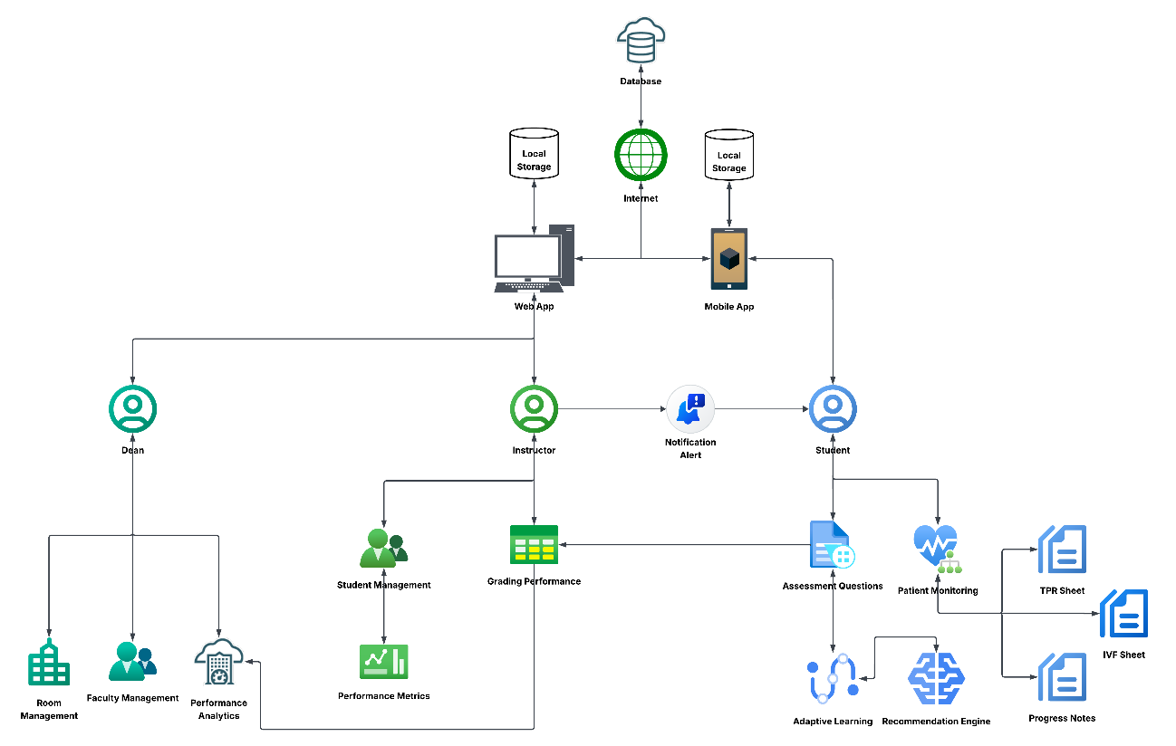
Figure 4. System Architecture of iCARE++.
Figure 4 illustrates the overall architectural design of iCARE++, showing how its key components interact across two primary access platforms: a Web Application and a Mobile Application. Both interfaces communicate with a central cloud-based Database through the Internet, while each platform maintains its own Local Storage to support offline data access in low-connectivity environments. The Dean accesses the system through the Web Application to perform administrative functions including Room Management, Faculty Management, and Performance Analytics.
The Instructor uses the system to manage Student Management, oversee Grading Performance, and track Performance Metrics, with Notification Alerts sent to the Student to facilitate task coordination. The Student interacts with the Mobile Application to carry out clinical tasks including Patient Monitoring, answering Assessment Questions, and encoding clinical records such as the TPR Sheet, IVF Sheet, and Progress Notes, with the Recommendation Engine and Adaptive Learning module providing personalized guidance based on the student's performance profile.

Requirements Analysis
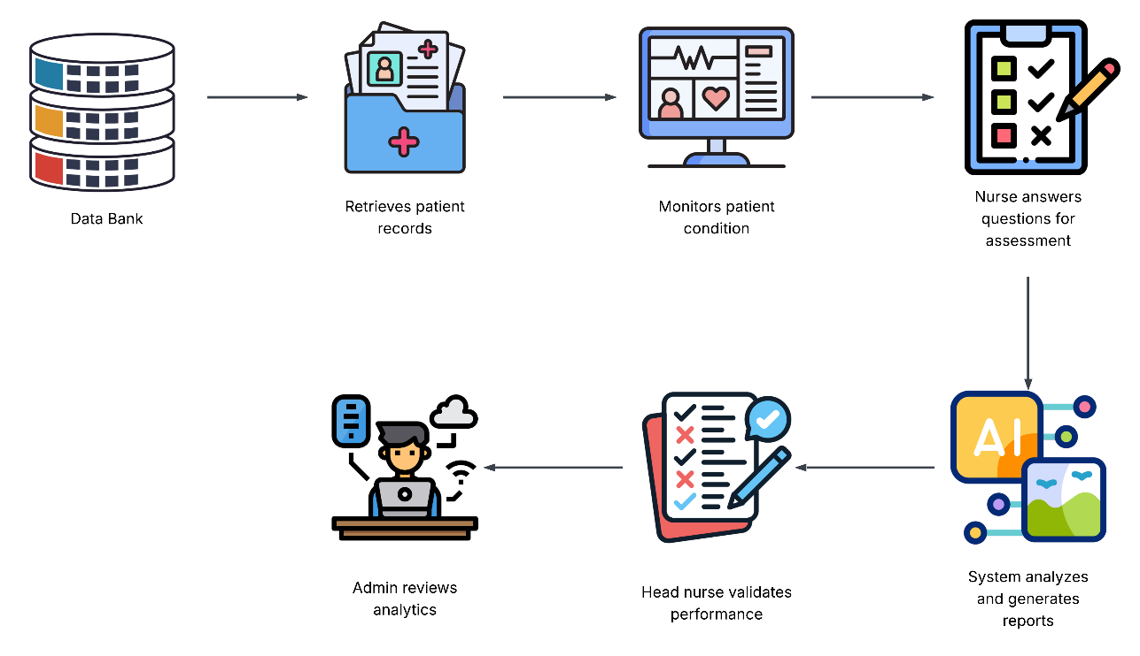
Figure 5. Requirements Analysis of iCARE++.
Figure 5 illustrates the operational workflow of iCARE++ as experienced by its primary users. The process begins with the system retrieving patient records from the central Data Bank, after which the nurse monitors the patient's condition in real time. The nurse then responds to a set of competency-based assessment questions corresponding to the clinical scenario at hand. Upon submission, the system automatically analyzes the responses and generates a performance report. The instructor then validates the student's performance based on the generated report, and the Admin reviews the aggregated analytics to support data-driven oversight of clinical training outcomes.

Use Case Diagram
The Figure 6 below presents the Use Case Diagram of iCARE++, illustrating the interactions between the system and its three primary actors: the Dean, Faculty, and Student. The Dean oversees system-wide administrative functions including account management, analytics viewing, and report generation; the Faculty performs supervisory roles such as task assignment, student monitoring, and performance validation; and the Student, as the primary end-user of the clinical module, engages with patient records, health monitoring, adaptive quizzes, and personalized learning recommendations. Together, these use cases define the full scope of functional requirements that iCARE++ must fulfill across all user roles.
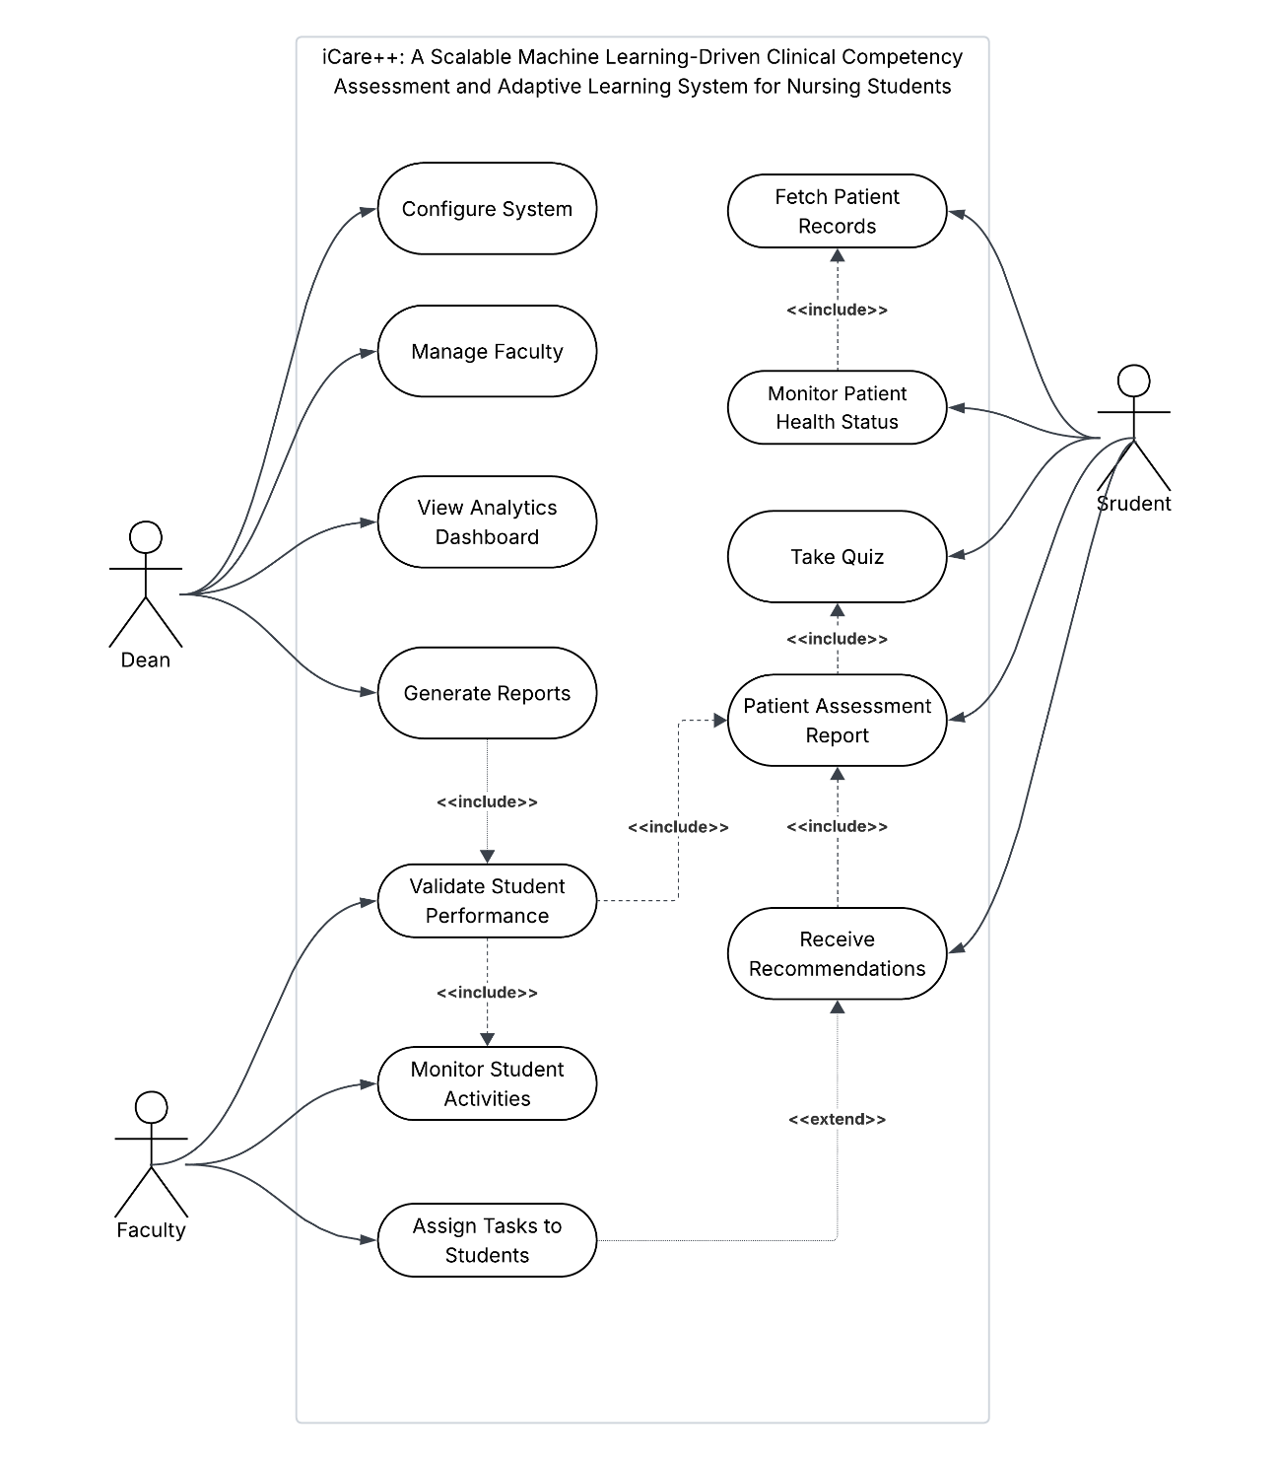
Figure 6. Use Case Diagram of iCARE++.

Requirements Analysis
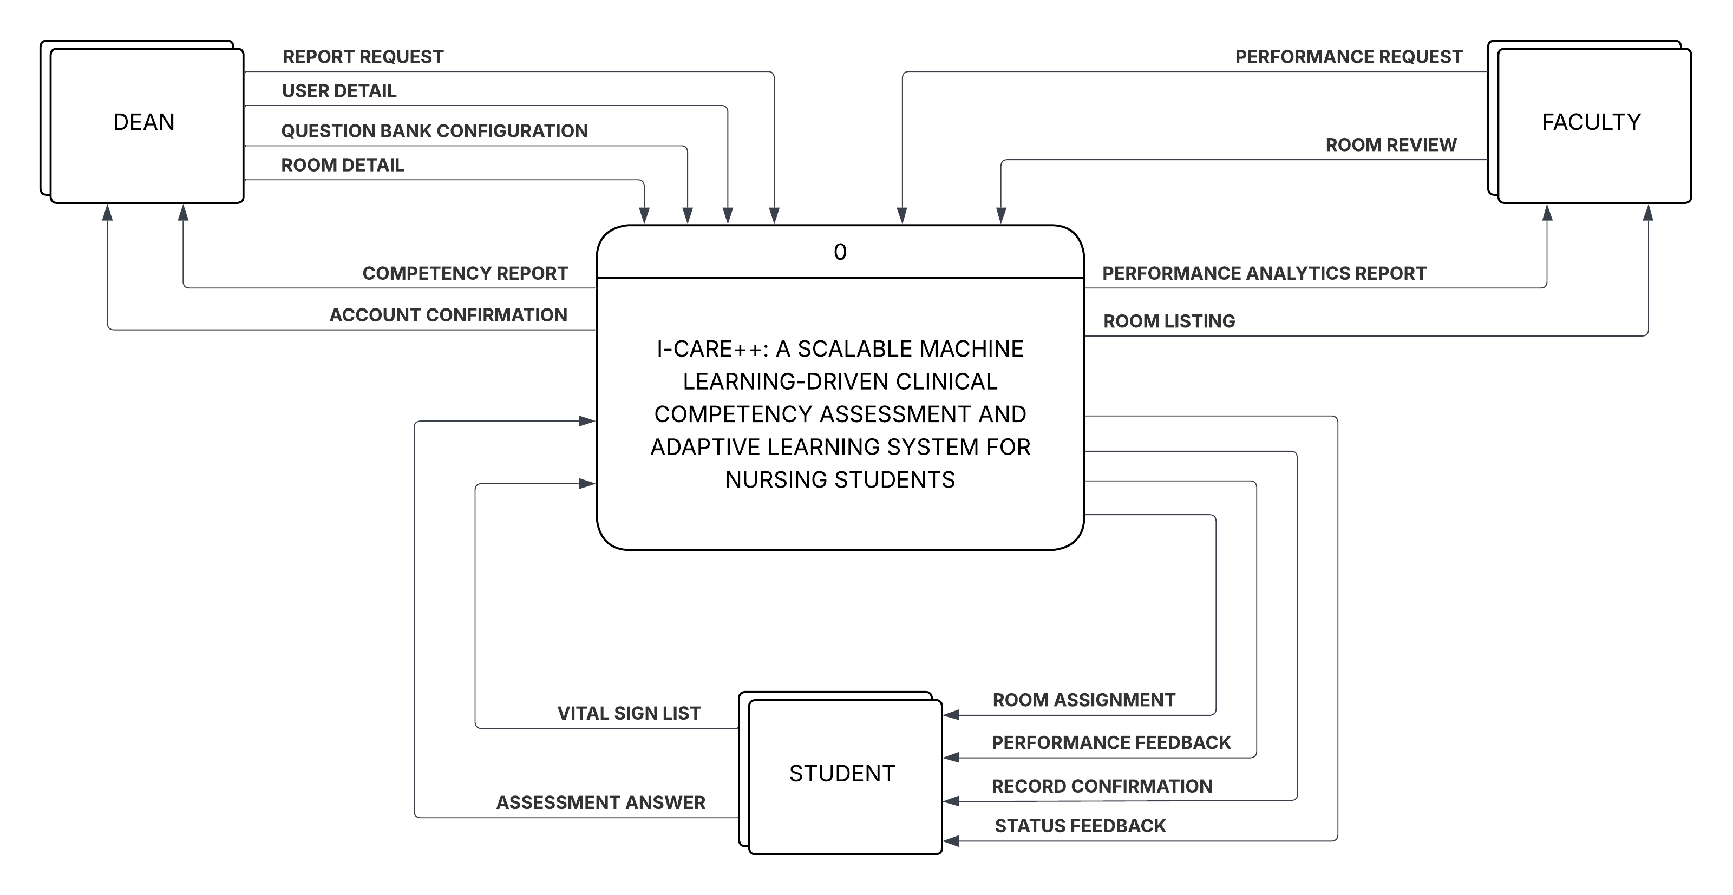
Figure 7. Context Diagram of iCARE++.
Figure 7 presents the Context Diagram of iCARE++, representing the entire system as a single high-level process and illustrating the data exchanges it maintains with three external entities: the Dean, the Faculty, and the Student. The Dean supplies the system with a Report Request, User Detail, Question Bank Configuration, and Room Detail, and receives a Competency Report and Account Confirmation in return. The Faculty sends a Performance Request and Room Review into the system, and receives a Performance Analytics Report and Room Listing in response.
The Student provides Assessment Answers, and a Vital Sign List, and receives Room Assignment, Performance Feedback, Record Confirmation, and Status Feedback from the system. This diagram establishes the boundaries of iCARE++ and defines the nature of all data flowing into and out of the system across its three user roles.

Data Flow Diagram
The Figure 8 below presents the Level 1 Data Flow Diagram of iCARE++, decomposing the system into six major processes and showing the data flows between them, the external entities, and the system's data stores. Process 1.0, Manage Accounts, handles user account creation and retrieval through the D1 Accounts data store, exchanging User Details and Account Confirmations with the Dean. Process 2.0, Manage Rooms, maintains room records through the D2 Rooms data store, processing Room Detail from the Dean and Room Review from the Faculty, and returning Room Listings and Room Assignments accordingly.
Process 3.0, Manage Patients, reads and the D3 Patients data store, returning Record Confirmations; Process 4.0, Monitor Vital Signs, receives the Vital Sign List from the Student and exchanges Patient Baseline and Updated Status data with D3, returning Status Feedback to the Student. Process 5.0, Adaptive Assessment, manages the question bank through D4 Questions, receives Assessment Answers from the Student, and returns Performance Feedback; Process 6.0, Generate Reports and Analytics, draws from all relevant data stores and processes Report Requests from both the Dean and Faculty, returning Competency Reports and Performance Analytics Reports respectively.
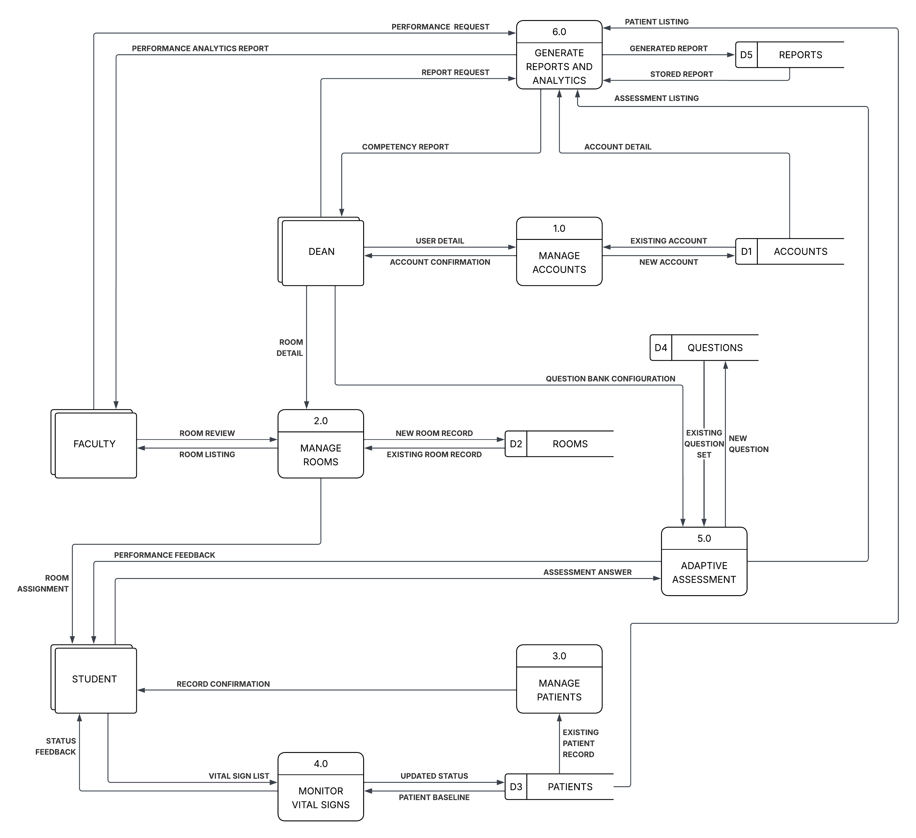
Figure 8. Data Flow Diagram of iCARE++.

Entity-Relationship Diagram
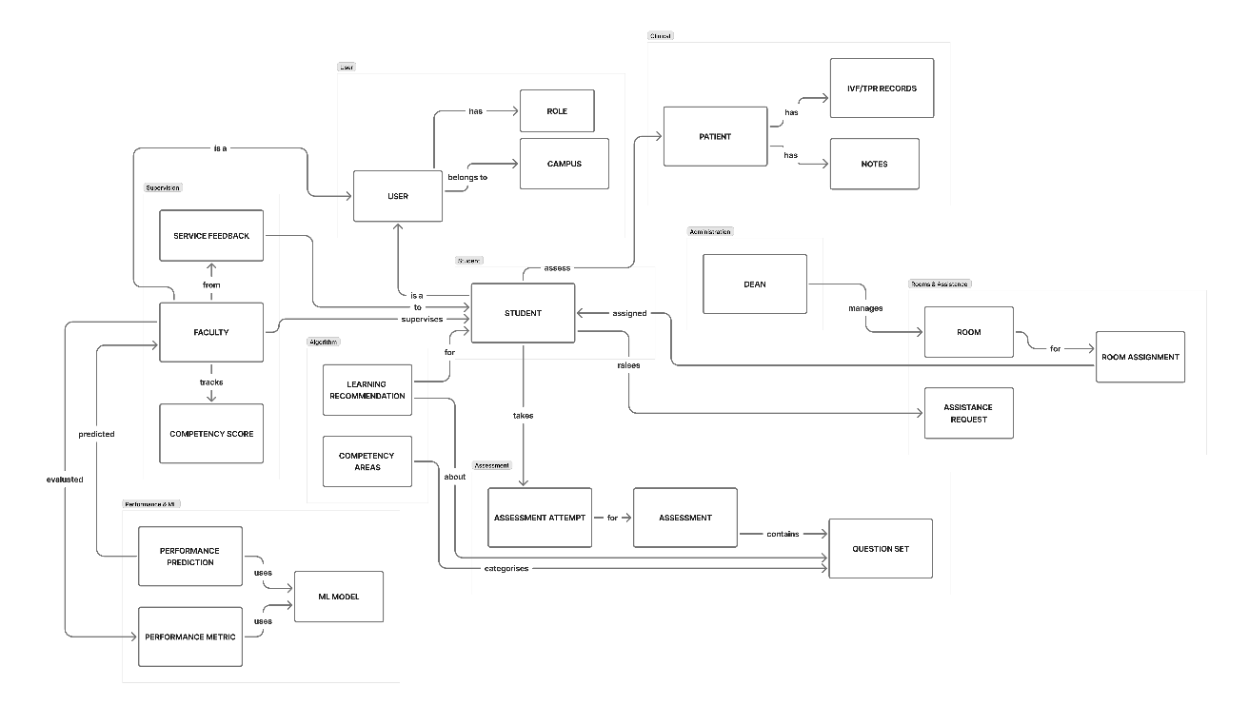
Figure 9. Entity-Relationship Diagram of iCARE++.
Figure 9 presents the Conceptual Entity-Relationship Diagram of iCARE++, organized into four thematic clusters that define the system's overall data structure. The User cluster establishes the relationships between Faculty, Student, Campus, and Role, with Faculty directly supervising the Student. The Clinical cluster captures the patient simulation environment, where Students are assigned to Rooms managed by the Dean, Patients hold IVF/TPR Records and clinical Notes, and Students may raise Assistance Requests. The Assessment cluster links Students to Assessment Attempts, Questions Sets, and Competency Areas, which drive the generation of personalized Learning Recommendations. Finally, the Performance and Machine Learning cluster captures the adaptive intelligence pipeline, where Faculty-tracked Competency Scores are predicted by a Performance Prediction model that draws on an ML Model and Performance Metrics to underpin the system's adaptive assessment capability.

SOFTWARE AND HARDWARE NEEDED IN THE DEVELOPMENT
The successful development and deployment of iCARE++ requires a carefully defined set of software and hardware resources that collectively support the system's technical demands across its web, mobile, machine learning, and database components. Given the complexity of building an AI-integrated, machine learning-driven clinical simulation platform within a nursing education context, every tool and technology included in the development environment has been deliberately selected based on its suitability, reliability, and compatibility with the overall system architecture. The software stack encompasses a range of modern frameworks, programming languages, and development tools that work in concert to ensure that iCARE++ is built with type safety, cross-platform accessibility, and long-term maintainability in mind. On the hardware side, the specifications have been established to provide the computational capacity and physical infrastructure necessary to support concurrent development tasks, machine learning model training, cross-device testing, and institutional deployment without performance degradation. Together, these software and hardware requirements define the complete technical foundation upon which iCARE++ will be constructed, tested, and ultimately deployed at the College of Health Sciences of Batangas State University – TNEU ARASOF Nasugbu. The following tables present the complete list of software and hardware requirements, accompanied by their respective specifications and descriptions of their specific roles in the construction and operation of iCARE++.

Software Requirements
TABLE I.
Software Needed in the Development
Software | Specification | Description
Next.js (React Framework) | Version 14.x or higher, with React 18 | Will serve as the primary web frontend framework for iCARE++, enabling server-side rendering, file-based routing, and API route handling for the faculty and administrator dashboards.
React Native with Expo | Expo SDK 50 or higher, React Native 0.73+ | Will be used to build the cross-platform mobile application for nursing students, enabling a single codebase to compile for both Android and iOS with access to native device features.
TypeScript | Version 5.x | Will be applied across both the Next.js web application and React Native mobile app to enforce static type checking, improve code maintainability, and reduce runtime errors in large-scale codebases.
PostgreSQL | Version 15 or higher | Will serve as the primary relational database management system for storing structured data including student records, patient charts, quiz history, activity logs, and the data warehouse star schema for analytics.
Python | Version 3.10+, with scikit-learn, pandas, and NumPy libraries | Will be used to develop and train the machine learning models for student performance prediction and adaptive quiz recommendation, including classification models such as Random Forest and Logistic Regression.
Git | Version 2.x, Version Control System | Will support distributed version-controlled development, enabling the team to manage branches, track code changes, and collaborate across all components of the iCARE++ system.
Visual Studio Code | Latest stable release, with ESLint, Prettier, and TypeScript extensions | A lightweight, cross-platform source code editor used as the primary IDE for developing web and mobile application components.
NeoVim | Latest stable release, plugins: nvim-treesitter, nvim-lspconfig, eslint-lsp, conform.nvim or null-ls, telescope.nvim | A highly extensible, terminal-based text editor used as an alternative development environment for web and mobile application components.

Table I describes the complete software stack that will be required for iCARE++ to function as a full-stack, machine learning-driven clinical competency assessment platform. Next.js will serve as the web frontend framework, delivering server-rendered dashboards for faculty and administrators, while React Native with Expo will power the cross-platform mobile application for nursing students on both Android and iOS. TypeScript will be applied uniformly across the frontend and mobile layers to enforce type safety and maintainability across the codebase. Next.js will handle all server-side API logic, authentication, and database interaction, supported by PostgreSQL as the primary relational database that will store student records, patient data, quiz history, and the data warehouse schema for analytics. Python will manage all machine learning operations, including the training and inference of student performance prediction and adaptive quiz recommendation models. Firebase Cloud Messaging will enable real-time notification delivery to support offline queuing of critical alerts. Git will ensure version-controlled collaboration across all system components, and NeoVim and Visual Studio Code will serve as the unified development environment for the team throughout the project lifecycle.

Hardware Requirements
TABLE II.
Hardware Needed in the Development
Hardware | Specification | Description
Development Machine | Minimum 8GB RAM, 256GB Storage, Windows 10/11 or macOS | A working unit that will be used for development, testing, debugging, and building of the iCARE++ web and mobile application components, including frontend, backend, and machine learning module integration.
Processor | Minimum 2.4 GHz dual-core or higher (Recommended: Intel Core i5/i7 or equivalent) | Will handle concurrent development tasks including running the Next.js development server, PostgreSQL database, Python ML model training, and mobile emulators simultaneously.
RAM | Minimum 8GB (Recommended: 16GB) | Will provide sufficient memory to support development tools, local server operations, machine learning model training, and running multiple development environments concurrently.
Storage | Minimum 256GB SSD or HDD | Will provide space for storing project files, PostgreSQL databases, trained machine learning models, node_modules, and system backups across all components of the system.
Smartphone / Tablet (Android or iOS) | Android 10 or higher / iOS 14 or higher | Will be used to test and validate the React Native Expo-based mobile application for iCARE++ across both Android and iOS platforms, ensuring cross-platform UI consistency and functionality.
Network / Internet Connection | Stable broadband connection | Will be required for package installation via npm, cloud service access, Firebase Cloud Messaging integration, and deployment to remote servers during development and testing.
Server | Linux OS | Will serve as the primary deployment environment for the iCARE++ system, hosting the web application, backend API, and PostgreSQL database, making the system accessible to students, faculty, and administrators within the institution.

The hardware listed above will ensure that the development, testing, and validation of iCARE++ are carried out efficiently. The development workstation will serve as the primary environment for coding both the web-based Next.js application and the React Native Expo mobile application, as well as training and evaluating the Python-based machine learning models. A minimum of 8GB RAM will be required to run the development server, local PostgreSQL database, and mobile emulators without performance degradation. Physical smartphones running Android and iOS will be used to validate the Expo-based mobile application on real devices, ensuring consistent user experience across platforms. A stable internet connection will be essential for package management, Firebase Cloud Messaging integration, and deployment workflows throughout the development lifecycle.

INSTRUMENTATION
To evaluate the overall performance, functionality, and reliability of iCARE++, a technical evaluation approach will be conducted using a descriptive-developmental research design. The system will be systematically assessed across its core quality attributes, namely functional correctness, system responsiveness, reliability, and security of access control mechanisms, with measurable and objective output data captured under simulated operational conditions that include concurrent multi-user access by nursing students, faculty members, and the Dean.
The iCARE++ system will be developed following the Agile methodology, with each module progressively constructed, tested, and refined throughout each sprint. This iterative approach allows for continuous validation of both front-end interfaces and back-end components, including machine learning pipelines, real-time notification systems, role-based access control mechanisms, and cross-platform data synchronization, ensuring that performance issues, functional gaps, or security vulnerabilities identified during each sprint are resolved before the system advances to the next phase.
The evaluation framework is grounded in the principle that a system intended to develop nursing students' digital literacy must perform reliably under the realistic demands of an active academic environment, extending beyond simple feature verification into stress testing, load simulation, machine learning model validation, and security enforcement. To this end, a structured approach of benchmarking and automated testing will be employed, covering performance testing, interface validation, API verification, machine learning model accuracy, adaptive quiz recommendation quality, data warehouse query performance, role-based access control enforcement, and offline functionality. The use of industry-standard benchmarking tools will generate quantitative, reproducible results directly tied to the system's defined objectives, serving both as evidence of technical readiness for institutional deployment and as a baseline reference for future development iterations. The table below presents the mapping of each evaluation area to its corresponding benchmarking tool and metric.
TABLE III.
Benchmarking Toolsand Corresponding Metrics per Evaluation Area
Evaluation Area | Benchmarking Tool | Metric Measured | Output
Response Time | Apache JMeter | Average Response Time (ms) | Performance Report
Throughput | Apache JMeter | Requests per Second (RPS) | Throughput Report
Scalability | Apache JMeter (Ramp-Up Test) | Performance Degradation (%) | Scalability Report
Reliability | Apache JMeter | Error Rate (%) | Stability Report
Functional Correctness (UI) | Selenium / Playwright | Pass / Fail per System Feature | Functional Test Report
API Endpoint Accuracy | Postman | HTTP Status Code & Response Accuracy | API Test Report
ML Model Accuracy (Performance Prediction) | Python Evaluation Scripts | Precision, Recall, F1-Score per Model | Model Accuracy Report
Adaptive Quiz Recommendation Accuracy | Python Evaluation Scripts | Precision, Recall, Hit Rate at K | Recommendation Accuracy Report
Data Warehouse Query Performance | Apache JMeter + SQL Query Analyzer | Query Execution Time (ms), Data Retrieval Accuracy | Data Warehouse Performance Report
Role-Based Access Control Enforcement | Postman + Selenium / Playwright | Pass / Fail per Role-Access Scenario | Security Test Report
Offline Functionality (PWA) | Manual Testing + Chrome DevTools | Feature Availability Rate (%) under No Connectivity | Offline Test Report

Table III presents the mapping of each evaluation area of iCARE++ to its corresponding benchmarking tool and the metric used to measure it. This structured approach ensures that every critical aspect of the system's performance and functional correctness will be evaluated using the most appropriate and reliable instrument available, and that the evaluation framework as a whole directly addresses the technical objectives of the study. The tools and their specific roles in the evaluation of iCARE++ are described in detail in the succeeding sections.
Apache JMeter
Apache JMeter is an open-source performance and load testing tool widely used in software engineering to simulate concurrent user requests and measure how a system responds under varying levels of load. In this study, JMeter will be used to evaluate iCARE++ across four performance dimensions: response time, throughput, scalability, and reliability under load. Separate test plans will be configured for each scenario, including a ramp-up test plan designed to simulate a gradually increasing number of concurrent users, specifically nursing students simultaneously accessing the adaptive quiz module, encoding patient vital signs, and navigating the academic EHR simulation; faculty members monitoring the machine learning-powered analytics dashboard and reviewing at-risk student alerts; and the Dean managing user accounts and generating competency reports. JMeter will automatically record average response times, request throughput in requests per second, error rates, and performance degradation metrics across all test scenarios, which will subsequently be exported and analyzed to determine whether iCARE++ maintains acceptable performance levels under realistic operational load conditions at the College of Health Sciences.

Selenium / Playwright
Selenium and Playwright are automated browser-based testing frameworks used to validate the functional correctness and user interface behavior of web-based applications. In this study, these tools will be used to evaluate the iCARE++ web application by simulating real-world user interactions across all defined user roles. Test scripts will be written to cover the key features of the system, including nursing students encoding patient vital signs, answering adaptive quiz items, completing clinical task logs, and receiving real-time performance alerts; faculty members reviewing student competency reports, monitoring at-risk prediction indicators, and overseeing simulation activities; and the Dean configuring role-based access settings and managing institutional data. Each test case will be assigned a Pass or Fail result based on whether the system produces the expected output for each simulated interaction, providing a clear and measurable indicator of functional compliance across all major features and user workflows of iCARE++.
Postman
Postman is a widely adopted API testing platform used to validate the correctness, reliability, and performance of application programming interfaces. In this study, the research team will create structured test collections covering all available iCARE++ backend API endpoints, including student activity data ingestion, machine learning performance prediction retrieval, adaptive quiz item delivery and response recording, academic EHR patient record creation and retrieval, automated pharmacy alert triggers, star schema data warehouse query execution, analytics dashboard data requests, real-time notification dispatch, and user authentication and role-based access enforcement. Each API request will be evaluated based on the returned HTTP status codes, the accuracy and completeness of the response body, and the response time recorded by the tool. The results obtained through API testing will confirm that the backend infrastructure of iCARE++ communicates correctly, consistently, and securely across all modules and platforms, both the Next.js web application and the React Native mobile application, under a range of request conditions.
Python Evaluation Scripts
To objectively measure the accuracy of iCARE++'s machine learning models, the research team will prepare a held-out evaluation dataset consisting of historical student activity records and corresponding actual academic performance outcomes collected during the data gathering phase of the study. This dataset will be withheld entirely from the model training process and reserved exclusively for evaluation purposes. Python evaluation scripts will be used to submit each input record to the trained Random Forest and Logistic Regression classification models and compare the predicted outputs, specifically whether a student will be flagged as at-risk or performing adequately, against the actual ground truth values. Standard classification performance metrics including precision, recall, and F1-score will be computed for each model to provide a reliable and unbiased assessment of the prediction module's accuracy. In addition to evaluating the performance prediction module, Python evaluation scripts will also be used to assess the accuracy of the adaptive quiz and learning recommendation engine. The quiz items recommended by the content-based filtering algorithm for each student's identified knowledge gaps will be compared against a set of validated ground truth mappings reviewed and confirmed by nursing faculty, and recommendation quality metrics including Precision, Recall, and Hit Rate at K will be computed to determine how accurately the engine surfaces the most relevant assessment items for each individual learner.
SQL Query Analyzer
To evaluate the performance of the star schema data warehouse and analytics dashboard, a SQL Query Analyzer will be used in combination with Apache JMeter to measure how efficiently iCARE++ retrieves and processes large volumes of consolidated student performance data. The SQL Query Analyzer will be applied to assess the execution time of representative analytical queries that the system is expected to run during actual use, including cohort-level performance summaries, at-risk student identification reports, and individual competency progress tracking. These queries will be executed under both single-user and simulated concurrent-user conditions to determine whether the data warehouse infrastructure can support timely and accurate reporting without degrading the overall responsiveness of the system. Data retrieval accuracy will also be verified by comparing query outputs against known expected values derived from the test dataset, confirming that the consolidated records stored in the data warehouse are correctly structured and accessible for analytical purposes.
Chrome DevTools
The offline-first Progressive Web Application architecture of iCARE++ is designed to ensure that nursing students can continue accessing core system features even in environments with limited or unstable internet connectivity. To verify that this architecture performs as intended, the research team will use Chrome DevTools network simulation in combination with structured manual testing procedures to evaluate the offline functionality of the iCARE++ PWA. During testing, internet connectivity will be deliberately disabled through Chrome DevTools network throttling and offline simulation settings while the system is in active use, and the research team will systematically navigate through all core student-facing features, including vital signs encoding, adaptive quiz answering, clinical task logging, and real-time alert viewing, to determine which features remain fully operable without a live connection. The Feature Availability Rate, defined as the percentage of core student-facing features that remain fully functional in offline mode relative to the total number of features tested, will be calculated and recorded. A high Feature Availability Rate will confirm that the PWA architecture of iCARE++ successfully delivers accessible and uninterrupted clinical training support regardless of the network conditions present in the deployment environment.
Postman + Selenium / Playwright
To verify that the role-based access control framework of iCARE++ correctly enforces data privacy and access restrictions across all defined user roles, the research team will conduct structured access control tests using a combination of Postman and Selenium / Playwright. Postman will be used to send API requests authenticated with tokens belonging to each user role, specifically nursing student, faculty member, and the Dean, and verify that the server correctly grants access to permitted endpoints while returning appropriate error responses for endpoints that a given role is not authorized to access. Selenium and Playwright will complement this by simulating browser-based login sessions for each role and confirming that the user interface only exposes the features, data, and navigation options that each role is permitted to interact with. For instance, a nursing student account should have no visibility into faculty-level competency reports or the Dean's user management panels, and a faculty account should not be able to access the Dean's administrative configurations. Each test scenario will be assigned a Pass or Fail result, and the overall results will be used to confirm that iCARE++ adequately protects sensitive student and institutional data in full compliance with the Philippine Data Privacy Act of 2012.

PREPARATION AND EVALUATION
The researchers will prepare the evaluation environment before executing benchmarking and acceptance tests to ensure consistency and fairness across all scenarios. A structured set of test cases, evaluation instruments, and validation datasets will be developed to serve as the primary tools for collecting quantitative data.
The preparation phase will include the configuration of evaluation instruments covering the five ISO/IEC 25010 quality characteristics of Functional Suitability, Usability, Reliability, Performance Efficiency, and Security. Ground truth datasets will be prepared and validated for the machine learning-based student performance prediction module, drawing from historical academic records, quiz scores, and clinical task completion logs sourced from prior cohorts.
The adaptive quiz recommendation engine will be tested using simulated student performance profiles to verify that content-based filtering correctly targets identified knowledge gaps. Postman collections will be prepared for backend API testing of all system modules, including the CDSS-EHR module, analytics dashboard, and automated notification system. Selenium and Playwright automation scripts will be developed to validate frontend functionalities across both the Next.js web application and the React Native mobile application.
All testing activities will be conducted in a controlled environment with consistent hardware and network conditions to minimize external variables. The system server will be maintained in a stable deployment state throughout the evaluation period. Results will be automatically logged, exported, and processed using defined statistical formulas to compute final evaluation metrics. These results will provide an objective and structured basis for assessing iCARE++'s effectiveness as a scalable, machine learning-driven clinical competency assessment and adaptive learning system for nursing education.
TABLE IV.
System Functionality Evaluation Criteria for iCARE++
System Feature | Evaluation Criterion | Test Output | System Feature
ML-Based Student Performance Prediction | Accurately classifies nursing students as at-risk or on track based on academic activity data using Random Forest and Logistic Regression | Accuracy / Precision / Recall / F1-Score per model | ML-Based Student Performance Prediction
Adaptive Quiz Recommendation Engine | Correctly generates personalized quiz items targeting each student's identified knowledge gaps using content-based filtering | Pass / Fail per recommendation scenario | Adaptive Quiz Recommendation Engine
AI-Driven CDSS - EHR Module | Accurately processes simulated patient cases, triggers clinical decision support alerts, and records documentation entries | Pass / Fail per clinical scenario test | AI-Driven CDSS - EHR Module
Analytics Dashboard (Data Warehouse) | Displays accurate, real-time individual and cohort-level performance data consolidated from the star schema data warehouse | Pass / Fail + data accuracy check | Analytics Dashboard (Data Warehouse)
Automated Notification & Alert System | Triggers correct real-time notifications for at-risk flags, vital sign anomalies, and pharmacy-related alerts | Pass / Fail per alert scenario | Automated Notification & Alert System
Role-Based Access Control (RBAC) | Enforces correct access restrictions across Student, Faculty, Administrator, and Super Administrator roles | Pass / Fail per role-access test | Role-Based Access Control (RBAC)
Audit Trail Mechanism | Accurately logs all user transactions, data access events, and system modifications with correct timestamps | Pass / Fail + log integrity check | Audit Trail Mechanism
Progressive Web App (Offline-First) | System core functions remain accessible without active internet connection after initial data synchronization | Pass / Fail per offline scenario | Progressive Web App (Offline-First)
Mobile Application (React Native/Expo) | Core student-facing modules (vital signs encoding, quiz delivery, task logging, notifications) function correctly on Android and iOS devices | Pass / Fail per mobile test case | Mobile Application (React Native/Expo)

Table IV will present the functional evaluation criteria for each major feature of iCARE++. Each criterion will define the expected system behavior required to achieve a passing result, while the test output column will specify how results will be recorded. These criteria will serve as the foundation for the automated test scripts developed during the preparation phase.

Performance Rating Scale
To standardize the interpretation of evaluation results, the researchers will adopt a five-point rating scale. This scale will be used to summarize overall system performance of iCARE++ and provide descriptive interpretations for each range of computed metric values.
Table V below presents the guideline intervals used to interpret the aggregated performance ratings for the level of effectiveness of iCARE++. The table shows the corresponding descriptive equivalents for each mean range, from Outstanding to Needs Redevelopment. These intervals provide a standardized basis for evaluating system quality attributes, ensuring a consistent interpretation of the results. The guideline also supports identifying areas of strength and aspects that require improvement before the full deployment of iCARE++ in the nursing education program.
TABLE V.
Guideline Interval for Performance Rating Scale
Scale | Mean Range | Descriptive Equivalent
5 | 4.21 – 5.00 | Outstanding
4 | 3.41 – 4.20 | Very Satisfactory
3 | 2.61 – 3.40 | Satisfactory
2 | 1.81 – 2.60 | Needs Improvement
1 | 1.00 – 1.80 | Needs Redevelopment

ETHICAL CONSIDERATIONS
In conducting the proposed study, multiple ethical considerations will be observed to ensure compliance with data privacy, security, and research integrity. The researchers will strictly uphold the confidentiality of all student academic records, clinical training data, and system activity logs accessed during the development and evaluation of iCARE++. All test data used in the benchmarking and user acceptance testing process will either be synthetically generated for evaluation purposes or sourced from actual student and faculty records for which proper authorization will be secured from the administration of Batangas State University – TNEU ARASOF Nasugbu. No personal data of any individual will be collected, processed, or disclosed beyond what is strictly necessary for system testing and validation.
Prior to the use of any data, the researchers will ensure that all activities comply with applicable institutional data governance policies and the provisions of the Data Privacy Act of 2012 (Republic Act No. 10173) [70]. All student records, clinical simulation data, and system logs stored within iCARE++ will be protected through the system's role-based access control mechanisms and audit trail features, ensuring that sensitive academic and clinical data remains accessible only to authorized users. The integrity of the historical student performance data set reserved for training and ground truth evaluation of the machine learning models will be preserved to prevent data contamination in the predictive analytics assessment.
Furthermore, all algorithms, frameworks, and literature utilized in the development of iCARE++ will be properly acknowledged and attributed to their respective authors in accordance with academic integrity standards. In particular, the machine learning classification algorithms including Random Forest and Logistic Regression, the Technology Acceptance Model originally proposed by DeLone and McLean Information Systems Success Model will be implemented and referenced in strict adherence to their publicly documented specifications and original publications [71]. Collectively, these ethical measures will aim to establish iCARE++ as a reliable, secure, and academically responsible platform that protects the rights, privacy, and integrity of all nursing students, faculty, and administrators involved in the study.

REFERENCES
[1] | H. Eguia, C. L. Sánchez-Bocanegra, F. Vinciarelli, F. Alvarez-Lopez and F. Saigí-Rubió, "Clinical decision support and natural language processing in medicine: Systematic literature review," J. Med. Internet Res., vol. 26, 2024.
[2] | I. Nascimento, H. Abdulazeem, L. Vasanthan, E. Z. Martinez, M. Zucoloto, L. Østengaard, T. Z. N. Azzopardi-Muscat and D. Novillo-Ortiz, "Barriers and facilitators to utilizing digital health technologies by healthcare professionals," Digital Medicine, vol. 6, 2023.
[3] | A. D. Gaspar and A. C. Banayat, "Undergraduate student nurses' satisfaction, self-confidence, and perception of high-fidelity simulation-based learning on critically-ill patients," Acta Medica Philippina, vol. 58, no. 12, 2024.
[4] | L. Reid, D. Button and M. Brommeyer, "Challenging the Myth of the Digital Native: A Narrative Review," Nursing Reports, vol. 13, no. 2, 2023.
[5] | A. G. G. Anilema, J. J. P. Chicaiza, M. T. B. Dávila and J. L. C. Olvera, "Clinical simulation in nursing, challenges, strategies and opportunities for competency development," Salud, Cienc. Tecnol., 2025.
[6] | K. Martzoukou, E. S. Luders, J. Mair, P. A. Kostagiolas, N. Johnson, F. Work and C. Fulton, "A cross-sectional study of discipline-based self-perceived digital literacy competencies of nursing students," Journal of Advanced Nursing, 2023.
[7] | K. Raghunathan, L. Mckenna and M. Peddle, "Baseline evaluation of nursing students’ informatics competency for digital health practice: A descriptive exploratory study," Digital Health, 2023.
[8] | M. Kleib, L. Nagle, K. E. Furlong, P. Paul, U. D. Wisnesky and S. Ali, "Are Future Nurses Ready for Digital Health?," Nurse Educator, 2022.
[9] | L. E. Purwanti, T. Sukartini, N. D. Kurniawati, N. Nursalam and T. Susilowati, "Virtual simulation in clinical nursing education to improve knowledge and clinical skills: Literature review," Open Access Macedonian Journal of Medical Sciences, vol. 10, pp. 396-404, 2022.
[10] | J. C. D. Gagne, "The state of artificial intelligence in nursing education: Past, present, and future directions," International Journal of Environmental Research and Public Health, vol. 20, no. 6, 2023.
[11] | N. Harder, "Advancing healthcare simulation through artificial intelligence and machine learning: Exploring innovations," Clinical Simulation in Nursing, vol. 84, 2023.
[12] | J. Ma, J. Wen, Y. Qiu, Y. Wang, Q. Xiao, T. Liu, D. Zhang, Y. Zhao, Z. Lu and Z. Sun, "The role of artificial intelligence in shaping nursing education: A comprehensive systematic review," Nurse Education in Practice, vol. 84, 2025.
[13] | A. U. Ruiz, P. E. Morcozo and M. U. Sorbito, MHED: A Mobile and Web Application for HealthCare Management Dedicated for Nursing Students, Batangas: Batangas State University - TNEU ARASOF, 2022.
[14] | L. J. E. Buenas, A. V. Paytaren and R. D. Malabanan, Intelligent Clinical Assessment and Recording: Development of Web-Based and Mobile Healthcare System Application for BatStateU Nursing Students, Batangas: Batangas State University - TNEU ARASOF, 2023.
[15] | L. J. Labrague, S. A. Sabei and A. A. Yahyaei, "Artificial Intelligence in Nursing Education: A Review of AI-Based Teaching Pedagogies," Teaching and Learning in Nursing, vol. 20, no. 3, pp. 210-221, 2025.
[16] | R. K. Rahul, "A Systematic Review on Predicting the Performance of Students in Higher Education in Offline Mode Using Machine Learning Techniques," Wireless Personal Communications, vol. 133, pp. 1643-1674, 2024.
[17] | M. D. Network, "Progressive Web Apps," MDN Web Docs., [Online]. Available: https://developer.mozilla.org/en-US/docs/Web/Progressive_web_apps. [Accessed 2026].
[18] | S. Hassanein, R. A. E. Arab, A. Abdrbo, M. S. Abu-Mahfouz, M. K. F. Gaballah, M. M. Seweid, M. Almari and H. Alzghoul, "Artificial intelligence in nursing: an integrative review of clinical and operational impacts," Frontiers in Digital Health, vol. 7, 2025.
[19] | E. Koch, "Use of an electronic health record system in the nursing education lab and simulation setting," SACAD: Scholarly Activities, 2024.
[20] | S. Hong, I. Cho and M. Park, "Simulation education incorporating academic electronic medical records for undergraduate nursing students: A pilot study," Healthcare Informatics Research, vol. 24, no. 4, pp. 376-386, 2022.
[21] | I. Reierson, R. Mofossbakke and H. Solli, "Use of electronic medical records in simulated nursing education and its educational outcomes: A scoping review," Nurse Education in Practice, vol. 84, 2025.
[22] | R. Y. H. D. Mesa, C. L. T. Galingan, C. S. C. Tan-Lim, M. A. U. Javelosa, J. M. S. Panganiban, N. M. C. Fabian, Y. Calderon and e. al., "Facing the digital frontier: exploring user acceptance of electronic health records in an urban, rural and remote setting in the Philippines," BMJ Open Quality, vol. 13, no. 2, 2024.
[23] | A. A. Jarelnape and E. I. Sagiron, "Evaluation of the effectiveness of simulation-based teaching on nursing education: A systematic review," Egyptian Journal of Health Care, vol. 14, no. 3, 2023.
[24] | A. Alsharari, D. Salihu and F. F. Alshammari, "Effectiveness of virtual clinical learning in nursing education: a systematic review," BMC Nursing, 2025.
[25] | C. S. Constantino, R. F. Genuino, N. K. P. Kilem, G. A. S. Perias and G. G. T. Ang, "A scoping review on the status of clinical simulation in healthcare education in the Philippines," Acta Medica Philippina, vol. 59, no. 6, 2025.
[26] | A. Susanto, D. Lyell, B. Widyantoro, S. Berkovsky and F. Magrabi, "Effects of machine learning-based clinical decision support systems on decision-making, care delivery, and patient outcomes: a scoping review," J. Am. Medical Informatics Association, vol. 30, no. 12, 2023.
[27] | J. Choi, H. Lee and Y. Kim-Godwin, "Decoding machine learning in nursing research: A scoping review of effective algorithms," Journal of Nursing Scholarship, vol. 57, no. 1, 2024.
[28] | I. Persson, A. Macura, D. Becedas and F. Sjövall, "Early prediction of sepsis in intensive care patients using the machine learning algorithm NAVOY® Sepsis, a prospective randomized clinical validation study," Journal of Critical Care, vol. 80, 2024.
[29] | P. N. S. Cantor, "Building the Capacity of Future Filipino Nurses: An Integrative Review," International Journal for Multidisciplinary Research, vol. 6, pp. 1-17, 2024.
[30] | T. Subramanian, "Integrating machine learning in clinical decision support systems," Health Informatics – An International Journal, vol. 13, no. 1, 2024.
[31] | L. G. Bukowiec and Y. Lu, "Supervised machine learning and clinical decision support," Hand Clinics, vol. 42, no. 1, 2025.
[32] | H. J. H. Ng, A. Kansal, J. F. A. Naseer, W. C. Hing, C. J. M. Goh, H. Poh, J. L. A. D’souza, E. L. Lim and G. Tan, "Optimizing Best Practice Advisory alerts in electronic medical records with a multi-pronged strategy at a tertiary care hospital in Singapore," JAMIA Open, vol. 6, no. 3, 2023.
[33] | M. S. Kim, J. Ryu and B. Choi, "Development and effectiveness of a clinical decision support system for pressure ulcer prevention care using machine learning," Computers, Informatics, Nursing, vol. 41, 2022.
[34] | M. Fareed and A. A. Yassin, "Privacy-preserving multi-factor authentication and role-based access control scheme for the e-healthcare system," Bulletin of Electrical Engineering and Informatics, vol. 11, no. 4, 2022.
[35] | A. U. R. Butt, T. Mahmoot, T. Saba, S. O. Bahaj, F. S. Alamri, M. W. Iqbal and A. R. Khan, "An Optimized Role-Based Access Control Using Trust Mechanism in E-Health Cloud Environment," IEEE Access, 2023.
[36] | G. Gellert, S. D. Kelly, E. W. Wright and L. C. Keil, "Zero Trust and the future of cybersecurity in healthcare delivery organizations," Journal of Hospital Administration, vol. 12, no. 1, pp. 1-10, 2023.
[37] | A. L. Martínez, M. Naghmouchi, M. L.-M. J. García, M. G. Pérez and A. Ruiz-Martínez, "Breaking barriers in healthcare: A secure identity framework for seamless access," Computer Standards & Interfaces, 2025.
[38] | M. S. Abalos, "Covid-19 data privacy in the Philippines and its implications," International Journal of Innovative Research in Multidisciplinary Education, vol. 3, no. 5, 2024.
[39] | Y. Singh, S. Jaiswal and V. Kumar, "Granular level privacy aware access control in blockchain based EHR systems," Proc. 12th Int. Conf. Reliability, Infocom Technologies and Optimization (ICRITO), 2025.
[40] | M. J. Kim, J. Kang, M. Chu, H. Min and S. Kim, "Use of electronic medical records in simulated nursing education and its educational outcomes: A scoping review," Clinical Simulation in Nursing, 2025.
[41] | M. Elhaddad and S. Hamam, "AI-driven clinical decision support systems: An ongoing pursuit of potential," Cureus, 2024.
[42] | S. Jung, "Challenges for future directions for artificial intelligence integrated nursing simulation education," Korean Journal of Women Health Nursing, vol. 29, no. 3, p. 239–242, 2023.
[43] | A. C. Tricco, A. Hezam and A. Parker, "Implemented machine learning tools to inform decision-making for patient care in hospital settings: A scoping review," BMJ Open, 2023.
[44] | S. Sugiyama, R. Hirata, Y. Oda and M. Tago, "On-Premises AI-Tool for Generating Nursing Care Summaries: A Phased-Implementation Study in Japan," Nursing: Research and Reviews, 2025.
[45] | T. Alkhaldi, K. G. Sahlen and I. Ekman, "Artificial intelligence-based clinical decision support systems in primary care: A scoping review of current clinical implementations," European Journal of Investigation in Health, Psychology and Education, vol. 14, no. 3, p. 685–698, 2024.
[46] | D. Zhang, M. Fu, J. Zhang, Y. Li, L. Chen, Y.-J. Chen, Z. Zhong and Y.-P. Zhang, "Evaluating Whether Nonimmersion Virtual Reality Simulation Training Improves Nursing Competency in Isolation Wards: Randomized Controlled Trial," Journal of Medical Internet Research, 2025.
[47] | L. Swinckels, F. C. Bennis, K. A. Ziesemer, J. F. Scheerman, H. Bijwaard, A. de Keijzer and J. J. Bruers, "The use of deep learning and machine learning on longitudinal electronic health records for the early detection and prevention of diseases: Scoping review," Journal of Medical Internet Research, 2024.
[48] | A. Elepaño, C. S. Tan-Lim, M. A. Javelosa, R. Y. De Mesa, M. Rey, J. Sanchez, L. Dans and A. M. Dans, "Implementing electronic health records in Philippine primary care settings: Mixed-methods pilot study," JMIR Medical Informatics, 2025.
[49] | B. D. Evio and S. R. Bonito, "Formative evaluation of the implementation of eHealth in the Philippines: A qualitative study," Acta Medica Philippina, vol. 58, no. 12, p. 35–47, 2024.
[50] | M. T. R. Layog, E. A. Carnaje, P. J. Arsenal, A. R. D. Ebrona, S. T. Nadales, J. Salinas and M. R. Fullon, "Reliance on Artificial Intelligence and Emotional Intelligence Among Student Nurses in a Private College in Iloilo," Asian Journal of Research in Nursing and Health, pp. 369-379, 2026.
[51] | R. F. Sarmiento, S. M. Overgaard, C. Gai, J. D. Overgaard and J. W. Ohde, "Guiding responsible AI in healthcare in the Philippines," npj Digital Medicine, vol. 8, p. 338, 2025.
[52] | P. J. Acacio-Claro, M. R. J. Estuar, D. A. Villamor, M. C. G. Bautista, C. E. Pulmano and Q. M. J. Sugon, "Understanding adoption of electronic medical records (EMRs) during a health emergency: An analysis of EMR usage logs from rural health facilities in the Philippines," Acta Medica Philippina, vol. 58, no. 22, 2024.
[53] | K. C. Dalawampu, A. K. Segovia, J. M. D. Sumajit, K. L. A. Vento and A. T. Miguel, "An Assessment of Nursing Students’ Utilization and Intent to Adopt Artificial Intelligence in a Selected Higher Education Institution: Basis for Proposed Guidelines on Proper Utilization of Artificial Intelligence," International Journal of Research and Scientific Innovation, 2026.
[54] | M. O. Source, "React – The Library for Web and Native User Interfaces," 26 February 2025. [Online]. Available: https://react.dev. [Accessed 2026].
[55] | Microsoft, "TypeScript — JavaScript with syntax for types," Microsoft Corporation, [Online]. Available: https://www.typescriptlang.org/. [Accessed 26 March 2026].
[56] | Expo, " Expo Documentation," Expo, [Online]. Available: https://expo.dev/. [Accessed 26 March 2026].
[57] | Meta Open Source, "React Native — Learn once, write anywhere," Meta Platforms, Inc., [Online]. Available: https://reactnative.dev/. [Accessed 26 March 2026].
[58] | Vercel, "Next.js by Vercel — The React Framework," Vercel, Inc., [Online]. Available: https://nextjs.org/. [Accessed 26 March 2026].
[59] | The PostgreSQL Global Development Group, "PostgreSQL: The World's Most Advanced Open Source Relational Database," The PostgreSQL Global Development Group, [Online]. Available: https://www.postgresql.org/. [Accessed 26 March 2026].
[60] | World Wide Web Consortium (W3C), "HTML — Living Standard," [Online]. Available: https://html.spec.whatwg.org. [Accessed 26 February 2026].
[61] | World Wide Web Consortium (W3C), "Cascading Style Sheets — CSS," [Online]. Available: https://www.w3.org/Style/CSS. [Accessed 26 February 2026].
[62] | Software Freedom Conservancy, "Git — Distributed Version Control System," [Online]. Available: https://git-scm.com. [Accessed 26 February 2026 ].
[63] | Microsoft Corporation, "Visual Studio Code — The Open Source AI Code Editor," [Online]. Available: https://code.visualstudio.com. [Accessed 26 February 2026].
[64] | N. Contributors, "Neovim — Hyperextensible Vim-based Text Editor," NeoVim, [Online]. Available: https://neovim.io/doc/. [Accessed March 2026].
[65] | T. CSS, "Tailwind CSS — A Utility-First CSS Framework," Tailwind Labs Inc., [Online]. Available: https://tailwindcss.com/docs. [Accessed March 2026].
[66] | L. S. Vygotsky, "Mind in Society: The Development of Higher Psychological Processes," Cambridge, Harvard University Press, 1978, p. 174.
[67] | V. K., "The relative effectiveness of human tutoring, intelligent tutoring systems, and other tutoring systems," Educational Psychologist, vol. 46, no. 4, pp. 197-221, 2011.
[68] | M. K. K. Rony, R. Parvin and S. Ferdousi, "Advancing nursing practice with artificial intelligence: Enhancing preparedness for the future," Nursing Open, 2024.
[69] | Alamy Limited, "Agile Lifecycle Methodology Infographic," Alamy, 2023. [Online]. Available: https://www.alamy.com/agile-lifecycle-methodology-infographic-is-a-processes-to-create-and-respond-to-change-life-cycle-of-product-development-and-agile-methodology-proce-image488077407.html. [Accessed 30 March 2026].
[70] | Republic of the Philippines, Data Privacy Act of 2012, Manila: National Privacy Commission, 2012.
[71] | W. H. DeLone and E. R. McLean, "The DeLone and McLean Model of Information Systems Success: A Ten-Year Update," Journal of Management Information Systems, vol. 19, no. 4, pp. 9-30, 2003.

