SOFTWARE QUALITY ASSURANCE
Automated Testing Report
End-to-end testing of J&R Studio with Playwright
Course / subject | Software Quality Assurance
Group | QAlibarate
QA tester | Mac Millan M. Abrenica
Date | 31 October 2026
System under test | J&R Studio: photo and video studio booking system (Next.js 16, Supabase)
Test tool | Playwright 1.55.0 (Chromium)
Overall result | PASS: 11 of 11 automated test cases passed in the final run

1. Introduction

Purpose
This document records the automated end-to-end (E2E) testing of the J&R Studio booking system. It describes what was tested and why, how each test case works, the results of every run, the evidence collected, and what is still not covered. A reader with QA experience should be able to understand, repeat and extend the tests from this document alone.

System under test
J&R Studio is a web system for a photo and video studio in Nasugbu, Batangas. Customers browse packages, sign up and book sessions online. The studio's staff use a back office to approve or decline bookings, move them, create bookings for walk-in customers, record payments and read messages sent through the website.

Scope
- In scope: customer sign-up and sign-in, access control by role, the booking lifecycle (request, approve, decline, move, pay, cancel, undo), studio bookings for walk-ins, the public contact form and admin inbox, and mobile layout of public and back-office pages.
- Out of scope: performance and load testing, manual exploratory testing, and the features listed in section 8 as not yet covered.

Who did what
Script file | Test cases | Prepared by
journey.spec.ts, layout.spec.ts, helpers.ts | TC-E2E-01, TC-LAY-01, TC-LAY-02 | Project team (group QAlibarate)
auth-access.spec.ts | TC-AUTH-01, TC-AUTH-02, TC-AUTH-03 | Mac Millan M. Abrenica
admin-booking.spec.ts | TC-ADM-01, TC-ADM-02 | Mac Millan M. Abrenica
walk-in.spec.ts | TC-WALK-01 | Mac Millan M. Abrenica
contact.spec.ts | TC-CONTACT-01, TC-CONTACT-02 | Mac Millan M. Abrenica
qa-helpers.ts | Shared set-up, clean-up and evidence functions | Mac Millan M. Abrenica

The three test cases prepared by the project team were run, analysed and documented by the QA tester. The eight other test cases were written, run and documented by the QA tester.

2. Test approach

Why these tests
The test cases were chosen by risk: what would hurt the studio most if it broke, and what the public can reach.
Risk area | Test cases
Money and bookings: a customer must be able to book, and the studio must be able to process the booking | TC-E2E-01, TC-ADM-01, TC-ADM-02, TC-WALK-01
Access control: customers must never reach the back office, and signed-out visitors must not reach private pages | TC-AUTH-01, TC-AUTH-02, TC-AUTH-03
Public input: the contact form accepts anyone on the internet | TC-CONTACT-01, TC-CONTACT-02
Phones: most customers will use a phone | TC-LAY-01, TC-LAY-02

Test design techniques used
- Positive and negative testing: correct and incorrect passwords (TC-AUTH-01), a complete and an empty form (TC-CONTACT-01, TC-CONTACT-02).
- Role-based access testing: signed-out visitor, customer and admin against the same pages (TC-AUTH-02, TC-AUTH-03).
- State-transition testing: a booking moving from pending to rejected, or being moved to another day, and the history recording it (TC-ADM-01, TC-ADM-02, TC-E2E-01).
- Scenario (end-to-end) testing: one customer journey across both the customer site and the back office (TC-E2E-01).
- Responsive layout testing: every page checked at phone size for sideways scrolling (TC-LAY-01, TC-LAY-02).

How the tests are built
- Each test is independent. It creates its own accounts and data, and removes them in a finally block, so a failure still cleans up.
- Set-up that is not the subject of a test is done through the database API (for example, creating a pending booking for TC-ADM-01), which is faster and less fragile. The feature under test is always driven through the browser.
- Checks cover both what the user sees on the screen and what was stored in the database.
- Key moments are captured as screenshots by the test itself, so the evidence shows the page while the check passed.

Pass and fail criteria
A test case passes when every step's expected result is met. It fails if any check does not hold, if the page does not behave as described, or if the browser reports a Content Security Policy violation where that is checked. A failure is then classified as an application defect or a test script defect (section 7).

3. Test environment and tools
Item | Detail
Operating system | Windows 11
Node.js | v22.20.0
Test tool | Playwright 1.55.0
Browser | Chromium (headless shell 140.0.7339.16)
Browser profiles | "Desktop Chrome" for the journey and the new test cases; "Pixel 7" phone for the layout tests
Application build | Production build (npm run build), served with next start on http://localhost:3100
Backend | Hosted Supabase development project (no real customers). Tests use real accounts, bookings and messages in it, then delete them
Email | EMAIL_MODE=test. No email key is set, so booking and contact emails are not sent and are not verified by any test
Execution mode | Headless, one worker (tests run one after another, because they share one database and the studio allows only one session at a time)
Reports and evidence | Playwright HTML report; screenshots, videos and traces on every run

4. Test case summary and traceability
ID | Test case | Type | Result | Prepared by
TC-E2E-01 | Sign up, book, approve, pay, cancel and undo | End-to-end | Pass | Project team
TC-LAY-01 | Public pages fit a phone and link to each other | Layout | Pass | Project team
TC-LAY-02 | Back-office pages fit a phone | Layout | Pass | Project team
TC-AUTH-01 | Wrong password is refused; correct password signs a customer in | Negative / positive | Pass | QA tester
TC-AUTH-02 | A signed-out visitor is sent to sign in | Access control | Pass | QA tester
TC-AUTH-03 | A customer cannot open the back office; an admin can; sign-out works | Access control | Pass | QA tester
TC-ADM-01 | The studio declines a pending booking | State change | Pass | QA tester
TC-ADM-02 | The studio moves a booking to another day | State change | Pass | QA tester
TC-WALK-01 | The studio books a walk-in customer | Positive | Pass | QA tester
TC-CONTACT-01 | An empty contact form is refused | Negative | Pass | QA tester
TC-CONTACT-02 | A message is accepted and reaches the admin inbox | Positive | Pass | QA tester

Traceability: feature to test case
Feature | Test case(s) | Covered
Customer sign-up with email code | TC-E2E-01 | Yes
Sign in with email and password | TC-AUTH-01, TC-E2E-01 | Yes
Access control by role | TC-AUTH-02, TC-AUTH-03 | Yes
Sign out | TC-AUTH-03 | Yes
Customer requests a booking | TC-E2E-01 | Yes
Studio approves a booking | TC-E2E-01 | Yes
Studio declines a booking | TC-ADM-01 | Yes
Studio moves a booking | TC-ADM-02 | Yes
Studio books a walk-in customer | TC-WALK-01 | Yes
Payment recording and paid status | TC-E2E-01 | Yes
Customer cancels and undoes a cancellation | TC-E2E-01 | Yes
Booking history | TC-E2E-01, TC-ADM-02 | Yes
Contact form validation | TC-CONTACT-01 | Yes
Contact message reaches the admin inbox | TC-CONTACT-02 | Yes
Phone layout of public pages | TC-LAY-01 | Yes
Phone layout of back-office pages | TC-LAY-02 | Yes
Browser security policy (CSP) | TC-E2E-01, TC-LAY-01, TC-LAY-02 | Yes
Password reset, assign staff, refunds, catalog, portfolio, reviews | None | No (section 8)

5. Detailed test cases

TC-AUTH-01: Wrong password is refused; correct password signs a customer in
Test type | Negative and positive
Feature area | Sign in
Script author | Mac Millan M. Abrenica
Script file | tests/e2e/auth-access.spec.ts
Objective | Confirm that the sign-in form rejects a wrong password with a clear error, stays on the sign-in page, and then accepts the correct password.
Preconditions | A confirmed customer account exists. It is created for the test through the admin API.
Test data | Email e2e-auth-customer-<timestamp>@example.com; a random password; the wrong password is the same password with -wrong added.

Step | Action | Expected result
1 | Open /login | The sign-in form is shown
2 | Enter the email and the wrong password, press Sign in | "Email or password is incorrect." is shown; the page stays on /login
3 | Enter the correct password, press Sign in | The browser moves to /account and the heading "Hello, ..." is shown

Actual result: Passed. The error message does not say whether the email or the password was wrong, which is the safer behaviour.
Clean-up: The account is deleted.
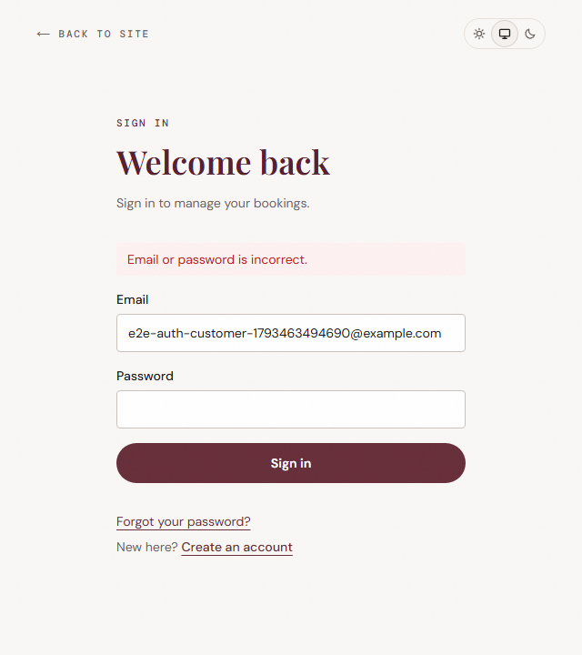
Figure 1. TC-AUTH-01, step 2: the error after a wrong password (sign-in form only).
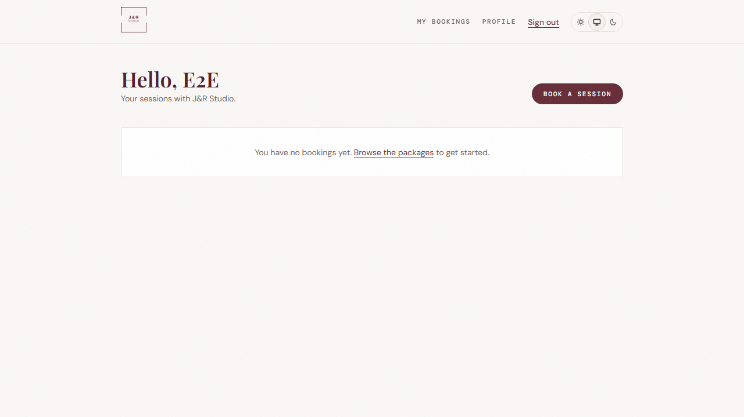
Figure 2. TC-AUTH-01, step 3: the customer's own area after the correct password.

TC-AUTH-02: A signed-out visitor is sent to sign in
Test type | Access control
Feature area | Authorisation
Script author | Mac Millan M. Abrenica
Script file | tests/e2e/auth-access.spec.ts
Objective | Confirm that the back office, the customer area and the booking page cannot be opened without signing in, and that the requested page is remembered.
Preconditions | No one is signed in.
Test data | Paths /admin, /account and /book.

Step | Action | Expected result
1 | Open /admin | The browser ends on /login?next=%2Fadmin
2 | Open /account | The browser ends on /login?next=%2Faccount
3 | Open /book | The browser ends on /login?next=%2Fbook

Actual result: Passed. The browser ended on the expected address each time (table below).
Page requested | Where the browser ended up (recorded by the test)
/admin | /login?next=%2Fadmin
/account | /login?next=%2Faccount
/book | /login?next=%2Fbook

Clean-up: None needed; the test creates no data.

TC-AUTH-03: A customer cannot open the back office; an admin can; sign-out works
Test type | Access control
Feature area | Authorisation, sign out
Script author | Mac Millan M. Abrenica
Script file | tests/e2e/auth-access.spec.ts
Objective | Confirm that a signed-in customer is kept out of the back office, that an admin gets in, and that signing out ends the session.
Preconditions | A confirmed customer account and a confirmed admin account exist, created through the admin API.
Test data | e2e-access-customer-<timestamp>@example.com (role customer) and e2e-access-admin-<timestamp>@example.com (role admin).

Step | Action | Expected result
1 | Sign in as the customer and open /admin | The browser ends on /account; no back-office navigation is on the page
2 | In a second browser page, sign in as the admin and open /admin | The browser ends on /admin; the back-office navigation is shown
3 | As the customer, press Sign out | The browser goes to the home page
4 | As the customer, open /account | The browser is sent to /login?next=...

Actual result: Passed.
Clean-up: Both accounts are deleted.
Figure 3. TC-AUTH-03, step 1: the customer who opened /admin was returned to their own area.
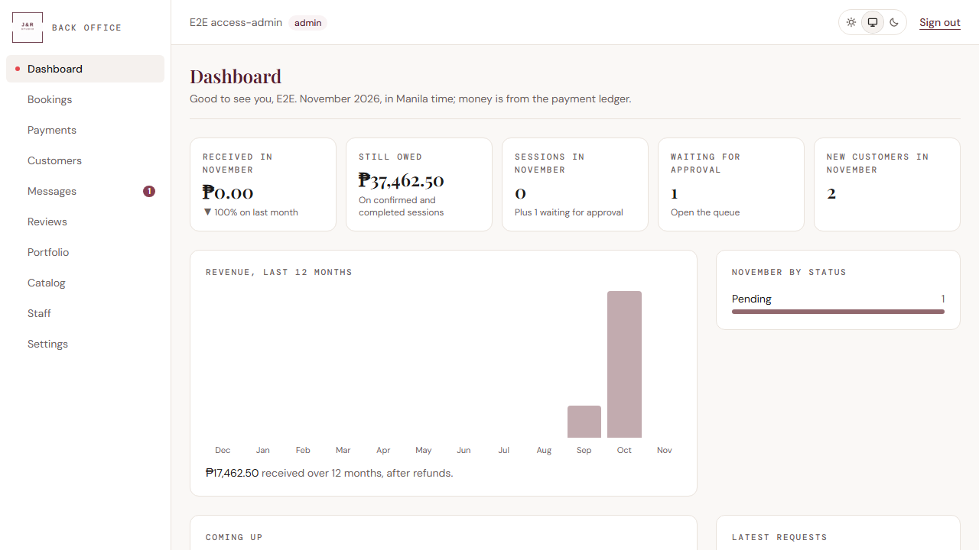
Figure 4. TC-AUTH-03, step 2: the admin reaches the back office dashboard.

TC-ADM-01: The studio declines a pending booking
Test type | State change
Feature area | Back office: booking status
Script author | Mac Millan M. Abrenica
Script file | tests/e2e/admin-booking.spec.ts
Objective | Confirm that an admin can decline a pending booking, that the status becomes final, and that the database agrees.
Preconditions | A customer account and an admin account exist. The customer has a pending booking.
Test data | Package Pro Portraits, first open time 12 days ahead (skipping Sundays), created through the booking API as the customer. Note text "No crew available that day".

Step | Action | Expected result
1 | Sign in as the admin and open the booking | The status badge in the page header reads "Pending"
2 | Type the note in the status note box | The note is accepted
3 | Press Decline and accept the confirmation dialog | "Booking declined." is shown
4 | Look at the page | The badge reads "Rejected" and "This booking is final" is shown
5 | Read the booking in the database | Its status is rejected

Actual result: Passed. See observation O-1 in section 7 about the wording "Decline", "declined" and "Rejected".
Clean-up: Both accounts and the booking are deleted.
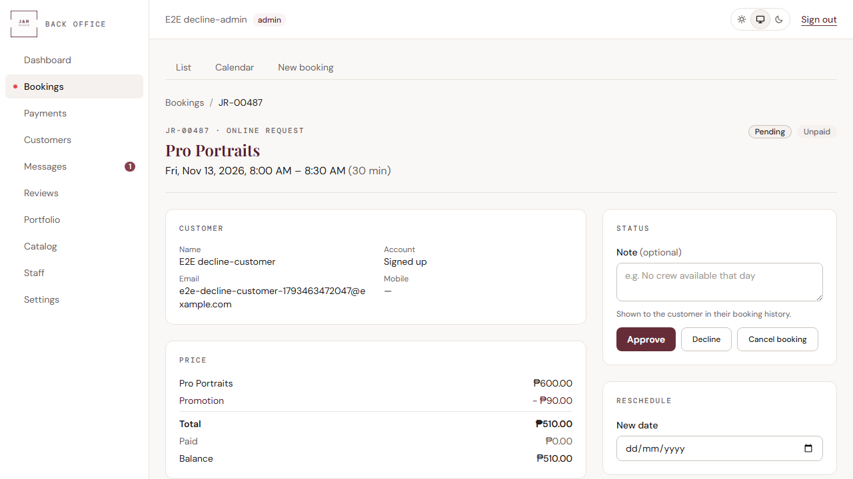
Figure 5. TC-ADM-01, step 1: the booking is pending.
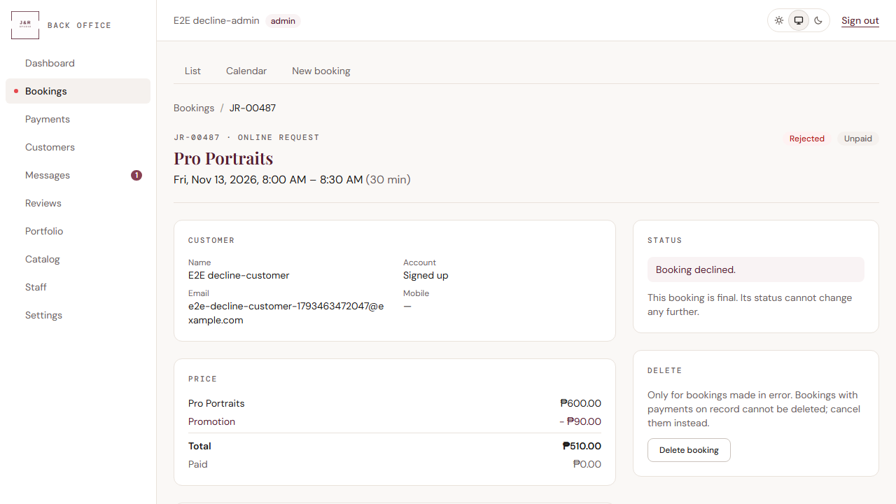
Figure 6. TC-ADM-01, step 4: the booking is rejected and final.

TC-ADM-02: The studio moves a booking to another day
Test type | State change
Feature area | Back office: reschedule
Script author | Mac Millan M. Abrenica
Script file | tests/e2e/admin-booking.spec.ts
Objective | Confirm that an admin can move a booking to a new date and time, that the new time is stored, and that the move is recorded in the booking's history.
Preconditions | A customer account and an admin account exist. The customer has a pending booking.
Test data | Package Pro Portraits booked 13 days ahead; moved to a date 17 days ahead (skipping Sundays), first open time.

Step | Action | Expected result
1 | Sign in as the admin and open the booking | The booking page is shown with a Reschedule panel
2 | Choose the new date | Open times for that day are listed
3 | Choose the first open time and press Move booking | "Booking moved. The customer is emailed the new time." is shown
4 | Read the booking in the database | Its start time differs from before and falls on the chosen date in Manila time
5 | Read the booking's history | It contains a rescheduled entry

Actual result: Passed. The test does not check that the email promised in the message is sent (section 8).
Clean-up: Both accounts and the booking are deleted.
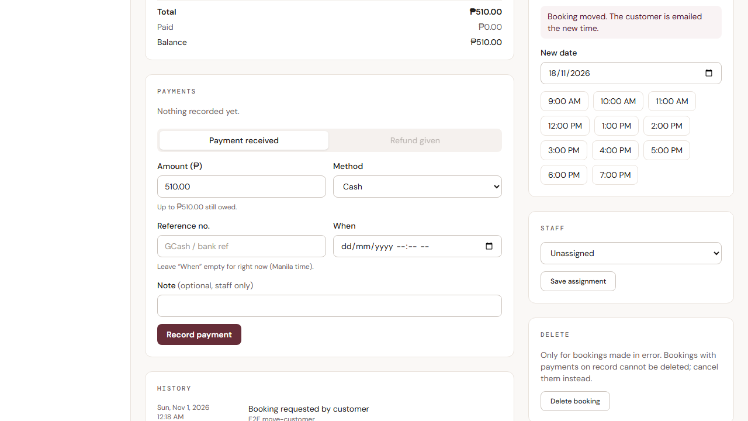
Figure 7. TC-ADM-02, step 3: confirmation after moving the booking (page scrolled to the Reschedule panel).

TC-WALK-01: The studio books a walk-in customer
Test type | Positive
Feature area | Back office: new booking
Script author | Mac Millan M. Abrenica
Script file | tests/e2e/walk-in.spec.ts
Objective | Confirm that an admin can create a booking for a customer who has no account, that it is approved straight away, and that it is recorded as a studio booking.
Preconditions | An admin account exists.
Test data | Walk-in name "Walk-in Tester", email e2e-walkin-<timestamp>@example.com; package Pro Portraits; first open time 14 days ahead (skipping Sundays).

Step | Action | Expected result
1 | Sign in as the admin and open /admin/bookings/new | The Book and approve button is disabled
2 | Choose New walk-in and enter the name and email | The fields accept the input
3 | Choose the package, the date and the first open time | The Book and approve button becomes enabled
4 | Press Book and approve | The browser moves to the new booking page; "Booked and approved." and "Walk-in (no login)" are shown
5 | Read the booking in the database | Its status is approved and its source is admin

Actual result: Passed.
Clean-up: The booking, the walk-in customer record and the admin account are deleted.
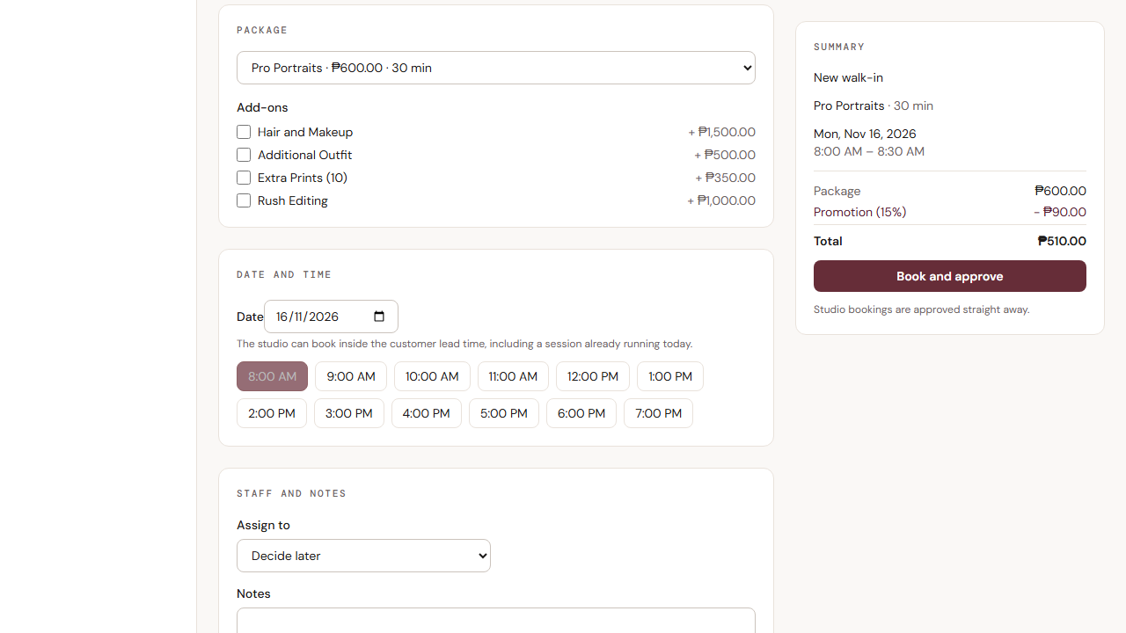
Figure 8. TC-WALK-01, step 3: the form is complete and the button is enabled (the summary on the right also shows the price with the promotion; the test checks only the button).
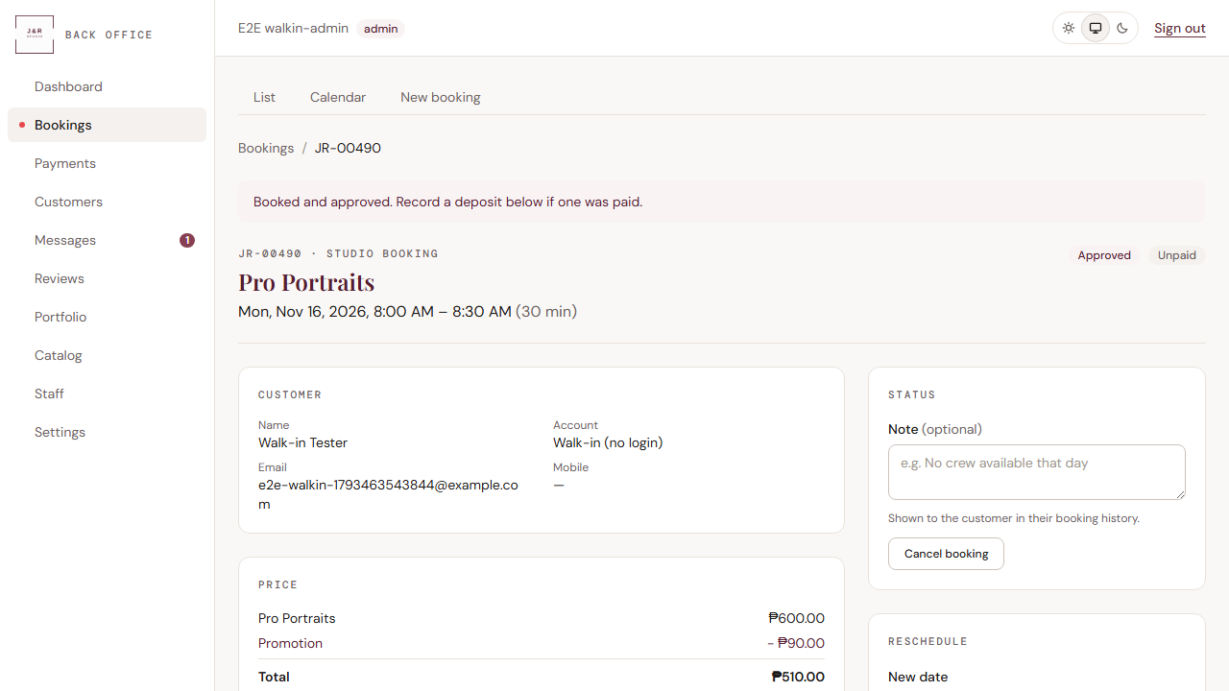
Figure 9. TC-WALK-01, step 4: the studio booking is approved for a walk-in customer.

TC-CONTACT-01: An empty contact form is refused
Test type | Negative
Feature area | Public site: contact form
Script author | Mac Millan M. Abrenica
Script file | tests/e2e/contact.spec.ts
Objective | Confirm that the contact form does not accept an empty submission and tells the visitor what is missing.
Preconditions | None. The page is public.
Test data | No input.

Step | Action | Expected result
1 | Open /contact | The contact form is shown
2 | Press Send message without typing anything | "Enter your name" and "Tell us a little more (at least 10 characters)" are shown
3 | Look for the success message | "Thank you!" is not shown

Actual result: Passed. The page also shows "Email is required"; the test checks the other two messages (figure below shows all three).
Clean-up: None needed; nothing is saved.
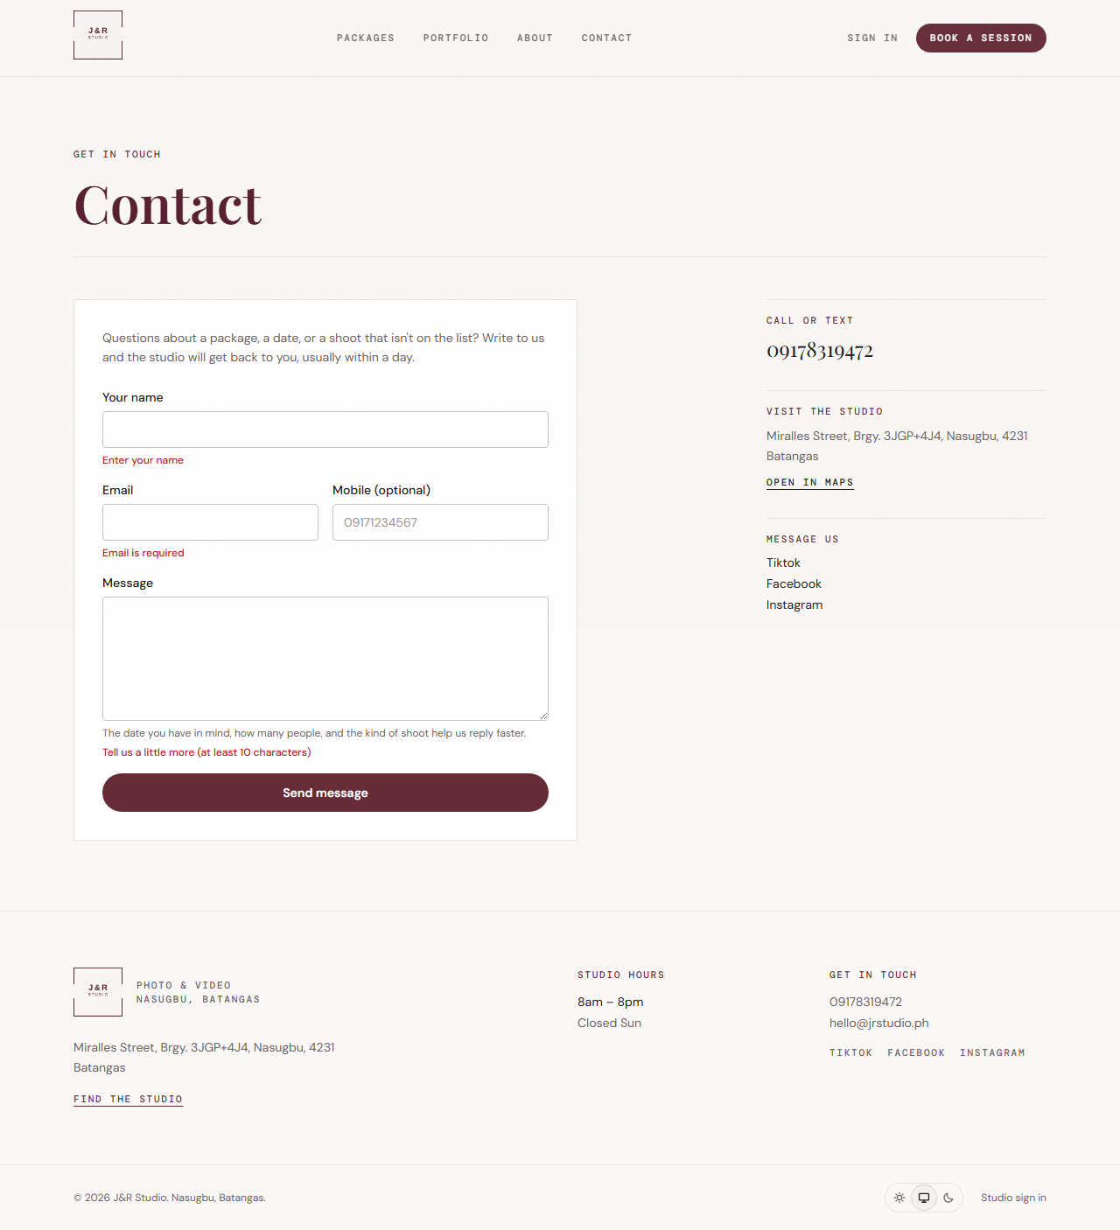
Figure 10. TC-CONTACT-01, step 2: the three validation messages on the empty form.

TC-CONTACT-02: A message is accepted and reaches the admin inbox
Test type | Positive
Feature area | Public site: contact form; back office: messages
Script author | Mac Millan M. Abrenica
Script file | tests/e2e/contact.spec.ts
Objective | Confirm that a visitor's message is accepted, stored as unread, and shown to the studio in the admin inbox.
Preconditions | An admin account exists.
Test data | Name "Contact Tester", email e2e-contact-<timestamp>@example.com, a message containing the timestamp so that it is unique.

Step | Action | Expected result
1 | As a visitor, open /contact, fill in the name, email and message, and press Send message | "Thank you! We'll get back to you soon." is shown
2 | Read the message in the database | It is stored with the sender's name and is marked unread
3 | Sign in as the admin and open /admin/messages | The message text and the sender's name are shown

Actual result: Passed. The test does not check the email notification to the studio (section 8).
Clean-up: The message and the admin account are deleted.
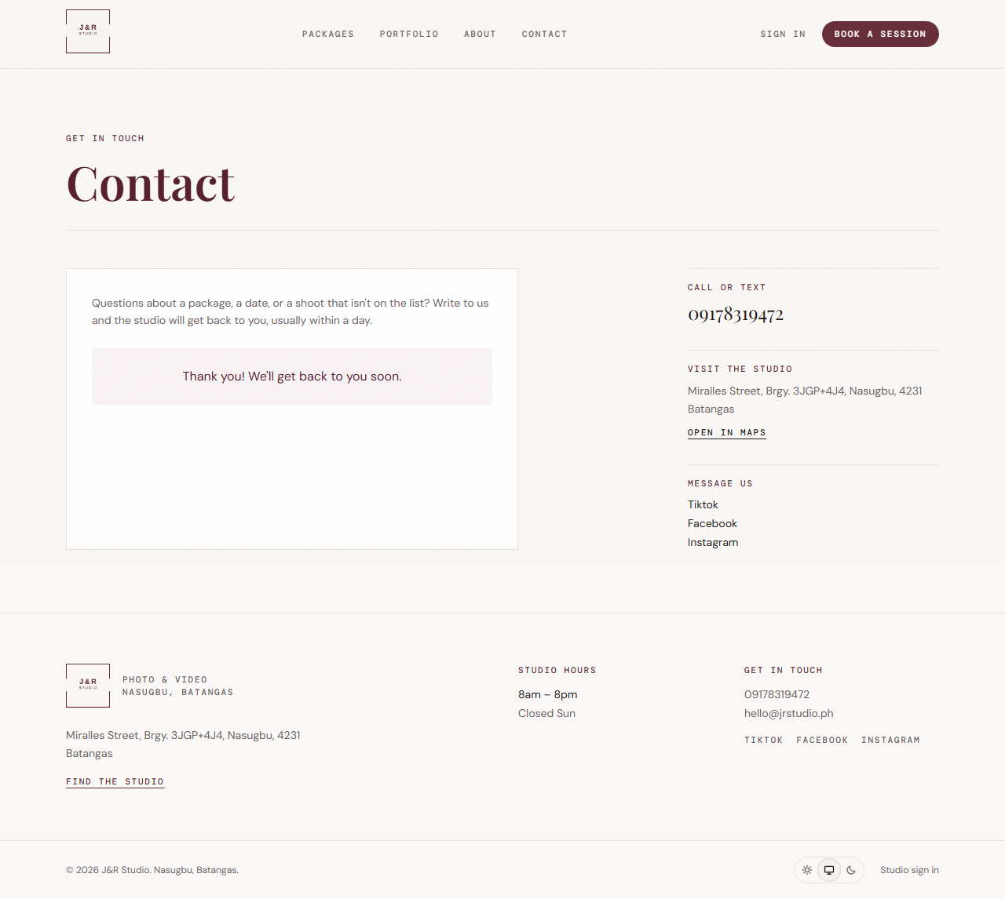
Figure 11. TC-CONTACT-02, step 1: the visitor sees the thank-you message.
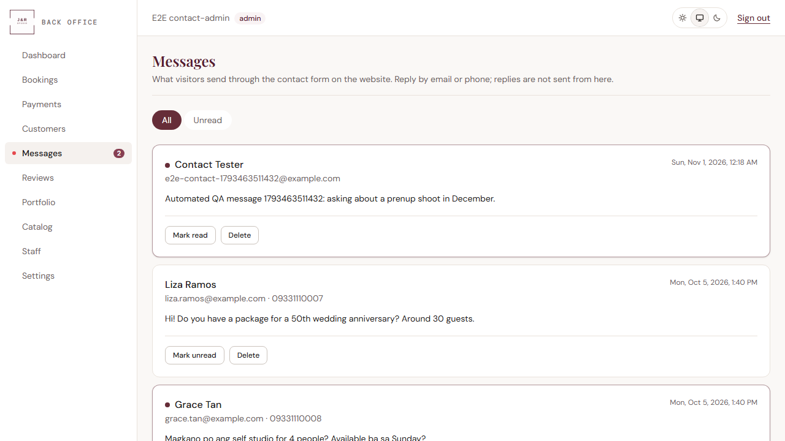
Figure 12. TC-CONTACT-02, step 3: the message at the top of the admin inbox, unread.

TC-E2E-01: Sign up, book, approve, pay, cancel and undo
Test type | End-to-end
Feature area | Sign-up, booking, payments, history
Script author | Project team (group QAlibarate)
Script file | tests/e2e/journey.spec.ts
Objective | Confirm that a customer can complete the whole booking journey, that the studio can process it, and that the system records every step correctly.
Preconditions | A temporary admin account is created for the studio side of the test. A unique customer email is generated for each run.
Test data | Customer delivered+e2e-<timestamp>@resend.dev (a Resend test address); package Pro Portraits; a date 10 days ahead (skipping Sundays); payment of the full balance in cash.

Step | Action | Expected result
1 | Open /signup, fill in name, email, password and confirmation, tick the booking terms, press Create account | The app moves to /verify?email=...
2 | Enter the 6-digit email code and press Verify email | Email confirmed; the customer lands on /account
3 | Open /book?package=pro-portraits, choose the date and first open time, press Request this booking | The new booking page is shown with "Request received."
4 | As the studio admin, open the booking and press Approve | "Booking approved." is shown
5 | Press Record payment (amount pre-filled with the balance) | "Payment recorded." is shown; the form switches to refunds; the booking shows Paid
6 | As the customer, reopen the booking | The booking shows Paid
7 | Press Cancel booking and confirm | An Undo cancellation button appears
8 | Press Undo cancellation | "Booking restored." is shown
9 | Check the database | Status is approved; history is exactly created, status_changed, payment_recorded, cancelled, undo_cancel
10 | Check the browser console of both pages | No Content Security Policy violations

Actual result: Passed in every run. The sign-up email is really sent (Supabase to Resend, to a test address); the test then obtains the 6-digit code through an admin API call instead of reading an inbox.
Clean-up: The customer, the temporary admin, the booking, its payments and its email log are deleted.
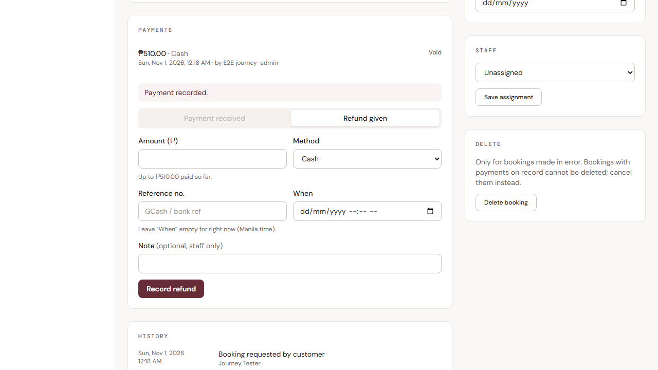
Figure 13. TC-E2E-01, step 5: the studio's view after the payment was recorded (automatic end-of-test screenshot).

TC-LAY-01: Public pages fit a phone and link to each other
Test type | Layout
Feature area | Public site on a phone
Script author | Project team (group QAlibarate)
Script file | tests/e2e/layout.spec.ts
Objective | Confirm that no public page scrolls sideways on a phone and that the header links are reachable.
Preconditions | None. Browser profile: Pixel 7.
Test data | Eight pages: /, /portfolio, /about, /contact, /packages/pro-portraits, /login, /signup, /book.

Step | Action | Expected result
1 | Open each page and compare its width with the screen width | No page scrolls sideways
2 | On the home page, look at the site navigation | Portfolio, About and Contact links are visible
3 | Check the browser console | No Content Security Policy violations

Actual result: Passed.
Clean-up: None needed; the test creates no data.
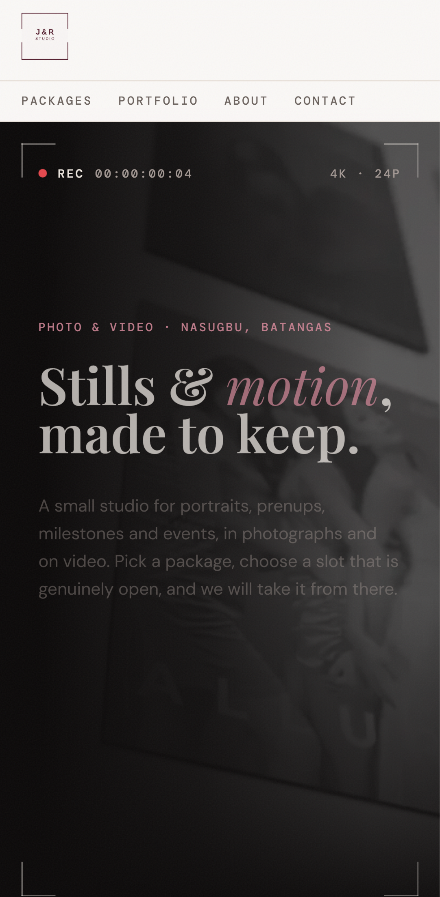
Figure 14. TC-LAY-01: the home page at phone size.

TC-LAY-02: Back-office pages fit a phone
Test type | Layout
Feature area | Back office on a phone
Script author | Project team (group QAlibarate)
Script file | tests/e2e/layout.spec.ts
Objective | Confirm that the back office is usable on a phone and that the sidebar marks the current section.
Preconditions | A temporary admin account exists. Browser profile: Pixel 7.
Test data | Twelve pages: /admin, /admin/bookings, /admin/bookings/calendar, /admin/bookings/new, /admin/payments, /admin/customers, /admin/messages, /admin/testimonials, /admin/portfolio, /admin/catalog/packages, /admin/staff, /admin/settings.

Step | Action | Expected result
1 | Open each page and compare its width with the screen width | No page scrolls sideways
2 | Check the browser console | No Content Security Policy violations
3 | Open /admin/catalog/addons | In the sidebar, Catalog is marked as the current page and Dashboard is not

Actual result: Passed.
Clean-up: The admin account is deleted.

6. Execution results

Results of the final run
Final run: 1 November 2026, 00:17 (Manila time), complete suite, 11 tests, 1.8 minutes.
ID | Test case | Result | Duration
TC-ADM-01 | The studio declines a pending booking | Pass | 11.8 s
TC-ADM-02 | The studio moves a booking to another day | Pass | 10.6 s
TC-AUTH-01 | Wrong password refused; correct password signs in | Pass | 4.0 s
TC-AUTH-02 | A signed-out visitor is sent to sign in | Pass | 1.0 s
TC-AUTH-03 | Customer kept out of back office; admin in; sign-out | Pass | 9.1 s
TC-CONTACT-01 | An empty contact form is refused | Pass | 1.0 s
TC-CONTACT-02 | Message accepted and reaches the admin inbox | Pass | 6.8 s
TC-E2E-01 | Sign up, book, approve, pay, cancel and undo | Pass | 24.6 s
TC-WALK-01 | The studio books a walk-in customer | Pass | 10.0 s
TC-LAY-01 | Public pages fit a phone | Pass | 2.7 s
TC-LAY-02 | Back-office pages fit a phone | Pass | 13.2 s
 | Total: 11 passed, 0 failed, 0 skipped |  | 1.8 min
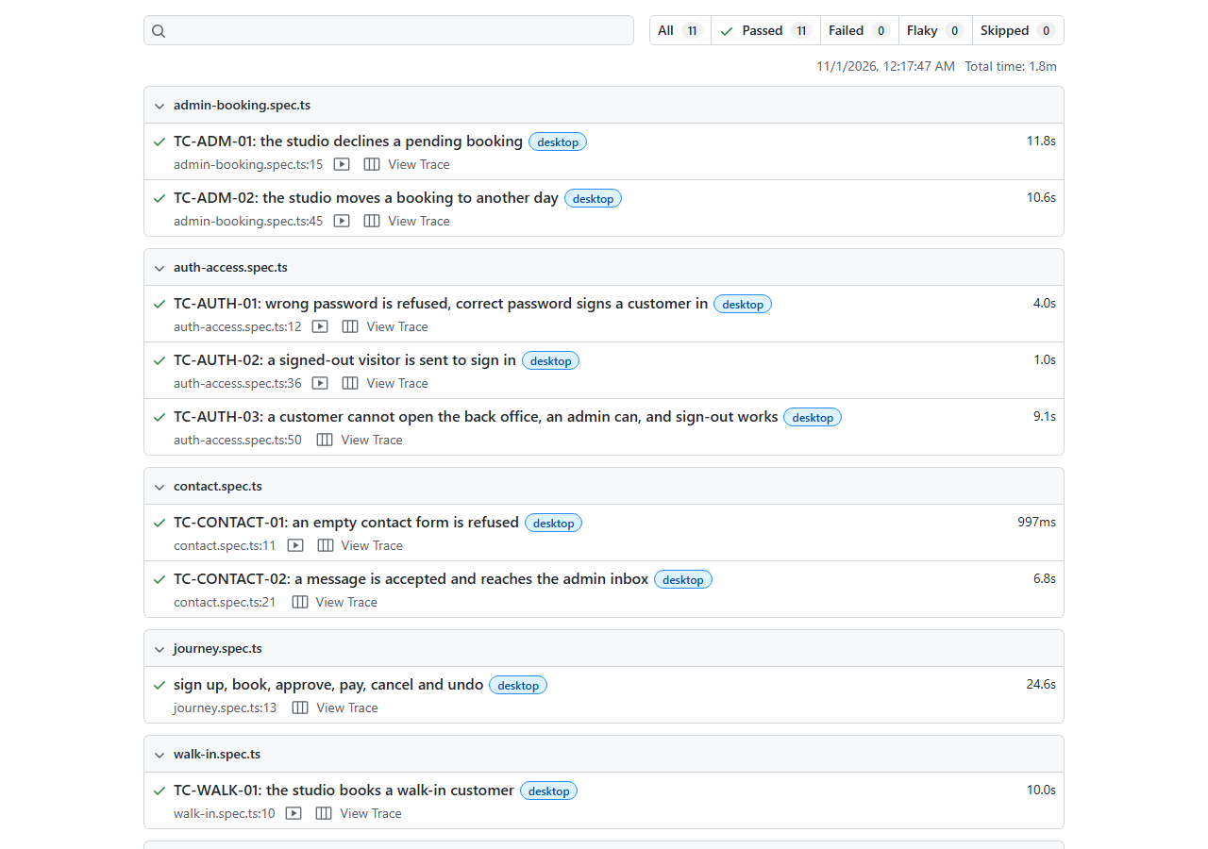
Figure 15. The Playwright HTML report for the final run: 11 passed, 0 failed, 0 flaky, 0 skipped.

History of all runs
Run | Date and time | What was run | Result | Duration
1 | 31 Oct 2026 | The 3 project-team tests, after set-up | 3 passed | 49.2 s
2 | 31 Oct 2026 | The same 3, with trace, video and screenshots switched on | 3 passed | 50.3 s
3 | 31 Oct 2026 | The same 3, on a freshly rebuilt application | 3 passed | 1.0 min
4 | 31 Oct 2026 | The 8 new tests, first run | 7 passed, 1 failed | 1.1 min
5 | 31 Oct 2026 | TC-ADM-01 and TC-ADM-02 after fixing the script (DEF-S01) | 2 passed | 26.3 s
6 | 31 Oct 2026, 23:40 | Complete suite (11 tests) | 11 passed | 1.6 min
7 | 1 Nov 2026, 00:12 | Complete suite, with in-test screenshots added | 11 passed | 2.0 min
8 | 1 Nov 2026, 00:15 | Complete suite, after making two screenshots full-page | 11 passed | 1.9 min
9 | 1 Nov 2026, 00:17 | Complete suite (the final run used for this document) | 11 passed | 1.8 min

In run 4, TC-ADM-01 failed because of a mistake in the test script, not in the application (DEF-S01 in section 7). It was corrected and passed in run 5 and in every later run. No test was flaky: no test failed and then passed without a change.

Test data and clean-up
Every test creates its own accounts, bookings or messages with identifiable names (e2e-... or delivered+e2e-... emails) and deletes them when it ends. After the runs, the database was queried for these names: no test accounts, customers, bookings or messages remained.
The database was also changed by people using the system by hand during the testing period (two accounts and one pending booking, JR-00440). These were created before the final runs and do not match the test naming, so they are not test leftovers.

Where the evidence is kept
Evidence | Location | How to view
HTML report | playwright-report/ | npx playwright show-report
Key-moment screenshots | qa/evidence/*.png | Open the image files (they are the figures in this document)
Screenshots, videos, traces of each run | test-results/<test name>/ | Open the files, or npx playwright show-trace <trace.zip>

7. Defects and observations
No application defects were found by the 11 automated test cases.

Defect log
ID | Description | Type | Severity | Status
DEF-S01 | TC-ADM-01 failed in run 4: the script looked for a field by the label "Note", but the page has two such fields (status and payment). The script was fixed to use the exact label "Note (optional)" | Test script | Low | Closed (fixed, run 5)

Observations (not failures)
ID | Observation | Impact | Status
O-1 | The same action uses three words: the button says "Decline", the message says "Booking declined.", and the admin status badge says "Rejected" (customers see "Declined") | Low: consistency | Open, for the team
O-2 | In one phone screenshot of the home page, the paragraph under the headline looked faint against the dark video background. It may have been a fade-in animation caught mid-way. Not confirmed | Possible readability issue | Open, verify by hand
O-3 | The automatic end-of-test screenshots are taken after clean-up and, for tests that open several pages, can show pages from earlier tests. The new tests therefore take their own screenshots; the project team's journey test does not | Evidence quality | Open, improvement
O-4 | The database used for testing is also used by hand, so tests and manual work share data | Risk of interference | Open, a separate test project is advisable
O-5 | No email key is configured, so no booking or contact email is sent in this environment, and no test checks emails | Coverage | Open, see section 8
O-6 | npm install reports 23 known vulnerabilities in dependencies (1 critical, 6 high). They were not investigated | Unknown | Open, needs review
O-7 | Next.js prints a warning at start-up about a package-lock.json outside the project folder | None on results | Open, cosmetic

8. Limitations and recommended next tests

Limitations of the testing done
- The tests were run in one browser engine (Chromium) at two sizes only (desktop Chrome and Pixel 7).
- The layout tests check for sideways scrolling and security-policy errors. They do not check how pages look (colours, contrast, alignment) and ran only in the default appearance, not in separate Light and Dark settings.
- Emails are not verified (O-5). TC-ADM-02 and TC-CONTACT-02 trust that an email is sent when the page says so.
- Set-up for TC-ADM-01 and TC-ADM-02 uses the database API, so the customer's own booking screen is covered only by TC-E2E-01.
- The tests run against a shared development database, not an isolated one.

Recommended next tests
- Password reset (forgot password and reset pages), and sign-up validation errors.
- Assigning staff, cancelling as the studio, recording a refund and voiding a payment.
- Two customers requesting the same time slot (the studio allows one session at a time).
- Catalog management (packages, add-ons, promotions) and its effect on the public site.
- Portfolio and staff photo uploads, reviews (testimonials), and unsubscribe.
- Light, Dark and System appearance settings, and other browsers and screen sizes.
- A check that proves a test can fail: change the application on purpose and confirm that the matching test fails.

Appendix A. Supporting run: integration tests (outside Playwright)
The project also has integration tests (npm test, Vitest) that check pricing, availability and database security rules directly against the database. They are not part of the Playwright results but were run for context.
Run | Result | Notes
First | 132 passed, 6 failed | Sample data had gone out of date: the seeded 15% promotion ended on 30 October 2026, and no approved booking existed in the future
After refreshing the promotion dates | 136 passed, 2 failed | The 4 pricing failures were resolved
Later run | 136 passed, 2 failed | The same 2 tests failed again

The 2 remaining failures depend on the sample data and the time of day: one needs an approved booking in the future, and one most likely fails because the tests ran at night, when the studio is closed (not yet confirmed). They do not point to an application defect.

Appendix B. How to repeat the tests
npm install
npx playwright install chromium # once
npm run build # again after any code change
npm run test:e2e # run all Playwright tests
npx playwright show-report # open the HTML report
Useful variations:
- npx playwright test auth-access runs one script file (also admin-booking, walk-in, contact, journey, layout).
- npx playwright test --project=phone runs the layout tests only; --project=desktop runs the others.
- Add --headed to watch the browser while the test runs.
Requirements: a valid .env.local with the Supabase URL, publishable key and secret key. The tests create and delete real records in the connected Supabase project, so do not run them against a database used by real customers.

Appendix C. Glossary
Term | Meaning
E2E (end-to-end) | A test that drives the whole application through its screens, like a real user
Playwright | The tool that controls a real browser to run those tests
Spec file | A file holding one or more automated test cases
Headless | The browser runs in the background without a visible window
Trace | A recording of every test step, with screenshots, to replay a run afterwards
Fixture / set-up | Data the test prepares before the check, such as an account or a booking
CSP | Content Security Policy: a browser security rule limiting what a page may load
RLS | Row-level security: database rules that decide which rows each user may read or change
Project (Playwright) | A test configuration: here, "desktop" (Desktop Chrome) and "phone" (Pixel 7)
Walk-in customer | A customer booked by the studio who has no online account

