Validation & Verification of proxy -> CAIS = Critical AI Systems

Building proxy systems for = High similarity systems
Values assigned to attributes
Transfer learning statistics for measuring similarities

Security, Privacy
Continuous Test, Evaluation, Verification, Validation (TEVV)
Cyber supply chain risk management across lifecycle

System req-
Validation & testing

--------- IMPORTANT
Assess CAIS Risk – determine risk (Phase 1) in Critical Infrastructure Sectors
ID Proxy Systems – Identify a proxy (Phase 2)
Verify Similarity – Verify the proxy to analyze similarities in the proxy system (Phase 3)
Create Misuse cases – Categorize risk (Phase 4)
Test Misuse cases – Phase 5
----------

Proxy goal =
- have the functional evidence of CAIS to enable safe testing
- cover those features that can’t be directly tested in the CAIS
Proxy coverage of CAIS is INCOMPLETE => but that doesn’t negate the value of proxy
Good proxy/Bad proxy depends on implementation
PHASE 2 -
CAIS Taxonomy Ladder =
- AI/ML Development Techniques
  - AI/ML Development Algorithms
    - Operational Characteristics
      - AI Application Purpose
        - Physical Operational Environment (OE)

- Physical –

lakes, oceans, forests and human-created environments (e.g., offices, factories, schools)
maritime, oceanography, hydrology
cyberspace

- Application

DfX = Design for Excellence – testability, reliability
System domain – communication, learning, planning, reasoning, providing a service
AI goals – NLP, CV, DL, DS, ML
Eg, Autonomous system if goal=autonomous operation

- Operational
Behavior and effect on system
O1: moving/stationary no=0/yes=1
O2: Mission: Navigation, target acquisition, target attack, gathering something, delivering something/payload (e.g., gas, water, packages) [can be >1 of these; b1b2b3b4b5, where bi=1 if the domain applies]
O3: Financial consequences (0-9 = none-catastrophic)
O4: Social consequences (0-9 = none-catastrophic eg, privacy, elections, compliance, law)
O5: Human risk (0-9 = none-catastrophic to the operator/user/passenger)

- Algorithms
- Dev techniques

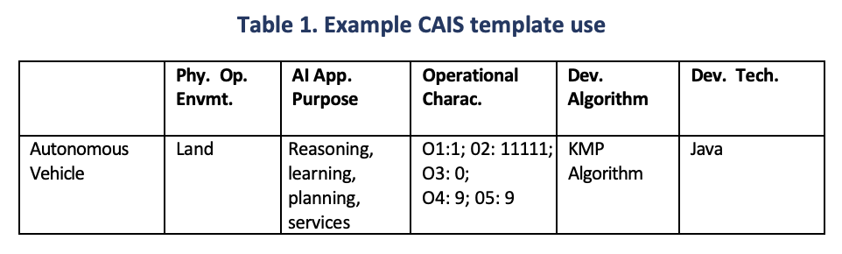
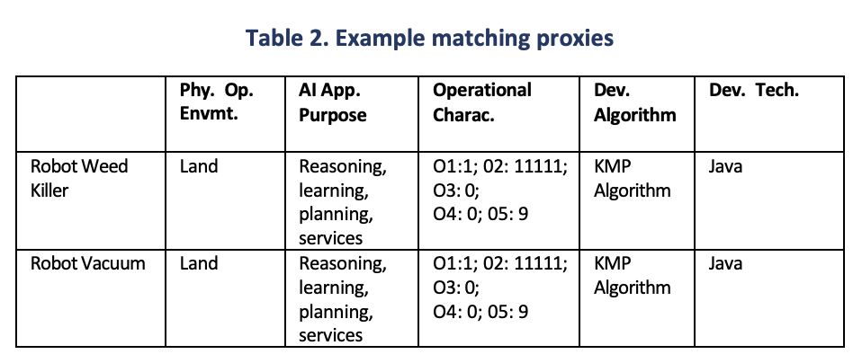

PHASE 3
Proxy Similarity testing
Phase 3 testing = similarity testing
Phase 5 testing = misuse case testing

For example,
multiple proxies for the autonomous vehicle were created in Phase 2.
Each proxy has increasing levels of criticality and functionality for an autonomous vehicle —
robot vacuum (level 1)
robot weed killer (level 2)
robot lawn mower (level 3)
autonomous vehicle (level 4)
— in that,
• They all use similar navigation system algorithms.
• They all use similar obstacle avoidance algorithms.
• Each proxy can have multiple failure use cases at various levels of criticality

in Phase 3,
appropriate use case scenarios of each proxy are tested against each other and against the CAIS to validate the matching process
In other words, using these proxy examples from Phase 2, the robot vacuum would be tested against the robot weed killer and then against the autonomous vehicle to validate the dimensions claimed in Phase 2

Phase 4
Define the workflow paths, dependences, and boundaries.
Identify the interactions, intersections, connections, dependencies, constraints, and triggers of the system and its components (e.g., GPS, ML, other sensors that could fail, weather, etc.).
Determine dysfunctional states (misuse cases), such as broken sensors, malicious entities, downtime, slow operating speeds, or misidentified obstacles.

- What will happen to the functions/capabilities delivered by the subsystem when components or subcomponents fail and result in an adverse operating state?
- What will the impact on subsystem operations be?
- Which of the components are most important for the subsystem to continue operating?

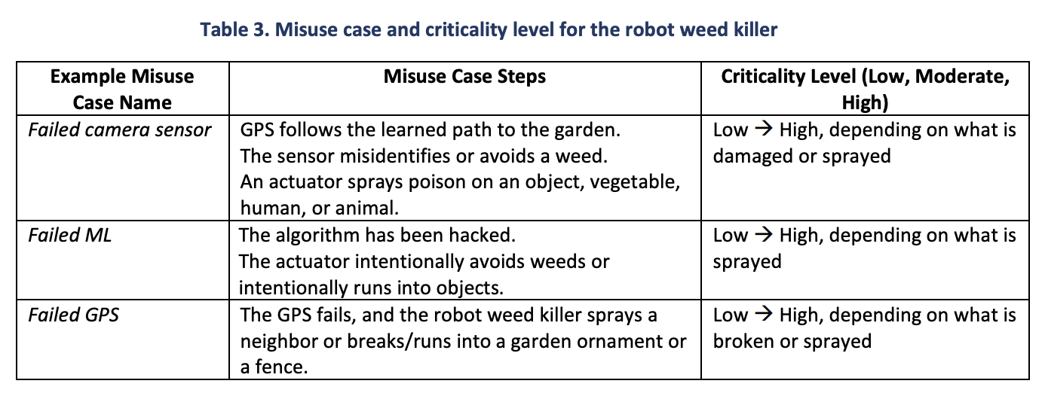

Phase 5 (Proxy Misuse case test
Test the misuse case scenarios determined in Phase 5 for each similar proxy tested in Phase 3.

PROXY SYSTEMS TO TEST CRITICAL AI SYSTEMS – software similarity
GOAL = Trustworthy AI
EXPENSIVE where edge cases too expensive or too dangerous to test –
- Healthcare
- Finance
- Transportation
- Public services

Behavior under stress? Rare edge cases behavior?
Ppl, infrastructure, reputations at risk

PROXY systems : non-critical software with similar behavior as normal; can stress, break, abuse in test.
CHALLENGE = find proxy match to Critical AI System; when we don’t have proprietary source code

Solution = software twins
AI + software + git logs
We look for proxy matches (human and technical fingerprint) –
- Commit messages
- Collaboration patterns
- File histories
- Development rhythms

Similarity
Code clones with matching functions, modules, snippets
Autonomous vehicles = env understanding into safe steer, brake, acc)- testing is challenging

WHAT IS SIMILARITY HERE?-
Does proxy system run in similar environment and serve similar purpose
Fail in similar ways?
Carry similar risks to ppl & infrastructure?

We can find non-critical systems to behave like CAIS & use as proxies
PUSH TO FAILURE
EXPLORE MISUSE & ADVERSARIAL CONDITIONS
w/o ever touching production!

NIST 5-layer approach =
- Physical environment
- Application purpose
- Operational characteristics
- AI/ML algos
- Development techniques

Problem = HOW ARE CANDIDATE SYSTEMS BUILT? Similarity technique FAILS here
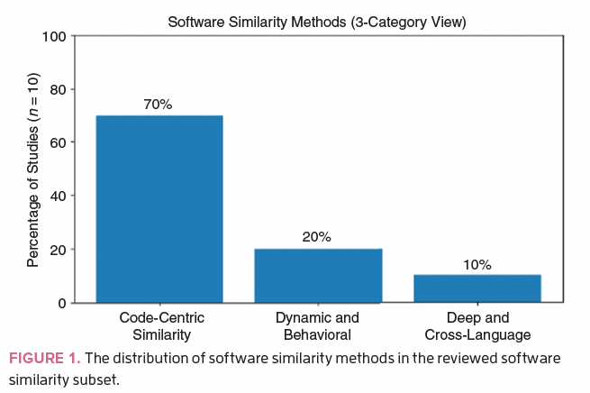
- Code centric (70% of literature)
Search for similar functions, tools, examples, functions, classes, modules
Reverse engineer code & correlate with maintainability, quality
Detect plagiarism, shared libraries, or refactored components

- Dynamic (20% of literature)
Run-time behavior –
Instrumenting systems
Comparing execution traces or state transitions
Building control flow & data flow graphs
Applying ML models to logs and runtime to learn behavioral “fingerprints”

- Deep & cross language (10%)
Eg, CroLSSim
Combines –
- Structural + semantic representations
- Abstract syntax trees
- Latent semantic analysis-based features
- Deep NN
NEEDED WHEN = reasoning similarity across language, platforms boundaries
CODE ACCESS is NECESSARY for these 3
CAISs = code access is unrealistic

Blink Spot
Code off limits ; not accessible for CAIS
- AI model = proprietary / hosted by 3rd party
- System mixes commercial & open source into CLOSED box
- Regulatory, contractual constraints limit reverse engineering or intrusive instrumentation

Issues = https://incidentdatabase.ai

Hard to modify the systems we’re most likely to probe

Need to FIND WAYS to IDENTIFY & COMPARE systems when –

- We cant see the code
- Cannot fully control runtime env
- Interact via APIs or logs

DESPITE NO CODE,
We have RICH METADATA about how software evolves (in open source and internal developer platforms) – git metadata

- READING BETWEEN COMMITS

Meta data
- Git histories
- Issue trackers
- CI (continuous integration) logs
- Deployment timelines

Shows how software evolves. Mapping to AI/ML algos and development techniques
[in CAIS Taxonomy]

Git based indicators = behavioral fingerprints for a software system

- Commit messages:
  - collectively tell the story about domain, features, and evolution of the system.
  - NLP embeds messages in semantic space
  - If “commit message corpus” of CANDIDATE PROXY has high semantic overlap with CAIS corpus, GOOD chance of handling similar concept
  - Find closer twins based on commit msg comparison

- Contribute behavior (SOCIOTECHNICAL SIGNATURE)
  - Who is committing? To what? When
  - Developer-to-file graphs
  - Authorship Entropy
  - Bus Factor metrics
Distinguish close-knit team vs vendor-heavy teams
- Mapping to development techniques dimension in CAIS Taxonomy

3. File change histories (ARCHITECTURE BY COCHANGE)
  - Cochange graphs & Churn metrics:
    - hidden architectural structure
    - modules edited in tandem are coupled
    - files with high churn MAY host volatile logic
    - stable core components sit at the center of these graphs
  - comparing patterns gives PROXY for underlying architecture & algo choices; like structural clones

4. Temporal evolution (RHYTHM OF DEVELOPMENT)
  - Project history = time series – these below, encode how a team works
    - Commit frequency
    - Burstiness
    - Release patterns
    - Long quiet intervals
  - Time series clustering
  - Dynamic time warping
  - Agile teams = regular cadence, frequent merges
  - Research prototype = sporadic flurries of work

Scoring Similarity at Repository scale
All 4 give partial view

SOLUTION = Combine them into a composite similarity score

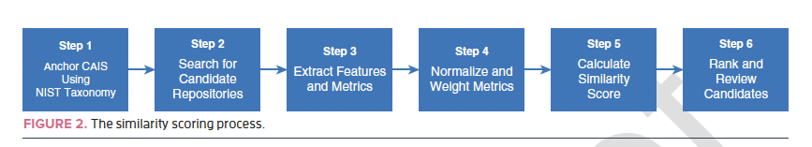

- In step 1 of the process, we anchor the CAIS using the five-dimensional NIST taxonomy:
- we describe where it operates, what it does, what risks it poses, which AI/ML algorithms it uses, and how it is developed.

- In step 2, candidate repositories are collected by searching widely for systems in related domains, open-source healthcare decision support tools, robotic control stacks, or financial risk engines, where at least Git metadata are available.

- In step 3, next feature vectors are computed for each candidate with a semantic embedding of
- commit messages
- graph-based features that summarize contributor behavior
- cochange and churn metrics for the file graph
- time series descriptors of commit activity

- Step 4 normalizes and weights the metrics.
- Min–max normalization places each metric on a common scale.
- We assign weights reflecting which dimensions matter most for a given proxy task
- for instance, heavier weight on commit semantics when functional purpose is critical or on contributor behavior when development technique is the focus

- In step 5,
- Weighted metrics aggregated into a similarity score for each CAIS-candidate pair
- Result = tunable similarity value that empathizes function, development practice, or architecture as needed

- Finally, in step 6, we rank and review the candidates.
- The top-ranked systems receive deeper expert scrutiny and, when possible, more detailed architectural or code inspection.

Consider two candidate proxy systems that both resemble an autonomous vehicle CAIS but in different ways:

- one closely matches the commit content and development rhythm but is built by a very different kind of development team (for example, more/less organized, using a different methodology, etc.)

- the other is maintained by a team whose behavior strongly matches the CAIS’s organization, but whose commit content is less aligned.

- With different weights, either candidate might come out on top

- This is a feature : to highlight similarity in testing campaign

SIMILARITY TO PROXY SAFETY LOOP

Just SIMILARITY scores != good PROXY
They narrow the search space

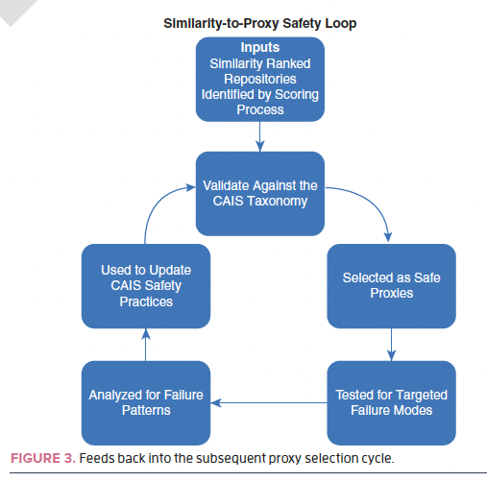

- If candidate shares same operational environment, purpose, development technique
- But different algo family
- STILL A SAFE PROXY for certain failure modes

Then DESIGN TARGETED TEST CAMPAIGNS around selected proxies
Use Proxy to test CAIS
- Explore edge cases that are unacceptable in live CAIS
  - Biased inputs
  - Adversarial cases
  - Infrastructure failures
  - Degraded sensors

Then transfer insights to CAIS
Failure patterns show RISK ASSESMENT, MONITORING STRATEGY, MITIGATION PLANS for real system

Validate the Similarity process

- Calibration against known pairs

- We need benchmark collections of systems where we do know the ground truth similarity, Both Functionally & Architecturally
- To tune weights, thresholds & feature choices for composite similarity scores

- Governance frameworks

Embed Meta-data driven similarity into broader RISK MANAGEMENT, CERTIFICATION, CONTINUOUS MONITORING

- Tooling for practitioners

- Safety engineers and auditors to point tool at CAIS repo (or metadata)
- & receive list of candidate proxies with similarity metrics

The core idea is simple: if we cannot see the code, we should pay close attention to the traces it leaves behind.
Git histories, developer networks, and architectural fingerprints carry enough information to discover software twins at scale. When those twins can serve as safe proxies for testing, we gain a powerful new lever for understanding and managing the risks of CAISs.
