Practical No.01
Definition:-write a program to create and import a user-defined module.
Objectives
- To understand,how to creates user define module
- To demonstrate the use of UDF in python

Code:
main.py
#write a program to create and import a user-defined module.
#importing user defined module
import demo
# we can call the properties,methods,class of another UDM
print(demo.add(20,30))
print(demo.sub(50,15))

demo.py
def add(a,b):
return a+b
def sub(a,b):
return a-b

Output:
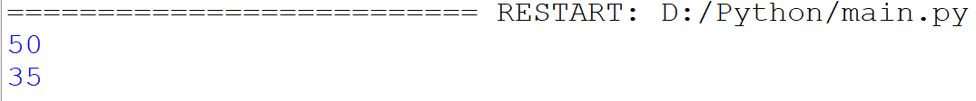

Conclusion:-This program demonstrates the use of user defined modules,Furthermore we can create multiple modules as per need and integrate related methods,class,attributes in our UDF.

Practical No.02
Definition:-write a program to demonstrate different import mechanisms in Python
Objective:
- To understand the different way of importing mechanism in Python
- To demonstrate the need of different types of import mechanism

Code:
#import complete module
import math
print(math.sqrt(25))

#import specific function
from math import factorial
print(factorial(5))

#import multiple function
from math import log,factorial,sqrt
print(log(10000))
print(factorial(5))
print(sqrt(4))

#import module with an alias
import math as mt
print(mt.log10(10000))

#import function with an alias
from math import log10 as l10
print(l10(10000))

Output:
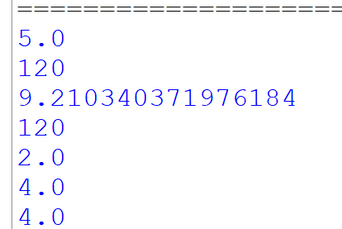

Conclusion:
This program shows that Python gives you different ways to use built-in tools. You can import a whole module, pick specific functions, import multiple functions at once, or use short nicknames (aliases) for both modules and functions to make your code cleaner and easier to read.

Practica No.03
Definition:-write a program to perform mathematical operations using math module.

Objective:
- To understand the use and need of methods and attributes of math module.
Code:
import math
#'sqrt' function gives the perfect or approximate square value
print(f"Square Root {math.sqrt(25)}")
print()
#log work as a sqrt but it has different power like 10^x
#Log transformations are useful in data preprocessing.while data contains asymmetricity
#with the help of this we can reduce the skewness.
print(f"Log Transformation : {math.log(10000)}")

print(f" Factorial : {math.factorial}")

Output:
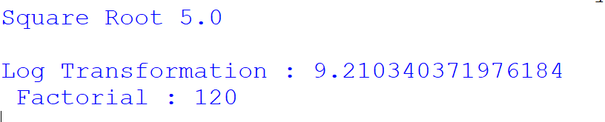

Conclusion:
This program shows how to use basic math tools like square roots and logarithms for calculations and data preparation.

Practical No.04
Definition:-Write a program to generate random numbers using random values.
Objective:
- To demonstrate how to generate random numbers using random module
Code:
import random
print(random.randint(1,10))
#random.randint generates random integer value,it takes two argument 1st is number of
#values and 2nd is range of value

print(random.random())
#random.random generates random values too,However it generates any random values.

Output:
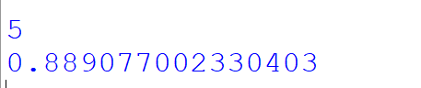

Conclusion:
This program shows that Python's random module can generate different types of random numbers: randint() produces random whole numbers within a specific range, while random() produces random decimal numbers between 0 and 1.

Practical No.05
Definition:-write a program to display current date and time using datetime module.
Objective:
- To display the current system date and time using Python's built-in datetime module.
Code:
import datetime as dt
print(f"Current Date : {dt.date.today()}")
print(f"Current Time : {dt.datetime.now().time()}")

Output:
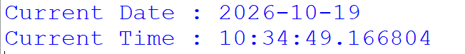

Conclusion:
Your program shows how to easily fetch and separate the current date and time using date.today() and datetime.now().time(), making it simple to work with date and time values in your code.

Practical No.06
Definition:-Write a program to perform file and directory operations using os and sys modules

Objective:
- To perform file and directory operations and retrieve system information using Python's built-in os and sys modules.
Code:
import os
import sys

#Current working Directory
print(f"Current Directory : {os.getcwd()}")

#Create directory
os.makedirs("Practical",exist_ok=True)

#Create a file inside the directory
file_path=os.path.join("Practical","demo.txt")

with open(file_path,"w") as f:
f.write("This is demo file")

#List of files and directories
print(f"Directory Content : {os.listdir("Practical")}")

#Display python version using sys
print("Python Version : ",sys.version)

#Display Command Line arguments
print("Command Line Arguments : ",sys.argv)

Output:
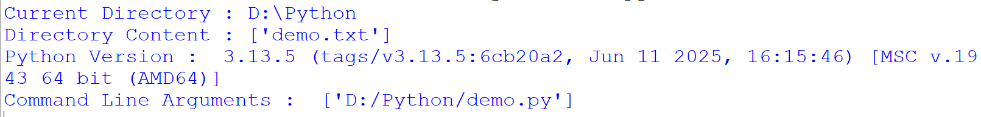

Conclusion:
This program demonstrates how to interact with the file system using the os module—such as checking the working directory, creating directories and files, and listing folder contents—while using the sys module to fetch system details like the Python version and command-line arguments.

Practical No.07
Definition:-Write a program to copy move and delete file using shutil module

Objective:
- To demonstrate how to copy, move, and delete files using Python's shutil and os modules.
Code:
import os
import shutil

#creating demo file for copy and move
with open("demo.txt","w") as f:
f.write("This is a demo file")

# Copy the File
shutil.copy("demo.txt","copy.txt")

with open("copy.txt","r") as f:
data=f.readlines()
for row in data:
print(row)
# move to the new folder
os.makedirs("myfolder",exist_ok=True)
shutil.move("copy.txt","myfolder/copy.txt")

#Delete the moved file
os.remove("myfolder/copy.txt")

Output:
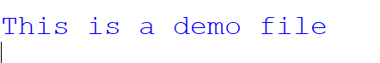

Conclusion:
This program demonstrates how to manage files programmatically—using shutil to easily copy and move files around your system, and os to handle tasks like creating folders and deleting files when they are no longer needed.

Practical No.08
Definition:-Write a program to demonstrate basic regular expression patter matching

Objective:
- To demonstrate basic regular expression pattern matching operations using Python's re module.

Code:
import re
text="My name is Kaif and my GR number is 150521"
#search for a word

result=re.search("Kaif",text)
if result:
print("Pattern found:",result.group())
else:
print("Pattern Not Found!")
#Find all digits
numbers=re.findall(r"\d+",text)
if numbers:
print("Numbers found : ",numbers)
else:
print("Numbers not found!")
result_2=re.match("My",text)
if result_2:
print("Text starts with : ",result_2.group())
else:
print("no match found at the beginning")

Output:
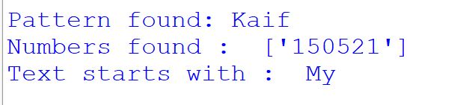

Conclusion:
This program demonstrates how to use the re module to search for specific words (re.search), extract digits using pattern matching (re.findall), and check if a string begins with a specific word (re.match), making text searching and data extraction easy.

Practical no.09
Definition:Write a program to read and write data into a file using different file modules.

Objectives:
- To demonstrate text pattern matching, searching, and extraction using Python's re (regular expression) module.
Code:
import re
text="Python is easy. Python is powerful. My roll number is 4107"
# match
result1=re.match("Python",text)
print("Match: ",result1.group() if result1 else "Not found")

#search
result2=re.search("easy",text)
print("Search : ",result2.group() if result2 else "Not Found")

#findall
result3=re.findall("Python",text)
print("Findall : ",result3)

Output:
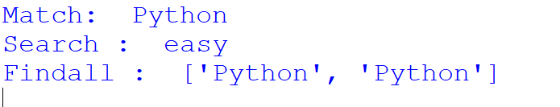
Conclusion:
This program shows how to use different regex functions—re.match to check the start of a string, re.search to find a word anywhere in the text, and re.findall to find all matching occurrences of a pattern within a given string.

Practical No.10
Definition:Write a program to extract specific information from a text file using regular expressions

Objective:
- To extract specific pieces of information (such as a name, roll number, and email) from a text file using regular expressions.

Code:
import re
with open("demo.txt","w") as f:
f.write("Name: Kaif\n")
f.write("Roll No: 4107\n")
f.write("Email: kaif@gmail.com")

with open("demo.txt","r") as f:
text=f.read()

#Extracting information using regular expression
name=re.search(r"Name:\s*(.*)",text)
roll=re.search(r"Roll No:\s*(\d+)",text)
email=re.search(r"Email:\s*(\S+)",text)

#Displaying Extracting information
print(f"Name: {name.group(1)}")
print(f"Roll : {roll.group(1)}")
print(f"Email : {email.group(1)}")

Output:
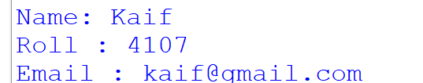

Conclusion:
Your program shows how to combine file handling with regular expression capture groups ((...)) to read data from a file and accurately pull out targeted fields.

